Case Study:
Continuous Integration Using Jenkins

Creating a Freestyle Build Job
The freestyle build job is a highly flexible and easy-to-use option. You can use it for any type of project; it is easy to set up, and many of its options appear in other build jobs.
Step 1) To create a Jenkins freestyle job, log on to your Jenkins dashboard by visiting your Jenkins installation path. Usually, it will be hosted on localhost at http://localhost:8080 If you have installed Jenkins in another path, use the appropriate URL to access your dashboard.
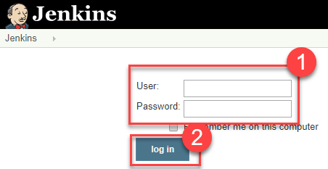
Step 2) Click on "New Item" at the top left-hand side of your dashboard.
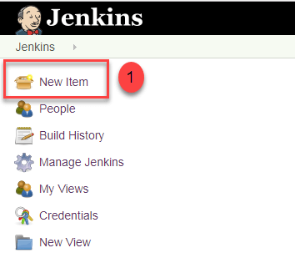
Step 3) In the next screen,
- Enter the name of the item you want to create. We shall use the"QA_UNIT_TEST" for this demo.
- Select Freestyle project
- Click Okay
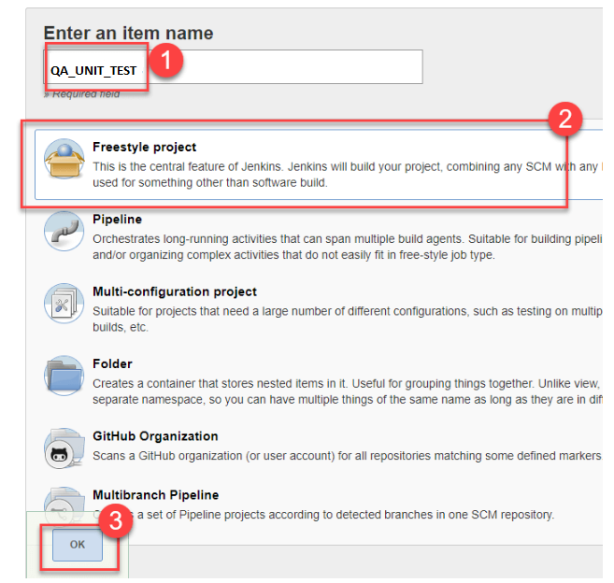
Step 4) Enter the details of the project you want to test.
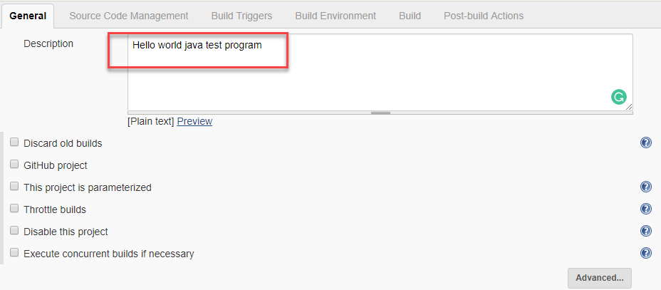
Step 5) Under Source Code Management, Enter your repository URL. We have a test repository located at https://github.com/edureka-devops/selenium-website
It is also possible for you to use a local repository.
If your GitHub repository is private, Jenkins will first validate your login credentials with GitHub and only then pull the source code from your GitHub repository.
Step 6) Now that you have provided all the details, it's time to build the code. Tweak the settings under the build section to build the code at the time you want. You can even schedule the build to happen periodically, at set times.
Under build,

1. Click on "Add build step"
2. Click on "Execute Windows batch command" and add the commands you want to execute during the build process.
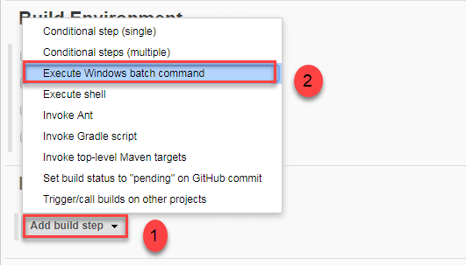
Here, I have added the java commands to compile the java code.
I have added the following windows commands:
javac HelloWorld.java
java HelloWorld
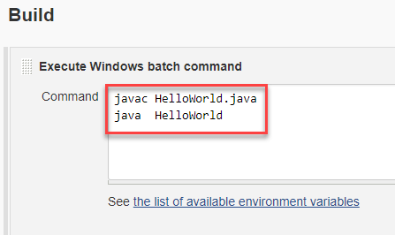
Step 7) When you have entered all the data,
- Click Apply
- Save the project.
Step 8) Now, in the main screen, Click the Build Now button on the left-hand side to build the source code.
Step 9) After clicking on Build now, you can see the status of the build you run under Build History.
Step 10) Click on the build number and then Click on console output to see the status of the build you run. It should show you a success message, provided you have followed the setup properly.

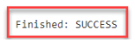

Cobertura
Cobertura is an open source code coverage tool that works well with both Maven and Jenkins. Our Maven demonstration project is already configured to record code coverage metrics, so all we need to do is to install the Jenkins Cobertura plugin and generate the code coverage metrics for Jenkins to record and display.

Figure 2.27. Jenkins has a large range of plugins available

To install a new plugin, go to the Manage Jenkins page and click on the Manage Plugins entry. This will display a list of the available plugins as well as the plugins already installed on your server (see Figure 2.27, “Jenkins has a large range of plugins available”). If your build server doesn’t have an Internet connection, you can also manually install a plugin by downloading the plugin file elsewhere and uploading it to your Jenkins installation (just open the Advanced tab in Figure 2.27, “Jenkins has a large range of plugins available”), or by copying the plugin to the $JENKINS_HOME/plugins directory.
In our case, we are interested in the Cobertura plugin, so go to the Available tab and scroll down until you find the Cobertura Plugin entry in the Build Reports section. Click on the checkbox and then click on the Install button at the bottom of the screen.
This will download and install the plugin for you. Once it is done, you will need to restart your Jenkins instance to see the fruits of your labor. When you have restarted Jenkins, go back to the Manage Plugins screen and click on the Installed tab—there should now be a Cobertura Plugin entry in the list of installed plugins on this page.
Once you have made sure the plugin was successfully installed, go to the configuration page for the gameoflife-default build job.
To set up code coverage metrics in our project, we need to do two things. First we need to generate the Cobertura coverage data in an XML form that Jenkins can use; then we need to configure Jenkins to display the coverage reports.
Our Game of Life project already has been configured to generate XML code coverage reports if we ask it. All you need to do is to run mvn cobertura:cobertura to generate the reports in XML form. Cobertura can also generate HTML reports, but in our case we will be letting Jenkins take care of the reporting, so we can save on build time by not generating the For this example, for simplicity, we will just add the cobertura:cobertura goal to the second build step (see Figure 2.28, “Adding another Maven goal to generating test coverage metrics”). You could also add a new build step just for the code coverage metrics. In a real-world project, code quality metrics like this are typically placed in a distinct build job, which is run less frequently than the default build.
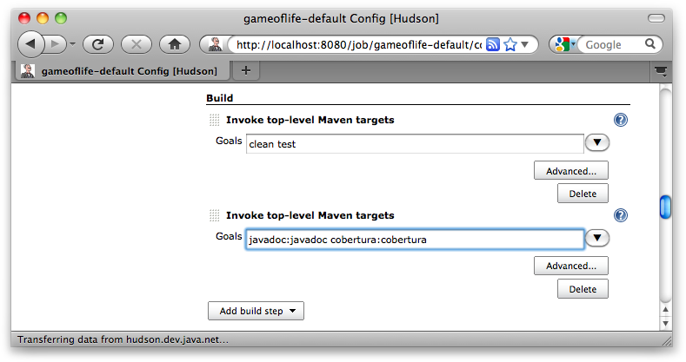
Figure 2.28. Adding another Maven goal to generating test coverage metrics

Next, we need to tell Jenkins to keep track of our code coverage metrics. Scroll down to the “Post-build Actions” section. You should see a new checkbox labeled Publish Cobertura Reports. Jenkins will often add UI elements like this when you install a new plugin. When you tick this box, Jenkins will display the configuration options for the Cobertura plugin that we installed earlier (see Figure 2.29, “Configuring the test coverage metrics in Jenkins”).
Like most of the code-quality related plugins in Jenkins, the Cobertura plugin lets you fine-tune not only the way Jenkins displays the report data, but also how it interprets the data. In the Coverage Metrics Targets section, you can define what you consider to be the minimum acceptable levels of code coverage. In Figure 2.29, “Configuring the test coverage metrics in Jenkins”, we have configured Jenkins to list any builds with less than 50% test coverage as “unstable” (indicated by a yellow ball), and notify the team accordingly.
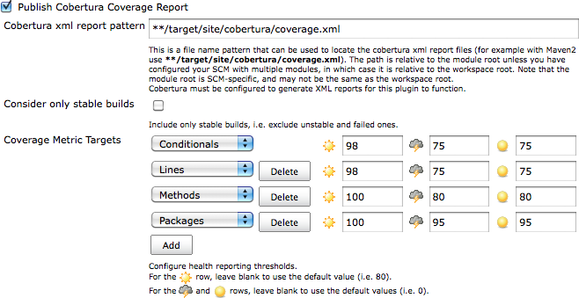
Figure 2.29. Configuring the test coverage metrics in Jenkins

This fine-tuning often comes in handy in real-world builds. For example, you may want to impose a special code coverage constraint in release builds, to ensure high code coverage in release versions. Another strategy that can be useful for legacy projects is to gradually increase the minimum tolerated code coverage level over time. This way you can avoid having to retro-fit unit tests on legacy code just to raise the code coverage, but you do encourage all new code and bug fixes to be well tested.
Now trigger a build manually. The first time you run the build job with Cobertura reporting activated, you will see coverage statistics for your build displayed on the build home page, along with a Coverage Report link when you can go for more details (see Figure 2.30, “Jenkins displays code coverage metrics on the build home page”). The Cobertura report shows different types of code coverage for the build we just ran. Since we have only run the test coverage metrics once, the coverage will be displayed as red and green bars.

Figure 2.30. Jenkins displays code coverage metrics on the build home page

If you click on the Coverage Report icon, you will see code coverage for each package in your application, and even drill down to see the code coverage (or lack thereof) for an individual class (see Figure 2.31, “Jenkins lets you display code coverage metrics for packages and classes”). When you get to this level, Jenkins displays both the overall coverage statistics for the class, and also highlights the lines that were executed in green, and those that weren’t in red.
This reporting gets better with time. Jenkins not only reports metrics data for the latest build, but also keeps track of metrics over time, so that you can see how they evolve throughout the life of the project.
For example, if you drill down into the coverage reports, you will notice that certain parts of this code are not tested (for example the Cell.java class in Figure 2.31, “Jenkins lets you display code coverage metrics for packages and classes”).
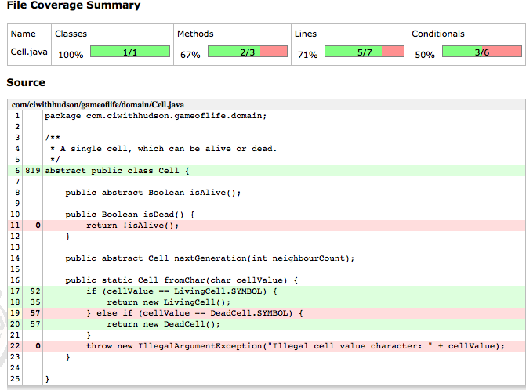
Figure 2.31. Jenkins lets you display code coverage metrics for packages and classes

Code coverage metrics are a great way to isolate code that has not been tested, in order to add extra tests for corner cases that were not properly tested during the initial development, for example. The Jenkins code coverage graphs are also a great way of keeping track of your code coverage metrics as the project grows. Indeed, as you add new tests, you will notice that Jenkins will display a graph of code coverage over time, not just the latest results (see Figure 2.32, “Jenkins also displays a graph of code coverage over time”).
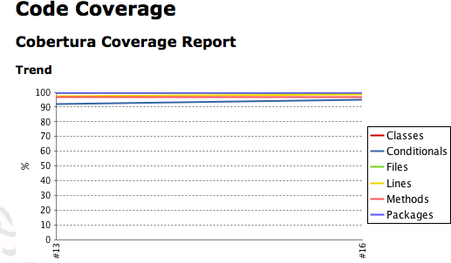
Figure 2.32. Jenkins also displays a graph of code coverage over time

Jenkins to create an executable jar/war file:-

The above command will make Jenkins accessible at http://localhost:8080 in your web browser. Upon first launch you’ll be guided through a wizard for configuration.
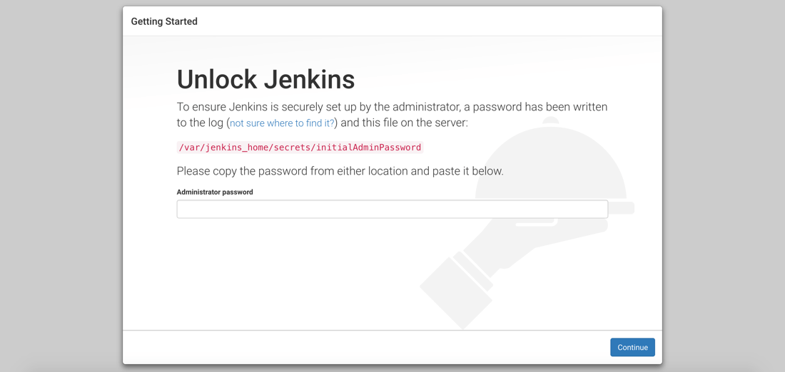
As part of the first configuration step, you’ll need to obtain a generated value to be used as the super admin password.
After providing the password as per the instructions on the screen, you’ll be asked about the installation of Jenkins plugins.
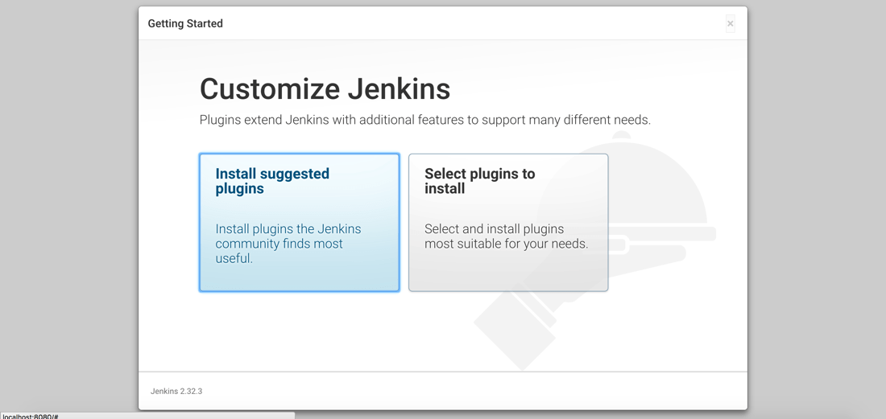
We’re going to start by installing the suggested plugins and then install extras later. It may take some time, but after the suggested plugins have been installed you’ll be prompted to set up your first administrative user account.
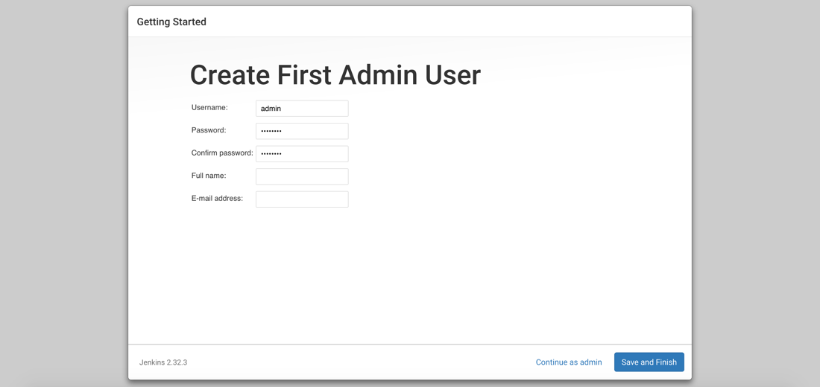
You can choose to create an administrative user, or continue to use the generated password when working with Jenkins.
After creating an account, Jenkins is ready to be used. Before we create our first workflow, or job, we need to install an extra plugin.
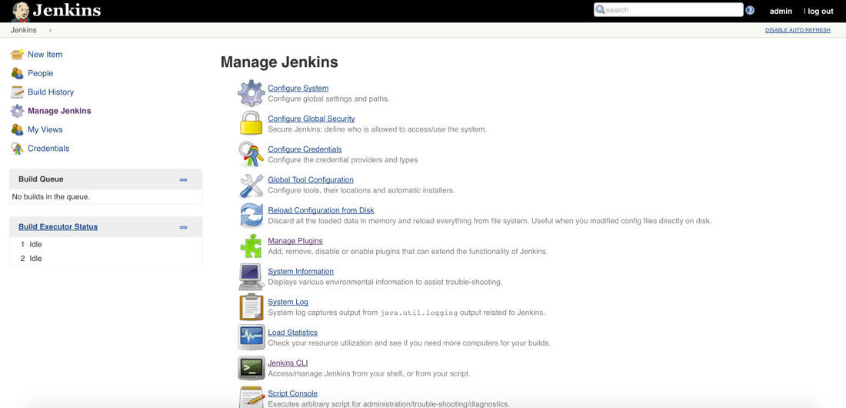
You’ll want to choose to Manage Jenkins which will bring us to a list of management sections, one of which being a section for managing plugins.
Choose to Manage Plugins and do a search for the Post-Build Script plugin.
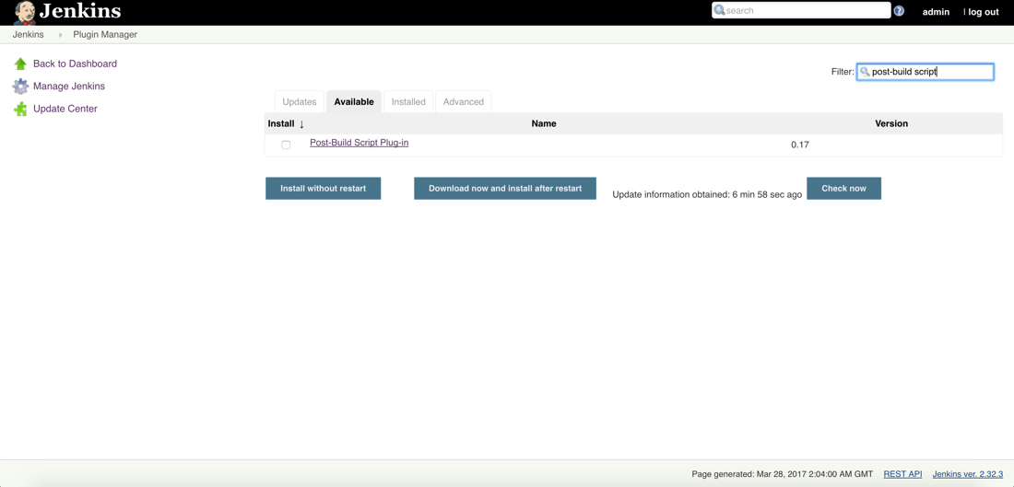
This plugin will allow us to execute scripts on the Jenkin host after the build has completed without errors. We need this so we can deploy our Java JAR after it has been packaged.
Jenkins as a whole has been configured. While it is ready for us to create jobs, we’re first going to get Couchbase ready to go.

Preparing Couchbase with a Bucket for Document Storage
Couchbase isn’t the highlight of this example, but since we’re using one of my old projects, it was a requirement per the project.
If you haven’t already downloaded Couchbase, do so now and walk through the configuration. For help with configuring Couchbase, check out a previous article I wrote.
What is important is the Bucket that we’ll be using. Make sure to create a Bucket titled restful-sample with at least a primary N1QL index.
If you need help with any of this, a full write-up of our project can be found here. Of course, that write-up doesn’t include continuous deployment with Jenkins.
Now we can focus on our pipeline.

Creating a Job for Building and Deploying an Application Developed with Java
With Jenkins and Couchbase ready to go we can focus on creating a job that will control our pipeline. To re-iterate on our plan, we will be pulling from GitHub, packaging a JAR in the build process, and deploying that JAR during the post-build (deployment) process.
Go ahead and create a new job in Jenkins. The first thing you’ll be asked is for a project name as well as the type of project name
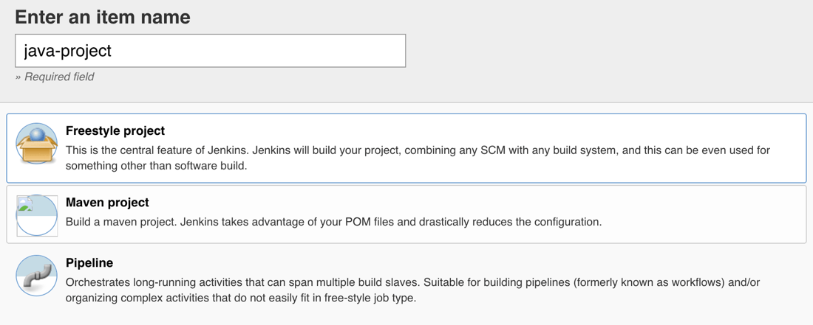
Give the job a unique name and also make sure to use Freestyle Project from the list. When configuring this project, our first concern is the GitHub repository that we’ll be using.
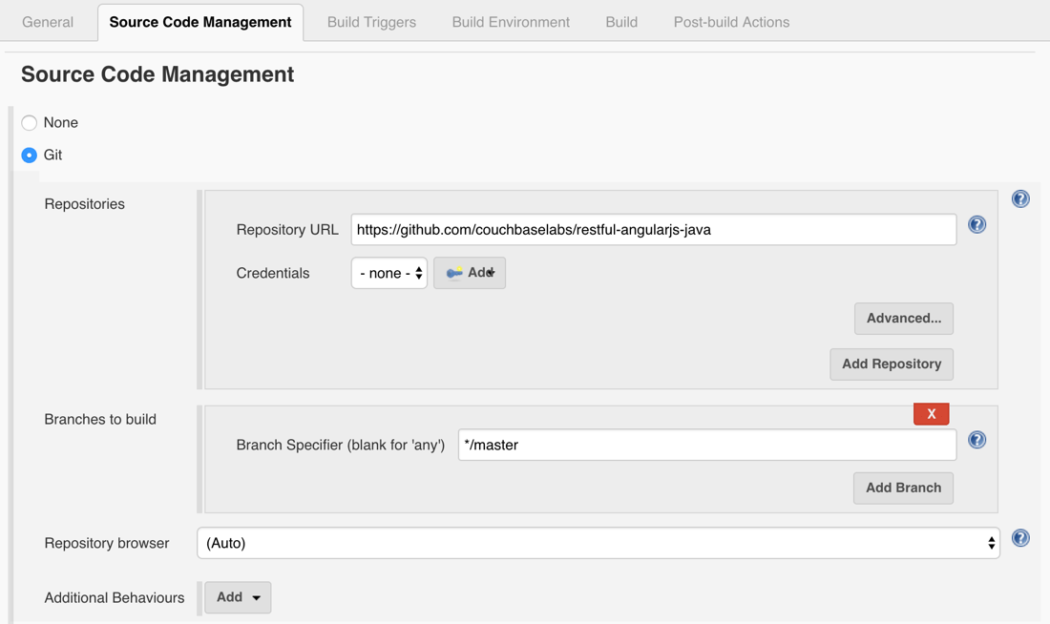
If your repository is not public, don’t worry as you can add credentials, but for this example my project is public.
I’m using the project found here:
1 | https://github.com/couchbaselabs/restful-angularjs-java

Feel free to use your own project if you’d like. With the source control figured out, let’s move onto the Build step.
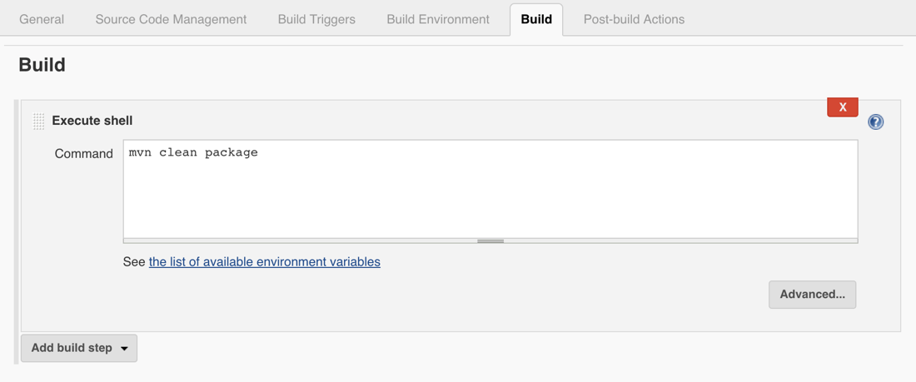
Here we can enter whatever shell commands that we want in order to build the application that was pulled from Git.
We only want to generate a JAR file in this example, which can be done by adding the following command:
1 | mvn clean package

This leaves us with a JAR file in a new target directory that is only relevant to Jenkins at this time. The final step is to kill any already running instance of the application and run it again.
Since we installed the Post-Build Plug-in Script we can define what happens with our build.
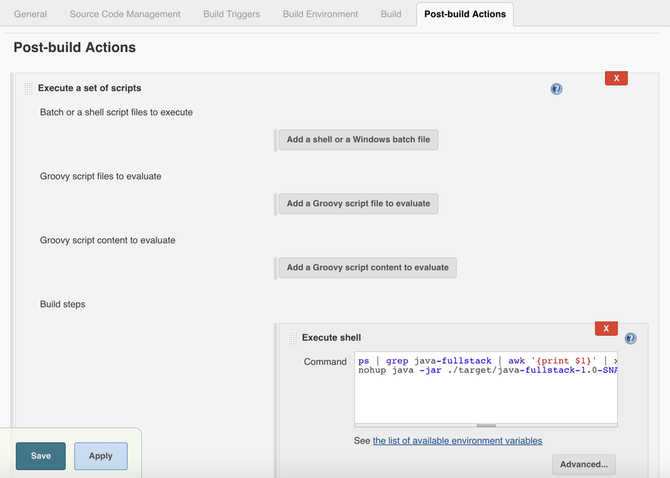
In this example we aren’t deploying it to another machine, but we could. Instead we’re just going to run it on the local machine.
Choose to execute a shell script and include the following:

1  2 | ps | grep java-fullstack | awk '{print $1}' | xargs kill -9 || true  env SERVER.PORT=8081 nohup java -jar ./target/java-fullstack-1.0-SNAPSHOT.jar &

The above is cheating a little, but it’s necessary because we’re running everything locally on the same machine.
The first command will search for any running process on my Mac that looks like our Java application. Once found it will kill the process. Even if it doesn’t find the process it will return true because of our pipe. This prevents the job from failing.
After the process is stopped, we run the built JAR in the background.
Keep in mind that your script may be a bit different if you’re running locally on Linux or Windows. In a production scenario, you’ll probably use the SSH plugin for Jenkins and push the JAR to some server and restart the controlling daemon.

Running load tests in Jenkins Pipeline with Taurus

Jenkins Pipeline is an important Jenkins feature for creating and managing a project in Jenkins. This is opposed to the traditional way of creating a Jenkins project by using the Jenkins GUI. When running your open-source load test, Jenkins Pipeline enables resilience, execution control, advanced logic and Version Control management. This blog post will explain how to run any open-source load test with Jenkins Pipeline, through Taurus.
Taurus is an open source test automation framework that enables running and analyzing tests from 9 open source load and functional testing tools: JMeter, Selenium, Gatling, The Grinder, Locust, Tsung, Siege, Apache Bench, and PBench. Test results can be analyzed in Taurus. For advanced analyses or running tests in the cloud, Taurus integrates with BlazeMeter.
Guy will be presenting more on this topic at Jenkins World in August, register with the code JWFOSS for a 30% discount off your pass.

Getting started with Taurus
- Install Taurus.
- Create the following Taurus configuration in YAML. Learn more about YAML in Taurus from this tutorial.
## execution:
- concurrency: 100
hold-for: 10m
ramp-up: 120s
scenario: Thread Group
scenarios:
Thread Group:
requests:
- label: blazedemo
method: GET
url: http://blazedemo.com/
This script runs 100 concurrent users, holds the load for 10 minutes, the ramp-up is 120 seconds and the thread group runs one GET request toblazedemo.com.
You can specify an executor by adding executor: <executor_name> to the script. Otherwise, the default executor will be JMeter. In the background, Taurus will create an artifact directory with a jmx file (or a Scala file if you run Gatling, a Python file if you are running Selenium, etc.).
- Open a terminal and run: bzt <file_name>.yml
- View the test results:
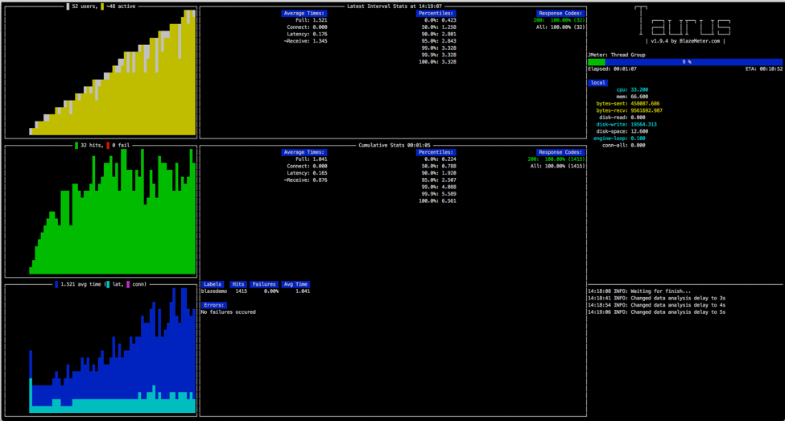
If you want to conduct an in-depth analysis of your test results, run your tests on BlazeMeter. You will be able to monitor KPIs through advanced and colorful reports, evaluate system health over time, and run your tests from multiple geo-locations.
Run the following command from the terminal:
bzt <file_name>.yml -report
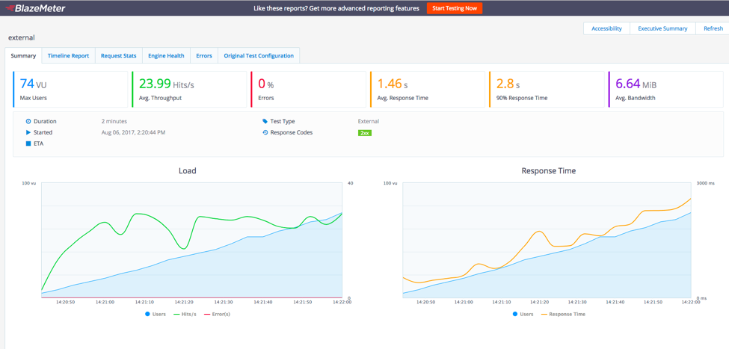

Integrate Taurus With Pipeline
To run Taurus through Pipeline, you can also go straight to Jenkins after creating your Taurus script.
- Open Jenkins → New Item → Fill in an item name → Click on ‘Pipeline’
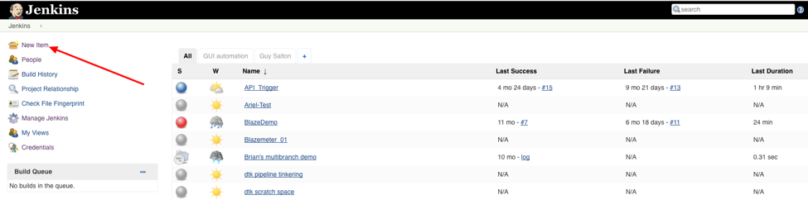
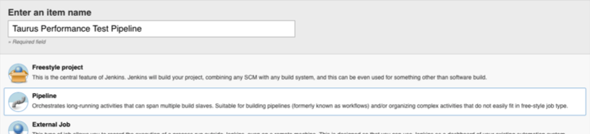
- Now create a Pipeline script. You can include all parts of your CI/CD process in this script: Commit, Build, Unit Test, Performance Test, etc., by creating different stages.
This Pipeline has three stages: The first is called “build”. In this example it is empty, but you can add commands that will build your code. The second, called “Performance Tests”, creates a folder called “Taurus-Repo” and runs the Taurus script that we created. At the same time (note the “parallel” command), there is a “sleep” command for 60 seconds. Obviously it makes no sense to put those two commands together, this is just to show you the option of running 2 commands in parallel. The third stage called “Deploy” is also empty in this example. This is where you could deploy your new version.
node {
stage('Build') {
// Run the Taurus build
}
stage('Performance Tests') {
parallel(
BlazeMeterTest: {
dir ('Taurus-Repo') {
sh 'bzt <file_name>.yml -report'
}
},
Analysis: {
sleep 60
})
}

stage(‘Deploy’) {
}
}
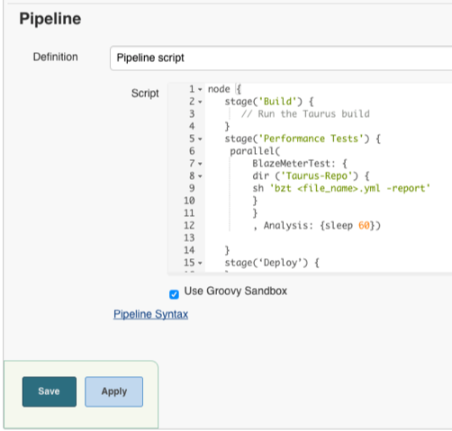
Note that you can either add the Pipeline inline, or choose the “Pipeline script from SCM” option and add the URL to the script on GitHub (in this case you need to upload a Jenkinsfile to GitHub). With "Pipeline from SCM", whenever you need to update the tests, you can just add new commits to theJenkinsfile.
- Save the Pipeline
- Click on ‘Build Now’ to run the Pipeline
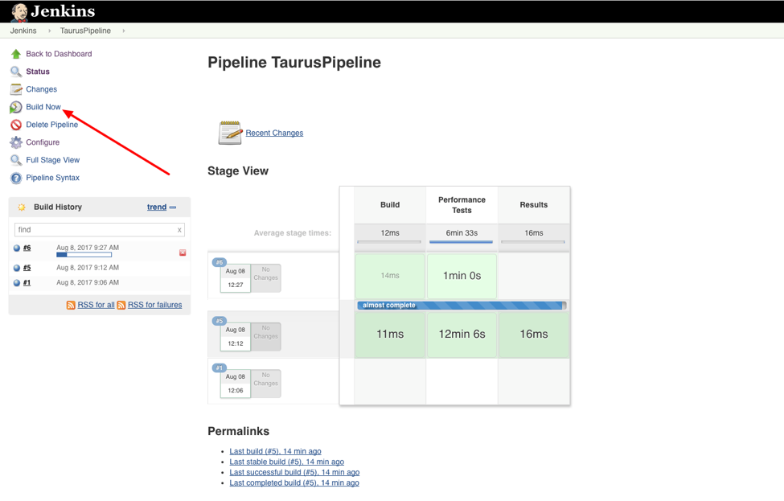
- Click on the new Build that is running now (build #6 in this example).
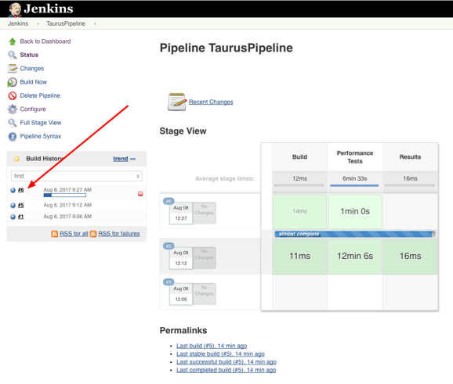
- Click on ‘Console Output’ to see the test results:

- In the Console Output you can see the test results and also the link to the report in BlazeMeter.

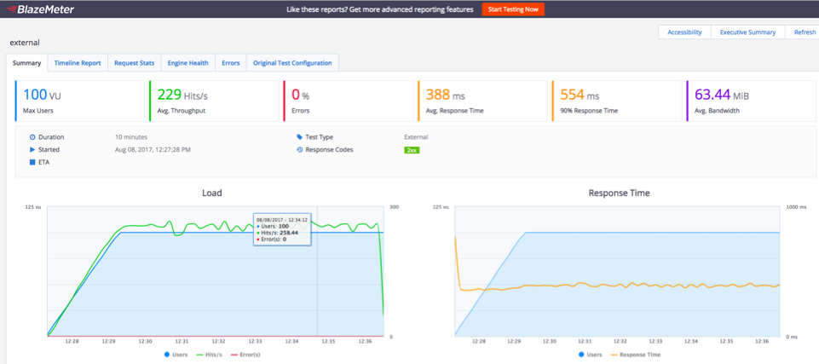
That’s it! Jenkins Pipeline is now running open-source load testing tools via Taurus.

