Project:

**Customer Service Requests Analysis**

**Question 1**

We will be using one-way ANOVA to test the similarity or difference in mean response time across complaint types (ie if the difference across their means is statistically significant or not.

Firstly, we will state our hypotheses:

**Hypotheses statements.**

**Null hypothesis**: The average response time across complaint types is equal or similar.

**Alternative hypothesis**: The average response time across complaint types is not equal or is different.

**Alpha** (Significance level): 0.05 (5%)

**Answers:**

**F-Statistic**: 132.46529732301363

**p-value**: 0.0

**Question 2**

To test the relationship between location type and complaint type, I will use the chi square test for Independence.

**Null hypothesis**: There is no relationship/association between location types and complaint types.

**Alternative Hypothesis**: There is a relationship/an association between location type and complaint type.

**Alpha** (Significance level): 5%

**Chi square statistic**: 1,625,098.2311304228

**p-value**: 0.0

Table 1: Mean Request Closing Time ordered by Complaint Type and grouped by Location Types

|  |  |  |  |
| --- | --- | --- | --- |
|  | Location Type | Complaint Type | Request Closing Time |
| 0 | Bridge | Homeless Encampment | 0.0 |
| 1 | Street/Sidewalk | Squeegee | 0.0 |
| 2 | Store/Commercial | Posting Advertisement | 0.0 |
| 3 | Park/Playground | Panhandling | 0.0 |
| 4 | Roadway Tunnel | Homeless Encampment | 0.0 |
| 5 | Highway | Homeless Encampment | 0.05263157894736842 |
| 6 | Roadway Tunnel | Traffic | 0.06451612903225806 |
| 7 | Subway Station | Urinating in Public | 0.07142857142857142 |
| 8 | Store/Commercial | Urinating in Public | 0.07246376811594203 |
| 9 | Park/Playground | Urinating in Public | 0.07317073170731707 |

From the table above, the complaint types with the fastest response time are complaints made about a Homeless Encampment around the Bridge, Roadway tunnel, Squeegee in street/sidewalk, panhandling around the park/playground and Posting Advertisement around store/commercials.

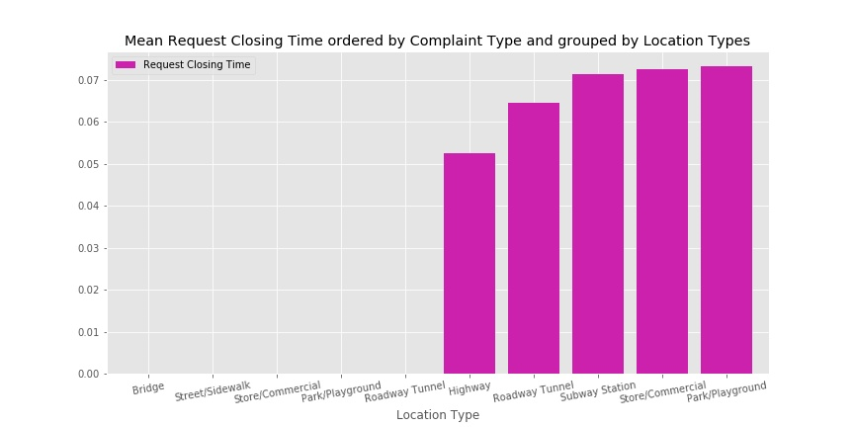

Fig 1: Mean Request Closing Time ordered by Complaint Type and grouped by Location Types

Table 2: Mean Request Closing Time grouped by Complaint Type

|  |  |  |
| --- | --- | --- |
|  | Complaint Type | Request Closing Time (in days) |
| 0 | Squeegee | 0.0 |
| 1 | Vending | 0.1027479091995221 |
| 2 | Traffic | 0.10912240184757506 |
| 3 | Urinating in Public | 0.12324492979719189 |
| 4 | Agency Issues | 0.125 |
| 5 | Bike/Roller/Skate Chronic | 0.12842105263157894 |
| 6 | Homeless Encampment | 0.1485960237753638 |
| 7 | Panhandling | 0.16923076923076924 |
| 8 | Noise - House of Worship | 0.19101123595505617 |
| 9 | Disorderly Youth | 0.19682539682539682 |

From the table above, the complaint type with the fastest mean request closing time is Squeegee.

This indicates that any complaint made about squeegee is quickly responded to and closed within a day.

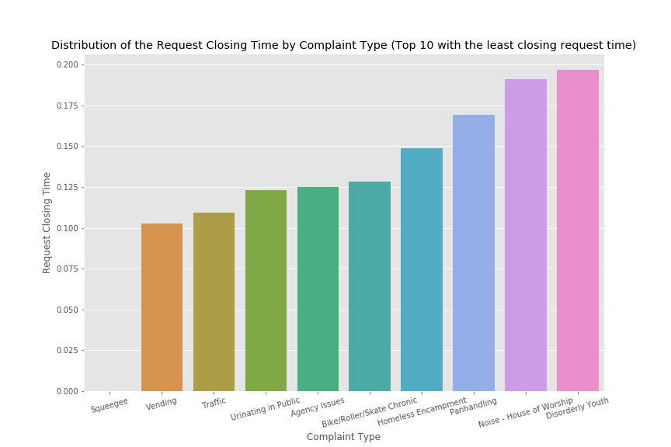

Fig 2: Mean Request Closing Time grouped by Complaint Type

Table 3: Top 10 Complaint Type by City

|  |  |  |
| --- | --- | --- |
|  | City | Total Complaint Types |
| 0 | BROOKLYN | 118849 |
| 1 | NEW YORK | 77289 |
| 2 | BRONX | 49166 |
| 3 | STATEN ISLAND | 15335 |
| 4 | JAMAICA | 8930 |
| 5 | ASTORIA | 7991 |
| 6 | FLUSHING | 7486 |
| 7 | RIDGEWOOD | 6391 |
| 8 | CORONA | 5383 |
| 9 | WOODSIDE | 4357 |

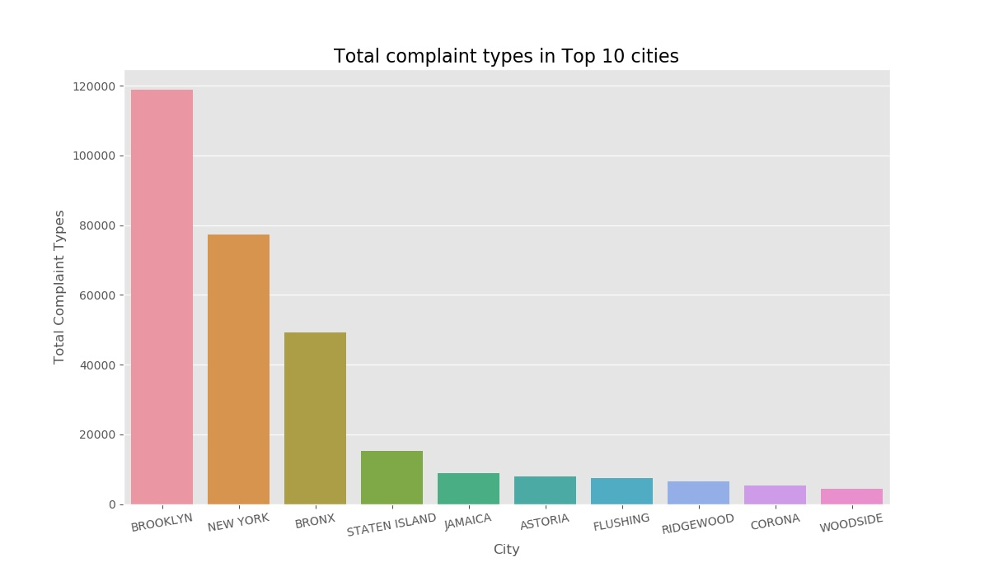

Fig 3: Total complaint types in top 10 cities

Table: Total Complaint Types

|  |  |  |
| --- | --- | --- |
|  | Complaint Types |  |
| 0 | Blocked Driveway | 100624 |
| 1 | Illegal Parking | 91716 |
| 2 | Noise - Street/Sidewalk | 51139 |
| 3 | Noise - Commercial | 43751 |
| 4 | Derelict Vehicle | 21518 |
| 5 | Noise - Vehicle | 19301 |
| 6 | Animal Abuse | 10530 |
| 7 | Traffic | 5196 |
| 8 | Homeless Encampment | 4879 |
| 9 | Vending | 4185 |
| 10 | Noise - Park | 4089 |
| 11 | Drinking | 1404 |
| 12 | Noise - House of Worship | 1068 |
| 13 | Posting Advertisement | 679 |
| 14 | Urinating in Public | 641 |
| 15 | Bike/Roller/Skate Chronic | 475 |
| 16 | Panhandling | 325 |
| 17 | Disorderly Youth | 315 |
| 18 | Illegal Fireworks | 172 |
| 19 | Graffiti | 157 |
| 20 | Agency Issues | 8 |
| 21 | Squeegee | 4 |
| 22 | Animal in a Park | 1 |

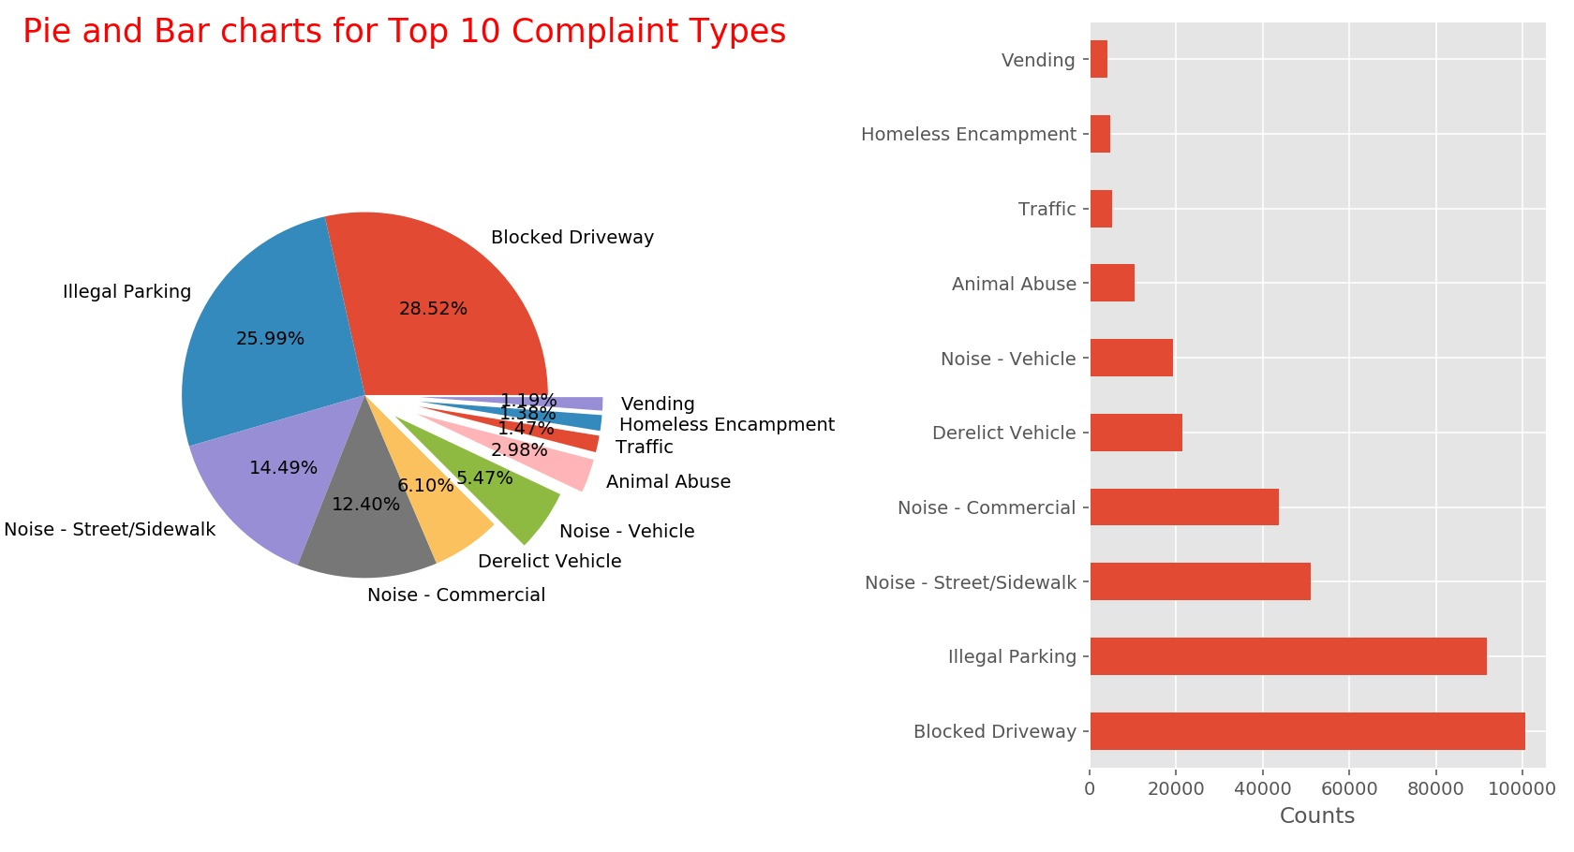

Fig 4: Top 10 Complaint Types