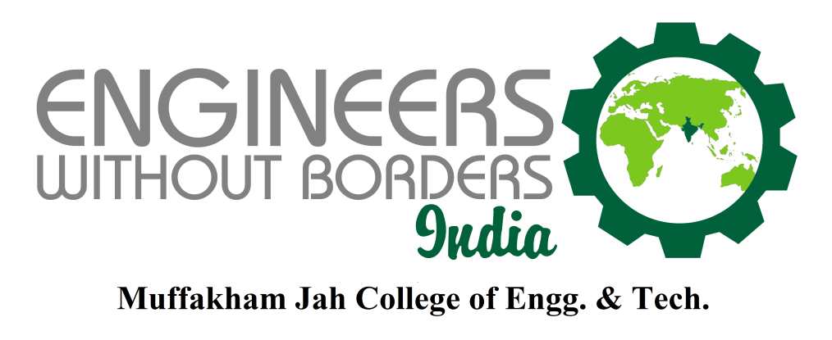
Chapter Nomination – EWB MJCET Student Chapter
EWB MJCET is trying to move ahead in the direction of its defined missions with unmatched support from EWB India.
Chapter Vision:
To utilize the engineering skills to its maximum potential for the development and benefit of the society.
Chapter Mission:
- To harness the resources available
- To develop a database for emerging sustainable and innovative technologies
- To create awareness among student members to work towards development of the society

- MISSION 500
We have identified the need for huge number of volunteers in the moment of strong establishment and started the ‘MISSION 500’ i.e. to become the domain for 500 members. Presently, our club has 170 student members. In our last membership drive, we have announced the mission and experiencing a elevation in registrations
- Effective planning for the chapter (projected plan for the year and its fulfillment)

We had planned for 10 activities and we have completed 11 activities till June 2014. Out of which, 4 projects are completed. 4 new projects for present semester are ongoing.

- List of projects undertaken and completed
There were a number of projects undertaken by our chapter last year and this year
- Kasturba Gandhi Trust Development
Kasturba National Memorial Trust provides a shelter for neglected and underprivileged women. Conditions at the shelter are very poor, lacking basic amenities. EWB MJCET Chapter participated in a project, based on a generous grant of $120,000 or Rs.68 lakhs from Pratt and Whitney Aerospace, USA, BELCAN, MTC, UTC, Cyient and their allied companies, to construct a two storey building, equipped with E-Learning Centre, Play ground, Bunker Beds, Water Harvesting System, Solar Water heater. Our students focused on various aspects including the Syllabi for E learning Center, designing the play ground area, analysis of water heating requirement and made the project a success.
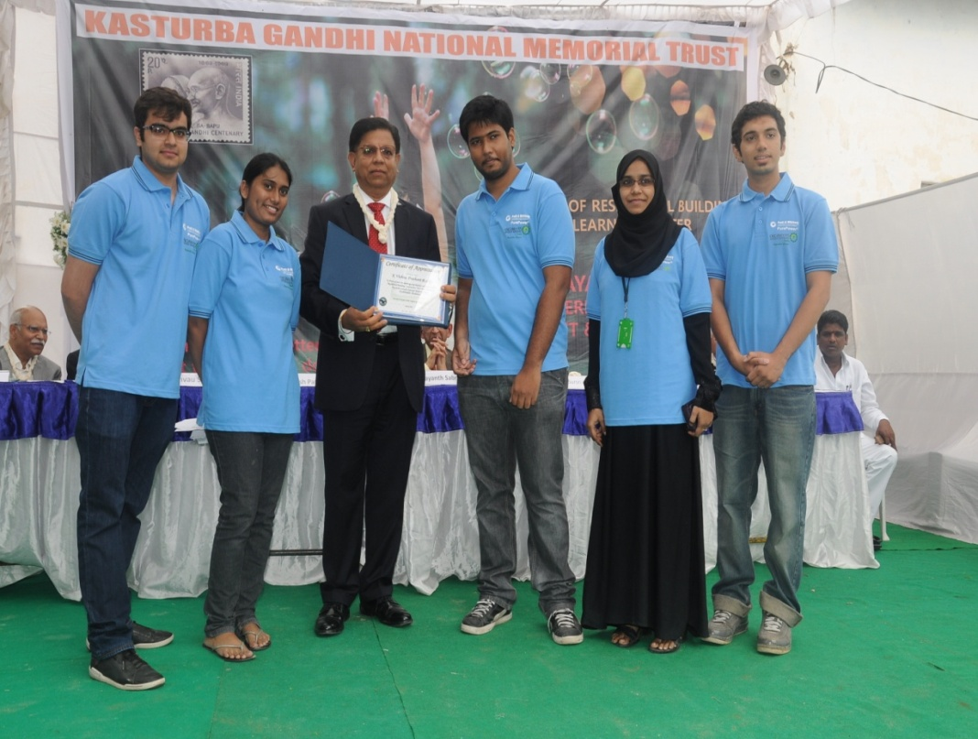
(Shri Mahesh Patel, Engineering Global Sourcing, Pratt and Whitney Aerospace, USA handing over the Certificate of Appreciation to the Mr. Prashant Reddy, President of EWB MJCET and his team members)
- Govt. School Survey Project:
Under the inspiration and guidance imparted by Dr. Ashok Agarwal Sir, EWB MJCET launched an initiative to study the conditions in poor Govt. Schools in Hyderabad with a view to improving the condition of some of these schools. There are many government schools that lack the most basic requirements. EWB- MJCET has taken up this task as a challenge. Though it is cumbersome, we were successful in creating a database of eight such schools by travelling round the city and examining these schools with the help of media. The photos below were taken at Govt Girls High School, Amberpet. The schools which are most in need will be short listed and will be developed in the next phases.

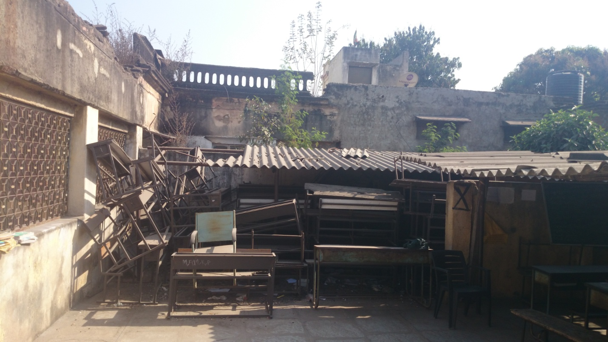
Hyderabad Urban Labs Project:
This project is a unique voluntary citizen mapping initiative in Hyderabad, taken up by Hyderabad Urban Lab (HUL), in which a team from EWB-MJCET chapter participated for a period of 1 week in November-December 2013. It is a multi disciplinary research programme supported by the Right to the City Foundation.

EWB- MJCET student chapter sourced bus route information and geocoded the bus stop locations in selected Greater Hyderabad Metropolitan Areas using QGIS software.

The data gathered by us filled a crucial gap in the databases. This data is expected to lay the foundation for a much better understanding of transit problems in Hyderabad.
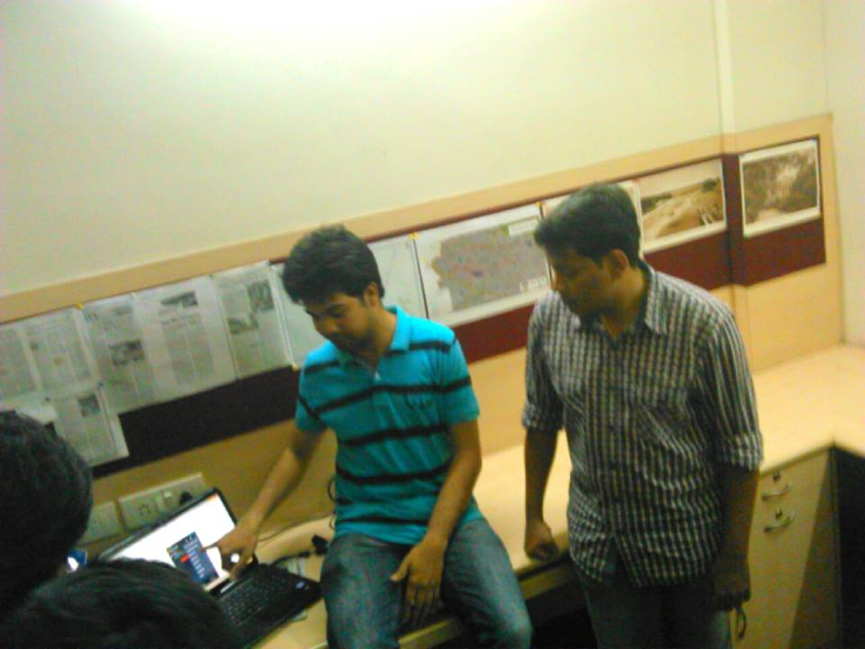
(Harsha, project coordinator, HUL using presentation to explain students)
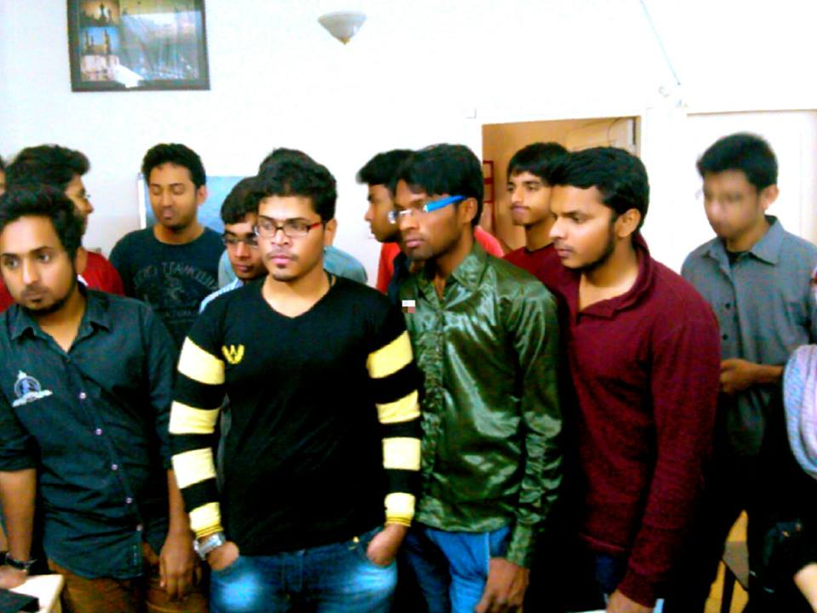
(A group picture of student members of team MJCET)

Burgula village project
EWB- India and Pragathi Welfare Association had agreed to study residents’ needs and improve living conditions in Burgula Village, Mahaboob Nagar. EWB MJCET volunteered to do a need assessment survey and give research solutions to the villagers’ problems regarding sanitation, water supply, housing and general infrastructure.
EWB- MJCET visited the Burgula Village and performed the need assessment study of 500 houses with a team of ten students in a single day with tremendous efforts. The data collected interpreted the needs of the village. The data obtained is compiled into a soft copy for future usage.
The next phases will be commencing through the intervention of Pragathi Welfare Association.

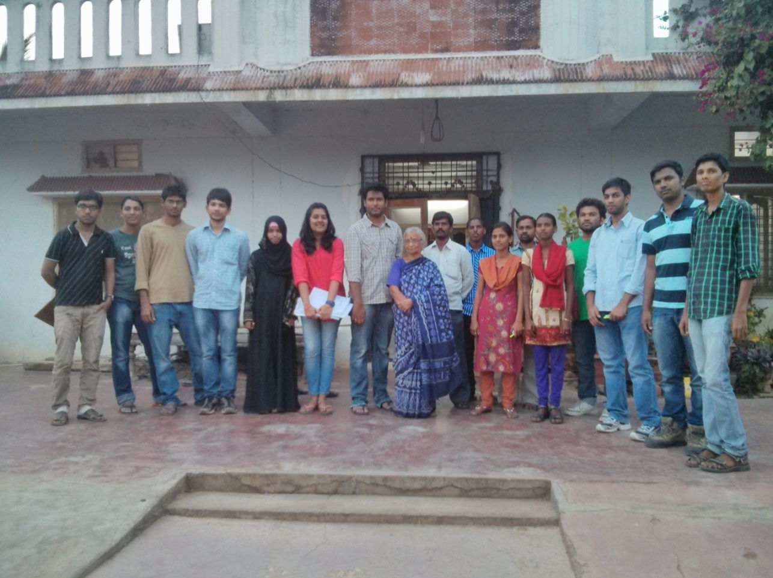
(A group picture of EWB MJCET team with Sarpanch of Burgula Village)
- Up-gradation of the skills of the members

- Research.
- Social Innovation
- Project management
- Group work
- Confidence

- Organization of seminars and workshops for increasing awareness of the
members and other stakeholders
Workshop and Industry tour:

- DFX design excellence workshop
- Metal Industries ltd.
Awareness Programmes:

- Airtel Hyderabad Marathon
- Paper Collection Drive
- Cloth Collection Drive

- Contribution to EWB-India activities including the Newsletter and volunteering activities undertaken

We have undertaken all the projects under the guidance of EWB INDIA. We have organized the seminar for Humanitarian Engineering by Prof. Bernard Amadei. We are grateful to EWB INDIA for giving us an opportunity to work on a community service project in Kasturba Gandhi National Memorial Trust with Pratt and Whitney, their allies. Till now our articles have been covered in 3 of the 4 newsletters.

- Sponsorships and fund generation and fund utilization/balance

This year for Adsophos 2013-2014, talwar Hyundai have sponsored us with 20,000/- and 15,000/- from Birla Group of Cement and few small contributions. All this money was used for the fest and in-house projects. For the other projects we received the fund either from EWB-INDIA or the company which was involved with the project or our College management. We have opened a bank account for ourselves and please find an enclosed bank statement.

- Awards & Miscellaneous Milestones in 2013-14

- EWB-MJCET has won the BEST STUDENT CLUB award from our college MJCET.
- EWB-MJCET has won the BEST CHAPTER AWARD, the award was presented by Dr. Ashok Agarwal, Chairman, EWB-India during EWB ALL CHAPTERS MEET held at BITS, Goa.
- EWB –MJCET Students were awarded as the Best Team for Volunteering for AIRTEL MARATHON which was organized by Airtel Tele-Services.
- EWB –MJCET will officially Sign an MOU (Memorandum of Understanding) with EWB-University of Connecticut (EWB-UCCON), EWB-USA for technical and knowledge transfer partnership.
