EWB-MJCET

Chapter Vision:

To utilize the engineering skills to its maximum potential for the development and benefit of the society.

Chapter Mission:
- To harness the resources available
- To develop a database for emerging sustainable and innovative technologies
- To create awareness among student members to work towards development of the society

NATIONAL CONFERENECE ON TECHNOLOGIES FOR SUSTAINABLE ECOSYSTEM
EWB MJCET has structured a national level conference-“Technologies for Sustainable Ecosystem” as an annual event for the chapter. As last year, it was also conducted in the year 2016.

Conference on “Technologies for Sustainable Ecosystem 2016”
25th-26thFebruary 2016
EWB MJCET held an conference on “Technologies for Sustainable Ecosytems” in association with various other student chapters of BITS Hyderabad, GitamUniversity,CBIT, GNITC and TKREC.
The conference was divided into various sessions which covered various topics like clean energy systems, ecological engineering, urban sustainability through smart cites and innovations in waste management. It was discussed how the above topics are important to the society and how they could be practically implemented in modern day conditions and situations for the betterment of the society.
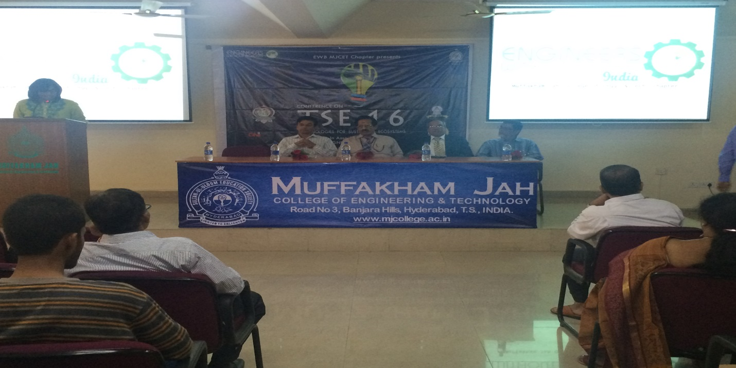

FELICITATION OF EWB-MJCET CABINET 2015-16

On the 30th of July 2016,EWB MJCET conducted a felicitation ceremony where the cabinet members of 2015-16 were felicitated for the immense contributions and hardwork they put in for EWB-MJCET which also embarked the introduction of new office bearers for 2016-17.

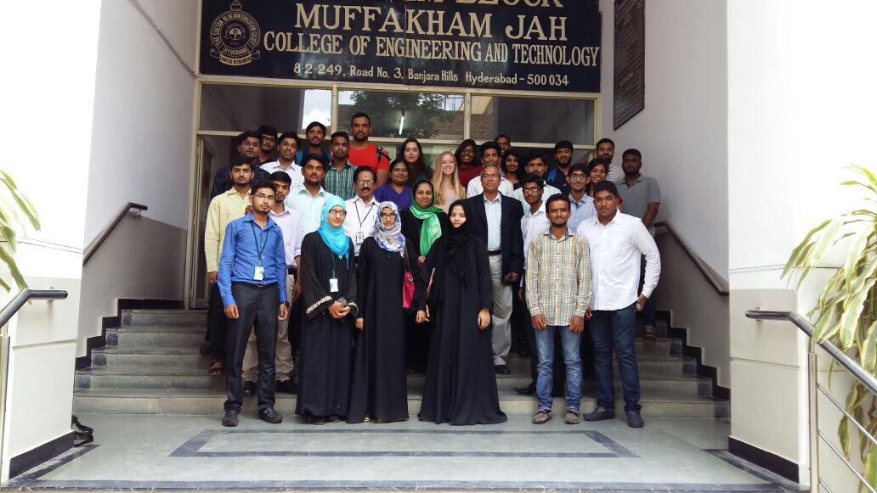

AirtelHyderabad Marathon : August 2016
The Airtel Hyderabad Marathon is the second largest city marathon in India.
The 2015 Marathon is their 5th edition and is organized by the Hyderabad Runners Society, a non profit organization founded in 2007 to encourage active and healthy lifestyle among all age groups in the cities of Hyderabad and Secunderabad.
Even in 2016 EWB-MJCET members volunteered for the Marathon to contribute towards the spirit of running. Around 60 members volunteered for the event and 2 teams of 30 members were allotted on 2 different stations, which were located at Nagarjuna Circle and KBR park respectively. The volunteers had to report on 4:30AM at the day of the marathon where they were assigned different tasks like cheering the runners, collection of waste, providing the runners with refreshments etc.
The marathon was a huge success and received immense media coverage.