Introduction

Document Flow play a major roles in all universities, government Companies, private companies etc. Almost all the companies and universities contain this and it is managed manually and stored in file based systems. And when we doing those stuffs manually we are wasting our time and efforts for example in an university when a staff want to get a leave She/he want to apply and get the approval first of all the staff has to get the application and the She/he has to fill those form and get the approval from the Head Of the Department and after HOD approves She/he wants to go to Faculty Dean and get the approval from Him/Her. And the She/he wants to take it to Vice chancellor/Senior Assistant Registrars and then get the approval from His/hers and then he can go on leave like the almost all the industries has a flow to get some approvals and in documentation process when we going to these by manually he has to waste more time to do this process and if the last person refuses to approve then the effort he/she was putting also wasted. This causes a wide discomfort for the staffs/workers. They don’t have any options to do it in online.

Therefor our group members came to an decision to develop an system to universities or any organization to undergo this process on an online/automated process so the workers and staffs of the organization don’t want waste His/hers time.

Aims

The Main goal of this project is to develop a Progressive Web Application compatible to all types devices to manage the document flow and store the documents in an electronic file or electronic database unless the file based systems in order to minimize the time wastage of the staffs/workers, minimize the workload of the staff/workers and make their day to day life more efficient.

Objectives

* Conduct a secondary research on Documents in University, and the way of flow and the way final manner how the final report has to be submitted each and every user.
* Learn Technologies that can be used in solving these problems.
* Collect requirements for Document Flow, Automated form fill , and approvals.
* Critically analyse the requirements of the system.
* Model the system.
* Design solution.
* Implementation of the system.
* Validate the developed system against requirements.
* Evolution of the system as per changing requirements.
* Deployment of the system.
* Preparation of final documentation.
* Preparation of the User Manual.

Proposed Solution

The proposed solution on Document Management system has various features according to the gathered requirements. These features are represented through various modules that are planned to execute under this system.

* Admin Login
* Management staff register and login
* Management Staff account approval by Admin
* Staff/worker Register and Login
* Staff account approval by HOD
* Filling and submitting Application
* Approvals
* Notification and Email
* Monthly report
* Edit profile

## Admin Login

Entire system should be under control of the administrator. He has the role to create newly added applications, update the existing applications, approve the role and account of management staffs and changing the role off management staffs and he only has the access to the databases and authentication process

## Management staff register and login

Management staff or workers can register themselves and then they have to go and approve that he/she has registered by going to admin of the application only admin can do that process and after approval only he/she can login and do processes in that application without approving themselves they cannot work on those processes

## Staff/worker Register and Login

Staff or workers can register and then they have to meet the HOD and get the approval of there respective HOD and then only they can use the application and login again these approval process are done due to some security reasons(all the public cannot register only the respective department staffs can register and use the application so this processes is to be done)

## Filling and submitting Application

Can be select any forms according to the user needs and the personal details asked on that form will be filled automatically using the details given in the profile and they have to input some of the details and submit it and the user will get a notification when it is approved or unapproved. When submit button is clicked it will be sent to the person who has to approve

## Approvals

The Management staffs who has given the permission to approve the application can approve it by clicking a button approve and they can also not approve and they will get an monthly report of the workers who works under them

## Notification and Email

When the application gets the approval the staff will get the notification on their application he/she will get an notification to email and the if the request was rejected he will get an notification on their application and to their email

When an user sends an application to an management staff to get an approval the management staff too gets an notification though there application and they will also get an email that there’s an approval pending

## Monthly report

The Management staffs will get an monthly report of their respective department,faculty or etc.. and they will get there personal report and they can get the whole yearly report by clicking more on that page no any changes cannot be done in the monthly report

## Edit profile

There will be edit profile page for everyone therefore they can add there profile picture and update some details in the profile

Mockups

Link for the mockups : <https://www.figma.com/file/i6Sv3nmWJ2sPHBjxDo4WTL/Untitled?node-id=0%3A1>

Project Plan

Link for the Gantt-chart : <https://share.clickup.com/g/h/36b9n-11/efa900be529bfa9>

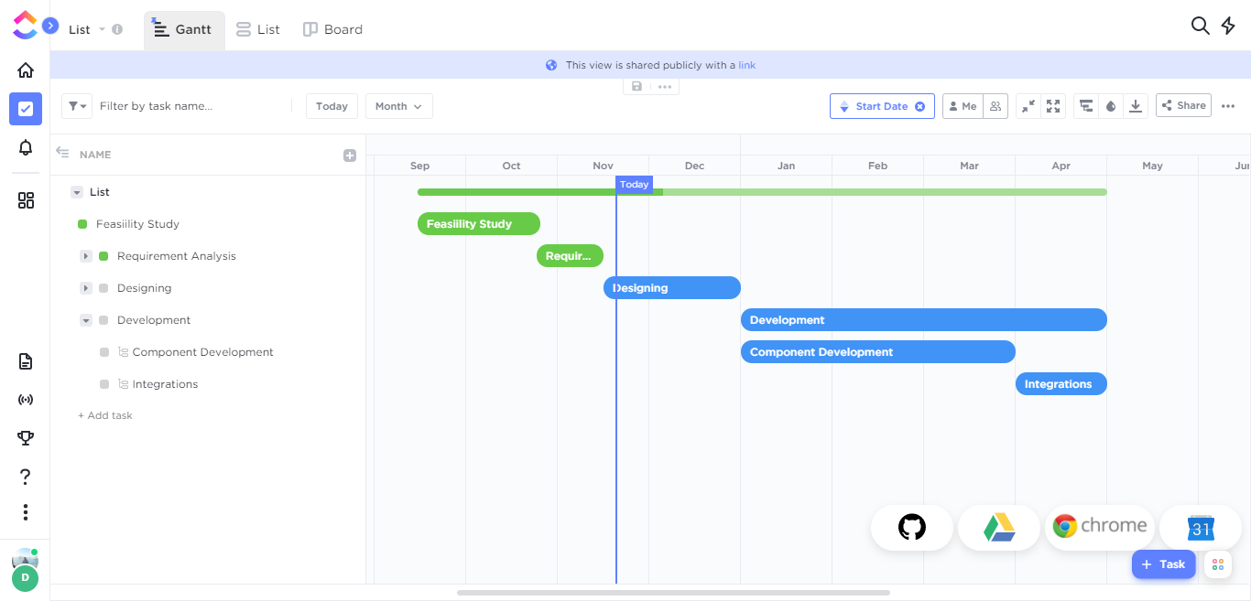

We are using **MERN Stack** for the designing and development process

## M - Mongo DB for Database

## E - ExpressJS for Back End

## R - ReactJS for Front End

## N - NodeJS for API Designs