**DESIGN AND IMPLEMENTATION OF**

**SECTOR MANAGEMENT INFORMATION SYSTEM**

**BY**

**…………………………..**

**A PROJECT PROPOSAL SUBMITTED TO THE DEPARTMENT OF INFORMATION SYSTEMS IN PARTIAL FULFILLMENT OF THE REQUIREMENTS FOR**

**THE AWARD OF A DIPLOMA OF INFORMATION SYSTEM**

**TABLE OF CONTENTS**

LIST OF FIGURES iii

LIST OF ABBREVIATIONS iv

CHAPTER ONE 1

INTRODUCTION 1

1.0 Introduction 1

1.1 Background 1

1.2 Statement of the problem 3

1.3 Main Objective 4

1.4 Specific objectives 4

1.5 Research questions 4

1.6 Scope 5

1.6.1 Geographical scope 5

1.6.1 Content scope 5

1.6.2 Time scope 5

1.6.3 Significance of the study 5

CHAPTER TWO 7

LITERATURE REVIEW 7

2.0 Introduction 7

2.1 Information System Management Practices 7

2.2 Administrative Sector Management Information System 7

2.3 Review of existing similar systems 8

2.4 Critique of existing systems 10

2.5 Research gaps 12

2.6 Proposed system 12

2.7 Conceptual framework 13

2.8 Conclusion 15

BIBLIOGRAPHY 16

# LIST OF FIGURES

Figure 1 Conceptual framework for Administrative Sector Management Information System. 14

# LIST OF ABBREVIATIONS

**IS:** Information Systems.

**CIS**: Computerized Information Systems.

**MIS:** Management Information Systems.

**IT:** Information Technology.

**ICT:** Information Communication Technology.

**km²:** A square kilometer, unit of measurement of area.

**HTTP:**HyperText Transfer Protocol

# CHAPTER ONE

# INTRODUCTION

## 1.0 Introduction

Computer based systems and information technology have had a significant impact on organizations over the past thirty years. They are viewed as means of providing competitive edge and hence, they are becoming part of the organization strategy. Recent generations of information systems in public sector support electronic delivery of public services to the citizens and business enterprises by enabling them to make most of their transactions with the government through electronic channels such as the Internet. (AJBUMA, 2010)

This study focuses on Design and Implementation of Administrative Sector Management Information System for byumba Sector in Gicumbi District, in northern province, Rwanda. The aim of the study is to deliver public services to the citizen via internet as an electronic channel. Information system is an integrated set of components for collecting, storing, and processing data and for providing information, knowledge, and digital products. Therefore, such system will provide capability for citizen to register their information and booking appointments.

This study will be conducted in byumba Sector-Gicumbi District, in Kigali province, Rwanda. byumba sector has 829 km² of the surface Area and 572,000 populations per km².

## 1.1 Background

During the 1950s and 1960s, MIS were first developed but came into the organizational mainstream somewhat later. However, the explosion of other organizational applications of IT has led MIS. Nonetheless, the fundamental importance of MIS has meant some writers continue to provide a broad and deep discussion of the topic. MIS provide reports which assist the managerial monitoring and control of organizational functions, resources or other responsibilities. Public sector MIS, address internal government transactions, public administration/regulation, and public service delivery.

However, many public sectors have developed management information systems to monitor and control the services that they provide. Both the US and UK Social Security agencies have developed MIS to report on the welfare payments and services that they provide. (Heeks, 1998).

In Africa, different countries like Kenya, are moving towards becoming more efficient operationally by collaborating across traditional departments and has to become more responsive towards its citizens’ needs. The government faces an increased pressure to form an effective public sector management system in order to bring public services online.

In 2012, the Kenyan government started a program of investing in ICT infrastructure with the help of foreign funding. Despite Kenya being classified as a less-developed country according to the UN’s Computer Industry Development index, the country managed to successfully introduce public sector services online with the aim of improving public services and reducing corruption. (Nunow, 2014).

In Rwanda, in 1998, the Rwandan ICT for Development (ICT4D) policy, commonly known as the National Information and Communication Infrastructure Plan (NICI) process began. The process was designed to implement the necessary policies and plans capable of addressing Rwanda’s developmental challenges in the information and technology age. (Muhaise, 2015). The use of Computerized Information Systems (CIS) was introduced in the year 1999.

In Rwanda, much of the domestic initiative for the ICT service industry has come from the government and has mostly targeted the institutionalization of service delivery in order to consolidate government services, reduce duplication of functions, increase efficiency, and cut down on costs. (Canisius, 2005)

Therefore, there is a need of using computerized information systems in administration of byumba sector in order to achieve different objectives and good service delivery.

Many sectors in Rwanda like byumba sector have not yet embraced adoption of automated information systems. Service delivery processes are done manually at byumba sector which creates room for error. For instance being late to register for a certain document like birth certificate. Thus, this project intends to come up with a computerized information system that will allow citizen to book an appointment with leaders and registering themselves for different documents like birth certificates. This will help byumba sector to achieve its objectives and good service delivery.

## 1.2 Statement of the problem

Despite the importance of booking appointment and registration of documents in the achievement of objectives at byumba sector, appointments and registration are not adequately managed by the sector administration. Appointments and registration for different documents practices have a number of problems which include insufficient technology and low priority of introducing ICT in the scheme of booking appointment and registration. Thus, management of sector information and booking appointments becomes an issue of great concern to sector stakeholders such as leaders, citizen, and government. Below are some problems to the current system:

1. Crowd of people: Since every registration like birth, death, and marriage are done to the sector, there is crowd of people waiting for services.
2. Time wastage: Service delivery in byumba sector has not been effective for a long time. Citizens have to wait for a long time at various departments counter which leads to a lot of time wastage and sometimes leaders are conducting meetings and don’t have time for them.
3. Lateness: Since everything and every detail are done down in the offices of the sector, there is a late problem. Many people who are 16 and above years old, be late for registering themselves to get Identification card because they do have to go down to the offices.
4. Bad service: byumba sector is marred with dismal performance in all the facets of service quality including reliability, responsiveness, tangibles assurance and empathy. There is lack of transparency, efficiency and unsecured delivery of service.

In the light of the above scenario, this study intends to design and implement a computerized information system which is the better solution for byumba Sector registration management and booking appointments in order to achieve its objectives and public service delivery.

## 1.3 Main Objective

The main objective of this study is to design and implement a computerized Administrative Sector Management Information system that will facilitate byumba Sector to retrieve information of citizen and meet with them according to the booked time in order to achieve its objectives and service delivery.

## 1.4 Specific objectives

1. To investigate the existing manual information system in byumba Sector in order to identify problems, opportunities and objectives.
2. To Determine and collect human information requirements.
3. To analyze the system needs basing on the gathered data.
4. To design, develop and document the recommended system that will manage the registration of different documents and booking appointments.
5. To test, maintain, validate, implement and evaluate the computerized Administrative Sector Management Information System to ensure that it is of expected quality.

## 1.5 Research questions

1.  What are the strengths and weaknesses of the current system? Is it possible to make an investigation in order to identify problems, and opportunities which are available and set the objectives?

2. What are the required information from the system stakeholders? Is it possible to conduct an interview in order to collect human information requirements?

3. What are the procedures of analyzing the system based on the gathered data? Is it possible to improve the existing system or to develop a new one?

4. What are the procedures of designing, developing and documenting the system? Is it possible to design the new system with any design procedures for data entry, interfaces and system controls?

5. What are the system testing, maintenance, validation, implementation and evaluation procedures? Is it possible to test the new system to determine whether it is of expected quality?

## 1.6 Scope

### 1.6.1 Geographical scope

The study will be conducted in byumba Sector in gicumbi District, in Kigali province, Rwanda.

### 1.6.1 Content scope

The study will investigate the existing information system in byumba Sector. I will examine the system to find out any strengths and weaknesses related to the current sector information management system, the available opportunities to solve the problems and set or revise the objectives accordingly. Then, the study will analyze the needs of the upcoming Administrative Sector Management information system.

### 1.6.2 Time scope

The study will cover a period of two months (july to sept 2019) as shown in Appendices.

### 1.6.3 SIGNIFICANCE of the study

The proposed system will help citizen of byumba sector to register themselves for different documents like birth, death, marriage certificates and to book an appointment with different leaders in different charges. The common functions of the computerized Administrative Sector Management information system will be to support the registration of different documents anytime and handling the issue of crowd of people and bad services in the sector by booking the appointment.

The study will wake up the byumba Sector stakeholders to recognize the role they have to play in ICT resources availability and their utilization to achieve their objectives and public service delivery. The registration of documents will be done adequately with minimum of time and money by the use of the computerized information system.

The administration and other sectors will use the findings as empirical information to improve the modern way of receiving citizens information, reducing crowd of people and bad services by booking appointments which leads to a fruitful and modern sector systems in countrywide.

The study will enhance my knowledge in area of Information Systems. Then, the findings will help me to apply Information Systems skills acquired from higher institution of learning in the Rwanda administration field.

The future researchers will utilize the findings of this study to embark on a related study.

# CHAPTER TWO

# LITERATURE REVIEW

## 2.0 Introduction

This chapter summarizes the information from authors and researchers who have carried out research in the same field of study.  This was sourced by reviewing documented resources such as text books and online publications such as Graduate theses and Dissertations, Encyclopedia of Educational research and Internet sites and resources (website, e-journals, and e-books) related with the research topic. The specific areas covered in this chapter are information systems management practices, proposed system, review of existing similar systems, research gaps review, and conceptual framework.

## 2.1 Information System Management Practices

Information systems management (ISM) is a multifaceted field, and requires multidisciplinary perspectives. ISM is seen as one solution to improve effectiveness in public service delivery. Investments in IS have grown rapidly in the last decade and there are great expectations that IS will solve many problems, especially with regard to the diminishing resources.  Information systems management is aim to achieve some improvement or change in qualitative aspects of the world faster processing, fewer delays, information that is more accurate and up to-date, lower costs, and so forth. (ABDI, 2014)

## 2.2 Administrative Sector Management Information System

The Republic of Rwanda is divided into Provinces, Districts, Sectors and Cells. The District is the basic political-administrative unit of the country. Sectors are the third level administrative subdivision in Rwanda and there are 416 Sectors. However, this study will focus on byumba Sector only. In this sector there are different activities that normally takes place regarding to the public services delivery. Some of them are registration of Mutuelle (Community Based Health Insurance), Birth Certificate, Application for National Identification Card, Marriage Certificate, Certificate of Celibacy, and land registration.

Information systems management is aim to achieve some improvement or change in qualitative aspects of the world faster processing, fewer delays, information that is more accurate and up to-date, lower costs, and so forth.  Management Information System is seen as one solution to improve effectiveness in public service delivery. Public sector MIS address internal government transactions, public administration/regulation, and public service delivery.

This study attempts to address the challenges faced by byumba sector and other sectors in Rwanda in the use of information system that serves as a major information tool that sustains and improve the public services delivery in order to achieve administrative goals and service delivery.

## 2.3 Review of existing similar systems

**Irembo**

Irembo is a Government to Citizen e-Service portal, which facilitates the citizen to submit the application and make the payment for various services. This is a joint project by Government of Rwanda and Rwanda Development Board. It is an initiative by Rwanda Development Board in conjunction with Ministry of Local Government, Rwanda National Police, National Public Prosecution Agency and the National Identification Agency. It is a web based application for every citizen and business (es) in Rwanda to access all government e-services. (Services, n.d.)

Irembo is the one-stop portal for e-Government services. Electronic Government (e-Government) refers to the application of information and communications technology (ICT) to innovate and modernize the field of public administration. It allows greater public access to information, and make government more accountable to citizens.

One-stop portal for government refers to the integration of public services from a customer of public services' point of view. It allows citizens, businesses and other authorities to have 24 hours access to public services from their home, their offices or even on the move using different access media and devices. The concept requires that all public authorities are interconnected and that the citizen is able to access public services by a single point even if these services are actually provided by different departments or authorities. One-stop government requires the reengineering of the public sector's processes towards online public services. It calls for a holistic framework that supports integrated modelling of electronic public services and synchronization with the technical developments. (Tambouris, 2002)

Irembo as one-stop portal, grant access to information and services, and act as the gateway to all Rwandan Government services and provides this service with ease, efficiency and reliability. Services are accessible through multiple delivery means (or channels), including physical presence at designated offices, call centers, Internet, and mobile devices.

**ECitizen Kenya**

ECitizen is an official digital platform which enables Kenyan citizens, residents and visitors to access government services online. The services offered include business name search and registration, notice of marriage, registration of marriage, driving licenses, land searches and clearances, passport and visa applications. The system allows citizens to sign up, apply for government services and conveniently pay using mobile money, credit/debit cards and online banking from local banks. Users receive email and SMS notification every time their application has progressed. One can get services in and around business, marriages, driving, lands immigration and civil registration services offered by their respective government departments. (Tsuma, 2015)

For instance, through the Office of The Attorney General and Department of Justice one can get services involving getting married or entering a civil partnerships in Kenya. Business name search and registration services are also offered. This is possible through, business, a portal of eCitizen which enables individuals owning business to access Government to Business service online. The services include application of business licenses, permits and business registration. (Tsuma, 2015)

To add on that one can apply for a provisional driving license, book in driving test, get a driving license, pay fees and track the application through the NTSA (National Transport and Safety Authority) in eCitizen. (Tsuma, 2015)

Thirdly, The Department of Immigration Services offers services such as application of passports and application of a work permit. In eVisa, another portal of eCitizen one can apply for a visa.

Lastly, The Ministry of Land Housing and Urban Development offers services such as searching for a title deed, land rent clearance demand notice and payments all through eCitizen. (Tsuma, 2015)

ECitizen is a platform designed to cater majorly for the citizen. It improves the speed in which the government serves its citizens thus making service rendering convenient.

**ECitizen Portal Uganda**

The eCitizen portal is a one-stop online center for Government online services. Its main objective is to enhance Government service delivery to citizens, non-citizens, businesses and to Government Ministries, Departments and Agencies (MDAs). The benefits include making Government services more accessible, reducing access cost and queuing at Government offices, transparency, timeliness and increasing convenience of transaction with the Government of Uganda anytime and from anywhere. (Okwii, 2015)

The portal has been designed to aggregate all Government services which are offered online and present them on a single portal. The portal allows one to access services such as eTax, Business registration, trading license registration and social security statements among others.

The portal is intended to reduce time and costs to citizens in accessing Government services and to increase efficiency in the provision of public service to citizens. (Okwii, 2015)

## 2.4 Critique of existing systems

**Irembo**

Irembo is a Government to Citizen e-Service portal, which facilitates the citizen to submit the application and make the payment for various services. However, this portal has some weaknesses.

Not user friendly: Julius Karenzi – a Kigali-based banker seeks Irembo services on a regular basis. However, he has to seek agents to conduct the process for him. “The system is not easily accessible. Sometimes I give up in the middle of the process.” (Ngabonziza, 2019)

Overcharging customers: At different Irembo service providing points, customers claim to be overcharged. (Ngabonziza, 2019)

Absence of booking appointment service: Irembo provide different public services to the citizen but it doesn’t allow them to book an appointment with different leaders.

**ECitizen**

The e-Citizen is a portal for citizens to access information and services provided by the Kenyan government. However, this portal has some weaknesses.

Overcharging customers: Kenyans using the government online payment portal eCitizen are spending more for services than when they paid in cash limiting the expected benefits of the digital switch. (Njoroge, 2016)

Absence of booking appointment service: eCitizen provide different public services to the citizen but it doesn’t allow them to book an appointment with different leaders.

**ECitizen Portal Uganda**

The eCitizen portal is a one-stop online center for Government online services. Government services more accessible, reducing access cost and queuing at Government offices, transparency, timeliness and increasing convenience of transaction with the Government of Uganda anytime and from anywhere. However, this system has some weaknesses.

Absence of booking appointment service: eCitizen provide different public services to the citizen but it doesn’t allow them to book an appointment with different leaders.

## 2.5 Research gaps

It is obvious that all the above studies left a knowledge gap in their researches. None of the system which implement booking appointment service to the public. Therefore, this study intends to assess an existing information system for byumba sector. Furthermore; the study will design and implement a system that will facilitate byumba sector to deliver public services online and allow citizens to book for appointments. This will allow byumba sector to achieve its objectives and service delivery.

## 2.6 Proposed system

**Administrative Sector Management Information System**

Computer based systems and information technology have had a significant impact on organizations over the past thirty years. They are viewed as means of providing competitive edge and hence, they are becoming part of the organization strategy.  Recent generations of information systems in public sector support electronic delivery of public services to the citizens and business enterprises by enabling them to make most of their transactions with the government through electronic channels such as the Internet. (AJBUMA, 2010)

This study focuses on Design and Implementation of Administrative Sector Management Information System for byumba Sector in gicumbi District, in northern province, Rwanda. The aim of the study is to deliver public services to the citizen via internet as an electronic channel and allow them to book for appointments. Information system is an integrated set of components for collecting, storing, and processing data and for providing information, knowledge, and digital products. Therefore, such system will provide capability for citizen to register their information and booking appointments with different leaders.

This study will be conducted in byumba Sector-gicumbi District, in northern province, Rwanda. byumba sector has 829 km² of the surface Area and 572,000 populations per km².

The proposed system will help citizen of byumba sector to register themselves for different documents like birth, death, marriage certificates and to book an appointment with different leaders in different charges. The common functions of the computerized Administrative Sector Management information system will be to support the registration of different documents anytime and handling the issue of crowd of people and bad services in the sector by booking the appointments. The registration of documents will be done adequately with minimum of time and money by the use of the computerized information system.

This system will improve the modern way of receiving citizens information, reducing crowd of people and bad services by booking appointments which will lead to a fruitful and modern sector systems in countrywide.

### 2.7 summary

In summary, this chapter has summarized the information from authors and researchers who have carried out research in the same field of this study. However, all those research have left a knowledge gap in their researches. None of the system which has implemented booking appointment service to the public. Therefore, this study intends to assess an existing information system for byumba sector. This study will also design and implement a system that will facilitate byumba sector to deliver public services online and allow citizens to book for appointments. This will allow byumba sector to achieve its objectives and service delivery

# CHAPTER THREE

## 3.0 RESEARCH AND DESIGN METHODOLOGY

### 3.1 INTRODUCTION

development of a system is a work which requires much attention and effort. The main goal of a new system is to satisfy the needs of users by solving problems faced with the existing system. Deep The analysis of users’ needs will most of the time lead to a useful software development as a system might give perfect result. (Alan.D, 2007)

## 3.2 Data Collection Techniques

In programming, the methodology is defined as an organized documented set of procedures and guidelines for one or many phases of software life cycle, such as analysis or design. The following techniques and methods were used in BSC

### 3.2.1 Documentation

This method is to read documents about what you need to research without talking to anybody. This was the main method used while collecting all information required to private companies and market publishing. Consulting documentation around the world has been one of the favorite techniques used to carry out this research work. (Grad, 2016)

### 3.2.2 Internet Research

This is the method to collect data where you search information on internet what people are doing and how they do things. I used this method when I visited the social media and other online research like (Grad, 2016)

### 3.2.3 Interview

The technique of interview is a formal meeting in person used gathers information or facts about a specific subject. This technique has been helpful in terms of information gathering. I had an interview with technical department, business department of BSC ltd. They explained me all process done to publish the market and all process done till the required goods or services is delivered or supplied. (Grad, 2016)

### 3.2.4 Observation

This is the method to collect data where you observe what people are doing and how they do things, is also process of recording the behavior of people, object and occurrences without questioning or communicating with them. I used this method when I sited in the Technical department and in the Sales department, I learnt much from that time about how they prepare to publish their market. (Grad, 2016)

## 3.3 Software Engineering Methods

The waterfall model is the system development methodology that used during the development of online market publication system’s web application for managing online market publishment in sale department.

The waterfall Mode refers to a linear-sequential life cycle model. In waterfall model, each phase must be completed fully before the next phase can begin. At the end of each phase, a review takes place to determine if the project is on the right path and whether or not to continue or discard the project. In waterfall model, phases do not overlap.

The waterfall model is a sequential design process, often used in software development processes, in which progress is seen as flowing steadily downwards through the phases of conception, initiation, analysis, design, construction, testing and maintenance. The figure below shows the sequence of phases followed in software development by using waterfall model.

**Software lifecycle in waterfall model with the stages.**

**Source**: Own drawing.

The sequential phases in Waterfall model that are used in the development of this project are:

* **Requirement Gathering and analysis:**All possible requirements of this system to be developed are captured in this phase and documented in a requirement specification doc. example of the requirement are the data to be used.
* **System and Software Design:** The requirement specifications from first phase are studied in this phase and system design is prepared. System Design helps in specifying hardware and system requirements and also helps in defining overall system architecture. The database and graphical interface of the project are developed here.
* **Implementation and Unit testing:** With inputs from this system design, the system is first developed in small programs called units, which are integrated in the next phase. Each unit is developed and tested for its functionality which is referred to as Unit Testing.
* **Integration and System Testing:** All the units developed in the implementation phase are integrated into a system after testing of each unit. Post integration the entire system is tested for any faults and failures.
* **Operation and Maintenance:** There are some issues which come up in the client environment. To fix those issues patches are released. Also to enhance the product some better versions are released. Maintenance is done to deliver these changes in the customer environment.

All these phases are cascaded to each other in which progress is seen as flowing steadily downwards (like a waterfall) through the phases. The next phase is started only after the defined set of goals are achieved for previous phase and it is signed off, so the name "Waterfall Model". In this model phases do not overlap.

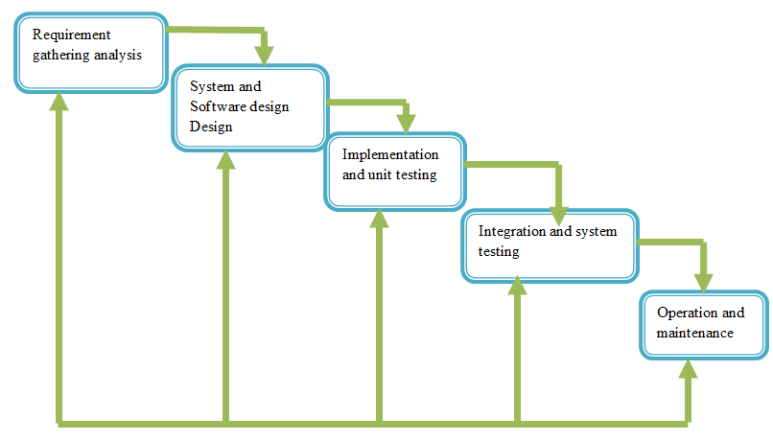Figure 2: Waterfall model

## 3.4 Organization of The Project

This work is divided into three main chapter:

**The first chapter** will be the general introduction which will contain the background

Of the problem, hypothesis of projection of language,

Objectives of projects, organization of project, scope and as well as limitation and delimitations of the projects.

**The second chapter** is about literature review, whereby we will talk about from

Different point of views of various authors and reseachers’contributions and findings

To this subject within this system, we are going to study the functioning of existing

System and suggest solution for existing system problem

**The third chapter** is research design and methodology

## 3.5 SYSTEM SPECIFICATION

### 3.5.1 HARDWARE SPECIFICATION

### Hardware specifications

Here, the hardware specifications which must hold in order to use this system are the following.

* A computer with the following specification:
* 1 Ram 2GB
* 1 Processor 1.60 GHZ
* 2 Hard disks 500 GB

### 3.5.2 Software specifications

1. **on the server side**

* windows operating system
* A windows-based server application that is responsible for accepting HTTP request.

The package must be including: Apache 2.2,11, MYSQL 5.1.30, and php vision 4 or 5.

* Phpmyadmin version 3.1.1 for database management.
* Ethernet Card and internet connection.

1. **On the client side**

* Windows and lunix operating system
* Web client

Ethernet card and internet connection

## 3.6 Functional Requirements

1. The system will provide interactive user interface
2. The system will provide the database to store citizens records
3. The system will allow the citizens to create account
4. The system will allow the citizens to request the document online
5. The system will allow the citizens to book appointment with their leaders
6. The system will allow the leaders to accept or deny the appointment
7. The system will allow leader to provide request document to the citizen online

## 3.7CONTEXT (level 0) DIAGRAM

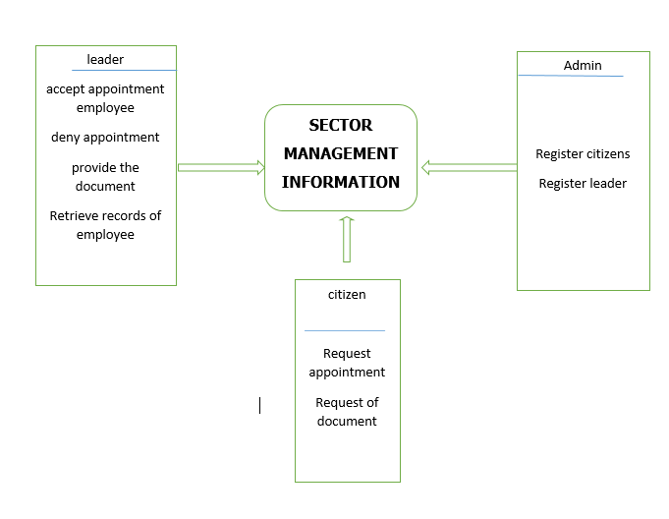

Figure 3:Context Diagram

## 

## 3.8 Data Flow Diagram

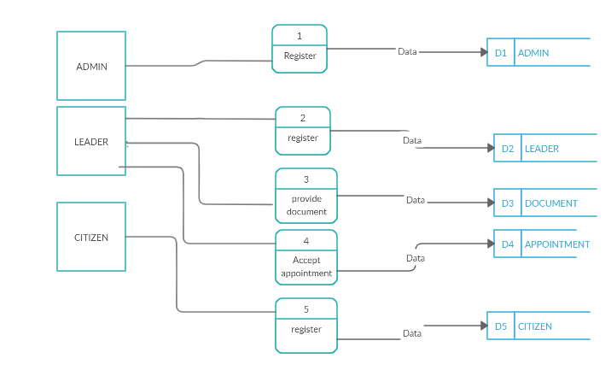Figure 5: Dfd level1

## 3.9 ENTITY RELATIONSHIP DIAGRAM

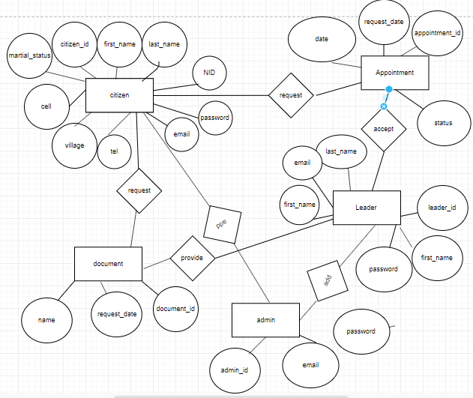

Figure 6**: Erd**

## 3.10 PHYSICAL DATA MODAL (PDM)

This model diagram illustrates the organization of data in the database that stores data for the database system. It describes all the details and the relationship between the tables that make up the database.

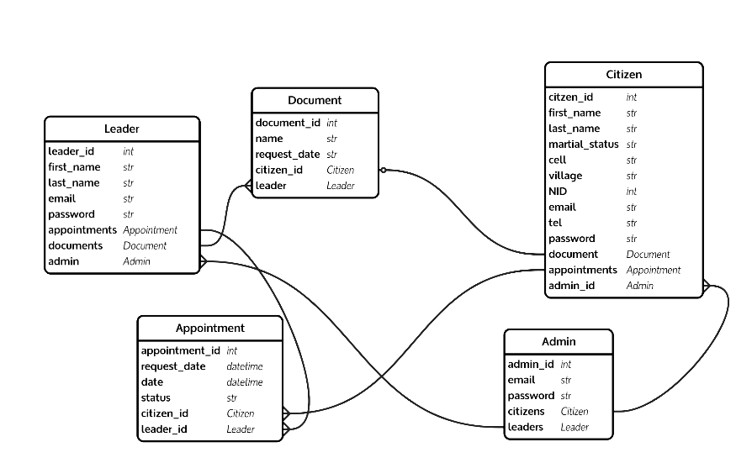

Figure 7: physical data modal

## 

## 3.11 DATA DICTIONARY

|  |  |  |
| --- | --- | --- |
| Table 1 **citizen** | | |
| **FIELD** | **DATATYPE & SIZE** | **INTEGRITY** |
| Citizen_id | Integer | Primary key |
| First_name | Varchar(45) | Not null |
| Last_name | Varchar(45) | Not null |
| Cell | Varchar(255) | Not null |
| Village | Varchar(255) | Not null |
| Email | Varchar(255) | Not null |
| Martial_status | Varchar(255) | Not null |
| NID | Varchar(255) | Not null |
| password | Varchar(255) | Not null |
| Admin_id | Int(25) | Foreign kry |

|  |
| --- |
| Table 2**leader** |

|  |  |  |  |  |  |  |
| --- | --- | --- | --- | --- | --- | --- |
| Leader_id | | Int(11) | | | Primary key | |
| First_name | | Varchar(255) | | | Not null | |
| Last_name | | | Varchar (255) | | Not null | |
| Email | | | Varchar (255) | | Not null | |
| password | | | Varchar (255 | | Not null | |
| |  |  |  | | --- | --- | --- | | Table 3: | **document** |  | | Document_id | Int(11) | Primary key | | Name | Varchar(45) | Not null | | Request_name | Varchar(255) | Not null | | Citizen_id | Int(25) | Foreign key | | Leader_id | Int (11) | Foreign key | | | | | | |
| Table 4: | **appointment** | | |  | |
| Appointment_id | Int(11) | | | Primary key | |
| Date | date | | | Not null | |
| Request_date | Varchar(255) | | | Not null | |
| Status | Varchar(255) | | | Not null | |
| Citizen_id | Int(11) | | | Foreign key | |
| Leader_id | Int(11) | | | Foreign key | |

|  |
| --- |
| Table 2**admin** |

|  |  |  |  |
| --- | --- | --- | --- |
| admin_id | Int(11) | | Primary key |
| Email | Varchar(255) | | Not null |
| password | | Varchar (255) | Not null |

## 3.12 Tools and languages to be used in software development

### HTML

Hypertext Markup Language (HTML) is a markup language designed for creating web pages, that is, information presented on the World Wide Web. Defined as a simple "application" of SGML, which is used by organizations with complex publishing requirements, HTML is now an Internet standard maintained by the World Wide Web Consortium (W3C). The most recent version is HTML 4.01, though it has been superseded by XHTML.

### PHP

Acronym: Hypertext Pre-processor. PHP is a server-side scripting language for creating dynamic Web pages. You create pages with PHP and HTML. When a visitor opens the page, the server processes the PHP commands and then sends the results to the visitor's browser. PHP is Open Source and cross-platform. PHP runs on Windows NT and many UNIX versions.

### CSS

Cascading Style Sheets (CSS): A style sheet language used to describe the presentation of a document written in a markup language. Its most common application is to style web pages written in HTML and XHTML, but the language can be applied to any kind of XML document. CSS is a W3C Standard.

### MySQL

MySQL is an open source relational database management system (RDBMS) that uses Structured Query Language (SQL), the most popular language for adding, accessing, and processing data in a database. Because it is open source, anyone can download MySQL and tailor it to their needs in accordance with the general public license.

### Apache web server

Often referred to as simply Apache, a public-domain open source Web server developed by a loosely-knit group of programmers. Apache has been the world’s most popular web server (HTTP Server) on the internet since April 1996 and is generally considered to be more stable than other servers.

The original version of Apache was written for UNIX, but there are now versions that run under OS/2, Windows and other platforms.

## 3.13 BIBLIOGRAPHY

**Books**

During the execution of this application, we have used different books and website for getting more information and over knowledge.

* **[1] Database processin**g by David Kroenke and David j. awer edition 12, publisher in 2012.
* **[6] Dictionary of computer terms** by Douglas and Michael Covington, published in 1986.

**Online references**

1. [1][www.rnp.gov.rw/on 16/05/2016](http://www.rnp.gov.rw/on%2016/05/2016)
2. [2] [http://databasev.co.uk/primary-foreign-key-constraints.html/visited on 14/04/2016](http://databasev.co.uk/primary-foreign-key-constraints.html/visited%20on%2014/04/2016)
3. [3] [http://www.softpanorama.org/SE/software_life_sycle_models.shtml/visited on 04/06/2016](http://www.softpanorama.org/SE/software_life_sycle_models.shtml/visited%20on%2004/06/2016)
4. [4][http://wikipedia.org/wiki/database-system/visited on 19/06/2016](http://wikipedia.org/wiki/database-system/visited%20on%2019/06/2016)
5. [5]<http://wwwcommentcamarche/sql/sqlintro/php3#LDD(phyusical> data model)/ visited on 03/07/2016
6. [6][http://en.wikipedia.org/wiki/waterfall_model/visited on 14/04/2016](http://en.wikipedia.org/wiki/waterfall_model/visited%20on%2014/04/2016)
7. [7][http://fr.wikipedia.org/phpC3%Adia:php](http://fr.wikipedia.org/phpC3%ADia:php) tutorial/ visited on 09/08/2016

# BIBLIOGRAPHY

AJBUMA. (2010, April 13). Information Systems Implementation in State Corporations. Retrieved from http://www.uonbi.ac.ke/conferences/aibuma/journal/Paper16_IS_Implementation_in_State_Corporations.pdf

Canisius, M. G. (2005, 11 12). E-governance in Rwanda: Application of ICT in delivery of services. Retrieved from http://erepository.uonbi.ac.ke/bitstream/handle/11295/95947/MAJ.%20GEN.%20C.C.%20KAYIZALI%20M.A._I.S_2005.pdf?sequence=1&isAllowed=y

Heeks, R. (1998, September). Public Sector Management Information System. Retrieved from http://unpan1.un.org/intradoc/groups/public/documents/UNTC/UNPAN001826.pdf

Moose. (2017, January 10). Most Important Invention: The computer. Retrieved from Study Moose: https://studymoose.com/most-important-invention-the-computer-essay

Muhaise. (2015, October). Management Information System in Rwanda. Retrieved from FortuneOfAfrica: https://fortuneofafrica.com/rwanda/rwanda-public-sector/management-information-system-in-rwanda/

Nunow, Y. (2014, October). E-government Information Systems Management. Retrieved from Semanticscholar: https://pdfs.semanticscholar.org/3cbc/6684b2bafbe900016d918192bdc276234d8c.pdf

ABDI, Y. N. (2014). E-GOVERNMENT INFORMATION SYSTEMS MANAGEMENT. Nairobi: University of Nairobi. Retrieved from https://pdfs.semanticscholar.org/3cbc/6684b2bafbe900016d918192bdc276234d8c.pdf

Adam, D. (2007). Conceptual Framework. Retrieved from Researchgate: https://www.researchgate.net/...framework...framework...conceptual_framework/.../T…

Ngabonziza, D. (2019, January 31). Untold-story-of-irembo-rwanda-one-stop-centre-for-govt-services. Retrieved from KTpress: https://ktpress.rw/2019/01/untold-story-of-irembo-rwandas-one-stop-centre-for-govt-services/

Njoroge, K. (2016, September 21). Kenyans-pay-more-for-State-services-on-eCitizen-portal. Retrieved from BusinessDailyAfrica: https://www.businessdailyafrica.com/corporate/Kenyans-pay-more-for-State-services-on-eCitizen-portal/539550-3389922-sgqfg0/index.html

Okwii, D. (2015, October 28). ecitizen-go-ug-is-an-online-portal-to-access-all-ugandan-government's-services. Retrieved from Dignited: https://www.dignited.com/15367/ecitizen-go-ug-is-an-online-portal-to-access-all-ugandan-governments-services/

Services. (n.d.). Retrieved from Irembo: https://irembo.gov.rw/rolportal/en/web/rolofficer/aboutus#

Tambouris, M. W. (2002, January). Online_One-Stop_Government_A_working_framework_and_requirements. Retrieved from Researchgate: https://www.researchgate.net/publication/216695145_Online_One-Stop_Government_A_working_framework_and_requirements

Tsuma, B. (2015, November 16). The-services-offered-by-ecitizen-portal-in-Kenya. Retrieved from KenyaPlex: https://www.kenyaplex.com/resources/12847-the-services-offered-by-ecitizen-portal-in-kenya.aspx

University, W. (2019). Theoretical and Conceptual Frameworks: Introduction to frameworks. Retrieved from University Library: https://academicguides.waldenu.edu/library/conceptualframework