Road Damage Classification
Experiment Report
Generated: 2026-06-11 15:46:23

1. Dataset

Class | Samples | Ratio
000_damage (damaged) | 167 | 42.7%
001_no_damage (no damage) | 224 | 57.3%
Total | 391 | 100%

- Image size: 256×256 (RGB) or 224×224 (ResNet)
- Split: Train 60% / Validation 20% / Test 20% (random_seed=1)
- Note class imbalance: no_damage is ~1.3x more frequent than damage. Accuracy alone may be misleading — a trivial majority-class predictor can score high.

2. Image Augmentation
The following augmentations were applied to training data to reduce overfitting.

Technique | Effect
Horizontal Flip | Learns position invariance through left-right flipping
Vertical Flip | Vertical inversion; rare in road images but aids generalization
Width/Height Shift (±10%) | Robustness to small positional shifts
Zoom (±10%) | Handles scale variation
Rotation (±10°) | Robustness to slight tilts

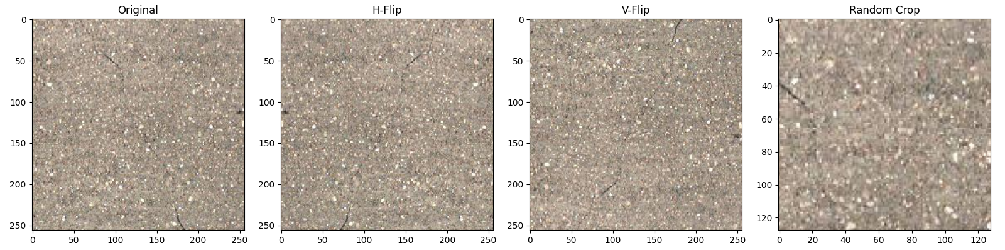
Figure 1: Augmentation examples (Original / H-Flip / V-Flip / Crop)

3. Model Architecture

Model 1: Simple Neural Network
- Input: 256×256 grayscale → Flatten (65,536 dims)
- Dense(512, ReLU) → Dropout(0.2) → Dense(512, ReLU) → Dropout(0.2) → Dense(2, Softmax)
- Optimizer: Adam(lr=0.01) / Epochs: 200 / Batch: 128
- Note: simplest fully-connected network; spatial information is entirely lost.

Model 2: CNN
- Input: 256×256 RGB
- BatchNorm → Conv2D(64, 7×7) → MaxPool → Dropout(0.4)
- BatchNorm → Conv2D(128, 3×3) → MaxPool → Dropout(0.4)
- BatchNorm → Conv2D(256, 5×5) → MaxPool → Dropout(0.4)
- Flatten → Dense(256, ELU) → Dropout(0.5) → Dense(2, Softmax)
- Optimizer: AdamW(lr=0.0001) / Epochs: 5 / Batch: 8
- Note: hierarchically extracts spatial features (edges, textures).

Model 3: ResNet50 (Transfer Learning)
- Input: 224×224 RGB
- ResNet50 (ImageNet pre-trained, include_top=True)
- Flatten → Dense(256, ELU) → Dropout(0.5) → Dense(2, Softmax)
- Optimizer: AdamW(lr=0.0001) / Epochs: 5 / Batch: 8
- Note: 25M+ parameter deep network. Transfer learning enables rich feature representations even on small datasets.

4. Results per Model

4-1. Simple Neural Network
Hyperparameters: Epochs=200, Batch=128, Optimizer=Adam(lr=0.01)

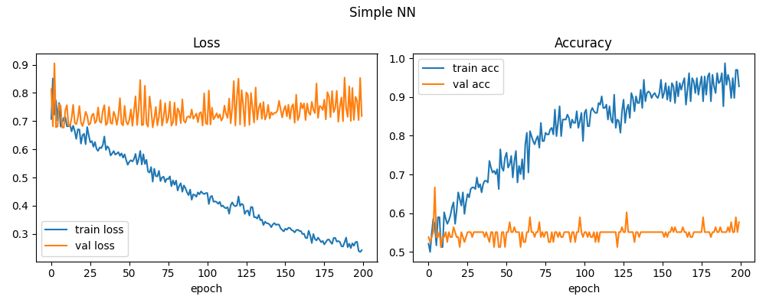
Figure 2: Simple NN training curves

Test Results

Metric | Value
Test Loss | 0.7439
Test Accuracy | 60.8%
TP — correctly detected damage | 3
TN — correctly excluded no_damage | 45
FN — missed damage | 30
FP — false alarm (no_damage predicted as damage) | 1
Total test images | 79

Confusion Matrix

 | Predicted: damage | Predicted: no_damage
Actual: damage | 3 (TP ✓) | 30 (FN ✗ missed)
Actual: no_damage | 1 (FP ✗ false alarm) | 45 (TN ✓)

Classification Report

Class | Precision | Recall | F1-score | Support
000_damage | 0.750 | 0.091 | 0.162 | 33
001_no_damage | 0.600 | 0.978 | 0.744 | 46
weighted avg | 0.663 | 0.608 | 0.501 | 79

Comments
- Accuracy 60.8% — must be interpreted in light of class imbalance (no_damage majority).
- damage Recall = 0.091 (9.1%) — share of actual damage cases detected. Most critical metric for road management. FN=30 missed cases.
- damage Precision = 0.750 — of all damage predictions, the proportion that were truly damaged. FP=1 false alarm.
- damage F1-score = 0.162 — harmonic mean of Precision and Recall; overall metric under class imbalance.

4-2. CNN
Hyperparameters: Epochs=5, Batch=8, Optimizer=AdamW(lr=0.0001)

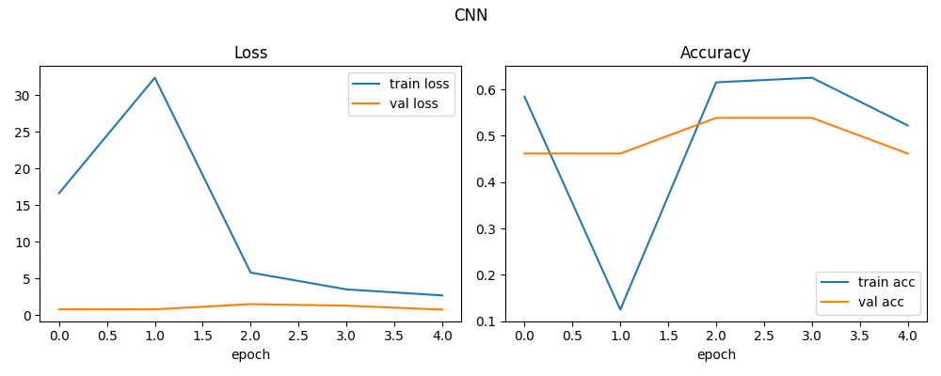
Figure 3: CNN training curves

Test Results

Metric | Value
Test Loss | 0.7411
Test Accuracy | 41.8%
TP — correctly detected damage | 33
TN — correctly excluded no_damage | 0
FN — missed damage | 0 ★ best
FP — false alarm (no_damage predicted as damage) | 46
Total test images | 79

Confusion Matrix

 | Predicted: damage | Predicted: no_damage
Actual: damage | 33 (TP ✓) | 0 (FN ✗ missed)
Actual: no_damage | 46 (FP ✗ false alarm) | 0 (TN ✓)

Classification Report

Class | Precision | Recall | F1-score | Support
000_damage | 0.418 | 1.000 | 0.589 | 33
001_no_damage | 0.000 | 0.000 | 0.000 | 46
weighted avg | 0.174 | 0.418 | 0.246 | 79

Comments
- Accuracy 41.8% — extreme bias: all samples predicted as damage.
- damage Recall = 1.000 (100%) ★ — zero missed damage cases; safest from a road management perspective.
- damage Precision = 0.418 — high false-alarm rate (FP=46).
- damage F1-score = 0.589

4-3. ResNet50 (Transfer Learning)
Hyperparameters: Epochs=5, Batch=8, Optimizer=AdamW(lr=0.0001)

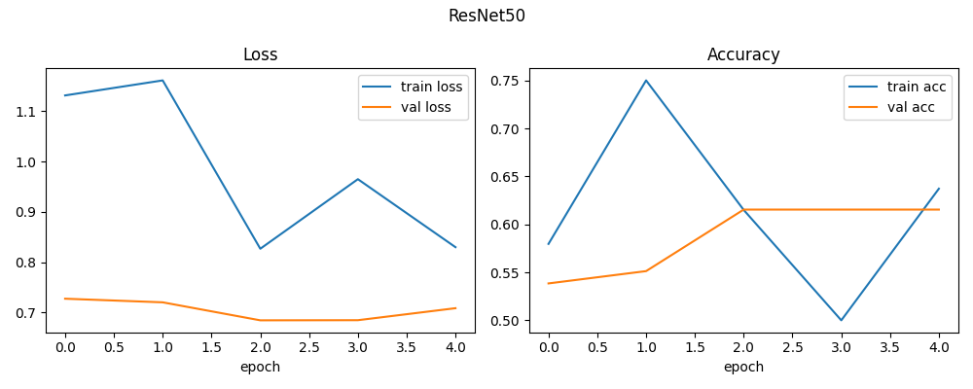
Figure 4: ResNet50 training curves

Test Results

Metric | Value
Test Loss | 0.5606 ★ lowest
Test Accuracy | 72.2% ★ highest
TP — correctly detected damage | 26
TN — correctly excluded no_damage | 31
FN — missed damage | 7
FP — false alarm (no_damage predicted as damage) | 15
Total test images | 79

Confusion Matrix

 | Predicted: damage | Predicted: no_damage
Actual: damage | 26 (TP ✓) | 7 (FN ✗ missed)
Actual: no_damage | 15 (FP ✗ false alarm) | 31 (TN ✓)

Classification Report

Class | Precision | Recall | F1-score | Support
000_damage | 0.634 | 0.788 | 0.703 | 33
001_no_damage | 0.816 | 0.674 | 0.738 | 46
weighted avg | 0.740 | 0.722 | 0.723 | 79

Comments
- Accuracy 72.2% ★ — highest among all three models.
- damage Recall = 0.788 (78.8%) — substantially fewer missed cases (FN=7).
- damage F1-score = 0.703 ★ — best balance of Precision and Recall.

5. Model Comparison

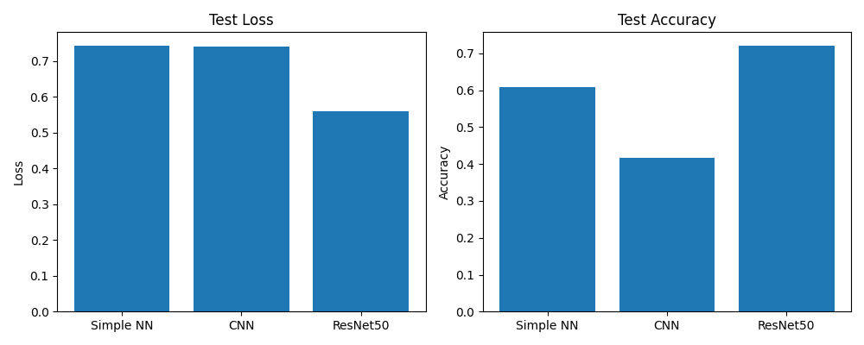
Figure 5: Loss & Accuracy comparison across all 3 models

Model | Test Loss | Test Accuracy | damage F1 | damage Recall | FN missed | FP false alarm
Simple NN | 0.7439 | 60.8% | 0.162 | 0.091 | 30 | 1
CNN | 0.7411 | 41.8% | 0.589 | 1.000 ★ | 0 ★ | 46
ResNet50 | 0.5606 ★ | 72.2% ★ | 0.703 ★ | 0.788 | 7 | 15

★ = best value in each column

Discussion
In road damage detection, the cost of missed detections (FN) is highest — undetected damage poses an accident risk. Therefore, damage class Recall should be prioritized over Accuracy when selecting the final model.

Summary of model characteristics:
- Simple NN — structurally disadvantaged for image classification since spatial information is discarded. Extremely low Recall leads to many missed damage cases.
- CNN — detects all damage (Recall=100%) but also flags every no_damage sample as a false alarm. Epoch count and regularization need tuning.
- ResNet50 — best Accuracy and F1. Transfer learning from ImageNet leverages rich feature representations even with a small dataset (391 images), making it the recommended choice.

6. Output Files

File | Description
image_augmentation.png | Augmentation examples (Original / H-Flip / V-Flip / Crop)
history_simple_nn.png | Simple NN training curves
history_cnn.png | CNN training curves
history_resnet.png | ResNet50 training curves
comparison.png | Loss & Accuracy bar chart comparison across all 3 models
SimpleNN/error_*.png | Simple NN TP / TN / FN / FP sample images
CNN/error_*.png | CNN misclassified & correct sample images
ResNet50/error_*.png | ResNet50 misclassified & correct sample images
report.md / report.docx | Experiment report

