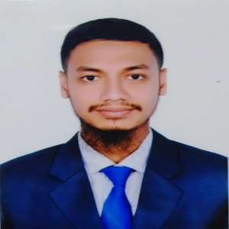

EDUCATIONAL QUALIFICATION

* Arts
* Public Speaking
* Volunteer

EXTRACURRICULAR ACTIVITIES

* BANGLA
* ENGLISH

LANGUAGES

* MS Excel
* MS PowerPoint
* MS Words
* Solid Edge

SKILLS

Cell: 01575597452

Email: eco1803047brur@gmail.com

House: Jahid vila,

MD. JAHID HASAN

D **Master’s of Social Science in Economics**

University : Begum Rokeya University, Rangpur.

d Passing Year : 2023

ff Result : CGPA 3.33 Out of 4.00

**Bachelor of Social Science in Economics**

University : Begum Rokeya University, Rangpur.

Passing year : 2022

Result : CGPA 3.21 Out of 4.00

**Higher Education Certificate in Business Management**

College : Chatra Science & Technical College.

Passing Year : 2017

Result : GPA 5.00 Out of 5.00

SKILL ENHANCEMENT TRAINING

Training Title : MULTILINGUAL SHORTHAND

Duration : 3 Month

Time Period : 1thApril to 30thJune

Institution : BKKB

HHHSfgSSHORTHAND