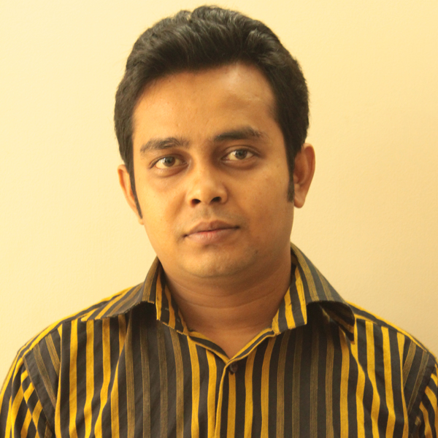
CURRICULUM VITAE
Mailing Address
Md. Mahfuzur Rahman
R # 10,H # 60, 1nd floor
Marul Badda,DIT Project
Dhaka,Bangladesh
Contact No: 01612262744
E-Mail: mahfuz.bappy@gmail.com

Career Objective

I am blending software development best practices adequately with over 7 years of professional experience. I am very much passionate about coding. I like challenging. I practice with my best.

