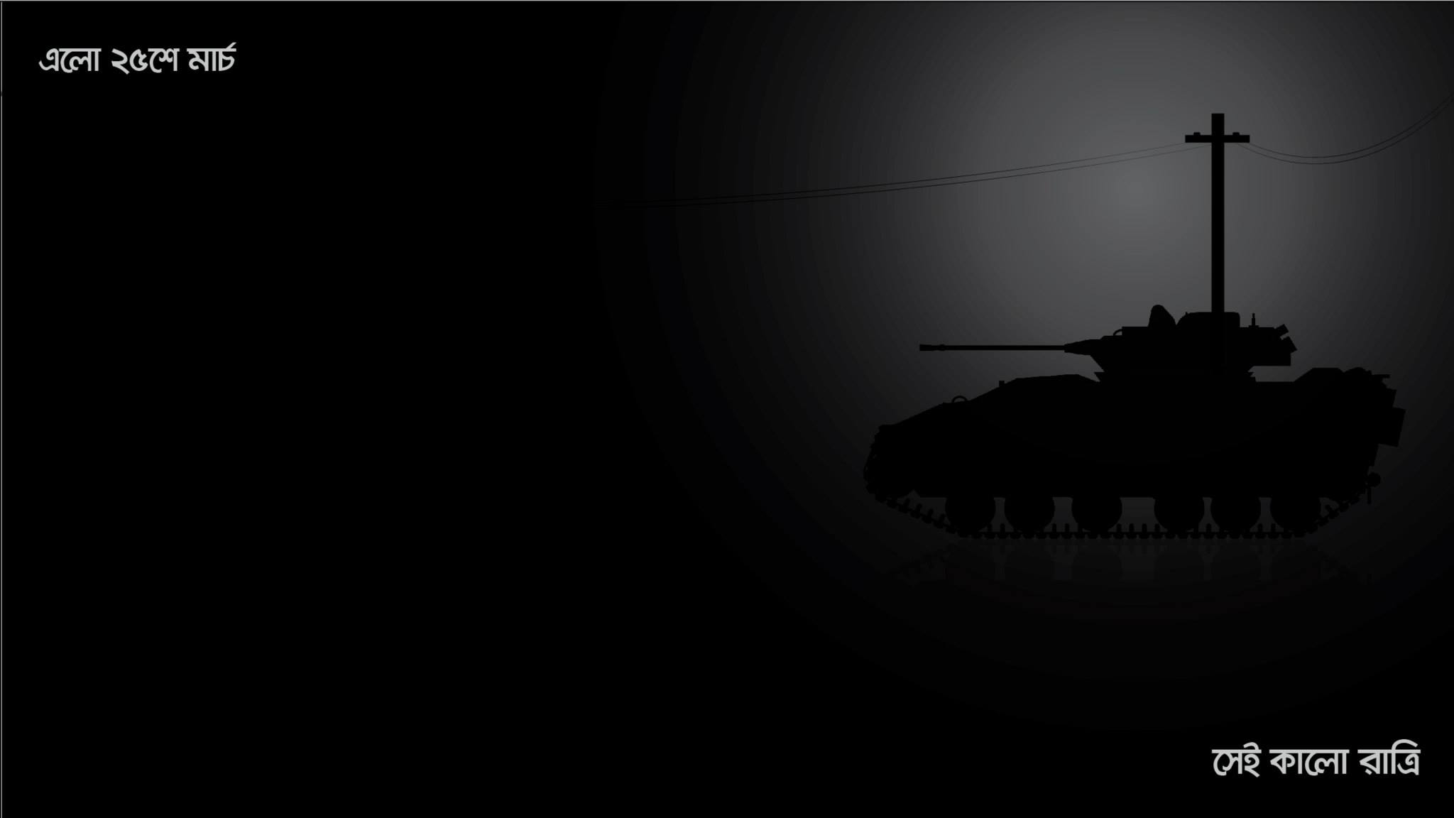

**CURRICULUM VITAE**

**Mailing Address**

Md. Mahfuzur Rahman

R # 10,H # 60, 1nd floor

Marul Badda,DIT Project

Dhaka,Bangladesh

Contact No: **01612262744**

E-Mail**:** [mahfuz.bappy@gmail.com](mailto:mahfuz.bappy@gmail.com)

**Career Objective**

I am blending software development best practices adequately with over **7 years** of professional experience. I am very much passionate about coding. I like challenging. I practice with my best.