Please find screenshots from Health Grades <https://www.healthgrades.com/> for specialist providers to whom Practice Name refers its patients. It should be noted that although we consult these types of websites for information on the quality of the providers to whom we refer, we are limited by the patient’s insurance company’s roster of providers. Additionally, our patients prefer providers who are locally based and accessible to our patient population by public transportation.

EXAMPLES

Dr. Simona Proteasa, MD (Pediatric Neurology)

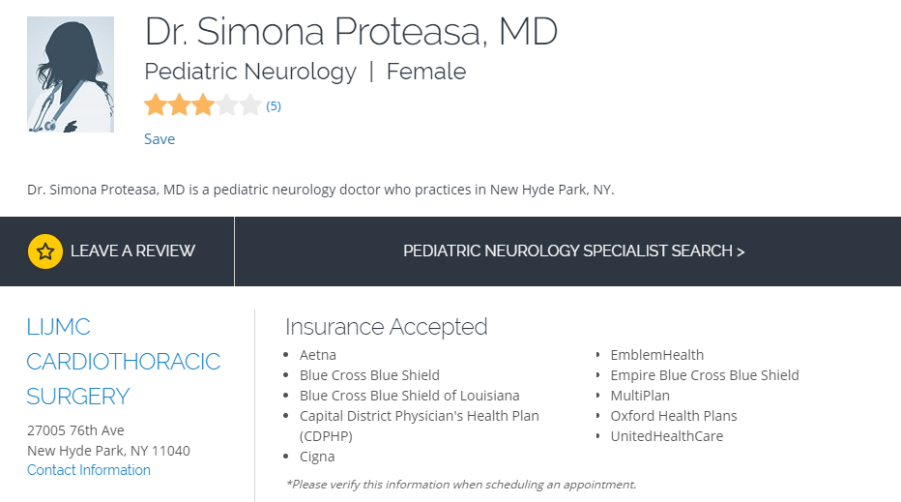





Dr. Tatyana Galinsky, OD (Optometry)

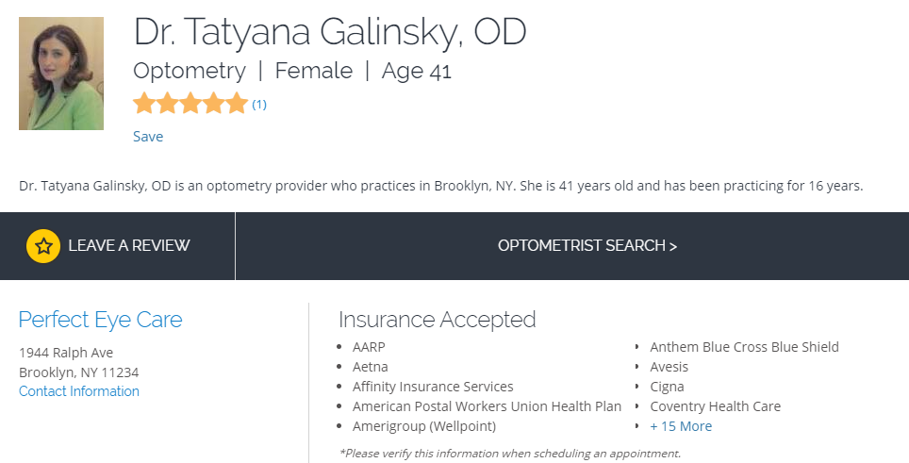

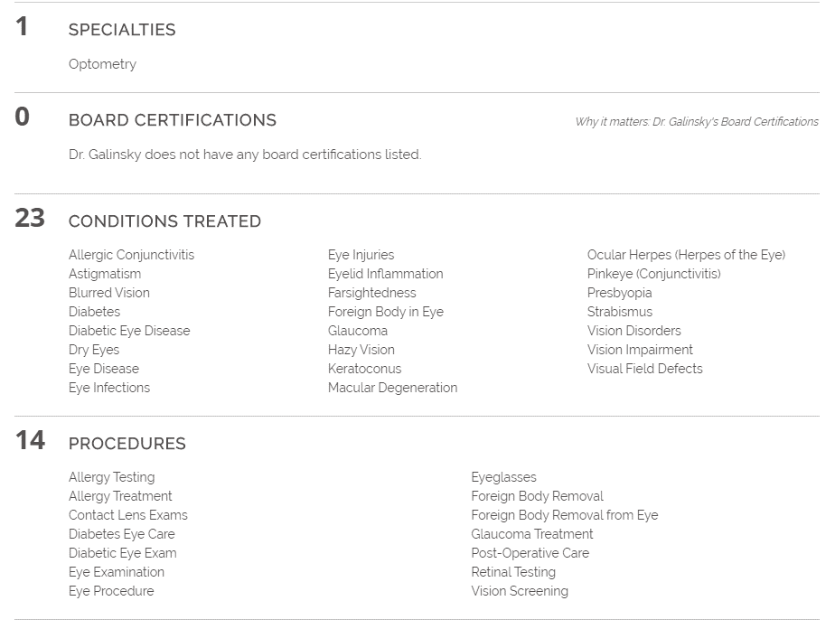

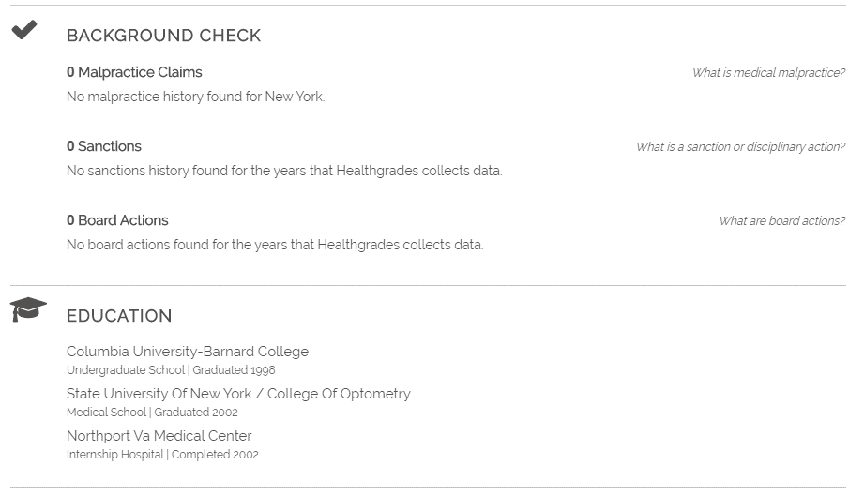

Dr. Hazel Goodwin, MD (Developmental-Behavioral Pediatrics)

