**How to create custom Templates (And Blurbs) for Care Plans, Referral & Hospitalization Inquires**

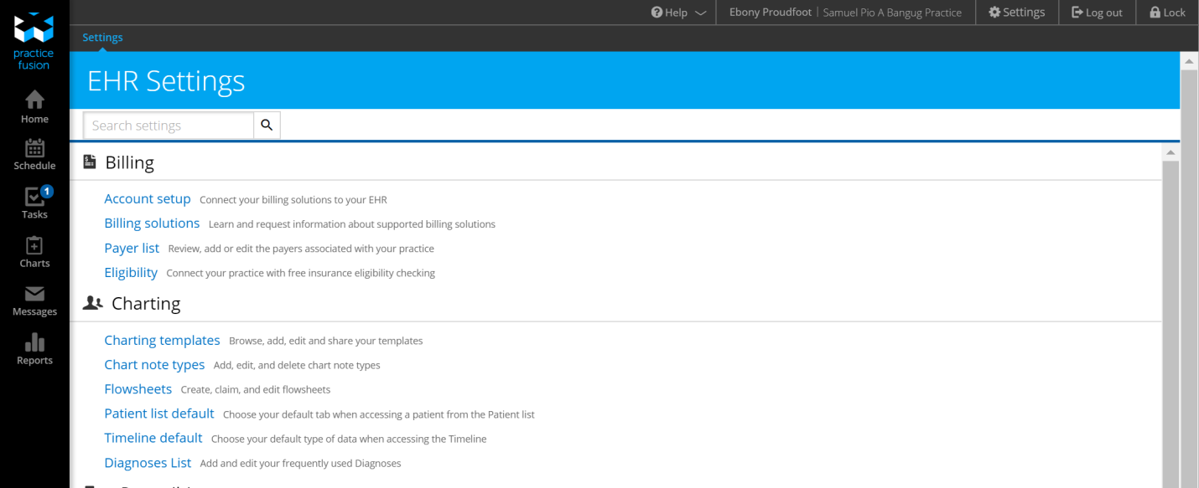

* Located in Settings, open **Charting Templates.**

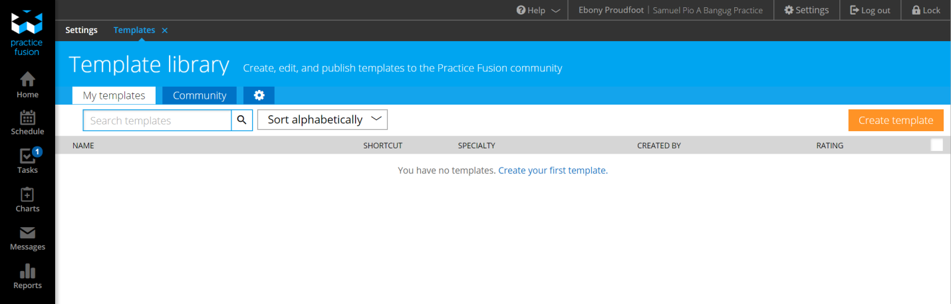

* Click ‘**Create Template’**
* In new template, enter in PCMH Blurbs and Medical Examination questions in respective fields.

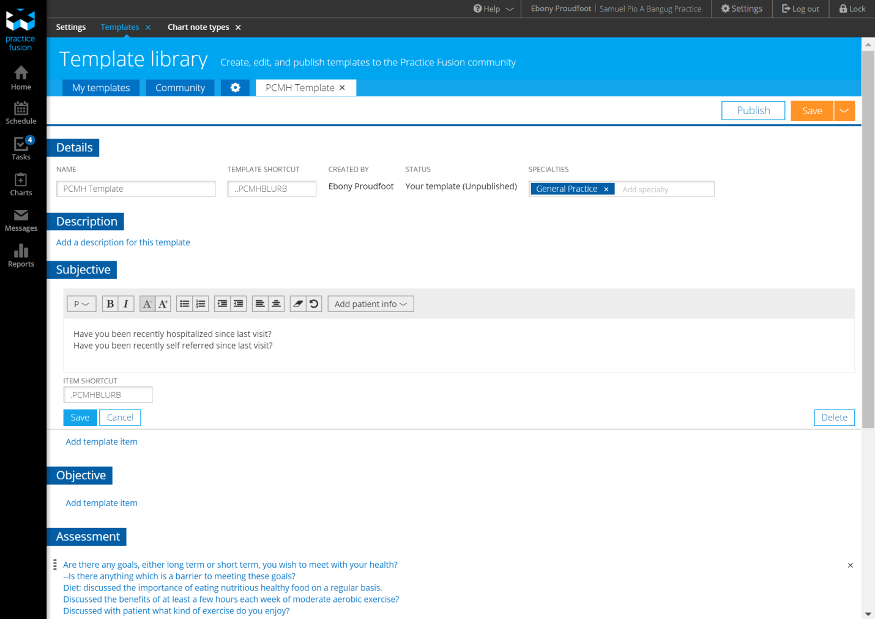

* 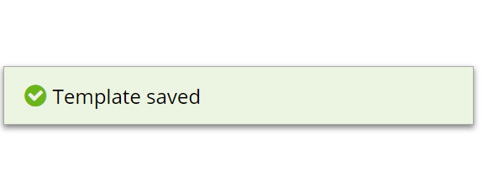Save **PCMH Template.**