Internship Data Analysis Report – Sales Trends

Name: Himendra Makode  
Internship Position: Data Analyst Intern  
Submission Date: June 29, 2025

# 1. Introduction

This report presents an in-depth analysis of sales data to uncover revenue patterns, popular products, city-wise performance, and monthly trends. The purpose of this analysis is to provide actionable insights for strategic planning and marketing optimization.

# 2. Data Overview

The provided dataset contains transactional sales records with the following fields:  
- Invoice ID  
- Date of Sale  
- Customer ID  
- City  
- Product and Category  
- Quantity Sold  
- Unit Price  
- Payment Method  
- Total Amount  
The data covers sales from April 2023 to May 2025

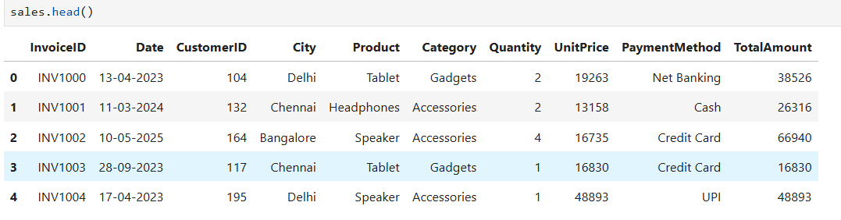

.

# 3. Key Findings

## 3.1 Revenue by City

Chennai and Kolkata are the highest revenue-generating cities. Other cities show moderate potential. 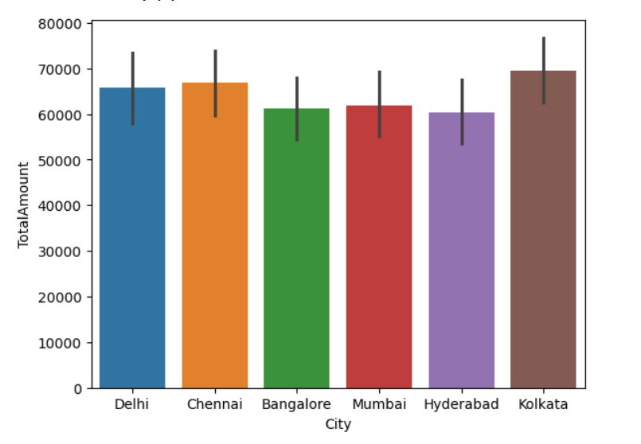

## 3.2 Top Products by Sales Volume

The most sold products are:  
1. Headphones   
2. Laptop   
3. Tablet

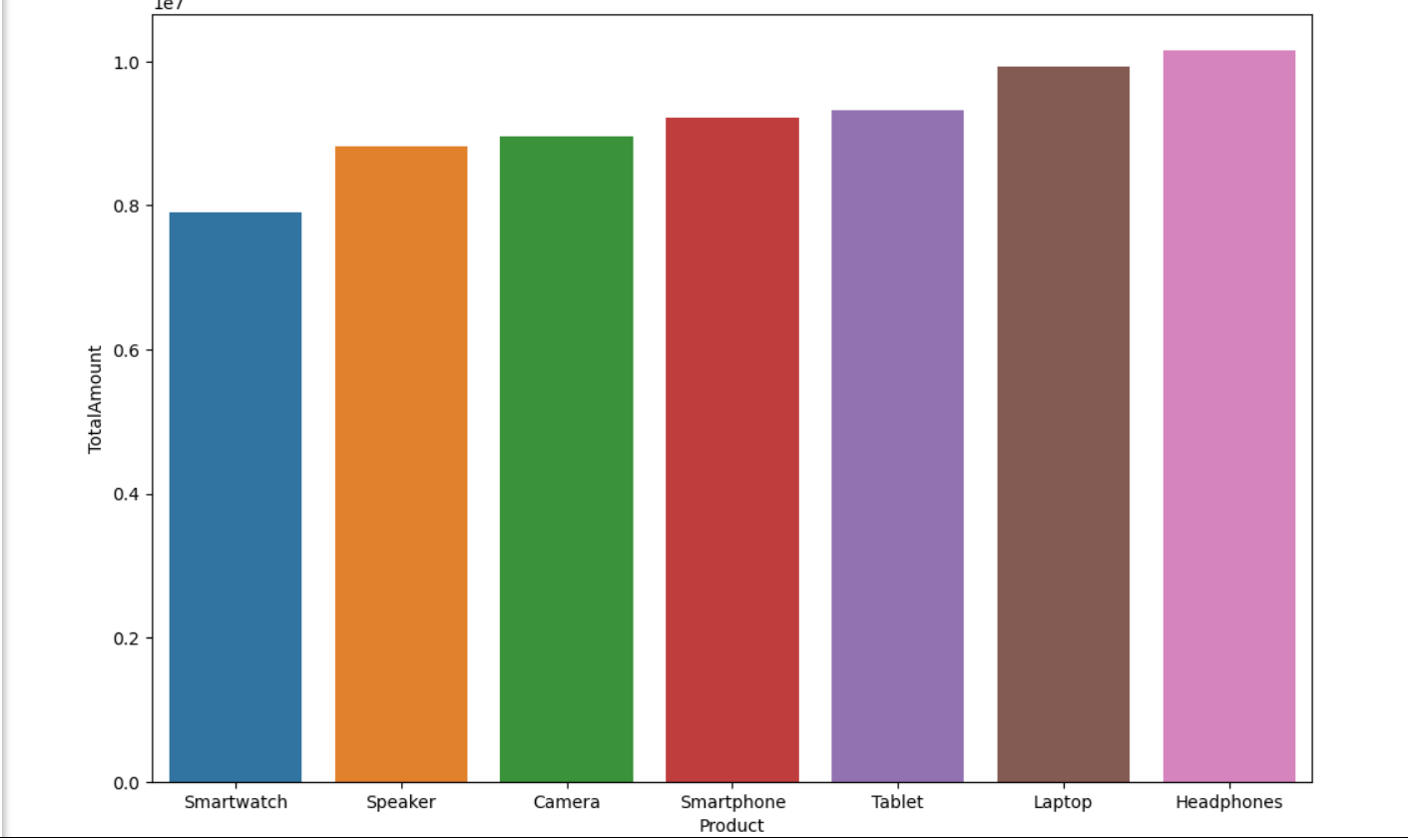

## 3.3 Comparing Payment Methods

Comparison between multiple methods shows that customers pays there bill in cash most frequently.

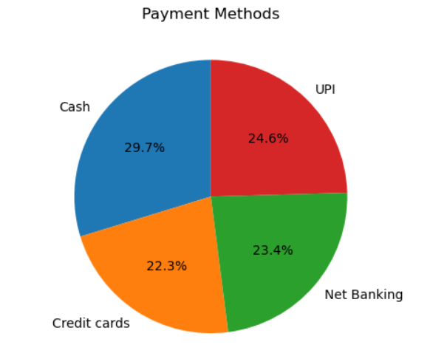

## 3.4 Monthly Revenue Trend

Revenue shows noticeable peaks during festive seasons and promotional months. The overall revenue trend is growing steadily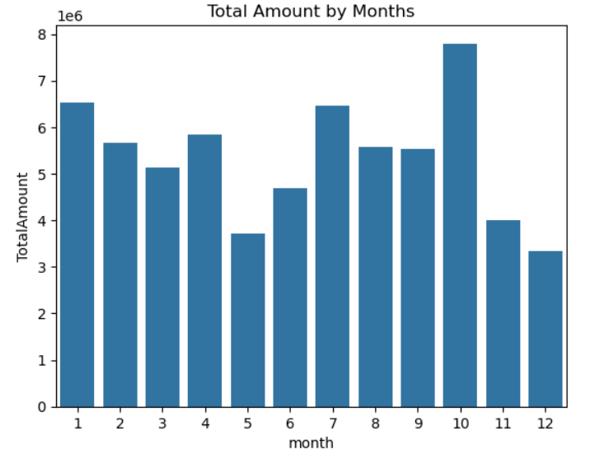

## 3.5 Customer with highest and lowest sale amount

CustomerID - 125 , sum(TotalAmount), = 1730102

CustomerID - 157 , sum(TotalAmount,) = 84705

# 4. Summary and Recommendations

## Summary:

The sales data analysis reveals that Chennai and Kolkata are driving the majority of the revenue. Product demand is centered around consumer accessories and gadgets, particularly headphones and laptops. Monthly sales patterns indicate a consistent upward trend with revenue spikes around promotional events. Revenue of all sales is $ 64286293 .

## Recommendations:

✔ Focus on high-performing cities for targeted marketing.  
✔ Optimize inventory management for top-selling products.  
✔ Plan promotional campaigns around high-revenue months.  
✔ Develop growth strategies for lower-performing cities.

# 5. Raw Data Analysis Code

* import pandas as pd  
  import matplotlib.pyplot as plt  
  import seaborn as sns
* Load the dataset  
  sales = pd.read_csv('sales_data.csv')
* Convert 'Date' to datetime  
  sales['Date'] = pd.to_datetime(sales['Date'], format='%d-%m-%Y')
* Revenue of total sales

r = sales["TotalAmount"].sum()

print(f'Revenue : {r}')

* Revenue by City  
  city_revenue = sales.groupby('City')['TotalAmount'].sum().sort_values(ascending=False)  
  print(city_revenue)
* Top Products by Quantity Sold  
  top_products = sales.groupby('Product')['Quantity'].sum().sort_values(ascending=False).head(5)  
  print(top_products)
* Total Amount by Payment Methods

payment_methods = sales.groupby("PaymentMethod").agg({"TotalAmount" : "sum"})

print(payment_methods)

* Monthly Revenue Trend  
  sales['Month'] = sales['Date'].dt.to_period('M')  
  monthly_revenue = sales.groupby('Month')['TotalAmount'].sum()  
  print(monthly_revenue)
* Highest and Lowest Total Amount of Customer  
  Highest_sale = sales.groupby("CustomerID")["TotalAmount"].sum()

Highest_sale.sort_values(ascending = False).head(1)

lowest_sale = sales.groupby("CustomerID")["TotalAmount"].sum()

lowest_sale.sort_values().head(1)

* **Visualizations (Bar plots, Line plots)**
  + **City’s Revenue(sum of TotalAmount) Comparison**

sns.barplot(x = "City", y = "TotalAmount", data = sales, hue = "City")

* + **Monthly Revenue(sum of TotalAmount) Comparison**

sns.barplot(data = monthly_revenue , x = "month",y = "TotalAmount")

plt.title("Total Amount by Months")

plt.show()

* + **Showing Pie chart of Paymennt Methods**

a = sns.barplot(x = "Product", y = "TotalAmount", data = sales, hue = "Product")

c = a.get_figure()

c.set_size_inches(12, 8)

* + **Product’s Revenue(sum of TotalAmount) Comparison**

plt.pie(x, labels = ["Cash", 'Credit cards', 'Net Banking', 'UPI'], autopct = '%1.1f%%', startangle = 90)

plt.title("Payment Methods")

plt.show()

# 6. Conclusion

This analysis has provided actionable insights into revenue trends, top-performing products, and sales patterns across cities. The included Python code demonstrates data processing, visualization, and exploratory analysis skills, which are critical for a data analyst role.