InstaVision SALES ORDER FORM (“ORDER”)
PARTIES
APEMAN INTERNATIONAL CO.,LIMITED , a Hong Kong limited liability company (“Company”) | InstaVision, Inc., a Utah C corporation (“InstaVision”)
COMPANY ADDRESS:  ROOM 2133 21/F REMEX CENTRE, 42 WONG CHUK ROAD, HK | INSTAVISION ADDRESS:  InstaVision, Inc.  450 N 1500 W Orem, 84057, UT
COMPANY BILLING CONTACT:  Name: [∙]  Phone: [∙]  Email: [∙] | INSTAVISION SALE REP:  Name: Yamin  Phone:  Email: yd@Instaview.ai
COMPANY CONTACT FOR NOTICES:  APEMAN INTERNATIONAL CO.,LIMITED  ROOM 2133 21/F REMEX CENTRE, 42 WONG CHUK ROAD, HK  Attention: [∙]  Email: [∙] | INSTAVISION CONTACT FOR NOTICES:  InstaVision, Inc.  450 N 1500 W Orem, 84057, UT  Attention: Legal Department  Email: contracts@Instaview.ai
COMPANY TECHNICAL CONTACT(S) (INCLUDING FOR SLA ISSUES):  Point of Contact:  Name: [∙]  Phone: [∙]  Email: [∙] | INSTAVISION TECHNICAL CONTACT(S) (INCLUDING FOR SLA ISSUES):  Point of Contact:  Name: InstaVision Technical Support Team  Phone: +1-877-916-3025  Email: support_alarm@Instaview.ai
The signatories to this Order represent that they are duly authorized to execute this Order and the Agreement on behalf of the party they represent.
ORDER EFFECTIVE DATE: Effective Date Upon Signature hereof.
COMPANY SIGNATURE:  Name: _________________  Title: ___________________  Date: ___________________ | INSTAVISION SIGNATURE:  Name: _________________  Title: ___________________  Date: ___________________

SERVICES; COMBINED PRODUCT INTEGRATION DETAILS; FEES; TERRITORY

InstaVision Services Description | InstaVision Emergency Platform, plus InstaVision Monitoring – as provided more fully in Combined Product SOW, which is appended as Annex III to this Order.
Combined Product Integration Details and Launch Plan | As provided in the Combined Product SOW,  which is appended as Annex III to this Order.
Fees | As provided in Annex I to this Order.
Subscription Fee Start Date | 11/15/2025
Initial Term | 12 months from Subscription Fee Start Date
Territory | United States

ADDITIONAL TERMS AND CONDITIONS:
Structural Agreements. This Order, together with the annexes, is governed by the terms and conditions of InstaVision’s Master Services Agreement, which is located at: TBD (the “MSA”), including its exhibits and/or addenda (collectively, the “Agreement”).
Annexes. The following Annexes are appended to and a made a part of this Order:
- Annex I – Pricing Annex
- Annex II – SLA
- Annex III – Combined Product SOW: Integration and Launch Plan

Annex I: Pricing
- “Billable Subscription” means a single account of a Customer, subscriber or end user of the Combined Product that is active at any time in a given month, and forms the basis for the calculation of the Subscription Fees.

The Billable Subscription for this Order is the individual user of the Combined Product.

- Subscription Fees for the InstaVision Services (“Subscription Fees”) shall consist of the following components:

“Minimum Subscription Fee(s)” means the commitment of Subscription Fees that Company shall be obligated to pay to InstaVision during the Initial Term (and as may be modified from time-to-time for any subsequent renewal terms), based upon a Minimum Number of Billable Subscriptions, as described more fully in this Section, which shall be payable quarterly in advance;

“Incremental Billable Subscription Fee(s)” means the variable fees for Billable Subscriptions that exceed the Minimum Number of Billable Subscriptions that correspond to the applicable Minimum Subscription Fees, which shall be payable on a monthly calendar basis, in arrears;

“Incremental Incident Fee(s)” means the variable fees for Incidents that exceed the allowable Incidents in the applicable Incident Factor Tier, which shall be payable on a calendar monthly basis, in arrears.

- Minimum Subscription Fee Commitment. For first 9 months from Nove 15 2025, Company agrees to pay the following Minimum Subscription Fees set forth in Table 1, based upon the number of Billable Subscriptions that are active at any time in the applicable month.

“time duration” means the first 6 months of the Billable Subscription starting on the Subscription Fee Start Date.”

Table 1

Time duration | Minimum Monthly Billable Subscriptions | Minimum Monthly Subscription Fee
9 months | 3,000 | $18,000

For avoidance of doubt, Company’s obligation is to pay the Minimum Subscription Fee, not to achieve the number of Minimum Monthly Billable Subscriptions. Therefore, as long as the Minimum Monthly Subscription Fee is paid, there will not be a penalty assessed if the Company does not meet the number of Minimum Monthly Billable Subscriptions, nor will the failure to meet the Minimum Monthly Billable Subscriptions be deemed to be a breach of the Agreement.

- Initial Deposit. The company will make an upfront deposit of $18,000, which covers first nine month of minimum subscription fees. This must be paid before any project work or integration services begin. After the company reaches 1,000 billable subscribers per month, the deposit will be applied toward the monthly subscription bills.

- Incremental Billable Subscription Fees. For each Billable Subscription that is active in any given month that exceeds the number of Minimum Monthly Billable Subscriptions set forth in Table 1 (each, an “Incremental Billable Subscription”), the Company will pay InstaVision the following amount, without pro-ration:

Monthly Subscribers total | Monthly fees per subscribers
0 – 10,000 | $6
10,001 – 100,000 | $5.5
100,001 – 500,000 | $5
500,001 or more | $4.5

- Incident Factor.

“Incident” means a single event (or transaction) that requires human interaction by a monitoring center agent or that results in a direct connection to a 911 center agent (i.e., an escalation), and is measured on a per call (transactional) basis.
“Incident Factor” means a factor of Incidents, which is calculated as the total number of Incidents in a month divided by the average number of Billable Subscriptions for that month;
“Baseline Incident Factor” means the initial Incident Factor to be used by the parties beginning on the Subscription Fee Start Date, subject to quarterly review and mutual adjustment.
  - The initial applicable monthly Subscription Fees shall be based upon a Baseline Incident Factor of 0.2, meaning that, in any given month, for every one hundred (100) Billable Subscriptions, Company shall be entitled to have 20 Incident(s) without incurring any Incremental Incident Fees.
  - In no event will the Subscription Fee be decreased if the actual Incident Factor in any given month or quarterly period is less than the Baseline Incident Factor.
  - If the actual Incident Factor per month is consistently higher than the Baseline Incident, then the parties may mutually agree to increase the Incident Factor and the corresponding Billable Subscription Fee

- Incremental Incident Fees.
For each Incident in any given calendar month that exceeds the allowable number of Incidents set forth in Section 6.a (each, an “Incremental Incident”), the Company will pay InstaVision $15 per Incident.
- Payment Terms.

  - Tax Exemption Status
    - ☐ No
    - ☐ Yes: if this box is checked, then Company must submit to InstaVision its tax exempt verification before InstaVision can honor Company’s tax exempt status.

  - Fees payable in advance shall be invoiced on or before the fifth (5th) day of the calendar month before the InstaVision Services are to be provided.
  - All Fees payable in arrears will be invoiced by InstaVision on the fifteenth (15th) day of the following the end of the prior Billable Period.
  - All Fees will be duethirty (30) days from the date of the invoice.

Annex II

Service Level Agreement (“SLA”)

Purpose
This SLA sets forth InstaVision’s undertakings with respect to providing customer support to Company, and the service levels associated with the InstaVision Services provided during the Term.
1. Service Reliability. InstaVision shall provide an uptime of 99.9% for the InstaVision Services, subject to scheduled updates and maintenance and to any downtime caused by a third party. For unplanned downtime (an “Event”), InstaVision will assign a trouble severity code based on InstaVision’s assessment of the Event at the point of trouble identification. InstaVision will adjust the trouble severity code based on how the Event proceeds.

Trouble Severity Code | Description | Initial Response Time | Status Update Intervals
Sev 1 | “Sev 1 Error” means a catastrophic Event causing a complete (100%) loss of a key safety related feature of the InstaVision Services | 4 hours | 4 hours
Sev 2 | “Sev 2 Error” means a non-catastrophic Event causing a significant component of the InstaVision Services, to fail or to perform materially different than expected, creating significant inconvenience to an End Customer or, as applicable, InstaVision or Company | For Events reported during normal business hours (9am to 5pm EST Monday through Friday), 24 hours from time of report. For Events reported outside of normal business hours, 24 hours from beginning of the next business day | 24 hours
Sev 3 | “Sev 3 Error” means an Event that: (a) has minimal current impact on End Customer, and (b) causes a malfunction of a non-essential features of the InstaVision Services | For Events reported during normal business hours (9am to 5pm EST Monday through Friday), 24 hours from time of report. For Events reported outside of normal business hours, 24 hours from beginning of next business day | As appropriate

2. Points of Contact and Escalations. If Company experiences an Event, Company may contact InstaVision’s customer support by e-mail at support_alarm@Instaview.ai.

Unless otherwise modified in the applicable Order or Annex, InstaVision Contact Information (for escalation or technical issues)

 | Contact Name & Title | Phone | Mobile | Email
Point of Contact | InstaVision Technical Support Team | +1-877-916-3025 | 723-325-4492 | support@Instaview.ai
Escalation | InstaVision Network Operations Center | +1-877-916-3025 | 408-693-5499 | N/A

3. Change Control Management/Update Management.

A. Implementation of Updates/Maintenance: InstaVision will ensure that any planned maintenance and update events within the InstaVision Service will be executed in a professional manner. Proper execution includes advance notification to Company by InstaVision.
B. Service Interruptions and Advanced Notification Requirements: InstaVision will provide Company with at least 72 hours advance notice via e-mail of all planned maintenance activities resulting in any service interruptions or possibility of any service interruption that will have a direct impact on the InstaVision Services.
C. InstaVision shall perform emergency maintenance as necessary and will, if possible, give advance notice thereof to Company. “Emergency” shall mean that InstaVision has become aware of a problem that, if an immediate remedy is not implemented, will prevent InstaVision from continuing to support and provide the elements and aspects of the InstaVision Services. Emergency downtime outside of the maintenance window will be counted as unscheduled downtime in determining whether InstaVision has achieved its service uptime goal.
4. Service Warranty and Security
A. InstaVision warrants service availability of 99.5% per month. Failure to meet this standard for 3 consecutive months entitles Company to terminate without penalty.
B. InstaVision shall comply with ISO 27001 standards and bear all costs of data breaches.

Annex III: Combined Product Description and Technical Specifications

Instaview Statement of Work

Introduction
The purpose of this document is to describe all elements of work to be completed by InstaVision and COMPANY to create a Combined Product for duration and use as described in the InstaVision Master Services Agreement.

This may include data and/or voice capabilities facilitating connectivity with emergency services, safety agents and/or other services as described in the Combined Product Description for the delivery of said services to company and/or its respective users, parties or representatives. Enabling these services requires cooperative development involving both InstaVision and Company; This document provides the framework under which InstaVision and Company will work together to develop these services.

Scope of work and description

Phases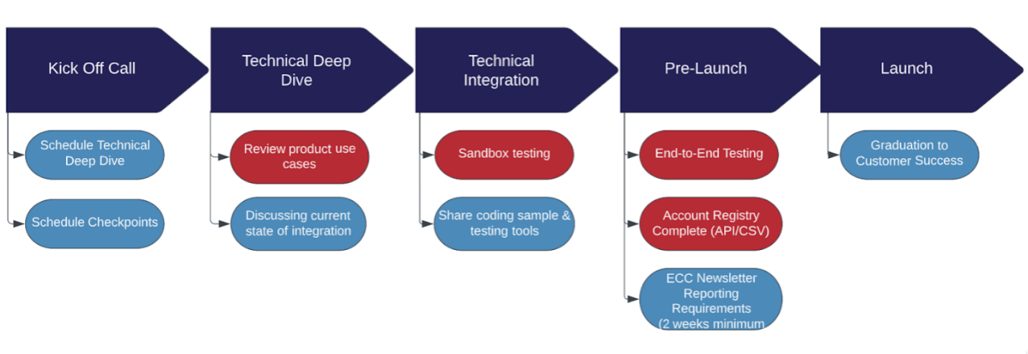

Alignment Phase
The Alignment phase kicks-off implementation of the combined product, beginning with a Kick-Off Call. This is where the project transitions to the Implementation leads (Implementation Engineer and Implementation Manager). The Implementation Engineer will be the main technical point of contact for the InstaVision side and will be the technical subject matter expert throughout the implementation. The Implementation Manager will project manage the implementation, ensuring deadlines are met, action items are clearly defined, and generally liaising between Company and InstaVision throughout the implementation.

Milestones

Kick-Off Complete
Kick-Off will be considered complete following adjournment of the “Kick-Off Call”

Technical Deep Dive Complete
Technical Deep Dive will be considered complete following adjournment of the “Technical Deep Dive Call”.

Alignment Phase Complete
The Alignment phase will be considered complete when all tasks have been completed and deliverables have been received by both Company and InstaVision.

Tasks

InstaVision
- InstaVision Will Schedule a “Kick-Off Call” with members of both InstaVision and Company who are responsible for implementing and managing the Combined Product. The purpose of this call is for members of Company and InstaVision to meet and coordinate details pertinent to complete all work items and deliverables outlined in this document. Representatives from the Company are required to attend the Kick-Off Call. If members of Company are unable to attend the Kick-Off Call then a representative from Company shall notify InstaVision in advance to re-schedule the call.
- InstaVision Will schedule a “Technical Deep-Dive Call” with members of both InstaVision and Company who are responsible for technical implementation of the Combined Product. The purpose of this call is for members of Company and InstaVision to align on technical implementation details and communication methods to be used throughout the development phase. From this stage, the integration build will start with a deep dive into the API itself, how it works, generation of credentials, creation of JSON Payload schema, and other technical set-up requirements to start the process.
- InstaVision Will create training materials for Emergency Communication Centers (ECC). InstaVision will require two weeks to alert Emergency Call Centers about new data sources to ensure telecommunicators are trained on your solution.

Company
- Company shall Review all InstaVision API Documentation noted in the section “InstaVision API Authorization” of the Combined Product Description
- Company shall Compile use cases for product and other questions for InstaVision team
- Company shall Let InstaVision know at least 48 hours in advance of any external demo
- Company will provide InstaVision an estimated date for testing commencement
- Company will provide InstaVision an estimated date for end-to-end testing
- Company will provide InstaVision an anticipated launch date
- Company shall provide a “Customer Service” phone number for InstaVision to include in training materials.

Development Phase
InstaVision will assign an Implementation engineer to lead all aspects of developing the combined product, including workflows and use-cases included in this document. Company will provide sufficient technical staffing to work cooperatively with InstaVision implementation engineer(s) to build the combined product

Milestones

Technical Integration Complete
Development will be considered complete upon delivery from InstaVision to Company, of a code-snippet and usage documentation for the combined product.

Tasks
Owner | Description
InstaVision | InstaVision Will provide Company with access to API and test environment tooling which may include and is not limited to: API access, emergency calling number(s),
InstaVision | InstaVision will build workflows and use-cases contemplated in the Combined Product description
InstaVision | InstaVision will provide company with a “code snippet” or OpenAPI spec of the InstaVision Emergency Workflow API containing the functionality outlined in the Combined Product Description
Company | Company will build integrations to InstaVision API(s) to complete use cases described in the Combined Product description

Quality Assurance and Testing (Pre-Launch)
Pre-Launch means the project phase occurring After the initial API testing is complete and wherein the final steps of preparation and testing will occur. This includes inclusion of information around the Company and its use case, data, workflows, and training documents which will be shared with the ECC (911 Centers).

InstaVision will provide integration, verification and validation testing of the combined product as described below:
- Testing: Using test environment tooling provided by InstaVision, Company will complete non-production testing of the combined product in non-live environments. Simulated, text-to-speech interfacing may be provided to simulate communication with InstaVision Monitoring and/or 911 Emergency Communications personnel.
- Production Testing: InstaVision may provide controlled testing, with Company, of the combined product, in a InstaVision production environment jurisdiction situated in the middle of the pacific ocean. Using this jurisdiction, Company may send data to the InstaVision production environment for verification purposes without any live interaction with emergency communications personnel or interference with live emergency communications center equipment. This testing will be at the discretion of InstaVision.
- Live Agent Testing: At the discretion of InstaVision, a limited amount of testing with a live InstaVision Safety Agent may be provided. All testing with InstaVision Safety agents shall be conducted during normal business hours in the Eastern Time Zone.
- Live 911 Testing: Due to the sensitive nature of sending non-emergency calls to live 911 agents, testing with emergency services will not be provided by InstaVision.

General Provision
Company is responsible for the testing, application development and connectivity to the InstaVision Emergency Response Data Platform through the specified endpoint API. Company is responsible for providing a test plan to InstaVision for the testing and validation of application readiness unless otherwise specified in this document.

InstaVision is responsible for the testing and internal application development for the InstaVision Emergency Response Data Platform and the connectivity to the Public Safety entities through the InstaVision Portal or through a 3rd Party Public Safety software integration.

We all have a responsibility to reduce, minimize or otherwise eliminate the chance of any false alarms being sent to emergency services. Company agrees that they will take all reasonable steps to ensure their product and any features or functionality contemplated by this combined product do not result in any egregious or false alarms being sent to emergency services.

Tasks

Owner | Description
InstaVision | InstaVision Will provide Company with access to API and test environment tooling which may include and is not limited to: API access, emergency calling number(s),
Company | Company will provide InstaVision with test documentation outlining the use cases, sample data payloads and other information material to verifying the behavior of the combined product
Company | Company will provide a written request to InstaVision for production or live-agent testing detailing the nature of the tests, expected duration of the tests, and date/time requested.
Company | Company must successfully test in API, then in a production environment with RSOS in order to proceed toward launch.

Milestones
- Completion: Pre-Launch will be considered complete when full combined product behavior has been verified to the satisfaction of InstaVision and Company.

Launch
Launch means the project phase where the Combined Product is launched into the Production environment. Implementation is complete and Company will be assigned a dedicated Customer Success Manager (CSM) who will be the long-term point of contact for Company for any requests, questions, update, or concerns throughout the life of the partnership.

At the discretion of InstaVision, quarterly business reviews may be conducted between Company and InstaVision to review and discuss combined product operation, usage or any other topics of interest or importance between the parties.

Deadlines and Schedule
An example schedule is provided below:
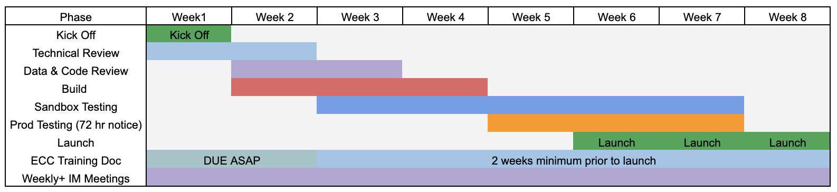All work described in this document will be completed to coincide with the Subscription Fee Start Date indicated in the Order Form.

Acceptance Criteria
Upon successful completion of Implementation, InstaVision will send an email to relevant points of contact within COMPANY to confirm that implementation is complete and that the combined product is now Live in InstaVision production environments.

Combined Product Description

Overview of solution
Usage of the InstaVision APIs to provide alarm SMS verification, IVR Verification, and Monitoring with supported Video Verification. Escalation of incidents to 911 via monitoring in the event of Intruder alarm emergencies or when appropriate supported with InstaVision transmitting user, alarm, location and additional data points, mutually agreed to by both parties, directly from Company through the InstaVision Emergency Response Data Platform to the PSAP/ECC (911 call center). Two use cases in scope for this offering, including a Self-Monitoring offering without supported video verification and a Pro-Monitoring offering with included video verification.

Flow Diagrams

Video - Pro, Verified
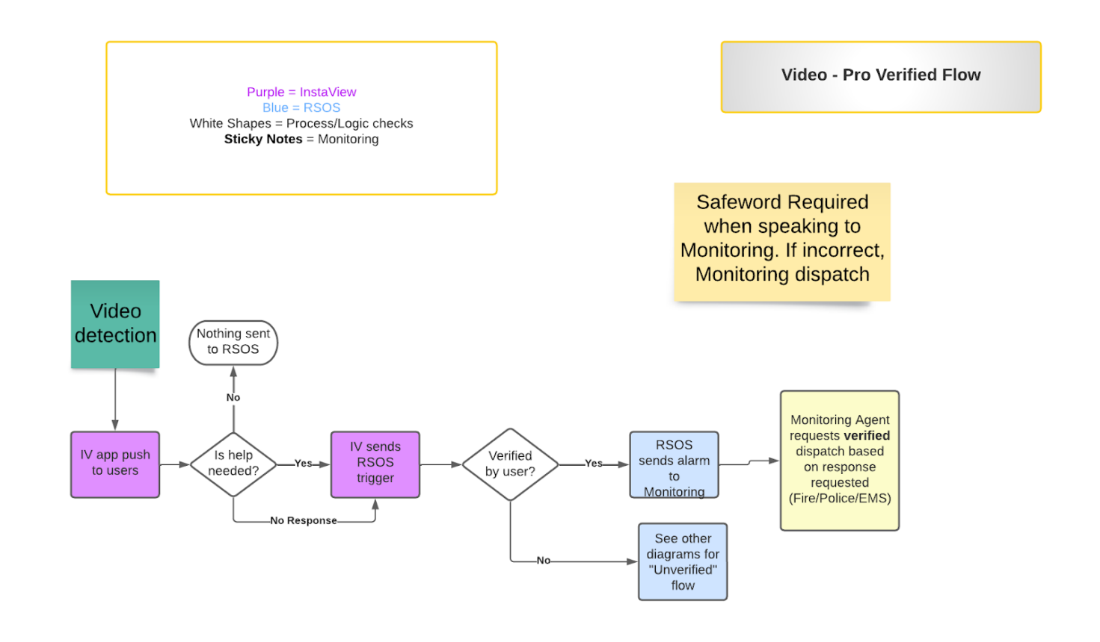
IV sends Alarm to monitoring
Company: 3rd party APP
IV: Instavision
Company send IV trigger
App push to user

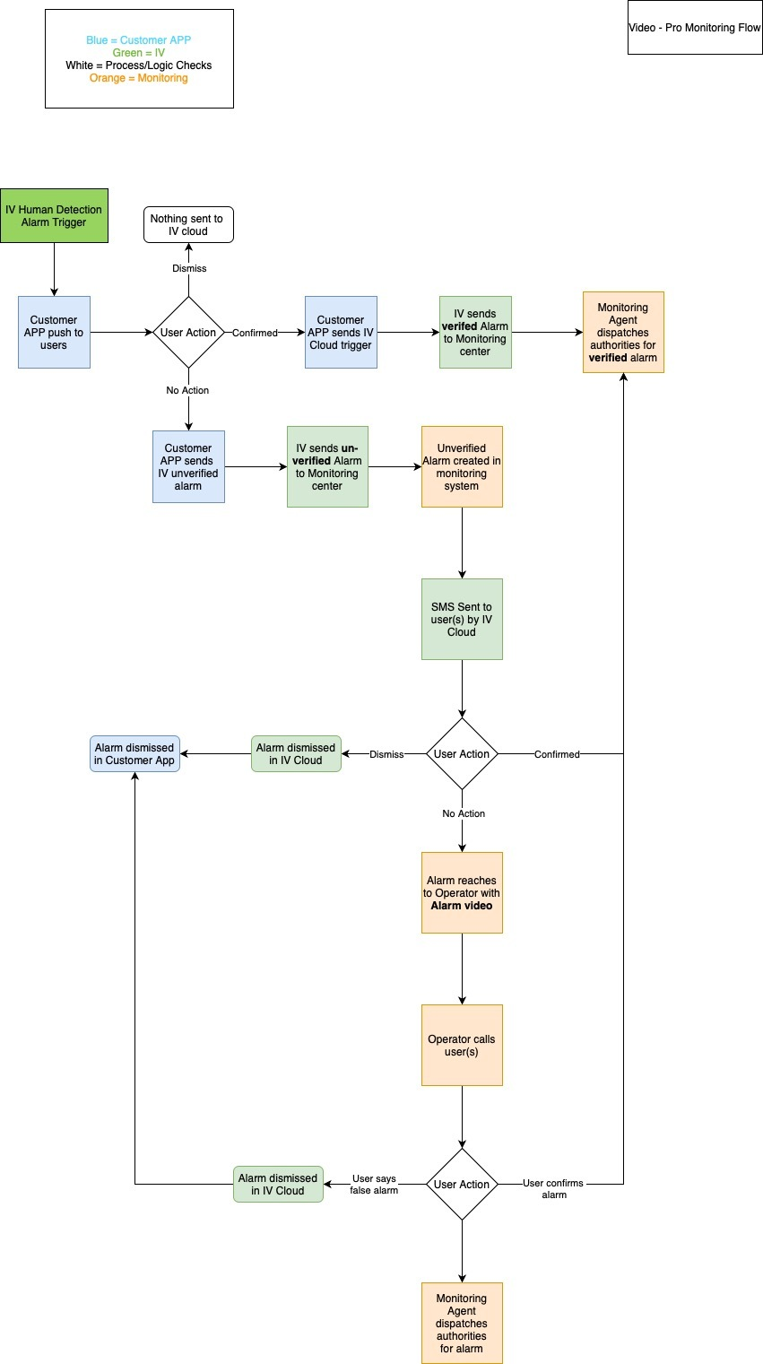
AI used by customer’s camera or cloud

