

COMP 6721 Report

**Spam Detector using Naïve Bayes Approach**

Date: April 26, 2020

Submitted To: Dr. René Witte, P.Eng. (Associate Professor)

Team : HA-G05

Khyatibahen Chaudhary (40071098)

Jenny Mistry (40092281)

Himen Hitesh Sidhpura (40091993)

**Analysis**

In order to calculate the accuracy, precision, recall and F1-measure for Spam & Ham Class as well as a confusion matrix, series of steps performed to generate classification result such as Common Aspect of Text Mining and Naïve Bayes Classifier Approach.

1. Common Aspect of Text Mining:

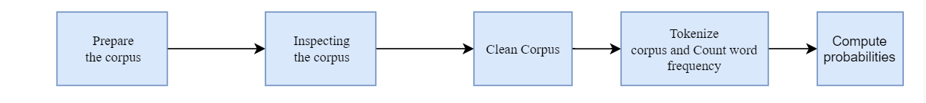

1. Naïve Bayes Classifier Approach:

Step 1: Build the Vocabulary of words by separating Spam and Ham from training Data.

Step 2: Store Vocabulary of words in a file.

Step 3: Train Classifier on Vocabulary.

Step 4: Evaluate Performance on Test data.

Step 5: Display Confusion and Evaluation Matrix

**Confusion Matrix:**

We considered SPAM as a positive class and HAM as the negative class,

|  |  |  |
| --- | --- | --- |
|  | SPAM (Predicted) | HAM (Predicted) |
| SPAM (Actual) | 336 | 64 |
| HAM (Actual) | 6 | 394 |

**Evaluation Matrix:**

|  |  |
| --- | --- |
| Accuracy | 91.25 |
| Precision | 98.24 |
| Recall | 84 |
| F1 | 90.566 |

* **Accuracy**: $\frac{TP + TN}{TP + TN + FP + FN}$
* **Precision**: $\frac{TP}{TP + FP}$
* **Recall**: $\frac{TP}{TP+FN}$
* **F1-Score**: $\frac{2 * Recall * Precision}{Recall + Precision}$

In our model, there is high probability of getting mail in SPAM class due to very high precision. It was also found that in our model, around 16 % of a mail is predicted as HAM class instead of SPAM due to lower recall.

**References**

[1] <https://www3.nd.edu/~steve/computing_with_data/20_text_mining/text_mining_example.html#/>

[2] <https://towardsdatascience.com/spam-filtering-using-naive-bayes-98a341224038>

[3] <https://medium.com/coinmonks/spam-detector-using-naive-bayes-c22cc740e257>

[4] https://en.wikipedia.org/wiki/Naive_Bayes_spam_filtering