Himesh Buch

Principles of Programming Language- Final Project Description

5/11/19

This is a python based general purpose search engine project. Using python modules and Google’s API, I created a very simple general-purpose search engine using. This is (sadly) not a replacement for Google or any other high-profile search engine.

**Tools:**

1. Python
2. Flask
3. AJAX
4. html, CSS, and Bootstrap

**Features:**

1. Users can search for any search term and 5-6 search results will be displayed
2. Users can either search for PDF files or simple URLs
3. Users can bookmark their favorite sites, and it will be saved in the database for future reference
4. Search history will be recorded as well
5. URL results will also display some description of the website
6. used CSS and Bootstrap to add some style and effects

**Limitations:**

1. we only display five-six search results as web scraping and using Google’s database to search, can be illegal
2. we could've used Mongo dB or SQL or any other database management systems but as this is not being deployed, graders will have difficulties with saving the data (e.g. maybe Mongo dB or SQL is not installed in their local machines, even if the website were to be deployed, deploying it with database is not free!)
3. the search results might take some time to be generated, as we are using third-party package to generate them, hence we don't have control over it (PDF searching is relatively faster)

**How to run the code?**

1. Please run the code in Linux OS (it is expected to work fine on Windows and Mac OS). Follow these steps to get the website up and running on localhost:

* Assuming that Python is installed in the machine and preferably use pip3 (see point 2)
* To install pip: ***sudo apt install python-pip***

(if you get any error: ***sudo apt-get update*** and then run the above command)

* Create a virtual environment first.

To install virtualenv: ***pip install virtualenv***

To create a virtual environment: ***virtualenv <name of the environment>***

To run the virtual environment: ***. /<name of the environment>/bin/activate***

* To install the packages (in the project directory and in the virtual environment): ***pip install -r requirements.txt*** (or ***pip3*** ***install -r requirements.txt***)
* To install flask: ***pip install flask*** (or ***pip3 install flask***)
* To install google: ***pip install google*** (or ***pip3 install google***)
* To install any other packages: ***pip install <name of the package>***
* After installing everything, to run the code: ***python3 main.py***
* If you get any errors, please don’t give up on it. Its most likely because of python’s version or respective package’s version. I have put a lot of hard work into it so please keep trying if any error occurs

1. If you get any errors:

* Install pip3: ***sudo apt install python3-pip***
* Run all the command by replacing pip to ***pip3***

1. It stores everything in local .txt files, so feel free to play around with it!

**How to use the website?**

1. in order to search for a URL, select "URL" option next to the input tab, and click on "SearchURL" button to see the results.

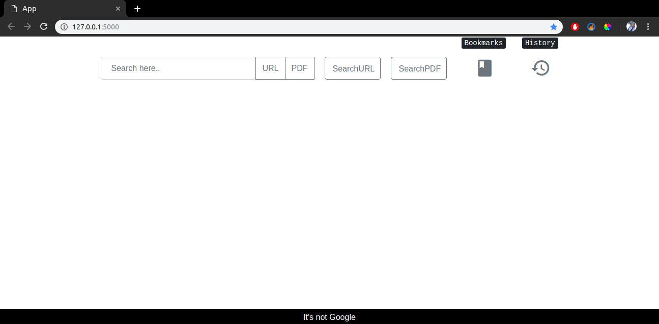

(main page)

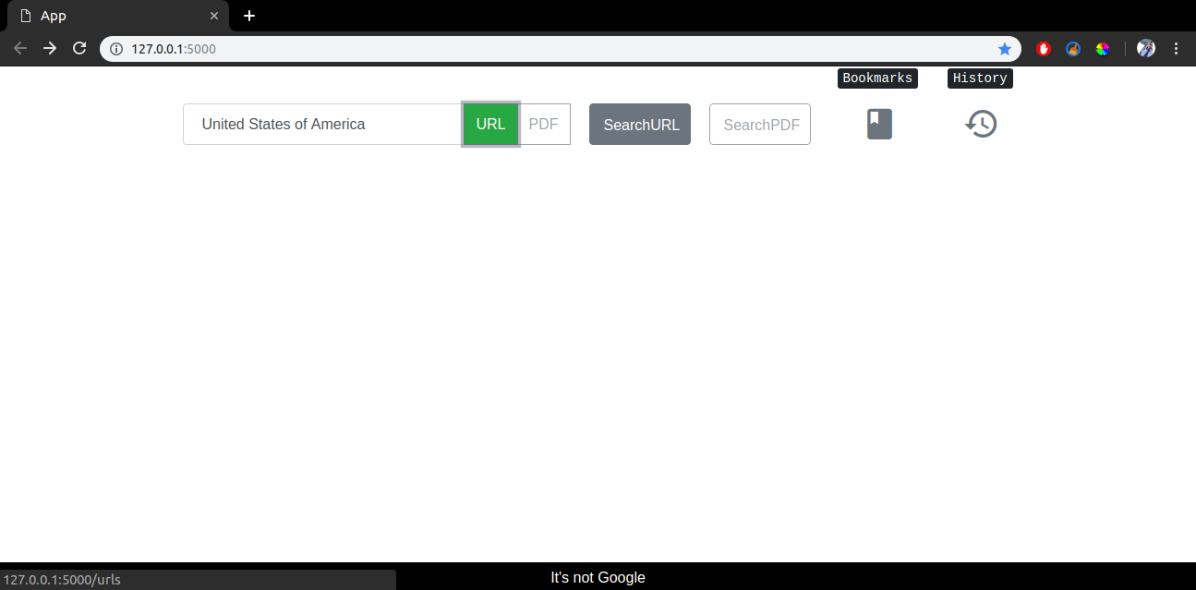

(searching for URLs)

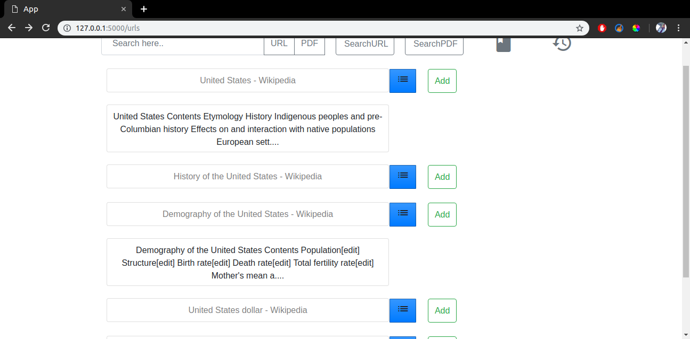

(displaying URL results)

1. for PDFs, select "PDF" option and click on "SelectPDF" button (see the screenshot)

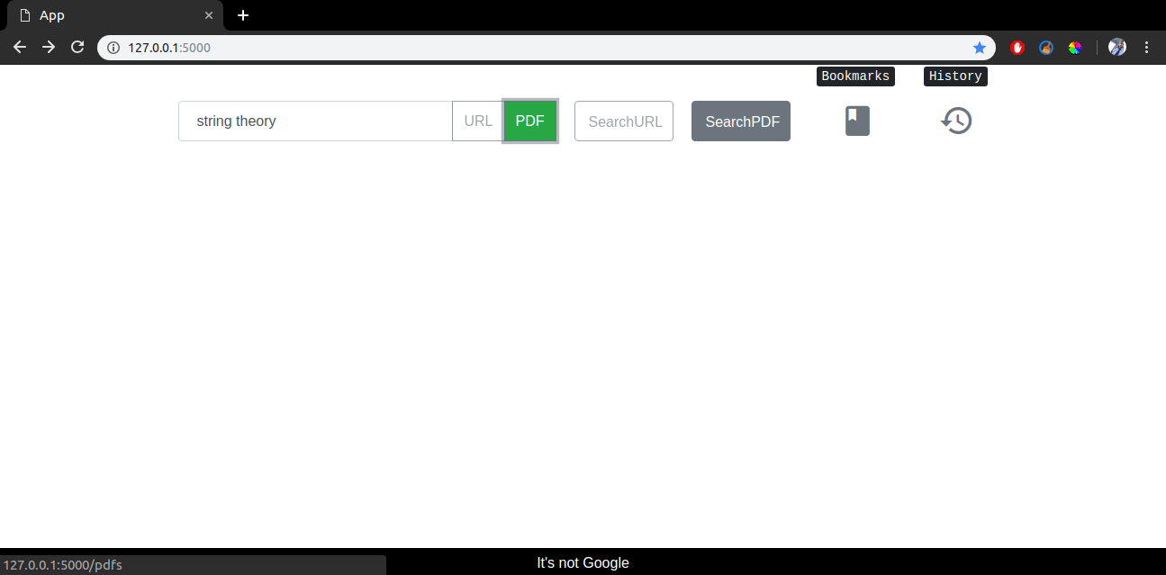

(searching for PDFs)

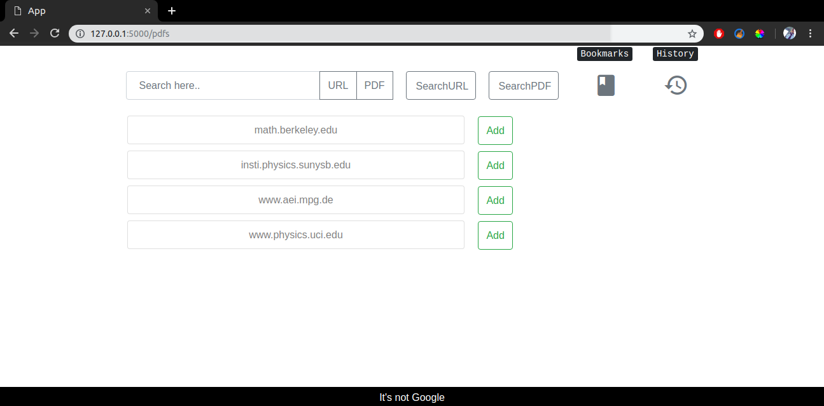

(displaying PDF results)

3) clicking on "ADD" button, saves the result in bookmarks (see the screenshot)

4) clicking on "Bookmarks" icon will show Bookmarks (see the screenshot)

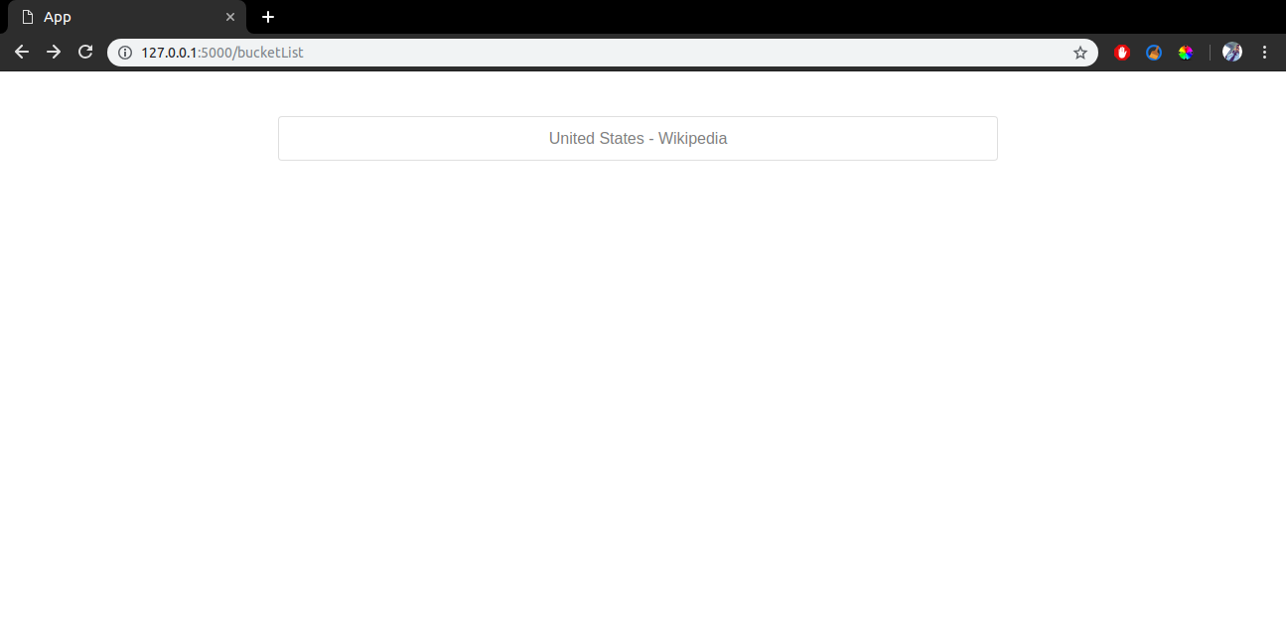

(displaying bookmarks)

5) any generated search results will be saved in "History" along with the date and time of its search (see the screenshot)

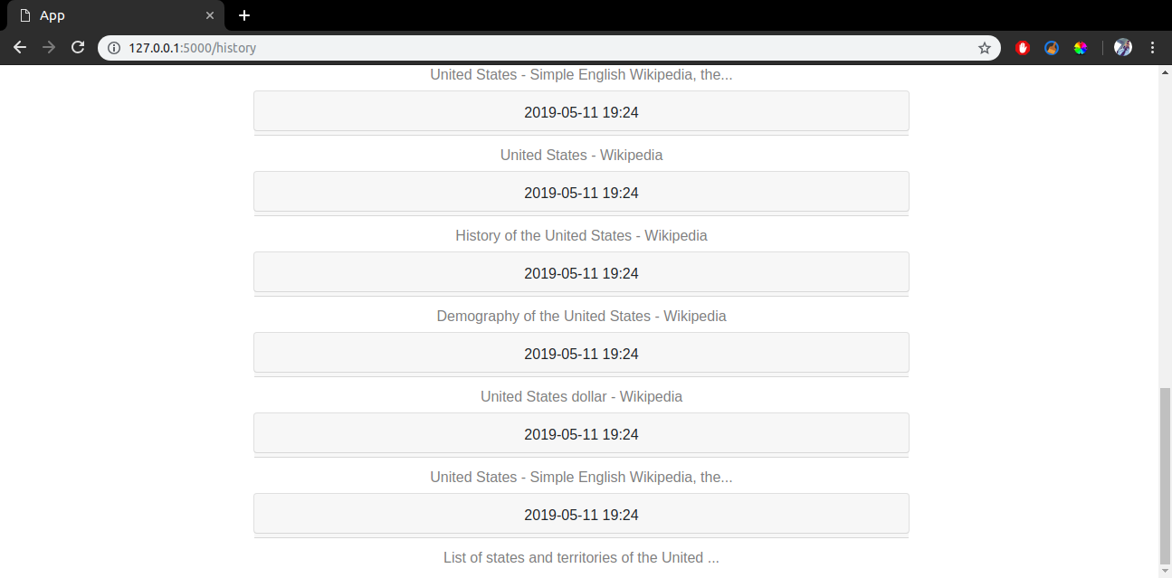

(history. It also contains my previously searched terms)