Statistical Analysis of Basketball Players’ Performance for the NBA season of 2018-19 (Tables and Graphs)

Author: Himesh Buch

Submitted to: Lynn A. Agre, MPH, PhD

Statistics 467/567

July 27, 2020

# Tables:

Table 1: Understanding the dataset on a high level

|  |  |  |
| --- | --- | --- |
| **Variables** | **Type** | **Sample** |
| Name | Factor | w/ 521 levels "Aaron Gordon",..: 8 405 235 451 34 114 319 411 183 231 ... |
| Height | int | 78 79 74 84 82 79 83 77 77 83 ... |
| Weight | int | 200 240 190 265 255 200 260 225 198 237 ... |
| Team | Factor | w/ 31 levels "","Atlanta Hawks",..: 22 25 2 22 17 1 28 1 30 4 ... |
| Age | int | 25 28 22 25 21 21 33 21 23 20 ... |
| Points | num | 5.3 1.7 3.2 13.9 8.9 1.7 21.3 3.7 5.6 10.9 ... |
| Blocks | num | 0.2 0.4 0.1 1 0.8 0.2 1.3 0 0.2 1.5 ... |
| Steals | num | 0.5 0.1 0.4 1.5 0.9 0.1 0.5 0.1 0.2 0.5 ... |
| Assists | num | 0.6 0.8 1.9 1.6 2.2 0.3 2.4 1.3 0.7 1.4 ... |
| Rebounds | num | 1.5 2.5 1.8 9.5 7.3 1 9.2 2.6 0.6 8.4 ... |
| FT. | num | 0.923 0.7 0.778 0.5 0.735 1 0.847 0.667 0.75 0.709 ... |
| FG. | num | 0.357 0.222 0.345 0.595 0.576 0.306 0.519 0.333 0.376 0.59 ... |

Table 2: Range and Standard Deviation of each variables

|  |  |  |
| --- | --- | --- |
| **Variables** | **Range** | **Standard Deviation** |
| Points | 36.1 | 6.085559 |
| Blocks | 2.7 | 0.4057938 |
| Steals | 2.2 | 0.4125885 |
| Assists | 10.7 | 1.776774 |
| Rebounds | 15.6 | 2.527316 |
| FT.(%) | NA | NA |
| FG.(%) | NA | NA |
| PER | 118.4 | 7.058072 |

Table 3: skewness of each variable

|  |  |
| --- | --- |
| **Variables** | **Skewness** |
| Points | 1.14982 |
| Blocks | 2.117004 |
| Steals | 0.9517342 |
| Assists | 1.754693 |
| Rebounds | 1.42078 |
| FT.(%) | NA |
| FG.(%) | NA |
| PER | 0.9631039 |

Table 4: R output of covariance matrix:

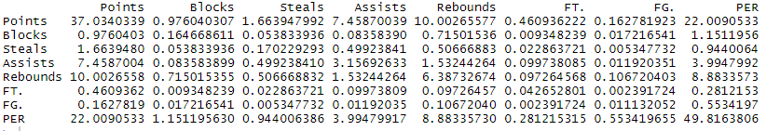

Table 5: R output of correlation matrix:

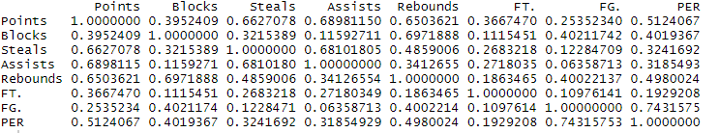

Table 6: R output of the variance

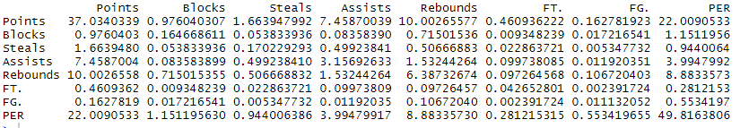

Table 7: R output for the correlation matrix

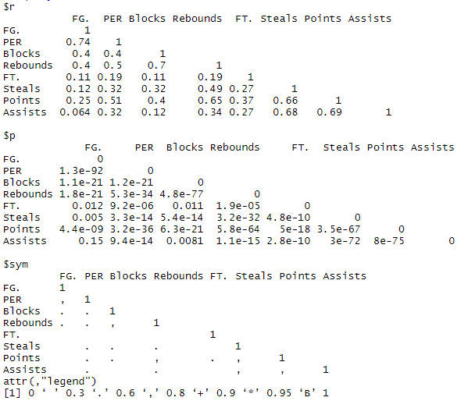

Table 8: R output of the Summary command,

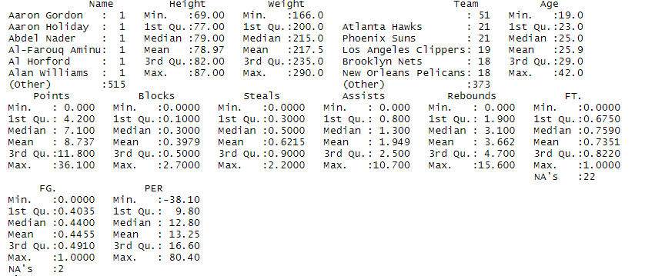

Table 9: Linear regression model for response variable Player Efficiency Rating

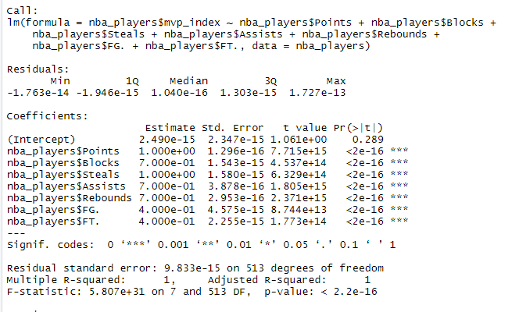

Table 10: Players and their mvp_index according to the new formula and analysis

|  |  |
| --- | --- |
| Player | MVP Index |
| James Harden | 48.9884 |
| Giannis Antetokounmpo | 43.4528 |
| Joel Embiid | 42.1552 |
| LeBron James | 41.35 |
| Russell Westbrook | 40.8436 |

Table 11: Players and their defender_index according to the formula and analysis

|  |  |
| --- | --- |
| Player | Defender Index |
| Russell Westbrook | 17.9224 |
| Giannis Antetokounmpo | 15.9716 |
| Andre Drummond | 15.536 |
| Anthony Davis | 15.4476 |
| Nikola Jokic | 15.0316 |

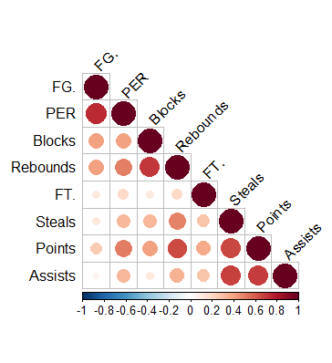 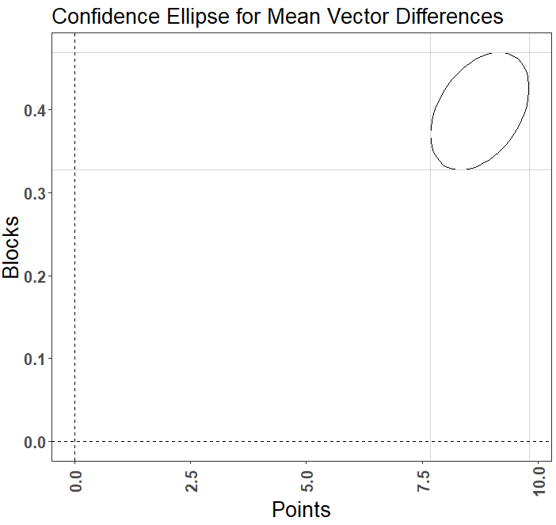

Figure 2: Hotellings T2 Confidence Intervals

Figure 1: Correlation matrix graph for bivariate analysis

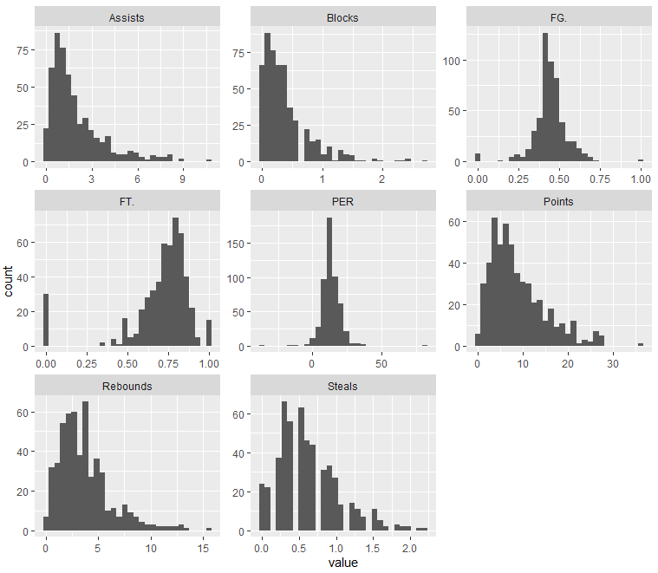

Figure 3: All plots for the numeric values in the dataset

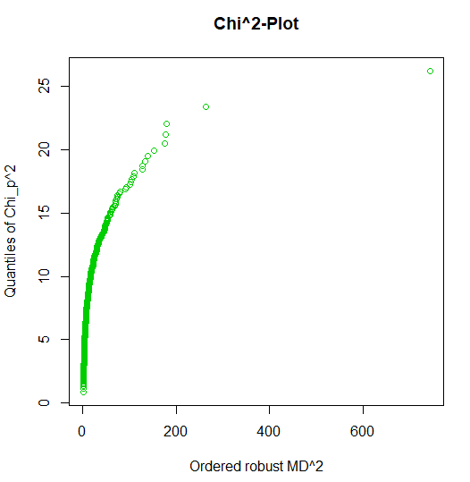

Figure 4: Chi square plot for PP-plot

# Univariate Graphs for variable Points:

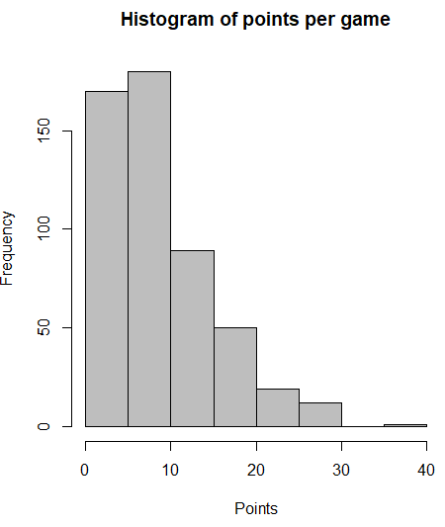 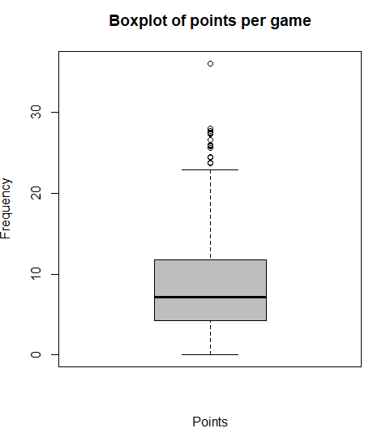

Figure 6: Boxplot of points per game scored by each player

Figure 5: Histogram of points per game scored by each player

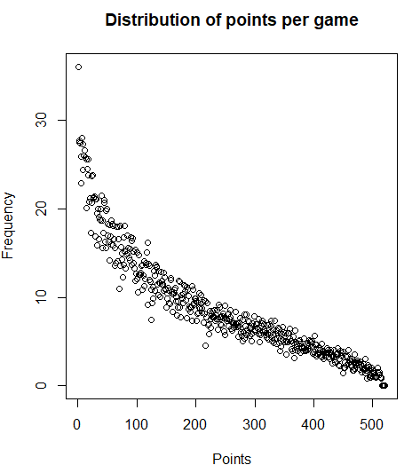 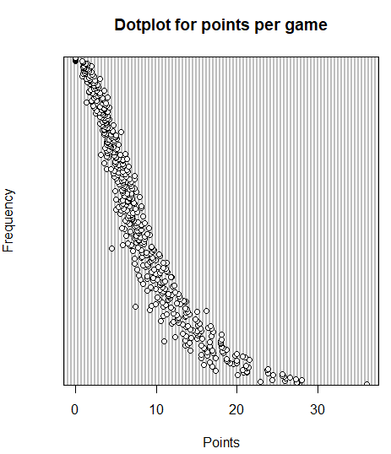

Figure 8: Dot plot of points per game scored by each player

Figure 7: Rough distribution of points per game scored by each player

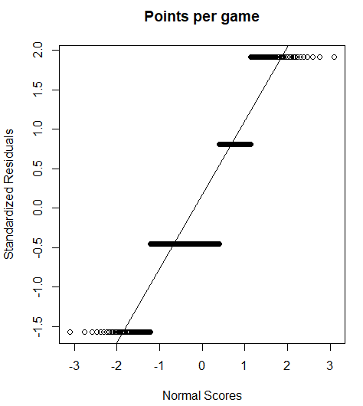 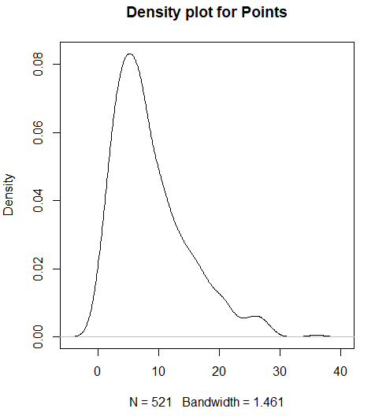

Figure 10: Density plot of points per game scored by each player

Figure 9: Normal probability plot of points per game scored by each player

# Univariate Graphs for variable Blocks:

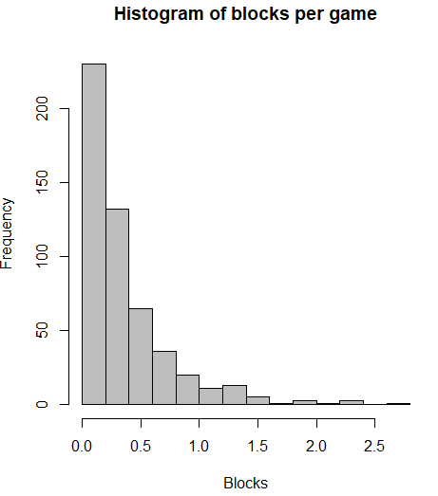 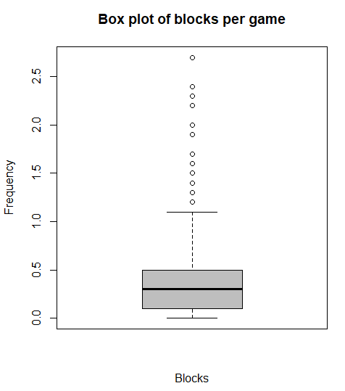

Figure 12: Box plot of blocks per game scored by each player

Figure 11: Histogram of blocks per game scored by each player

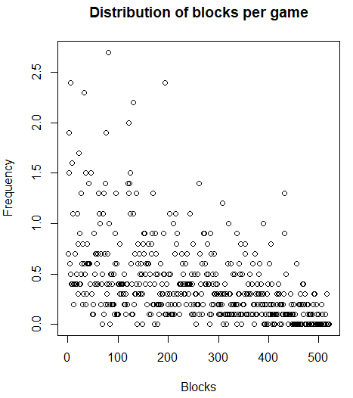 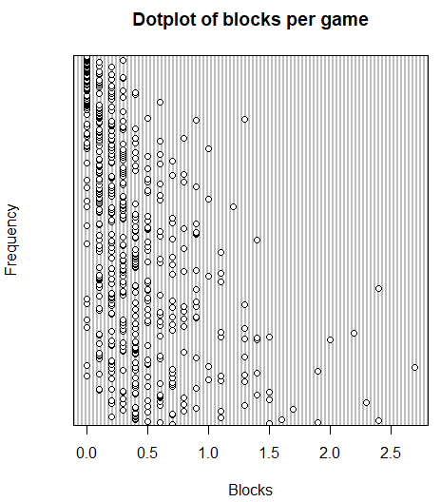

Figure 14: Dot plot of blocks per game scored by each player

Figure 13: Rough distribution of blocks per game scored by each player

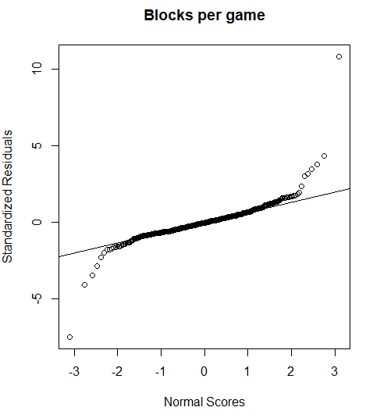 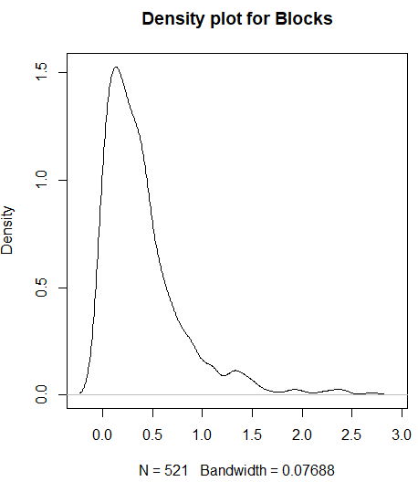

Figure 16: Density plot of blocks per game scored by each player

Figure 15: Normal probability plot of blocks per game scored by each player

# Univariate Graphs for variable Steals:

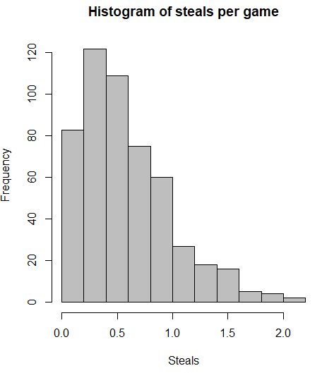 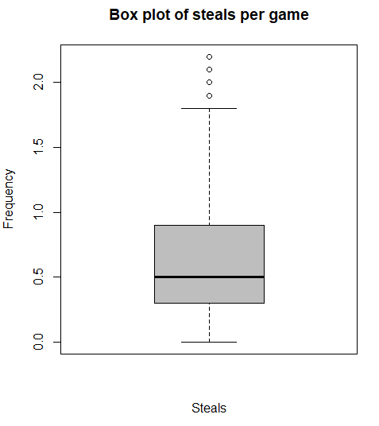

Figure 18: Box plot of steals per game scored by each player

Figure 17: Histogram of steals per game scored by each player

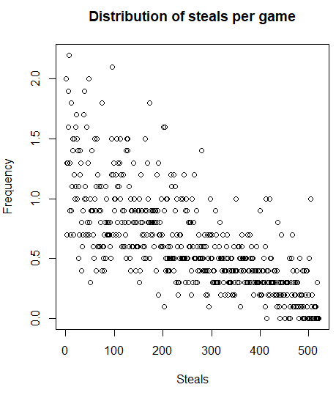 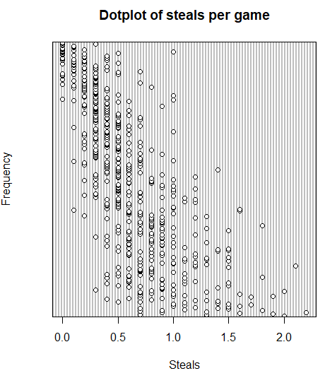

Figure 19: Rough distribution of steals per game scored by each player

Figure 20: Dot plot of steals per game scored by each player

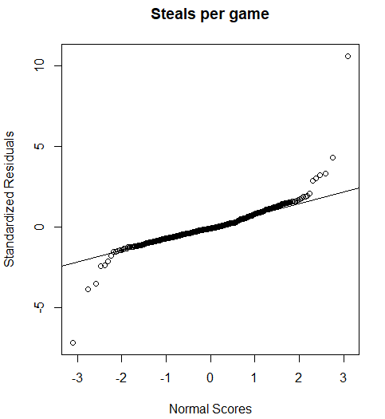 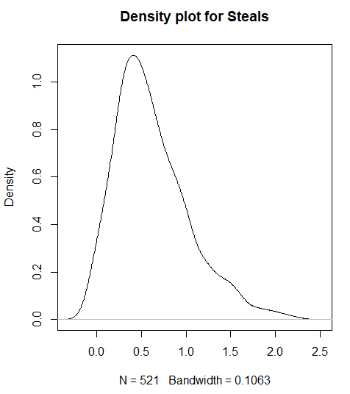

Figure 22: Density plot of steals per game scored by each player

Figure 21: Normal probability distribution of steals per game scored by each player

# Univariate Graphs for variable Assists:

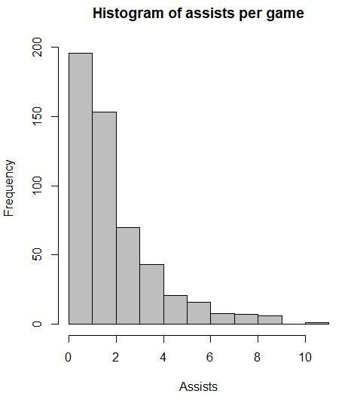 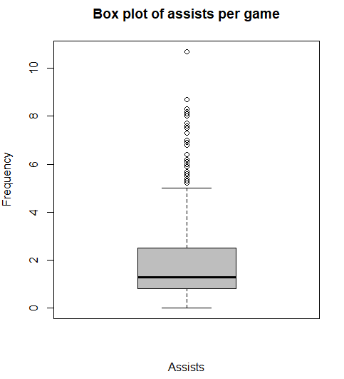

Figure 24: Box plot of assists per game scored by each player

Figure 23: Histogram of assists per game scored by each player

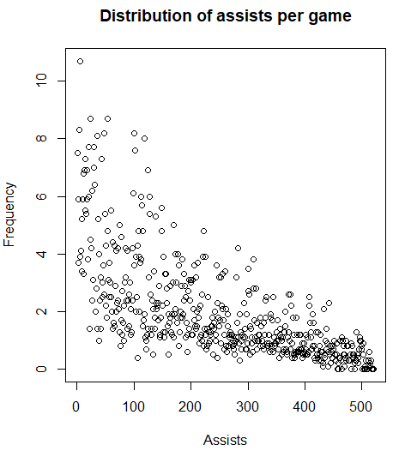 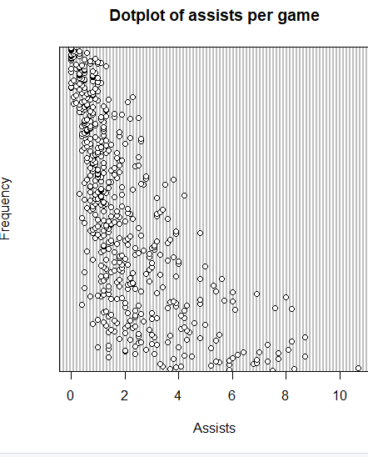

Figure 26: Dot plot of assists per game scored by each player

Figure 25: Rough distribution of assists per game scored by each player

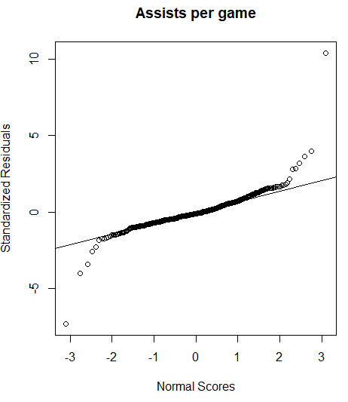 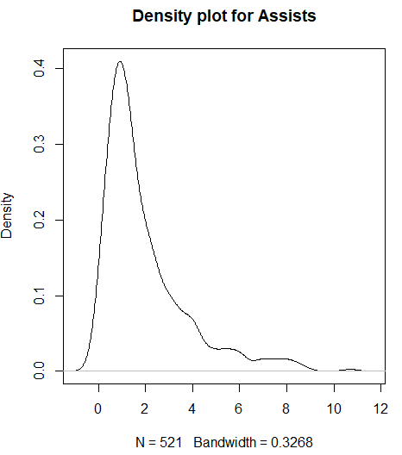

Figure 28: Density plot of assists per game scored by each player

Figure 27: Normal probability distribution of assists per game scored by each player

# Univariate Graphs for variable Rebounds:

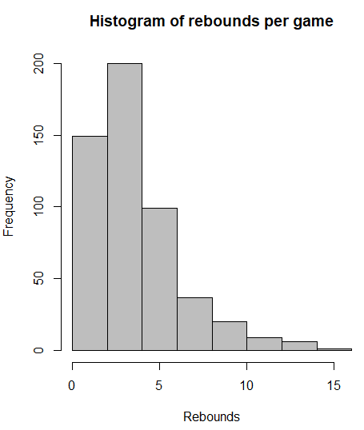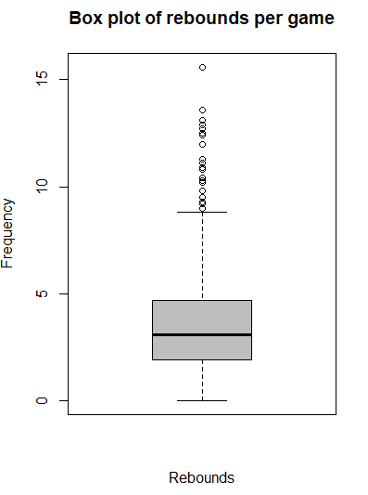

Figure 30: Box plot of rebounds per game scored by each player

Figure 29: Histogram of rebounds per game scored by each player

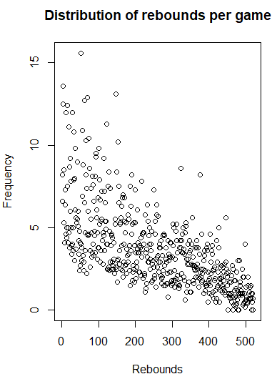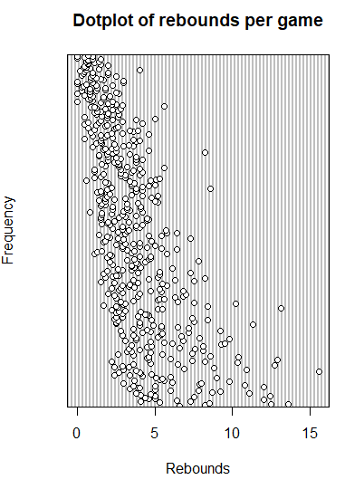

Figure 32: Dot plot of rebounds per game scored by each player

Figure 31: Rough distribution of rebounds per game scored by each player

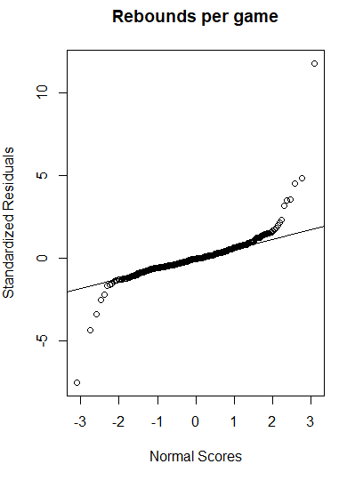 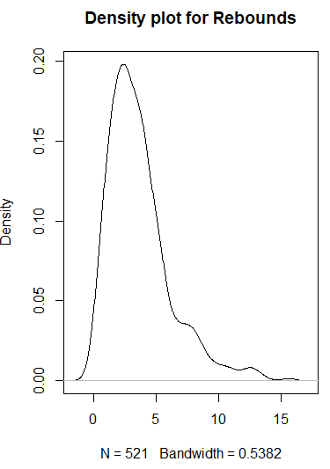

Figure 34: Density plot of rebounds per game scored by each player

Figure 33: Normal probability distribution of rebounds per game scored by each player

# Univariate Graphs for variable Free throw %:

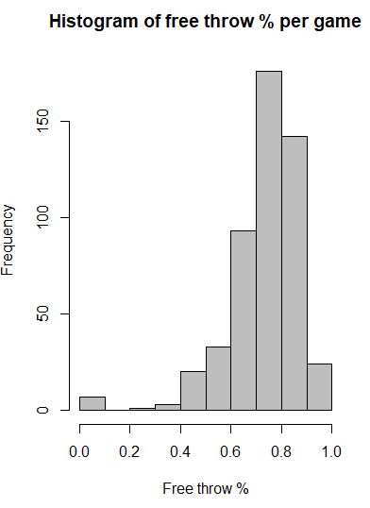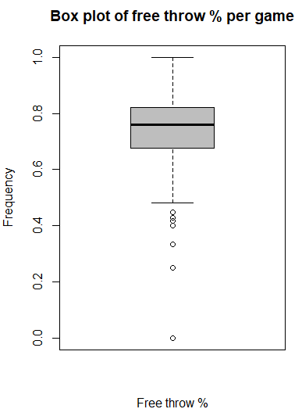

Figure 36: Box plot of free throw percentage per game scored by each player

Figure 35: Histogram of free throw percentage per game scored by each player

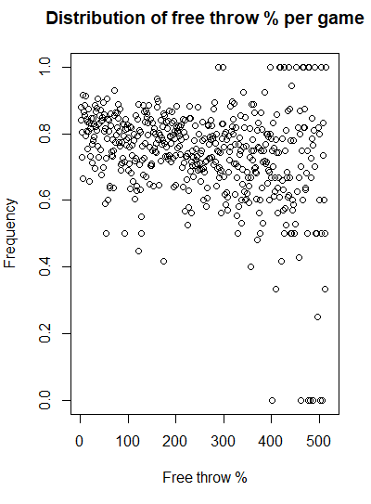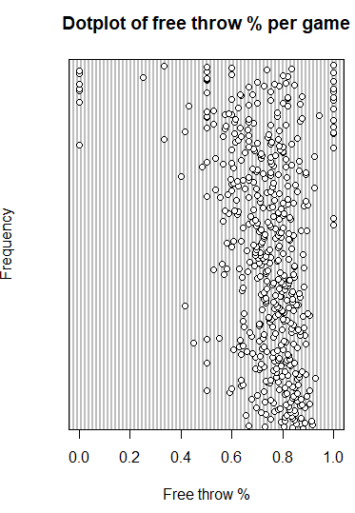

Figure 38: Dot plot of free throw percentage per game scored by each player

Figure 37: Rough distribution of free throw percentage per game scored by each player

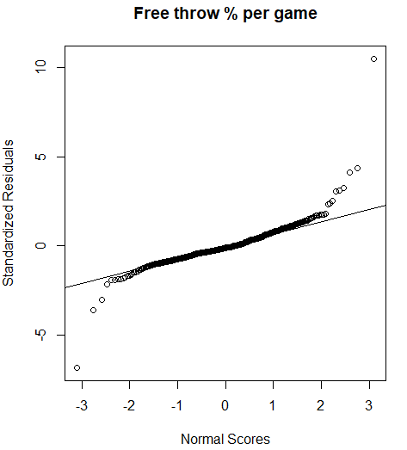 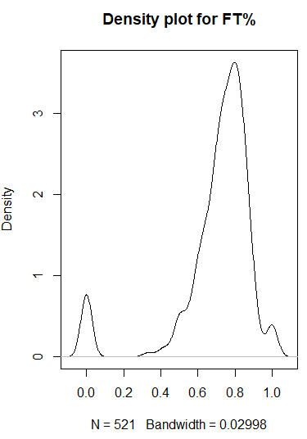

Figure 40: Density plot of free throw percentage per game scored by each player

Figure 39: Histogram of free throw percentage per game scored by each player

# Univariate Graphs for variable Field goal %:

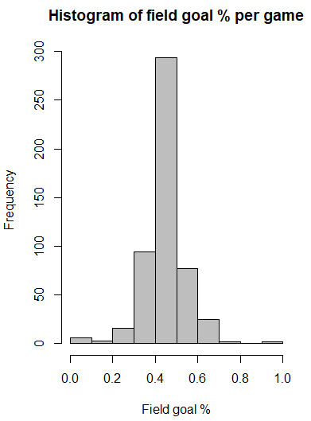 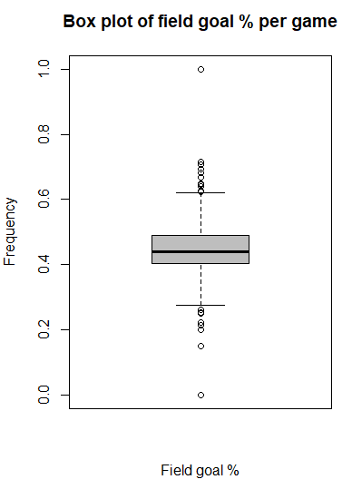

Figure 42: Box plot of field goal percentage per game scored by each player

Figure 41: Histogram of field goal percentage per game scored by each player

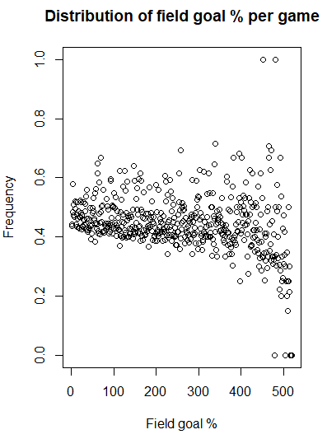 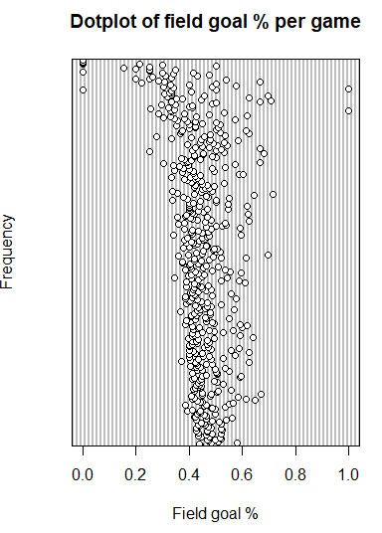

Figure 44: Dot plot of field goal percentage per game of each player

Figure 43: Rough distribution of field goal percentage per game of each player

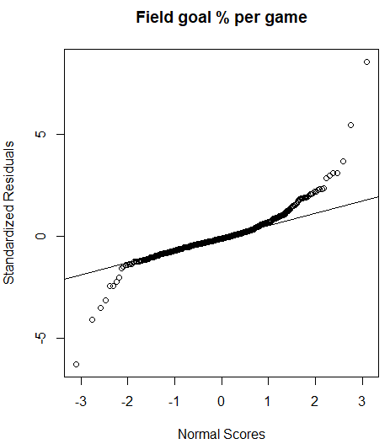 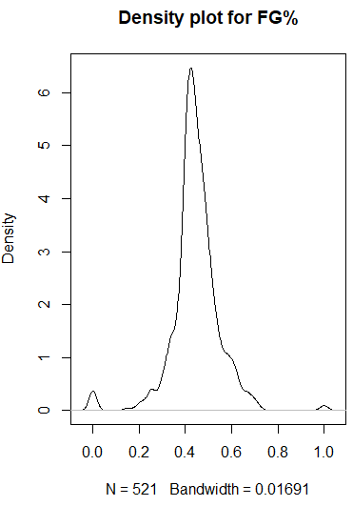

Figure 46: Density plot of field goal percentage per game of each player

Figure 45: Normal probability distribution of field goal percentage per game of each player

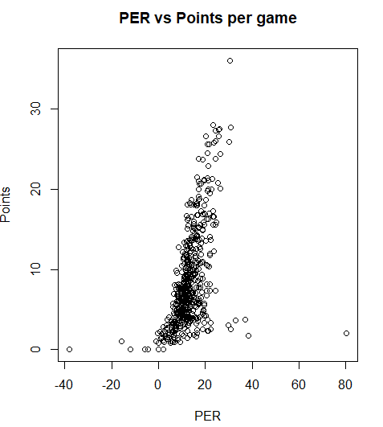 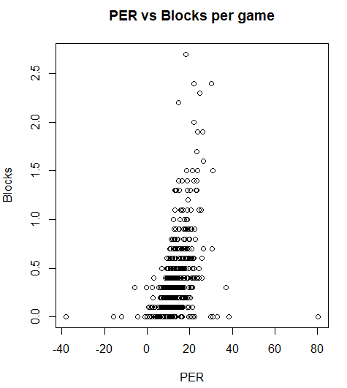

Figure 47: Scatter plot of points vs PER per game of each player

Figure 48: Scatter plot of blocks vs PER per game of each player

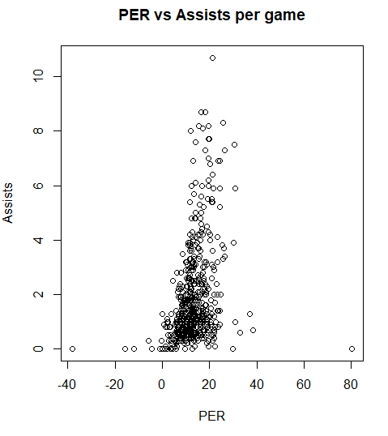 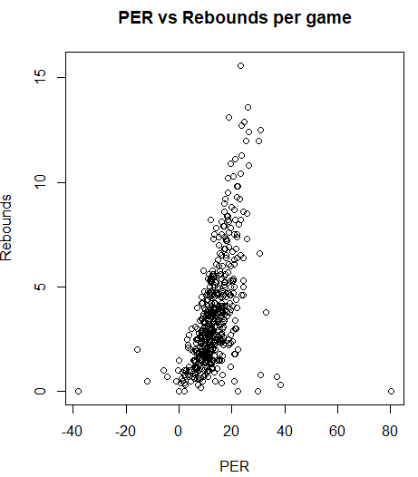

Figure 50: Scatter plot of rebounds vs PER per game of each player

Figure 49: Scatter plot of assists vs PER per game of each player

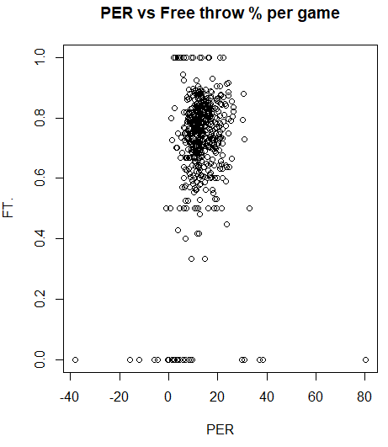 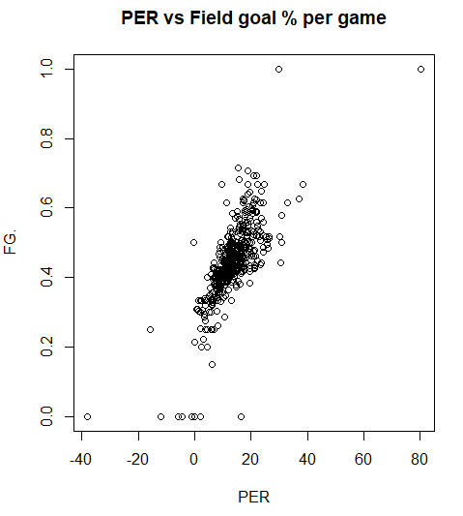

Figure 51: Scatter plot of free throw percentage vs PER per game of each player

Figure 52: Scatter plot of field goal percentage vs PER per game of each player

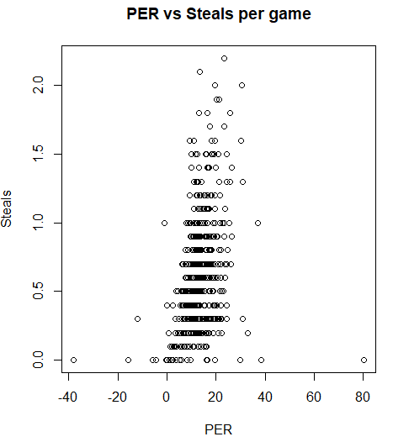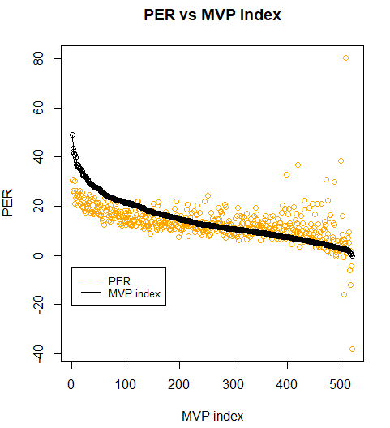

Figure 54: Comparison of PRE and MVP index for players

Figure 53: Scatter plot of steals vs PER per game of each player