* Here are the two graphs with span of 0.2 and 0.8 respectively

(span of 0.2)

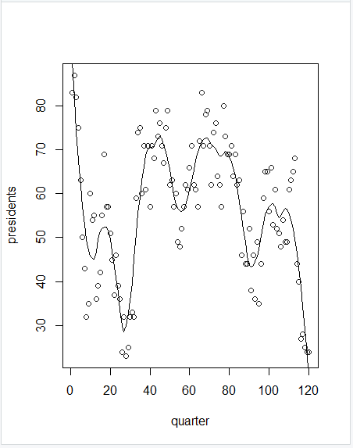

(span of 0.8)

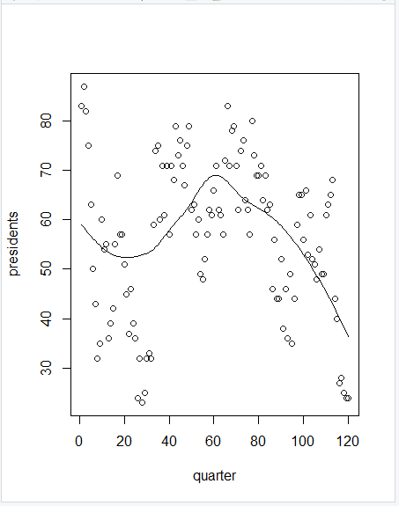

A higher span smooths out the fit more, while a lower span captures more trends but introduces statistical noise if there is too little data. And thus, we will choose the option with larger span, 0.8 in this case.

* We would like to choose a value for h where CV is the lowest, meaning the error will be lowest at that h