# Ergodicity Economics and Consumer Preferences Under Additive and Compound Wealth Growth

## Project overview:

This is a research project that was done by the department of economics. I worked with Professor Barry Sopher (Professor of Economics and Undergraduate Program Director) and did some regression analysis on the data that we got from the experiment. Here are some things that might help you understand the experiment.

Note that this entire project was done in the past couple of months (the experiment was done in February), and this is not the work of several years, so the regression methods I learnt in the class were very useful and thus, implemented here.

## What am I submitting?

I wrote all my code in R, and to make it more interactive, meaning, in order to show both the commands and its output I used Google Collaborator. I will be submitting the actual collaborator file (analysis.ipynb), its pdf version (analysis.pdf), along with the graphs (graphs folder) and the R script that generated those graphs (regression_graphs.R). A file containing all the methods I considered in analyzing the data (methods.txt) is also attached.

## Peek at the data:

I am not allowed to share the entire data file, but I have attached data.xlsx file to give you a basic understanding on what the data looked like

## Understanding Economic Theory:

Economic theory has traditionally treated time discounting, or the devaluation in one’s mind of future payoffs compared to present ones, as part of a decision maker’s preferences. A new literature, sometimes referred to as “Ergodicity Economics,” focuses on alternate decision-making models under which time discounting is dependent on environmental factors rather than individual preferences. In this study, we begin an investigation of a new model that predicts decision makers will maximize the likelihood of a positive rate of growth in wealth. We consider the choice between two payment plans under two different environments. Option A is a plan of small but frequent payments, while Option B is a plan of larger payments over longer intervals, both options ending after a fixed number of days. The first environment is one without interest rates, while the second is with compounding interest on the current balance of each account

## What is the problem?

## Objective

Specific objective is to compare the choices made when the wealth generation is a simple additive process versus when wealth generation is a more complex multiplicative process with compound interest. For both additive and multiplicative processes, as the interval between payments is increased for both the more and less frequent payment processes, there is a switch point at which the larger, less frequent payment is preferred to the smaller, more frequent payment scheme. But the switch-over point is at a longer interval for the multiplicative process.

## How did I solve the problem?

## Experiment:

Participants were invited into a laboratory where they answered a 21-question survey. Each question let the participants selected their preference or indifference between options A and B, as demarcated in the theory. These questions were selected such that participants should be indifferent when the “horizon”, (symbolized H), or the difference between the interval between accumulations of A and accumulations of B, was equal to 4. There were two surveys in use: one where participants could earn interest on their earnings during each interval (Multiplicative), and one where they would not (Additive). Each group was randomly selected to participate in either multiplicative or additive surveys. Decision makers were also given the option of receiving their payment in 10 days by participating in a lottery that could lower their total earnings. The smaller the total they were willing to accept, the more likely that they’d receive that total early

## Basic Idea:

The coefficients in the regression can all be interpreted in probability units, as we have regressed choice (which is either 0 or 1, meaning the subject choice option A or option B, resp., or coded as .5 (not common), meaning they were not sure. The regressors are a constant term and indicator variables for the different values of H, the "horizon." Note that the lowest value of H is not included. That is, the lowest value of H is part of the constant term, and for any other value of H, it's contribution to the probability of choosing option B is just added to the constant term to get the overall prob of choosing B at that value of H. Graphing the estimated value of the Prob of choosing B (vertical) against H (horizon) is what I have done.

## What did I do?

My main job was to do regression analysis and basically see what variables mattered the most and eventually see how the probability of choosing option B changes with the horizon. I used R to do most of the regression analysis.

## Who helped me out?

As mentioned above, Professor Barry Sopher helped me out in understanding the Economics concepts, but the regression analysis is done solely by me

## Whose work did I refer to?

In understanding the concepts and designing the experiment, we used a paper called “Micro foundation of Economics” by Alexander Adamou, Yonatan Berman, Diomides Mavroyiannis, and Ole Peters. It was published on July 3, 2019.

## What did I find out?

Overall, the results showed that the model correctly predicts that a horizon of 4 days results in preference for option B, as seen in the graph below.

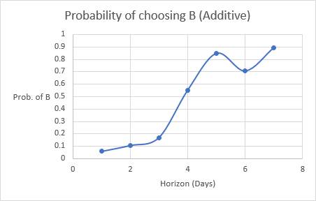

The results were most consistent with predictions in the additive case rather than the multiplicative case. Though less sharply consistent, the results of the second environment, the compound processes, were still broadly consistent with the predicted answers of the questions. The difficulty in calculating with the inclusion of an interest rate likely contributed to this result.

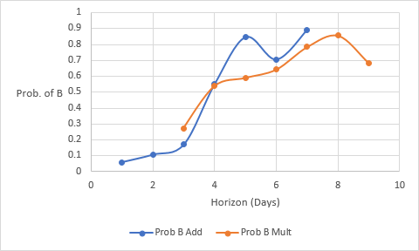

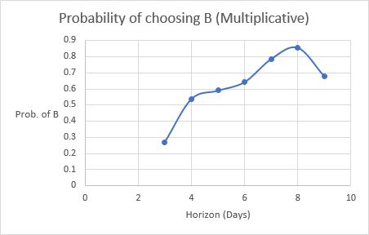

The data generated by the early payment option lottery has not yet been analyzed in detail, though we believe these results will reflect factors relating to uncertainty rather than an indication of a pure time preference.

In simpler terms, the whole purpose of the experiment was to see how the choice preference is affected by the factors like Horizon. The multiplicative process is more interesting to look at than additive as it is hard to do those calculations in head. We realized that the probability of choosing option B, which is more money than option A, increases as the Horizon increases. Meaning, for a question, what will you choose if you are given $10 now or $20 after a week with a compound interest of 3% for that month, the horizon here is a week, which is 7 days. As explained above, as this number (7 from the example) increases, probability of choosing option B increases as well, meaning people will tend to choose the option with that offers more money