|  |
| --- |
| > library(faraway)  > library(glmnet) # include glmnet library including functions for LASSO  Loading required package: Matrix  Loaded glmnet 3.0-2  >  > # glmnet requires the x matrix and the response vector  >  > hw14x <- as.matrix(meatspec[,-101]) #creates the x matrix for all 100 predictors V1-V100  > hw14y <- meatspec[, 101] #creates the y vector  >  > lassomod <- glmnet(hw14x,hw14y)  > plot(lassomod)  > print(lassomod)  Call: glmnet(x = hw14x, y = hw14y)  Df %Dev Lambda  1 0 0.00000 6.5840  2 1 0.04555 5.9990  3 1 0.08337 5.4660  4 1 0.11480 4.9800  5 1 0.14080 4.5380  6 1 0.16250 4.1350  7 1 0.18040 3.7670  8 1 0.19540 3.4330  9 1 0.20770 3.1280  10 1 0.21800 2.8500  11 1 0.22650 2.5970  12 1 0.23360 2.3660  13 1 0.23950 2.1560  14 1 0.24440 1.9640  15 1 0.24850 1.7900  16 1 0.25180 1.6310  17 1 0.25460 1.4860  18 1 0.25690 1.3540  19 1 0.25890 1.2340  20 1 0.26050 1.1240  21 1 0.26180 1.0240  22 1 0.26290 0.9332  23 3 0.34690 0.8503  24 4 0.43180 0.7748  25 4 0.50260 0.7059  26 4 0.56120 0.6432  27 3 0.61050 0.5861  28 4 0.65100 0.5340  29 4 0.68480 0.4866  30 5 0.71300 0.4434  31 5 0.73650 0.4040  32 9 0.76200 0.3681  33 10 0.78520 0.3354  34 7 0.80720 0.3056  35 9 0.82330 0.2784  36 12 0.83680 0.2537  37 7 0.85200 0.2312  38 8 0.86160 0.2106  39 9 0.86980 0.1919  40 8 0.87950 0.1749  41 7 0.88670 0.1593  42 8 0.89150 0.1452  43 8 0.89580 0.1323  44 7 0.90080 0.1205  45 8 0.90350 0.1098  46 8 0.90590 0.1001  47 9 0.90970 0.0912  48 8 0.91260 0.0831  49 10 0.91390 0.0757  50 10 0.91500 0.0690  51 11 0.91740 0.0628  52 9 0.92070 0.0573  53 10 0.92130 0.0522  54 12 0.92190 0.0475  55 12 0.92240 0.0433  56 8 0.92620 0.0395  57 11 0.92630 0.0360  58 13 0.92670 0.0328  59 14 0.92690 0.0299  60 14 0.92710 0.0272  61 17 0.92740 0.0248  62 15 0.93000 0.0226  63 16 0.93220 0.0206  64 17 0.93400 0.0188  65 17 0.93540 0.0171  66 18 0.93680 0.0156  67 18 0.93790 0.0142  68 22 0.93790 0.0129  69 20 0.93940 0.0118  70 22 0.93940 0.0107  >  > cvfit <- cv.glmnet(hw14x,hw14y)  > plot(cvfit)  > cvfit$lambda.min  [1] 0.01072971  > coef(cvfit,s="lambda.min") #variables with non-zero coefficients should be included in the LASSO model  101 x 1 sparse Matrix of class "dgCMatrix"  1  (Intercept) 23.326350487  V1 46.281285337  V2 .  V3 .  V4 .  V5 .  V6 .  V7 .  V8 .  V9 .  V10 .  V11 .  V12 .  V13 .  V14 -46.391774856  V15 -24.146945092  V16 -13.805976630  V17 -19.081269221  V18 -12.459335443  V19 -5.282139705  V20 -5.498186144  V21 -1.928623138  V22 -0.905030775  V23 -0.513157794  V24 -2.978587676  V25 .  V26 .  V27 .  V28 .  V29 .  V30 .  V31 .  V32 .  V33 .  V34 .  V35 .  V36 .  V37 .  V38 .  V39 0.002004740  V40 2.924055012  V41 139.783700920  V42 .  V43 .  V44 .  V45 .  V46 .  V47 .  V48 .  V49 -0.001367663  V50 -0.176612219  V51 -30.427759255  V52 -33.872229538  V53 .  V54 .  V55 .  V56 .  V57 .  V58 .  V59 .  V60 .  V61 .  V62 .  V63 .  V64 .  V65 .  V66 .  V67 .  V68 .  V69 .  V70 .  V71 .  V72 .  V73 .  V74 .  V75 .  V76 .  V77 .  V78 .  V79 .  V80 .  V81 .  V82 .  V83 .  V84 .  V85 .  V86 .  V87 .  V88 .  V89 .  V90 .  V91 .  V92 .  V93 .  V94 .  V95 .  V96 .  V97 .  V98 0.681081905  V99 3.400822628  V100 0.912022252  >  >  > hw14x_2 <- as.matrix(meatspec[,1:30]) #includes the the first 30 variables V1 - V30  > hw14y_2 <- meatspec[, 101] #creates the y vector  >  > lassomod_2 <- glmnet(hw14x_2,hw14y_2)  > plot(lassomod_2)  > print(lassomod_2)  Call: glmnet(x = hw14x_2, y = hw14y_2)  Df %Dev Lambda  1 0 0.00000 5.6150  2 1 0.03313 5.1160  3 1 0.06063 4.6610  4 1 0.08346 4.2470  5 1 0.10240 3.8700  6 1 0.11820 3.5260  7 1 0.13120 3.2130  8 1 0.14210 2.9270  9 1 0.15110 2.6670  10 1 0.15860 2.4300  11 1 0.16480 2.2150  12 1 0.16990 2.0180  13 1 0.17420 1.8390  14 1 0.17770 1.6750  15 1 0.18070 1.5260  16 1 0.18310 1.3910  17 1 0.18520 1.2670  18 1 0.18690 1.1550  19 1 0.18830 1.0520  20 1 0.18940 0.9586  21 1 0.19040 0.8734  22 1 0.19120 0.7959  23 1 0.19190 0.7251  24 1 0.19240 0.6607  25 1 0.19290 0.6020  26 1 0.19330 0.5485  27 1 0.19360 0.4998  28 4 0.23440 0.4554  29 3 0.32950 0.4150  30 3 0.40710 0.3781  31 4 0.47140 0.3445  32 3 0.52970 0.3139  33 3 0.57530 0.2860  34 4 0.61300 0.2606  35 4 0.64520 0.2375  36 3 0.67740 0.2164  37 4 0.69970 0.1971  38 4 0.71850 0.1796  39 4 0.73720 0.1637  40 3 0.75390 0.1491  41 4 0.76490 0.1359  42 4 0.77400 0.1238  43 4 0.78550 0.1128  44 4 0.79510 0.1028  45 4 0.80020 0.0937  46 4 0.80470 0.0853  47 4 0.80850 0.0778  48 5 0.81760 0.0708  49 4 0.82160 0.0646  50 4 0.82340 0.0588  51 4 0.82530 0.0536  52 4 0.82690 0.0488  53 5 0.83440 0.0445  54 4 0.83630 0.0405  55 6 0.83880 0.0369  56 6 0.84450 0.0337  57 7 0.84930 0.0307  58 7 0.85330 0.0279  59 7 0.85660 0.0255  60 7 0.85940 0.0232  61 8 0.86180 0.0211  62 7 0.86420 0.0193  63 7 0.86590 0.0176  64 7 0.86730 0.0160  65 8 0.86850 0.0146  66 8 0.86950 0.0133  67 8 0.87040 0.0121  68 8 0.87110 0.0110  69 9 0.87170 0.0100  70 9 0.87220 0.0092  71 9 0.87260 0.0083  72 10 0.87300 0.0076  73 10 0.87330 0.0069  74 10 0.87360 0.0063  75 12 0.87380 0.0057  76 12 0.87400 0.0052  77 12 0.87420 0.0048  78 12 0.87440 0.0043  79 12 0.87450 0.0040  80 14 0.87470 0.0036  81 14 0.87480 0.0033  82 15 0.87490 0.0030  83 15 0.87500 0.0027  84 16 0.87500 0.0025  85 16 0.87510 0.0023  86 18 0.87510 0.0021  87 19 0.87510 0.0019  88 20 0.87520 0.0017  89 21 0.87520 0.0016  90 22 0.87530 0.0014  91 22 0.87530 0.0013  92 24 0.87530 0.0012  93 24 0.87540 0.0011  94 24 0.87540 0.0010  95 25 0.87540 0.0009  96 25 0.87540 0.0008  97 25 0.87540 0.0007  98 26 0.87550 0.0007  99 26 0.87550 0.0006  100 26 0.87550 0.0006  >  > cvfit_2 <- cv.glmnet(hw14x_2,hw14y_2)  Warning messages:  1: from glmnet Fortran code (error code -82); Convergence for 82th lambda value not reached after maxit=100000 iterations; solutions for larger lambdas returned  2: from glmnet Fortran code (error code -68); Convergence for 68th lambda value not reached after maxit=100000 iterations; solutions for larger lambdas returned  3: from glmnet Fortran code (error code -95); Convergence for 95th lambda value not reached after maxit=100000 iterations; solutions for larger lambdas returned  4: from glmnet Fortran code (error code -74); Convergence for 74th lambda value not reached after maxit=100000 iterations; solutions for larger lambdas returned  > plot(cvfit_2)  > cvfit_2$lambda.min  [1] 0.0005614567  > coef(cvfit_2,s="lambda.min")  31 x 1 sparse Matrix of class "dgCMatrix"  1  (Intercept) 2.126504e+01  V1 1.301820e+02  V2 8.607730e+00  V3 9.192629e-01  V4 4.977477e-01  V5 3.606875e-01  V6 2.674593e-01  V7 1.582467e-01  V8 8.133827e-02  V9 3.955897e-03  V10 .  V11 .  V12 -6.165863e+00  V13 -2.117181e+02  V14 -9.495298e+01  V15 -3.040558e+01  V16 -5.466616e+01  V17 -7.436514e+00  V18 -5.492066e+00  V19 -3.764233e+00  V20 -2.701857e+00  V21 -9.047923e-01  V22 -1.052601e+01  V23 .  V24 .  V25 1.574325e-01  V26 3.789064e-01  V27 5.601517e-01  V28 1.195295e+00  V29 2.472871e+00  V30 2.723522e+02 |
|  |
| |  | | --- | | > | |

**PLOTS:**

**plot(lassomod):**

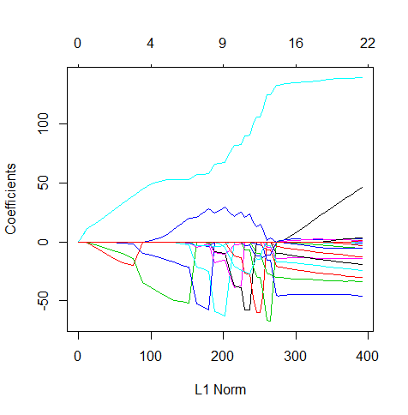

**plot(cvfit):**

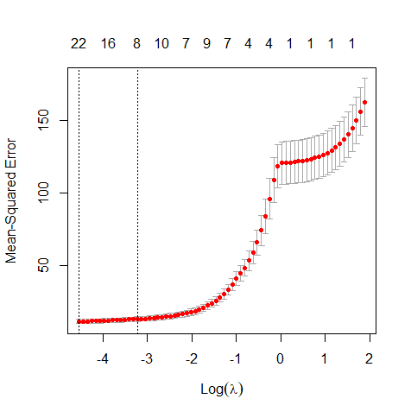

**plot(lassomod_2):**

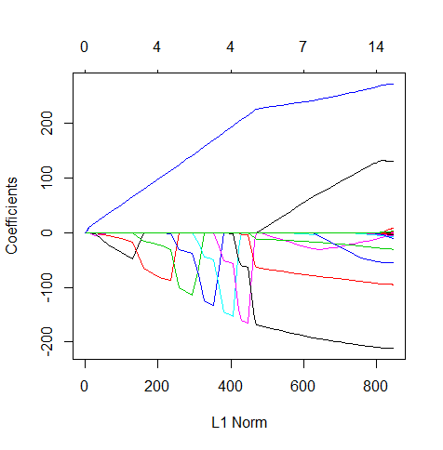

**plot(cvfit_2):**

