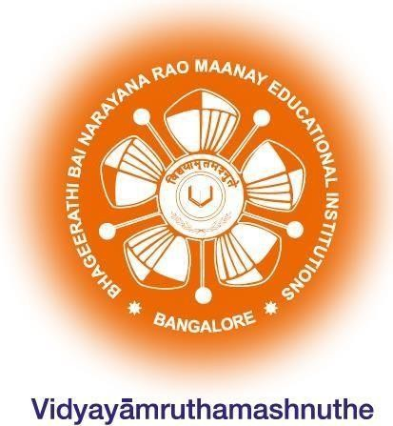B.N.M. Institute of Technology

An Autonomous Institution under VTU Department of Artificial Intelligence and Machine Learning

Internship Report on
BLOCKCHAIN & WEBTECHNOLOGY

Submitted in partial fulfillment for the award of degree of

Bachelor of Engineering
In

Artificial Intelligence and Machine Learning

Submitted by
K. PREETHAM YADAV(1BG23AI038)

2024-2025

B.N.M. Institute of Technology

An Autonomous Institution under VTU Department of Artificial Intelligence and Machine Learning

CERTIFICATE

Certified that the Internship Course on Blockchain and Web Technology carried out by K. Preetham Yadav USN 1BG23AI038 bonafide student of III Semester B.E., B.N.M Institute of Technology in partial fulfillment for the Bachelor of Engineering in ARTIFICIAL INTELLIGENCE AND MACHINE LEARNING of the Visvesvaraya Technological University, Belagavi during the year 2024-25. It is certified that all corrections / suggestions indicated for Internal Assessment have been incorporated in the report. The Internship report has been approved
as it satisfies the academic requirements.

Dr. Mahantesh Designation, Dept. of AIML  BNMIT, Bengaluru | Dr. Sheba Selvam  Professor and HOD  Dept. of AIML BNMIT, Bengaluru | Dr. S.Y. Kulkarni  Additional Director and  Principal BNMIT, Bengaluru

ACKNOWLEDGEMENT

The satisfaction and euphoria that accompany the successful completion of any task would be incomplete without the mention of the people who made it possible, whose constant guidance and encouragement crowned my effort with success.

I would like to thank Shri Narayan Rao R. Maanay, Secretary, BNMEI, Bengaluru for providing an excellent academic environment in the College.

I would like to sincerely thank Prof. T. J. Rama Murthy, Director, BNMIT, Bengaluru, for having extended his support and encouraging me during the course of the work.

I would like to sincerely thank Dr. S.Y. Kulkarni, Additional Director and Principal BNMIT, Bengaluru, for having extended his support and encouraging me during the course of the work.

I would like to express my gratitude to Prof. Eishwar N. Maanay, Dean, BNMIT, Bengaluru for his relentless support, guidance and assistance.

I would like to thank Dr. Krishnamurthy G.N, Deputy Director, BNMIT, Bengaluru for his constant encouragement.

I would like to thank Dr. Sheba Selvam, Professor and Head of the Department of Artificial Intelligence and Machine Learning, BNMIT, Bengaluru who has shared her opinions and thoughts which helped me in completion of my project successfully.

I would also like to thank my Guide <name>, Designation, Department of Artificial Intelligence and Machine Learning, BNMIT, Bengaluru for guiding in a systematic manner.

Finally, I would like to thank all technical and non-technical faculty members of Department of Artificial Intelligence and Machine Learning, BNMIT, Bengaluru, for their support. I would like to thank my Family and Friends for their unfailing moral support and encouragement.

K. PREETHAM YADAV
1BG23AI038

