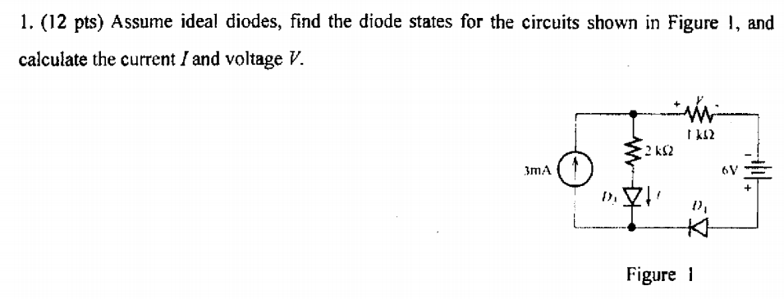

2.For the BJT amplifier circuit shown in Figure 2, where Vc=20V,β=200,

a. Find the value of 。

b. Draw the small-signal equivalent circuit of the amplifier.

c. Find the voltage gain.

d. Find the input resistance, .

e. Find the output resistance, .

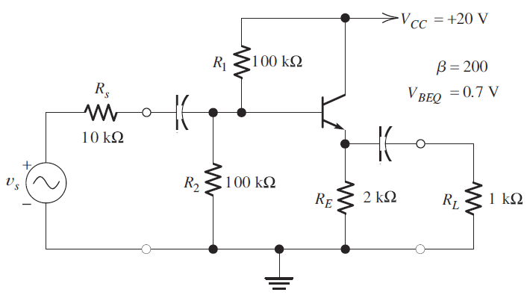

3. The circuit shown in Figure 3 is a common-drain (or source follower) amplifier. The

transistor parameters, and component values are: RL = 1 kΩ and R1 = R2 =2 MΩ. KP=50μA/, =1V, L=2 μm, W=160 μm.

1. Find the value for to achieve = 10 mA.
2. Draw the AC small-signal equivalent circuit.
3. Determine the values of the input resistance Ri, the output resistance R0, and voltage gain .

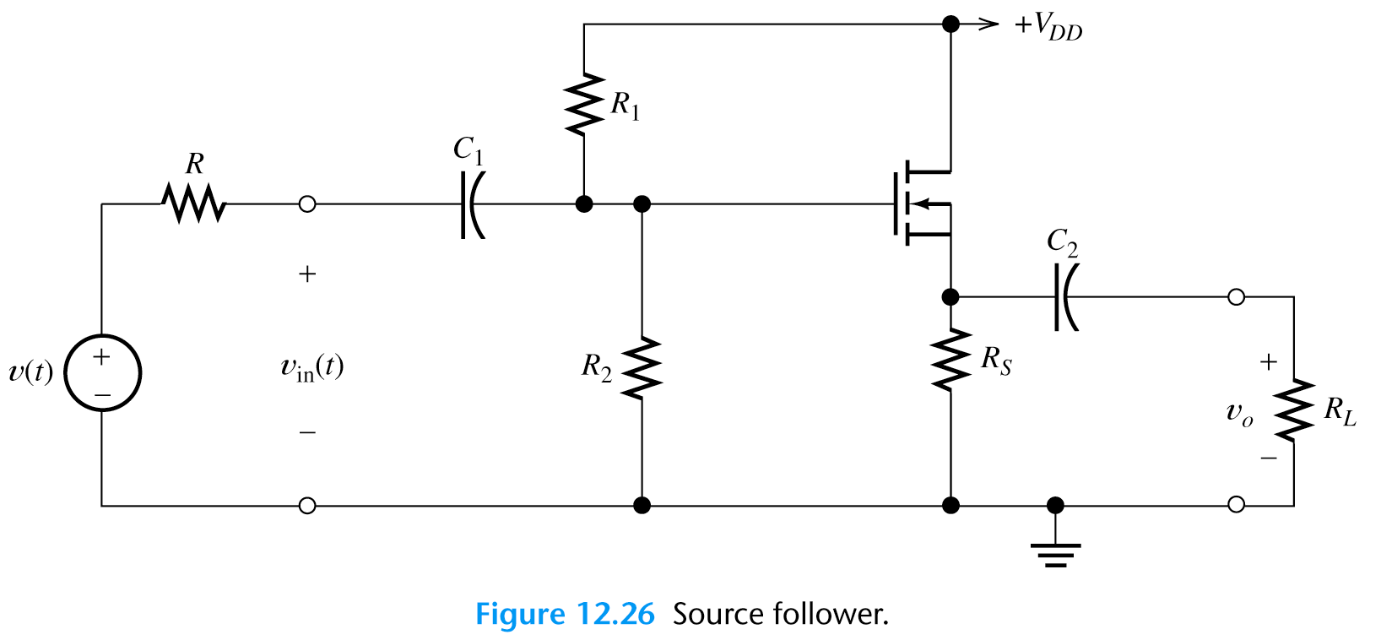

4. The circuit composed of ideal operational amplifiers is shown in Figure 4,

a. Derive the expression of .

b. When ，=?

c. What is the feedback type of ?

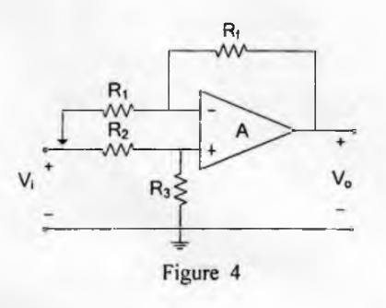

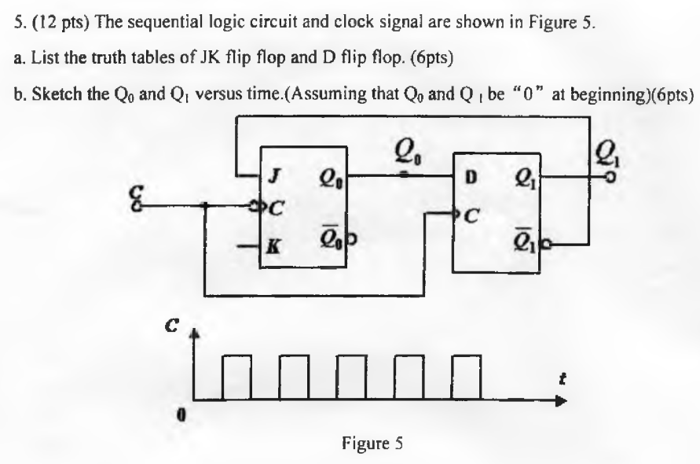

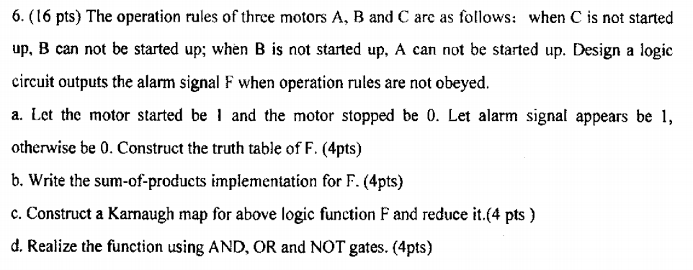

7. The differential amplifiers is shown below，where β =50,=0.7V, input voltage =6mV, =4mV ,Ucc=6V, Ee=-6V, =10 kΩ , Rc=5 kΩ,=5 kΩ;

a. Find the values of .

b. Decompose and to common-mode signals and as well as differential signalsand .

c. Calculate the single-ended outputs and for differential signals;

d. If the gain of common mode signal for single-ended outputs is calculate the single-ended outputs and ；

e. Calculate the common-mode output and differential output .

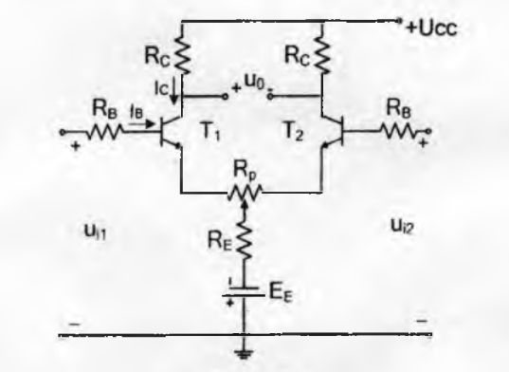

Answer：  
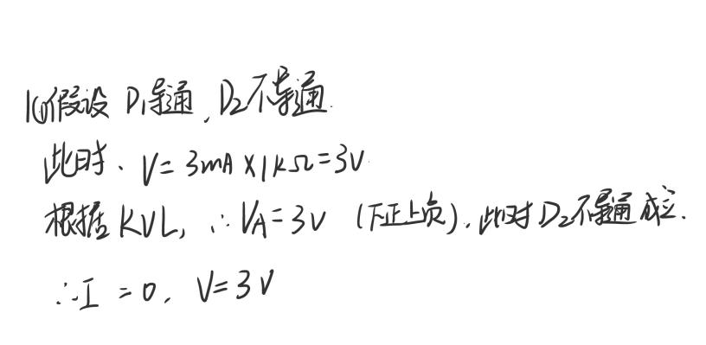

1. 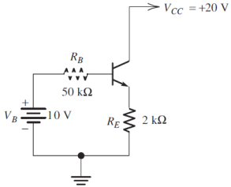





b.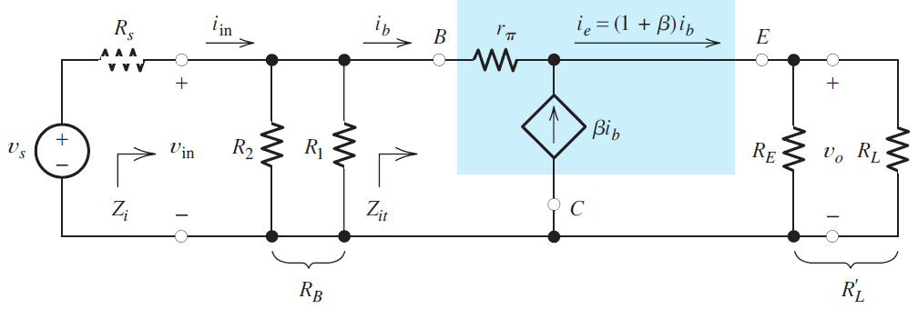

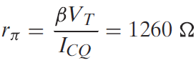 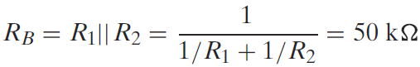 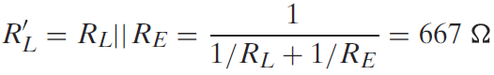

C.

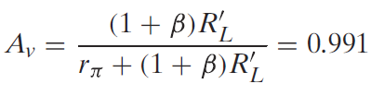

d.

 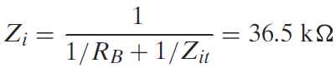

E.

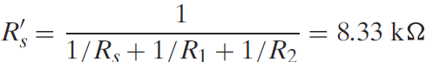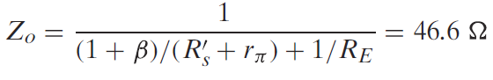

3.

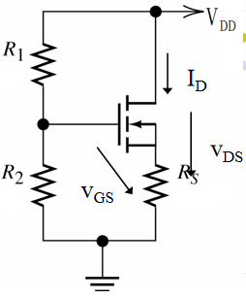A.

 





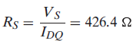

B.

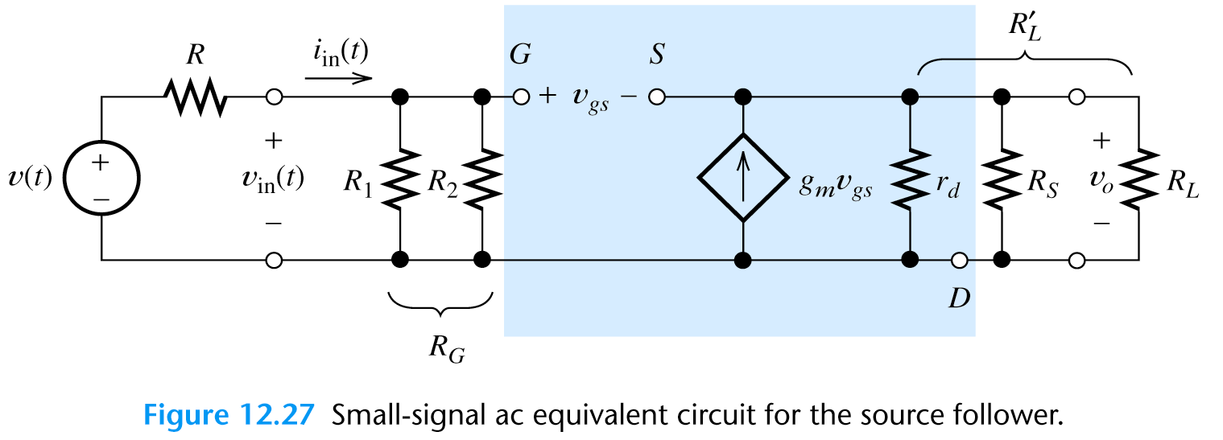

C.











4.

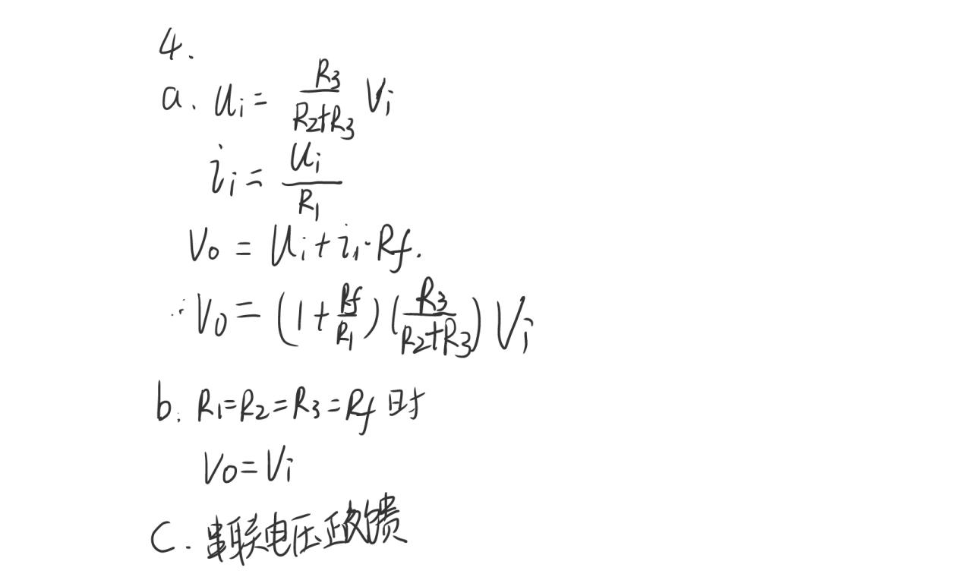

5.

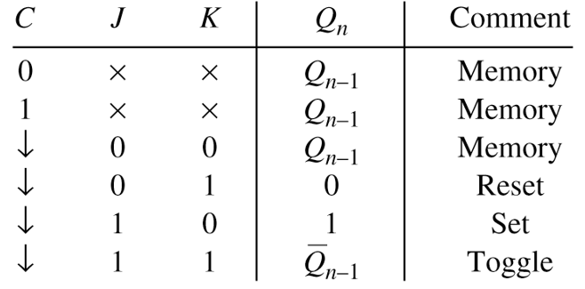 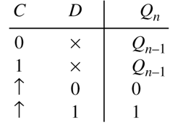

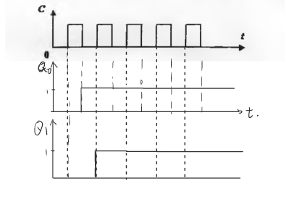

6.