Understanding EJB 3.0

What Is an Enterprise Bean?
Written in the Java programming language, an enterprise bean is a server-side component that encapsulates the business logic of an application. The business logic is the code that fulfills the purpose of the application.
For example: In an inventory control application, the enterprise beans might implement the business logic in methods called checkInventoryLevel and orderProduct. By invoking these methods, remote clients can access the inventory services provided by the application.

In simple words EJB = POJO + Annotations

Benefits of using EJBs
1) EJB-container can manage the ejbs, the developer just need to concentrate on the business logic
2) Portability, scalability, reusable business application
3) Can be distributed to different machines
4) EJB allows application developers to focus on building business logic without having to spend time on building infrastructure code.

Enterprise Bean Type

Session Bean: Performs a task for a client; implements a web service
Entity Bean: Represents a business entity object that exists in persistent storage
Message-Driven Bean: Acts as a listener for the Java Message Service API, processing messages asynchronously

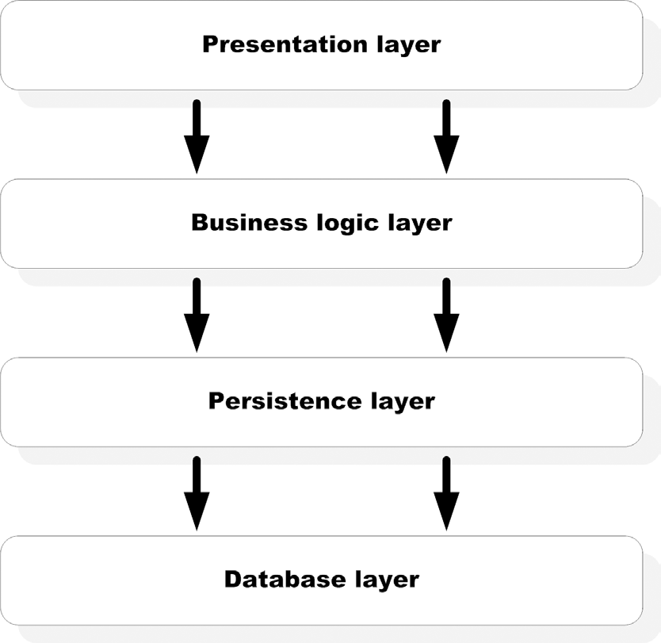

Figure 1:4-layered architecture

-Session beans and message-driven beans are used to implement business logic in an EJB application, and they live in the ejb-container, which manages these beans and provides services to them.

-Entities are used for persistence. It is the persistence provider that manages entities. A persistence provider is pluggable within the container and is abstracted behind the Java Persistence API (JPA).

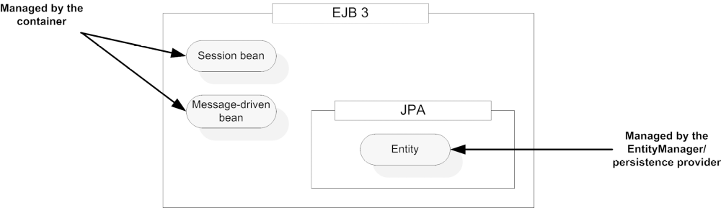
Figure 2: Overall organization of the EJB 3 API. The Java persistence API is completely separable from the EJB 3 container. The business logic processing is carried out by two component types: session beans and message-driven beans. Both components are managed by the container. Persistence objects are called entities, which are managed by the persistent provider through the EntityManager interface.

What Is a Session Bean?
A session bean represents a single client inside the Application Server. To access an application that is deployed on the server, the client invokes the session bean's methods. The session bean performs work for its client, shielding the client from complexity by executing business tasks inside the server. The name session implies that a bean instance is available for the duration of a “unit of work” and does not survive a server crash or shutdown.

-Session beans are the only EJB components that are invoked directly by clients. A client can be anything, such as a web application component (servlet, JSP, JSF, and so on), a command-line application, or a Swing GUI desktop application. A client can even be a Microsoft .NET application using
web services access.

- Session bean implementation classes can never be abstract, which means that all methods mandated by declared business interfaces must be implemented in the class.

- Note that EJB implementation classes can have nonprivate methods that are not accessible through any interface. Such methods can be useful for creating clever unit-testing rameworks and while implementing lifecycle callback.

- Each session bean implementation has two distinct parts—one or more bean interfaces and a bean implementation class. All session beans must be divided into these two
parts. This is because clients cannot have access to the bean implementation class directly. Instead, they must use session beans through a business interface.

Session Beans programming rules :
- A session bean must have at least one business interface.
- The session bean class must be concrete. You cannot define a session bean class as either final or abstract since the container needs to manipulate it.
- You must have a no-argument constructor in the bean class. As we saw, this is because the container invokes this constructor to create a bean instance when a client invokes an EJB. Note that the compiler inserts a default noargument constructor if there is no constructor in a Java class.
- A session bean class can subclass another session bean or any other POJO.
For example, a stateless session bean named BidManager can extend another session bean PlaceBidBean in the following way:
@Stateless
public BidManagerBean extends PlaceBidBean implements BidManager {
...
}
- The business methods and lifecycle callback methods may be defined either in the bean class or in a superclass. It’s worth mentioning here that annotation inheritance is supported with several limitations with EJB 3 session beans. For example, the bean type annotation @Stateless or @Stateful specified in the PlaceBidBean superclass will be ignored when you deploy the BidManagerBean.
- Business method names must not start with “ejb.” For example, avoid a method name like ejbCreate or ejbAddBid because it may interfere with EJB infrastructure processing. You must define all business methods as public, but not final or static. If you are exposing a method in a remote business interface of the EJB, then make sure that the arguments and the return type of the method implement the java.io.Serializable interface.

2 Types:
1) Stateful
2) Stateless

Stateless
Stateless session beans do not maintain any state and model application services that can be completed in a single client invocation. You could build stateless session beans for implementing business processes such as charging a credit card or checking customer credit history.

A session bean can be invoked either locally or remotely using Java RMI. A stateless session bean can be exposed as a web service.

Bean life cycle
The container manages almost every aspect of session beans. This means that neither the client nor the bean is responsible for determining when bean instances are created, when dependencies are injected, when bean instances are destroyed, or when to take optimization measures.
The most obvious two events of a bean lifecycle are creation and destruction. All EJBs
go through these two phases. In addition, stateful session beans go through the
passivation/activation cycle.
The lifecycle for a session bean starts when a bean instance is created. This typically happens when a client receives a reference to the bean either by doing a JNDI lookup or by using dependency injection. The following steps occur when a bean is initialized:
1) The container invokes the newInstance method on the bean object. This essentially translates to a constructor invocation on the bean implementation class.
2) If the bean uses DI, all dependencies on resources, other beans, and environment
components are injected into the newly created bean instance.
After the container determines that an instance is no longer needed, the instance is destroyed.

Understanding lifecycle callbacks
Lifecycle callbacks are bean methods (not exposed by a business interface) that the container calls to notify the bean about a lifecycle transition, or event. When the event occurs, the container invokes the corresponding callback method, and you can use these methods to perform business logic or operations such as initialization and cleanup of resources.
Callback methods are bean methods that are marked with metadata annotations such as @PostContruct and @PreDestroy. They can be public, private, protected, or package-protected. A Post-Construct callback is invoked just after a bean instance is created and dependencies are injected. A PreDestroy callback is invoked just before the bean is
destroyed and is helpful for cleaning up resources used by the bean.

While all session beans have PostConstruct and PreDestroy lifecycle events, stateful session beans have two additional ones: PrePassivate and PostActivate. Since stateful session beans maintain state, there is a stateful session bean instance for each client, and there could be many instances of a stateful session bean in the container. If this happens, the container may decide to deactivate a stateful bean instance temporarily when not in use; this process is called passivation. The container activates the bean instance again when the client needs it; this process is called activation. The @PrePassivate and @PostActivate annotations apply to the passivation and activation lifecycle events.

Callbacks must follow the pattern of void <METHOD>(). Unlike business methods, callbacks cannot throw checked exceptions (any exception that doesn’t have java.lang.RuntimeException as a parent).

Example of Stateless session bean:

Stateless session bean:

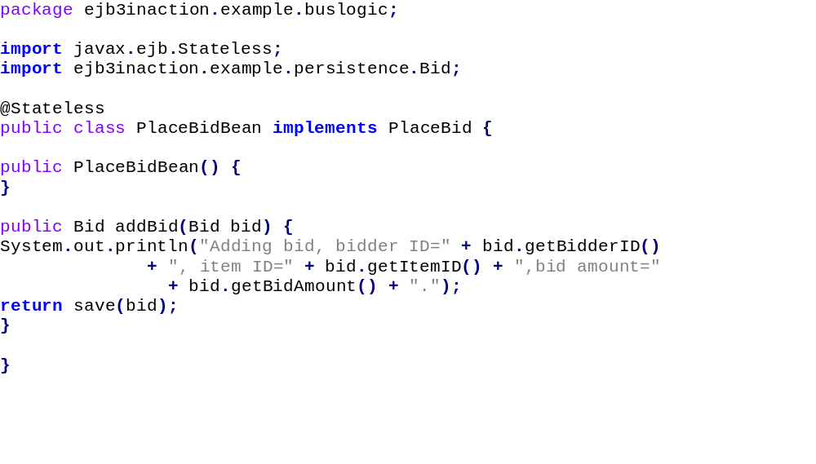

Interface

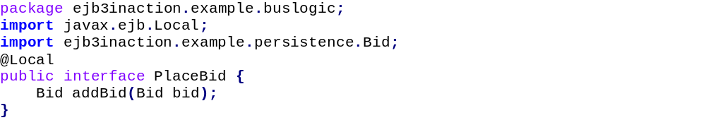

Description:
Some important annotations used by stateless session beans:
- @Stateless :
The @Stateless annotation tells the EJB container that Place-BidBean is a stateless session bean. This means that the container automatically provides such services to the bean as automatic concurrency control, thread safety, pooling, and transaction management. In addition, you can add other services for which stateless beans are eligible, such as transparent security and interceptors. In this annotation some params can also be added as shown : @Stateless( name="something...", mappedName="something else...")
- mappedName => is the vendor specific JNDI name
- name => uniquely identifies a EJB within a deployment unit. Although it may not be used during lookup, its there to identify a bean in a deployment unit. This most of the times is used internally by the application servers. Some containers use this parameter to bind the EJB to the global JNDI tree. the name parameter is optional since it is defaulted to an empty String. If the name parameter is omitted, the container assigns the name of the class to the bean.
- description

Client applications can invoke a stateless session bean in three different ways. In addition to local invocation within the same JVM and remote invocation through RMI, stateless beans can be invoked remotely as web services.

If the interface is marked with annotation @Local : the jndi name will go into java:global
If the interface is marked with annotation @Remote : the jndi name will go into a seperate block

- @local :
The @Local annotation on the PlaceBid interface tells the container that the PlaceBid EJB can be accessed locally(means same jvm) through the interface. Since EJB and servlets are typically collocated in the same application, this is probably perfect.

- @Remote :
The @Remote annotation on the interface tells the container that the EJB can be accessed remotely that is from diff jvm(using rmi). If EJB and servlets are typically located in different jvms, this annotation will be used by the interface.

- @WebService :
If the EJB needs to be accessed by non-Java clients like Microsoft .NET applications, web services, based remote access can be enabled using the @WebService annotation applied either on the interface or the bean class. The ability to expose a stateless session bean as a SOAP-based web service is one of the most powerful features

A client to use the stateless ejb made above:
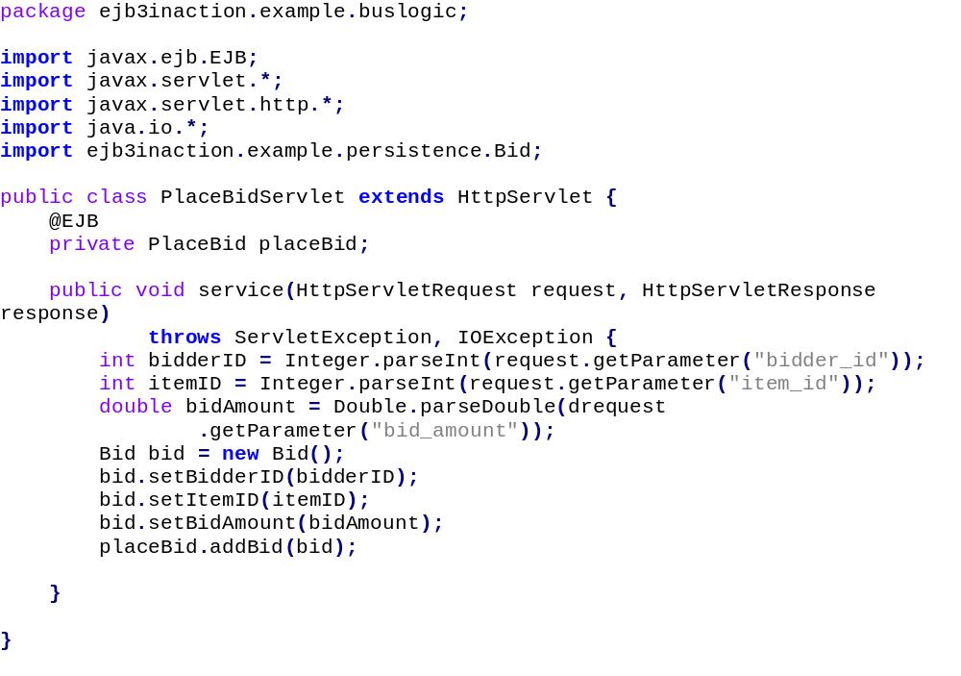

Stateful
A Stateful session bean automatically saves bean state between client invocations without your having to write any additional code. A typical example of a state-aware process is the shopping cart for a web merchant like Amazon.
Unlike with stateless beans, the container makes sure that subsequent method invocations by the same client are handled by the same stateful bean instance.

Rules to use stateful beans
- Stateful bean instance variables used to store conversational state must be Java primitives or Serializable objects.
- Since stateful session beans cannot be pooled and reused like stateless beans, there is a real danger of accumulating too many of them if we don’t have a way to destroy them. Therefore, we have to define a business method for removing the bean instance by the client using the @Remove annotation.
- In addition to the PostConstruct and PreDestroy lifecycle callback methods, stateful session beans have the PrePassivate and PostActivate lifecycle callback methods. A PrePassivate method is invoked before a stateful bean instance is passivated and PostActivate is invoked after a bean instance is brought back into the memory and is method ready.

Sateful Session Bean Interface:
Stateful session beans support local and remote invocation through the @Local and @Remote annotations.
However, a stateful session bean cannot have a web service endpoint interface.
This is because SOAP-based web services are inherently stateless in nature.
Also, you should always include at least one @Remove annotated method in your
stateful bean’s business interface.

Life Cycle Flow:
The container follows these steps:
1) Always creates new bean instances using the default constructor whenever
a new client session is started.
2) Injects resources.
3) Stores the instance in memory.
4) Executes the requested business method invoked through the business
interface by the client.
5) Waits for and executes subsequent client requests.
6) If the client remains idle for a period of time, the container passivates the
bean instance. Essentially, passivation means that the bean is moved out
of active memory, serialized, and stored in temporary storage.
7) If the client invokes a passivated bean, it is activated (brought back into
memory from temporary storage).
8) If the client does not invoke a passivated bean instance for a period of
time, it is destroyed.
9) If the client requests the removal of a bean instance, it is first activated if
necessary and then destroyed.

Life-Cycle callback methods:
- @PostConstruct : Same role as it plays in stateless bean
- @PreDestroy : Same role as it plays in stateless bean
- @PrePassivate
- @PostActivate
Passivation and activation :
If clients don’t invoke a bean for a long enough time, it is not a good idea to continue
keeping it in memory. For a large number of beans, this could easily make the machine run out of memory. The container employs the technique of passivation to save memory when possible.
NOTE Passivation essentially means saving a bean instance into disk instead of holding it in memory. The container accomplishes this task by serializing the entire bean instance and moving it into permanent storage like a file or the database. Activation is the opposite of passivation and is done when the bean instance is needed again. The container activates a bean instance by retrieving it from permanent storage, deserializing it, and moving it back into memory. This means that all bean instance variables that you care about and should be saved into permanent storage must either be a Java primitive or implement the java.io.Serializable interface

The point of the PrePassivate callback is to give the bean a chance to prepare for serialization. This may include copying nonserializable variable values into Serializable variables and clearing unneeded data out of those variables to save total disk space needed to store the bean. Most often the prepassivation step consists of releasing heavy-duty resources such as open database, messaging server, and socket connections that cannot be serialized. A well-behaved bean should ensure that heavy-duty resources are both closed and explicitly set to null before passivation takes place.

Features | Stateless | Stateful
Conversational state | No | Yes
Pooling | Yes | No
Performance problems | Unlikely | possible
Lifecycle events | PostConstruct,  PreDestroy | PostConstruct, PreDestroy,  PrePassivate, PostActivate
Timer | Yes | no
SessionSynchronization for  transactions | No | yes
Web services | Yes | No
Extended PersistenceContext | No | Yes

Example of stateful session bean :

Stateful session bean :

Interface
package ejb3inaction.example.buslogic;
import javax.ejb.Remote;
@Remote
public interface PlaceOrder {
void setBidderId(Long bidderId);
void addItem(Long itemId);
void setShippingInfo(ShippingInfo shippingInfo);
void setBillingInfo(BillingInfo billingInfo);
Long confirmOrder();
}

Description :

- @Stateful: The state of the bean is maintained for specific session.

- @Remove:
The @Remove annotation marks the end of the workflow modeled by a stateful bean. In our case, we are telling the container that there is no longer a need to maintain the bean’s session with the client after the confirmOrder method is invoked. If we didn’t tell the container what method invocation marks the end of the workflow, the container could wait for a long time until it could safely time-out the session. Since stateful beans are guaranteed to be dedicated to a client for the duration of a session, this could mean a lot of “orphaned” state data consuming precious
server resources for long periods of time!

- @Remote:
The @Remote annotation on the interface tells the container that the EJB can be accessed remotely that is from diff jvm(using rmi). If EJB and servlets are typically located in different jvms, this annotation will be used by the interface.

Stateful session bean client:
package ejb3inaction.example.buslogic;
import javax.ejb.EJB;
public class PlaceOrderTestClient {
@EJB
private static PlaceOrder placeOrder;
public static void main(String [] args) throws Exception {
System.out.println("Exercising PlaceOrder EJB...");
placeOrder.setBidderId(new Long(100));
placeOrder.addItem(new Long(200));
placeOrder.addItem(new Long(201));
placeOrder.setShippingInfo(
new ShippingInfo("123 My Sweet Home",
"MyCity","MyState"));
placeOrder.setBillingInfo(
new BillingInfo("123456789","VISA","0708"));
Long orderId = placeOrder.confirmOrder();
System.out.println("Order confirmation number: " + orderId);
}
}

Session Bean Client:
Almost any Java component can be a session bean client. POJOs, servlets, JSPs, or other EJBs can access session beans. In fact, stateless session beans exposed through web services endpoints can even be accessed by non-Java clients such as .NET applications.

A session bean client follows these general steps to use a session bean:
1)The client obtains a reference to the beans directly or indirectly from JNDI.
2)All session bean invocations are made through an interface appropriate
for the access type.
3)The client makes as many method calls as are necessary to complete the
business task at hand.
4)In case of a stateful session bean, the last client invocation should be a
remove method.

Ways to get access to the session bean:
1)Dependency injection : i.e, using the @Ejb annotation.
the @EJB annotation is specifically intended for injecting session beans into client code. Also recall that since injection is only possible within managed environments, this annotation only works inside another EJB, in code running inside an application-client container
(ACC), or in components registered with the web container (such as a servlet or JSF backing bean).
@Ejb annotation has 3 parameters :
-Name : The name element suggests the JNDI name that is used to bind the injected EJB in the environment naming context.
-BeanInterface : The beanInterface specifies the business interface to be used to access the EJB.
-BeanName : The beanName element allows us to distinguish among EJBs if multiple EJBs implement the same business interface.
Keep in mind that you must not inject a stateful session bean into a stateless object, such as a stateless session bean or servlet that may be shared by multiple concurrent clients (you should use JNDI in such cases instead). However, injecting an instance of a stateless session bean into a stateful session bean is perfectly legal.

2)using EJB context lookup

3)using JNDI lookup

What is Message-Driven Bean?
Like session beans, MDBs process business logic. However, MDBs are different in one important way: clients never invoke MDB methods directly. Instead, MDBs are triggered by messages sent to a messaging server, which enables sending asynchronous messages between system components. MDBs are typically used for robust system integration or asynchronous processing.

MDB Programming rules
Like all EJBs, MDBs are plain Java objects that follow a simple set of rules and sometimes have annotations. Don’t take these rules too seriously yet; simply note them in preparation for going through the code-intensive sections that follow.
■ The MDB class must directly (by using the implements keyword in the class declaration) or indirectly (through annotations or descriptors) implement a message listener interface.
■ The MDB class must be concrete. It cannot be either a final or an abstract class.
■ The MDB must be a POJO class and not a subclass of another MDB.
■ The MDB class must be declared public.
■ The bean class must have a no-argument constructor. If you don’t have any constructors in your Java class, the compiler will create a default constructor. The container uses this constructor to create a bean instance.
■ You cannot define a finalize method in the bean class. If any cleanup code is necessary, it should be defined in a method designated as PreDestroy.
■ You must implement the methods defined in the message listener interface.These methods must be public and cannot be static or final.
■ You must not throw the javax.rmi.RemoteException or any runtime exceptions. If a RuntimeException is thrown, the MDB instance is terminated.

MDB Code Example:

Simple JMS steps to send message:

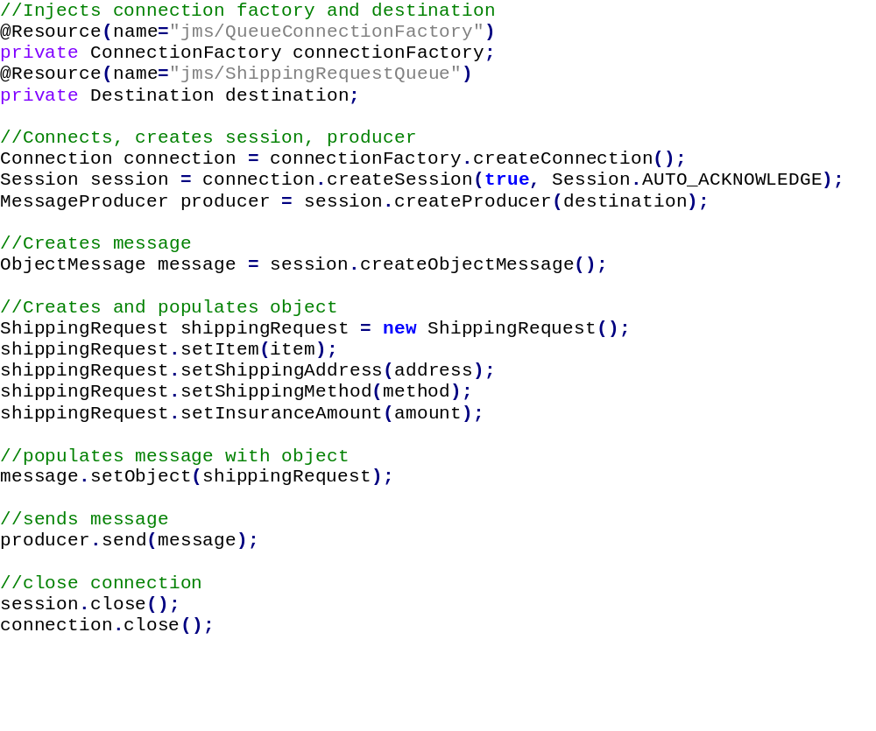

PlaceOrderBean that produces the JMS message
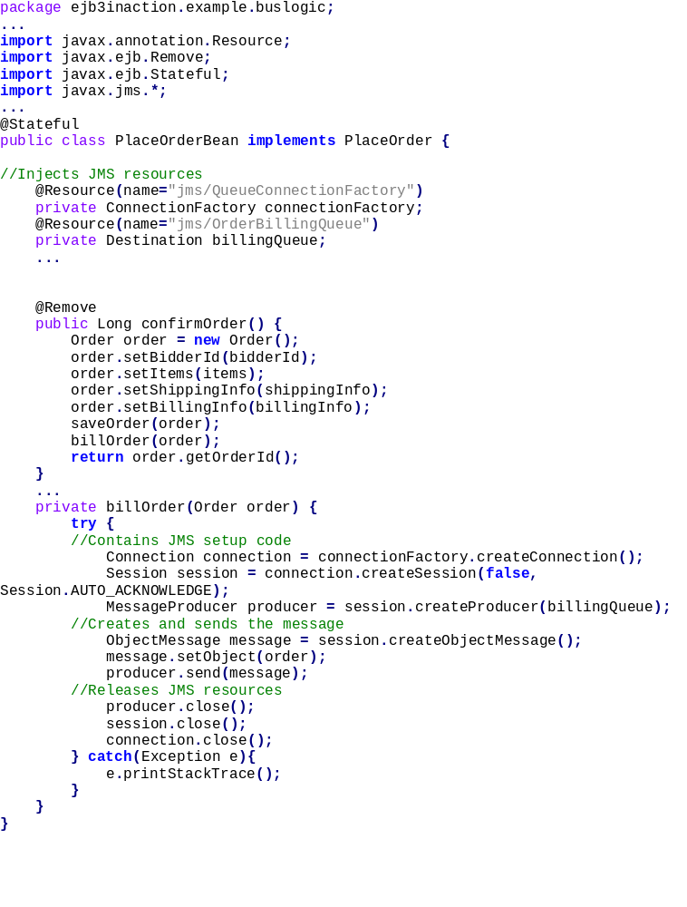

Description :
Like stateless beans, MDBs are not guaranteed to maintain state. The
@MessageDriven annotation is the MDB counterpart of the @Stateless and
@Stateful annotations—it makes the container transparently provide messaging
and other EJB services into a POJO. The activation configuration properties
nested inside the @MessageDriven annotation tells the container what JMS destination
the MDB wants to receive messages from.

NOTE Behind the scenes, the container takes care of several mechanical
details to start listening for messages sent to the destination specified
by the activation configuration properties. As soon as a message arrives
at the destination, the container forwards it to an instance of the MDB.

Instead of implementing a remote or local business interface, MDBs implement the
javax.jms.MessageListener interface. The container uses this well-known JMS
interface to invoke an MDB. The onMessage method defined by the interface has a
single javax.jms.Message parameter that the container uses to pass a received
message to the MDB.

OrderBillingMDB : message consumer
package ejb3inaction.example.buslogic;
import javax.ejb.MessageDriven;
import javax.ejb.ActivationConfigProperty;
import javax.jms.Message;
import javax.jms.MessageListener;
import javax.jms.ObjectMessage;
import ejb3inaction.example.persistence.Order;
import ejb3inaction.example.persistence.OrderStatus;
@MessageDriven(
activationConfig = {
@ActivationConfigProperty(
propertyName="destinationName",
propertyValue="jms/OrderBillingQueue")
}
)
public class OrderBillingMDB implements MessageListener {
...
public void onMessage(Message message) {
try {
ObjectMessage objectMessage = (ObjectMessage) message;
Order order = (Order) objectMessage.getObject();
try {
bill(order);
notifyBillingSuccess(order);
order.setStatus(OrderStatus.COMPLETE);
} catch (BillingException be) {
notifyBillingFailure(be, order);
order.setStatus(OrderStatus.BILLING_FAILED);
} finally {
update(order);
}
} catch (Exception e) {
e.printStackTrace();
}
}
...
}

JPA
Persistence is the ability to have data contained in Java objects automatically stored into a relational database like Oracle, SQL Server, and DB2. Persistence in EJB 3 is managed by the JPA. It automatically persists the Java objects using a technique called object-relational mapping (ORM). ORM is essentially the process of mapping data held in Java objects to database tables using configuration. It relieves you of the task of writing low-level, boring, and complex JDBC code to persist objects into a database.
In EJB 3 terms, a persistence provider is essentially an ORM framework that supports the EJB 3 Java Persistence API (JPA). The JPA defines a standard for
-The creation of ORM configuration metadata for mapping entities to relational tables
-The EntityManager API standard API for performing CRUD (create, read, update, and delete)/persistence operations for entities
-The Java Persistence Query Language (JPQL), for searching and retrieving persisted application data

Entity Bean
If you’re using JPA to build persistence logic of your applications, then you have to use entities. Entities are the Java objects that are persisted into the database. Just as session beans model processes, entities model lower-level application concepts that high-level business processes manipulate.
While session beans are the “verbs” of a system, entities are the “nouns.” Examples include an Employee entity, a User entity, an Item entity, and so on. Here’s another perfectly valid (and often simpler to-understand) way of looking at entities: they are the OO representations of the application data stored in the database. In this sense, entities survive container crashes and shutdown. You must be wondering how the persistence provider knows where the entity will be stored. The real magic lies in the ORM metadata; an entity contains the data that specifies how it is mapped to the database.

The EntityManager
The JPA EntityManager interface manages entities in terms of actually providing persistence services. While entities tell a JPA provider how they map to the database, they do not persist themselves. The EntityManager interface reads the ORM metadata for an entity and performs persistence operations. The Entity-Manager knows how to add entities to the database, update stored entities, and delete and retrieve entities from the database. In addition, the JPA provides the
ability to handle lifecycle management, performance tuning, caching, and transaction management.

Containers
In the Java world, containers aren’t just limited to the realm of EJB 3. You’re probably familiar with a web container, which allows you to run web-based applications using Java technologies such as servlets, JSP, or JSF. A Java EE container is an application server solution that supports EJB 3, a web container, and other Java EE APIs and services. BEA WebLogic Server, Sun Microsystems’s GlassFish, IBM WebSphere, JBoss Application Server, and Oracle Application Server 10g are examples of Java EE containers. The relationship between the Java EE container, web container, EJB container, and JPA persistence provider is shown in figure 1.7.
If you install a Java EE compliant application server such as GlassFish, it will contain a preconfigured web container, EJB container, and a JPA provider. However, some vendors and open source projects may provide only a web container such as Tomcat or an EJB 3¨Ccompliant persistence provider such as Hibernate. These containers provide limited functionality compared to what you get with a complete Java EE 5 container.

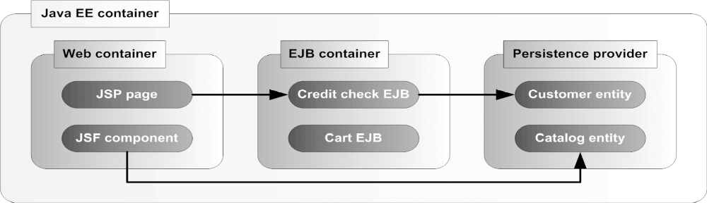
Figure 1.7 Java EE container typically contains web and EJB containers and a persistence provider. The stateless session bean (Credit Check EJB) and stateful session bean (Cart EJB) are deployed and run in the EJB container. Entities (Customer and Catalog) are deployed and run within an EJB persistence provider and can be accessed by either web or EJB container components.

Table 1.1 Major EJB 3 component services and why they are important to you. The persistence services are provided by the JPA provider.
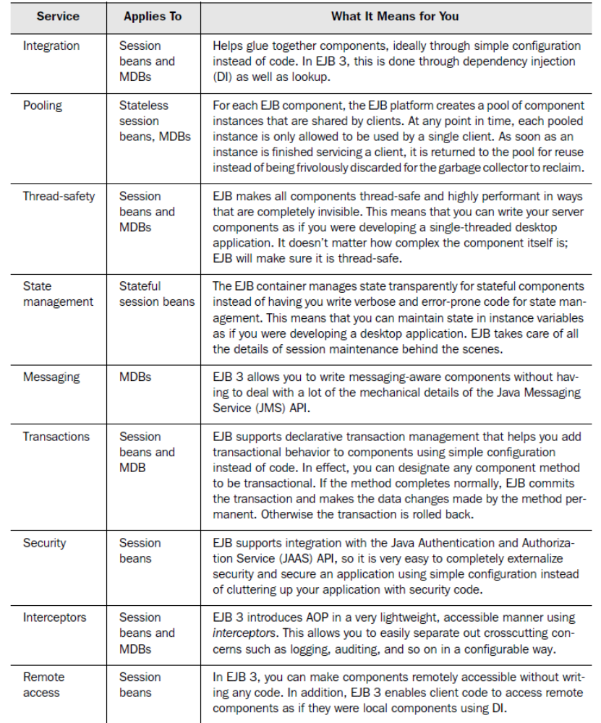

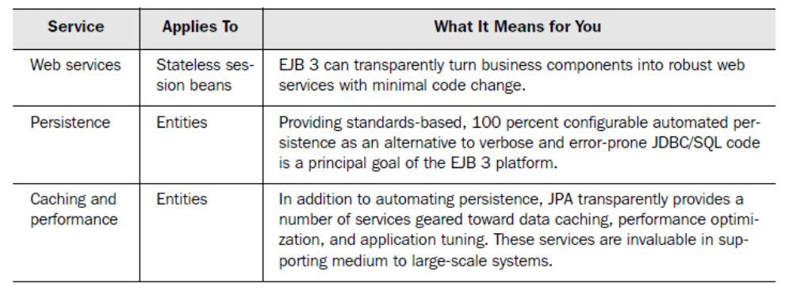

Table2.1
Major metadata annotations introduced in Java EE. Although primarily geared toward EJB, these annotations apply to Java EE components such as servlets and JSF managed beans as well as application clients. Annotations defined in the javax.annotation.* package are defined by the Common Metadata Annotations API (JSR-250).
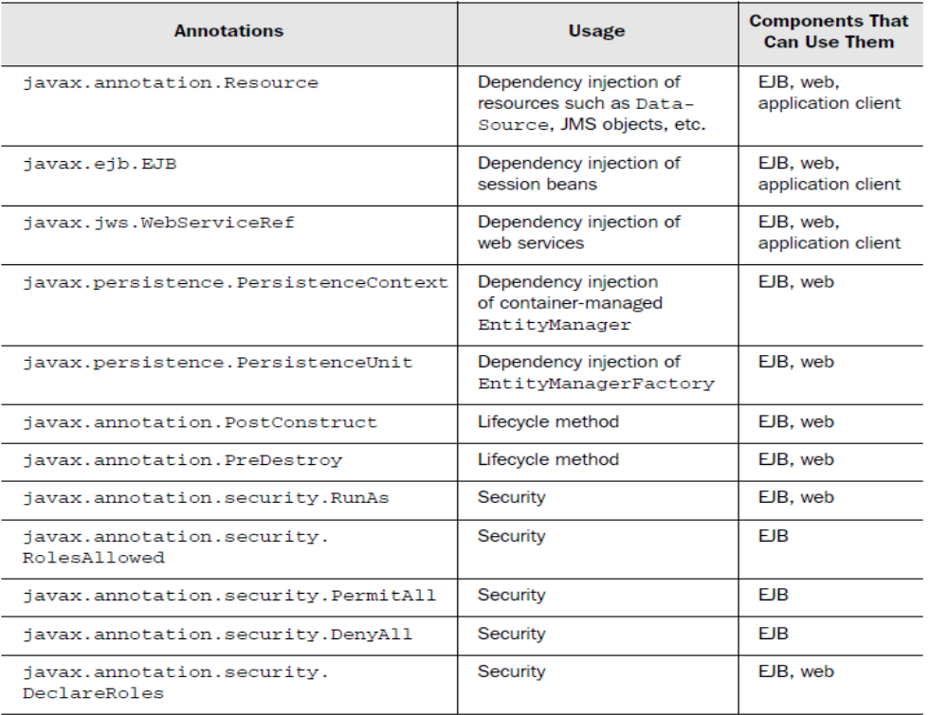

Interceptors:
Interceptors are objects that are automatically triggered when an EJB method is invoked.
Interception takes place at various points (called point cuts) including at the beginning of a method, at the end of a method, and when an exception is triggered.
Interceptors can be applied to both session and message-driven beans.

Eg:

@Stateless
public class PlaceBidBean implements PlaceBid {
...
@Interceptors(ActionBazaarLogger.class)
public void addBid(Bid bid) {
...
}
}
-------
public class ActionBazaarLogger {
@AroundInvoke
public Object logMethodEntry(
InvocationContext invocationContext)
throws Exception {
System.out.println("Entering method: ”
+ invocationContext.getMethod().getName());
return invocationContext.proceed();
}
}

Description of the above code:
The interceptor class, ActionBazaarLogger, is attached to the addBid method of the PlaceBid stateless session bean using the @javax.interceptor.Interceptors annotation. The ActionBazaarLogger object’s log-MethodEntry method is annotated with @javax.interceptor.AroundInvoke and will be invoked when the addBid method is called. The logMethodEntry method prints a log message to the system console, including the method name entered using the javax.interceptor.InvocationContext. Finally, the invocation context’s
proceed method is invoked to signal to the container that the addBid invocation can proceed normally.

Entity Bean Example:

Entity Bean:
package ejb3inaction.example.persistence;
import java.io.Serializable;
import java.sql.Date;
import javax.persistence.Column;
import javax.persistence.Entity;
import javax.persistence.Id;
import javax.persistence.Table;
import javax.persistence.GenerationType;
import javax.persistence.GeneratedValue;
@Entity
@Table(name="BIDS")
public class Bid implements Serializable {
private Long bidID;
private Long itemID;
private Long bidderID;
private Double bidAmount;
private Date bidDate;
@Id
@GeneratedValue(strategy=GenerationType.AUTO)
@Column(name="BID_ID")
public Long getBidID() {
return bidID;
}
public void setBidID(Long bidID) {
this.bidID = bidID;
}
@Column(name="ITEM_ID")
public Long getItemID() {
return itemID;
}
public void setItemID(Long itemID) {
this.itemID = itemID;
}
@Column(name="BIDDER_ID")
public Long getBidderID() {
return bidderID;
}
public void setBidderID(Long bidderID) {
this.bidderID = bidderID;
}
@Column(name="BID_AMOUNT")
public Double getBidAmount() {
return bidAmount;
}
public void setBidAmount(Double bidAmount) {
this.bidAmount = bidAmount;
}
@Column(name="BID_DATE")
public Date getBidDate() {
return bidDate;
}
public void setBidDate(Date bidDate) {
this.bidDate = bidDate;
}
}

Description
1)The @Entity annotation signifies the fact that the Bid class is a JPA entity.
Note that Bid is a POJO that does not require a business interface, unlike session
and message-driven beans.
2)The @Table annotation tells JPA that the Bid entity is mapped to the BIDS table.
3)The @Column annotations indicatewhich Bid properties map to which BIDS table fields.

Note that entities need not use getter- and setter-based properties. Instead, the field mappings could have been placed directly onto member variables exposed through nonprivate access modifiers.

Using Entity bean:
package ejb3inaction.example.buslogic;
...
import javax.persistence.PersistenceContext;
import javax.persistence.EntityManager;
...
@Stateless
public class PlaceBidBean implements PlaceBid {
@PersistenceContext(unitName="actionBazaar")
private EntityManager entityManager;
...
public Bid addBid(Bid bid) {
System.out.println("Adding bid, bidder ID=" + bid.getBidderID()+ ", item ID=" + bid.getItemID() + ", bid amount="+ bid.getBidAmount() + ".");
return save(bid);
}
private Bid save(Bid bid) {
entityManager.persist(bid);
return bid;
}
}

Important Points :
-Deployment descriptor entries override configuration values hard-coded into EJB components
- EJB should always implement interface.

Dependeny Injection:
EJB 3 DI using the @EJB annotation reduces all this mechanical JNDI lookup code to a single statement!
In a nontrivial application, this can easily translate to eliminating hundreds of lines of redundant, boring, error-prone code. You can think of EJB 3 DI as a high-level abstraction over JNDI lookups.

Field- vs. property-based persistence
An entity maintains its state by using either fields or properties (via setter and getter methods).The variables in the @Entity annotated class, can be persisted either using the getter/setter methods(property-based persistence) or by directly accessing the variables(field based persistence).@Id annotation indicates that how to persist the data.
If the @Id annotation is on a varibale then directly persist the variable.
If the @Id is on the getter method then getter/ steer methods will be used to persist the data.
Annotations used with a setter method are ignored by the persistence provider for property-based access.Persisted setters and getters cannot be declared final, as the persistence provider may need to override them.

@Transient
If necessary, you can stop an entity property from being persisted by marking the getter with the @Transient annotation or marking the field with @Transient annotation.

The @Id annotation
Using the javax.persistence.Id annotations is the simplest way of telling the persistence
provider where the entity identity is stored. The @Id annotation marks a field or property as identity for an entity. This marks the field as the primary-key. EJB 3 supports primitives,
primitive wrappers, and Serializable types like java.lang.String, java.util.Date, and java.sql.Date as identities. In addition, when choosing numeric types you should avoid types such as float, Float, double, and so forth because of the indeterminate nature of type precision. Another type you should avoid choosing as identifier is TimeStamp.

Assume that we changed our minds and decided that a Category is uniquely identified by its name and creation date. There are two ways we can accomplish this: by using either the @IdClass or @EmbeddedId annotation.

@Table
@Table specifies the table containing the columns to which the entity is mapped.
In sample code shown below, the @Table annotation makes the USERS table’s columns available for ORM.The @Table annotation itself is optional. If it’s omitted, the entity is assumed to be mapped to a table in the default schema with the same name as the entity class. If
the name parameter is omitted, the table name is assumed to be the same as the
name of the entity.

@Entity
@Table(name="USERS")
@SecondaryTable(name="USER_PICTURES",
pkJoinColumns=@PrimaryKeyJoinColumn(name="USER_ID"))
public class User implements Serializable {

@Id
@Column(name="USER_ID", nullable=false)
protected Long userId;

@Column(name="USER_NAME", nullable=false)
protected String username;

@Column(name="FIRST_NAME", nullable=false, length=1)
protected String firstName;

@Column(name="LAST_NAME", nullable=false)
protected String lastName;

@Enumerated(EnumType.ORDINAL)
@Column(name="USER_TYPE", nullable=false)
protected UserType userType;

@Column(name="PICTURE", table="USER_PICTURES")
@Lob
@Basic(fetch=FetchType.LAZY)
protected byte[] picture;
@Column(name="CREATION_DATE", nullable=false)
@Temporal(TemporalType.DATE)
protected Date creationDate;
@Embedded
protected Address address;
public User() {}
}

@Embeddable
public class Address implements Serializable {
@Column(name="STREET", nullable=false)
protected String street;
@Column(name="CITY", nullable=false)
protected String city;
@Column(name="STATE", nullable=false)
protected String state;
@Column(name="ZIP_CODE", nullable=false)
protected String zipCode;
@Column(name="COUNTRY", nullable=false)
protected String country;
}

@Enumerated
This effectively means that any data type defined as UserType (like our persistent
field in the User object) can only have the four values listed in the enumeration.
Can be of 2 types:
1)EnumType.ORDINAL : This means that if the value of the field is set to UserType.SELLER, the value 0 will be stored into the database.
Eg :
@Enumerated(EnumType.ORDINAL)
...
protected UserType userType;

2)EnumType.STRING : In this case a UserType.ADMIN value would be saved into the database as "ADMIN". By default an enumerated field or property is saved as an ordinal. This
Eg:
@Enumerated(EnumType.STRING)
...
protected UserType userType;

@GeneratedValue:

@Id
@GeneratedValue(strategy=GenerationType.IDENTITY)
@Column(name="USER_ID")
protected Long userId;

This code assumes that an identity constraint exists on the USERS.USER_ID column. Note that when using IDENTITY as the generator type, the value for the identity field may not be available before the entity data is saved in the database because typically it is generated when a record is committed. The two other strategies, SEQUENCE and TABLE, both require the use of an externally defined generator: a SequenceGenerator or TableGenerator must be created
and set for the GeneratedValue. You’ll see how this works by first taking a look at the sequence generation strategy.

@JoinColumn
If the underlying table for the referencing entity is the one containing the foreign
key to the table to which the referenced “child” entity is mapped, you can map the
relationship using the @JoinColumn annotation.
In our User-BillingInfo example shown below, the USERS table contains a foreign key named USER_BILLING_ID that refers to the BILLING_INFO table’s BILLING_ID primary key.

@Entity
@Table(name="USERS")
public class User {
@Id
@Column(name="USER_ID")
protected String userId;
...
@OneToOne
@JoinColumn(name="USER_BILLING_ID",
referencedColumnName="BILLING_ID", updatable=false)
protected BillingInfo billingInfo;
}
@Entity
@Table(name="BILLING_INFO")
public class BillingInfo {
@Id
@Column(name="BILLING_ID")
protected Long billingId;
...
}

Entity-Manager

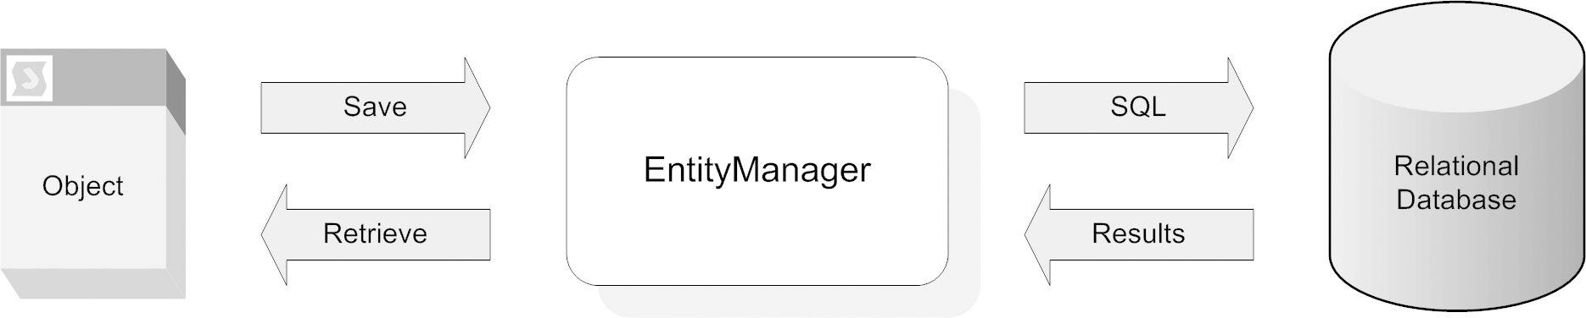

The EntityManager acts as a bridge between the OO and relational worlds. It interprets the O/R mapping specified for an entity and saves the entity in the database.
Besides providing these explicit SQL-like CRUD operations, the EntityManager also quietly tries to keep entities synched with the database automatically as long as they are within the EntityManager’s reach.

When we talk about managing an entity’s state, what we mean is that the Entity-Manager makes sure that the entity’s data is synchronized with the database. The EntityManager ensures this by doing two things. First, as soon as we ask an Entity-Manager to start managing an entity, it synchronizes the entity’s state with the database. Second, until the entity is no longer managed, the EntityManager ensures that changes to the entity’s data (caused by entity method invocations, for example) are reflected in the database. The EntityManager accomplishes this feat by holding an object reference to the managed entity and periodically checking for data freshness. If the EntityManager finds that any of the entity’s data has changed, it automatically synchronizes the changes with the database. The EntityManager stops managing the entity when the entity is either deleted or moves out of persistence provider’s reach. An entity can become attached to the EntityManager’s context when you pass the entity to the persist, merge, or refresh method. Also an entity becomes attached when you retrieve using the find method or a query within a transaction.
A managed entity becomes detached when it is out of scope, removed, serialized, or cloned.
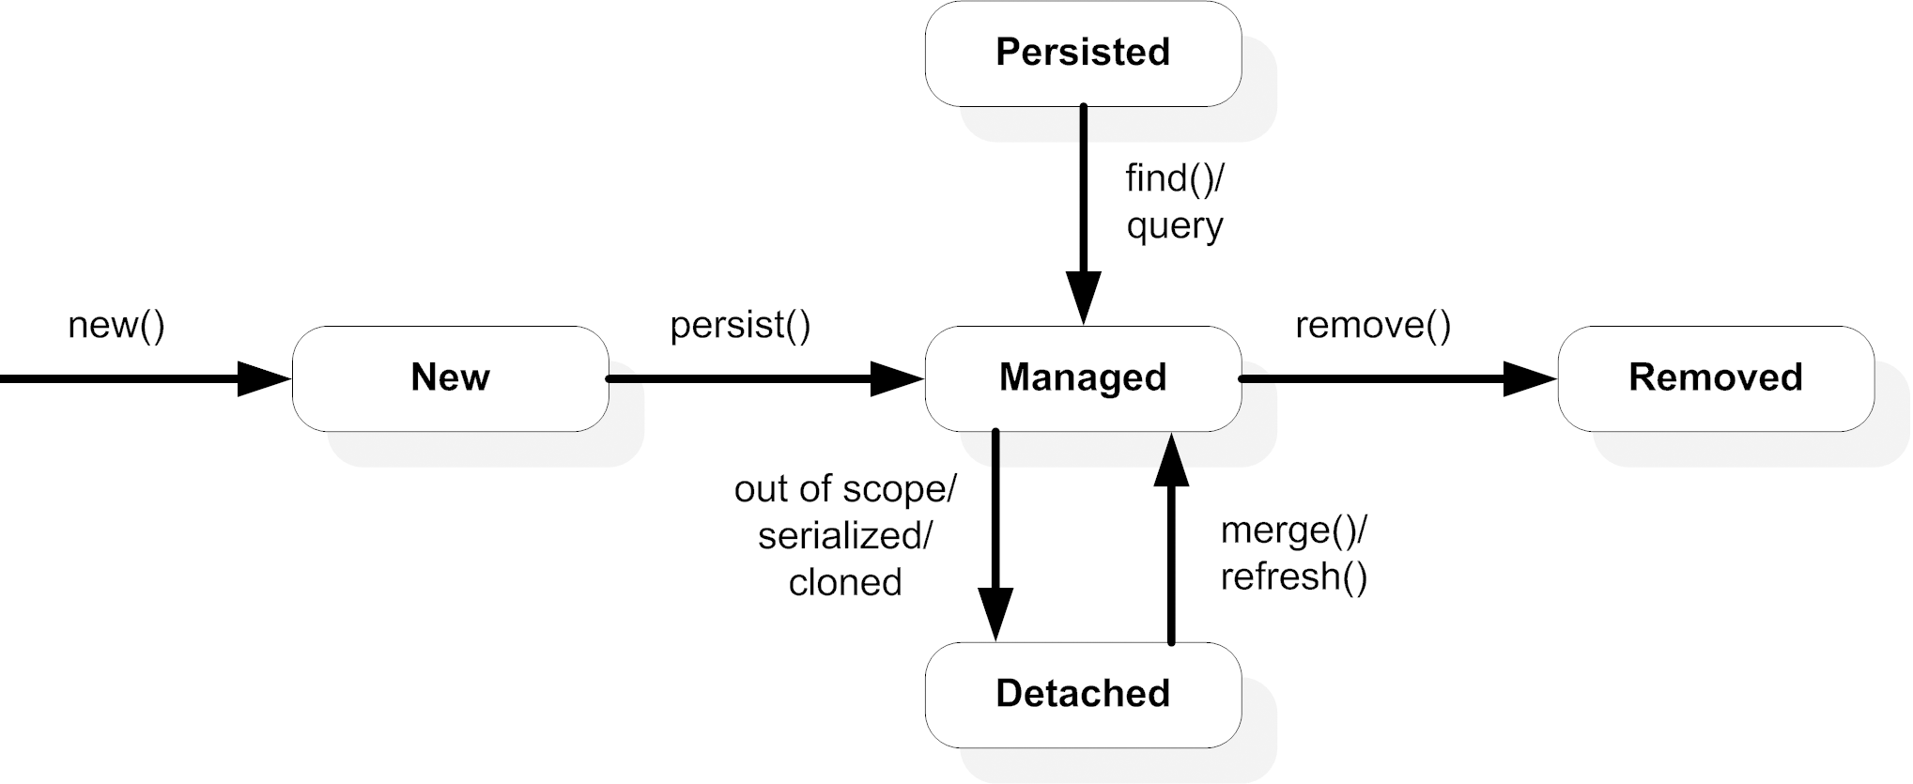
Example of using Container managed Entity-Manager
@Stateless
public class ItemManagerBean implements ItemManager {
@PersistenceContext(unitName="actionBazaar")
private EntityManager entityManager;
public ItemManagerBean() {}
public Item addItem(String title, String description,
byte[] picture, double initialPrice, long sellerId) {
Item item = new Item();
item.setTitle(title);
item.setDescription(description);
item.setPicture(picture);
item.setInitialPrice(initialPrice);
Seller seller = entityManager.find(Seller.class, sellerId);
item.setSeller(seller);
entityManager.persist(item);
return item;
}
public Item updateItem(Item item) {
entityManager.merge(item);
return item;
}
public Item undoItemChanges(Item item) {
entityManager.refresh(entityManager.merge(item));
return item;
}
public void deleteItem(Item item) {
entityManager.remove(entityManager.merge(item));
}
}

Application-managed EntityManager
An application-managed EntityManager wants nothing to do with a Java EE container.
This means that you must write code to control every aspect of the Entity-
Manager’s lifecycle. By and large, application-managed EntityManagers are most
appropriate for environments where a container is not available, such as Java SE
or a lightweight web container like Tomcat.
However, a justification to use application-managed EntityManagers inside a
Java EE container is to maintain fine-grained control over the EntityManager lifecycle
or transaction management.

@Stateless
public class ItemManagerBean implements ItemManager {
@PersistenceUnit
private EntityManagerFactory entityManagerFactory;
private EntityManager entityManager;
public ItemManagerBean() {}
@PostConstruct
public void initialize() {
entityManager = entityManagerFactory.createEntityManager();
}
...
public Item updateItem(Item item) {
entityManager.joinTransaction();
entityManager.merge(item);
return item;
}
...
@PreDestroy
public void cleanup() {
if (entityManager.isOpen()) {
entityManager.close();
}
}
...
}

Application-managed EntityManagers outside the Java EE container
EntityManagerFactory entityManagerFactory =
Persistence.createEntityManagerFactory("actionBazaar");
EntityManager entityManager =
entityManagerFactory.createEntityManager();
try
{
EntityTransaction entityTransaction =
entityManager.getTransaction();
entityTransaction.begin();
entityManager.persist(item);
entityTransaction.commit();
}
finally
{
entityManager.close();
entityManagerFactory.close();
}

With JPA, you can use the following methods to retrieve entities and related data:
■ EntityManager.find with the entity’s primary key : entityManager.find(Seller.class, sellerId);
■ Queries written in JPQL
■ SQL queries native to the underlying database

Note : you will likely choose to work with JPQL rather than SQL, since a SQL query returns database records and a JPA query returns entities.

Types of queries
The query API supports two types of queries: named and dynamic. Named and dynamic queries have different purposes. Named queries are intended to be stored and reused. Dynamic (or ad hoc) queries are different from named queries in that they are created on the fly.

Example of dynamic query to retrieve all the categories in the system:
@PersistenceContext em;
...
public List findAllCategories() {
Query query = em.createQuery("SELECT c FROM Category c"); ...
return query.getResultList(); ............
}

Example of NamedQuery :
Say you want to create a named query on the Category entity to retrieve all categories by
passing a category name. To achieve this, use the @javax.persistence.Named-Query annotation:
@Entity
@NamedQuery(
name = "findAllCategories",
query = "SELECT c FROM Category c WHERE c.categoryName
LIKE :categoryName ")
public class Category implements Serializable {

…...
Query query = em.createNamedQuery("findAllCategories");
..
}

For a complex application, you’ll probably have multiple named queries. In that case, you can use the @javax.persistence.NamedQueries annotation to specify multiple named queries like this:
@Entity
@NamedQueries({
@NamedQuery(
name = "findCategoryByName",
query = "SELECT c FROM Category c WHERE c.categoryName
LIKE :categoryName order by c.categoryId"
),
@NamedQuery(
name = "findCategoryByUser",
query = "SELECT c FROM Category c JOIN c.user u
WHERE u.userId = ?1"
)})
@Table(name = "CATEGORIES")
public class Category implements Serializable {
}

note : named queries are globally scoped. You can create a named query instance from any component that has access to the persistence unit to which the entity belongs.

Let’s recap where we are now. We’ve created an instance of the EntityManager,
and we’ve created an instance of the query. The next step is the actual execution
of the query. The Query interface provides the methods we need.

query = em.createNamedQuery("findCategoryByName");
query.setParameter("categoryName", categoryName);
query.setMaxResults(10);
query.setFirstResult(3);
List categories = query.getResultList();

In this above example, we create a query instance from a named query that was defined
earlier. Here we want to retrieve a List of Category entities by name and hence we
set the parameter. We limit the maximum number of items returned to 10, and
we position the first entity to be returned at the third item. Finally we retrieve the
result

Setting parameters for a query
The number of entities retrieved in a query can be limited by specifying a WHERE
clause. If we want to retrieve all instances of the Item entity with a specific price,
the JPQL would look like this:
SELECT i FROM Item i WHERE i.initialPrice = ?1
In this statement, we’ve used a parameter (?1) for the WHERE clause. There are
two ways we can specify this parameter: by number or by name. When we have
an integer in the parameter, we call it a positional (or numbered) parameter.
Before we execute a query, we have to set the parameter for the query:
query.setParameter(1, 100.00);
In some cases you’ll want to specify multiple parameters for a query. Say you want
to retrieve all items with an initialPrice that falls within a particular range:
SELECT i FROM Item i WHERE i.initialPrice > ?1 AND i.initialPrice < ?2
The following code should do the trick:
query.setParameter(1, 100.00);
query.setParameter(2, 200.00);

When you specify a specific name for a parameter, it’s called a named parameter.
Eg :
SELECT i FROM Item i WHERE i.initialPrice = :price
query.setParameter("price", 100.00);
As you can see, the only difference between the positional parameter and the
named parameter is the notation of the parameter itself. A positional parameter
starts with a ? followed by the parameter’s position. A named parameter starts
with : and is followed by the name of the parameter.

To retrieve a single entity :
Category cat = (Category)query.getSingleResult();

To retrieve a collection of entities :
Category cat = (Category)query.getSingleResult();

JPQL
JPQL operates on classes and objects (entities) in the Java space. SQL operates on tables, columns, and rows in the database space. While JPQL and SQL look similar to us humans, they operate in two very different worlds.
The JPQL Query Parser or Processor Engine of a persistence provider, as shown in figure below, translates the JPQL query into native SQL for the database being used by the persistence provider.
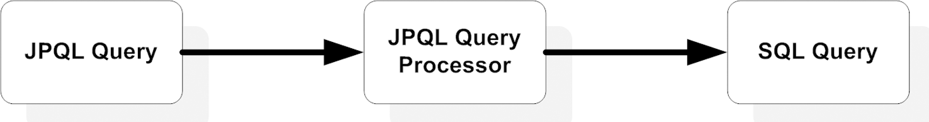

Defining and using SELECT
Suppose we get jump-started with a simple JPQL query:
SELECT c
FROM Category c
WHERE c.categoryName LIKE :categoryName
ORDER BY c.categoryId
This JPQL query has (or can have) the following:
■ A SELECT clause that specifies the object type or entity or values being
retrieved
■ A FROM clause that specifies an entity declaration that is used by other
clauses
■ An optional WHERE clause to filter the results returned by the query
■ An optional ORDER BY clause to order the results retrieved by the query
■ An optional GROUP BY clause to perform aggregation
■ An optional HAVING clause to perform filtering in conjunction with
aggregation

Using UPDATE
Only one entity type can be specified with an UPDATE statement, and we should
provide a WHERE clause to limit the number of entities affected by the statement.
Here is the syntax for the UPDATE statement:
UPDATE entityName indentifierVariable
SET single_value_path_expression1 = value1, ...
single_value_path_expressionN = valueN
WHERE where_clause
You can use any persistence field and single value association field in the SET
clause of the UPDATE statement. Assume that we want to provide Gold status and a
commissionRate of 10 percent to all Sellers whose lastName starts with Packrat.
Start with the following JPQL statement:
UPDATE Seller s
SET s.status = 'G', s.commissionRate = 10
WHERE s.lastName like 'PackRat%'

Using DELETE
Like UPDATE, DELETE in JPQL resembles its SQL cousin. You can specify only one
entity type with a DELETE statement, and again you should specify a WHERE clause
to limit the number of entities affected by the statement. Here is the syntax for
the DELETE statement:
DELETE entityName indentifierVariable
WHERE where_clause
For example, if we want to remove all instances of Seller with Silver status we’d
use this:
DELETE Seller s
WHERE s.status = 'Silver'

From Clause
FROM Category c
Category is the domain that we want to query, and here we have specified c as an
identifier of type Category. Category is the entity name.
In the previous example, we are assuming the Category entity class that we discussed
in earlier chapters does not define a name. If we assume that the Category
class defines an entity name using the name element as follows:
@Entity(name = "CategoryEntity")
public class Category
then we must change the FROM clause of the query as follows:
FROM CategoryEntity c

Identifier variables
In our JPQL example, we defined an identifier variable named c, and we used
that variable in other clauses, such as SELECT and WHERE. A simple identifier variable
is defined using the following general syntax:
FROM entityName [AS] identificationVariable
The square brackets ([]) indicate that the AS operator is optional. The identifier
variable (which is not case sensitive) must be a valid Java identifier, and it must
not be a JPQL reserved identifier.

What is a path expression?
In our JPQL example we used expressions such as c.categoryName and c.categoryId.
Such expressions are known as path expressions. A path expression is an
identifier variable followed by the navigation operator (.), and a persistence or
association field. We normally use a path expression to narrow the domain for
a query by using it in a WHERE clause, or order the retrieved result by using an
ORDER BY clause.

if we have a many-to-many relationship between
Category and Item, we can utilize a query to find all Category entities that have
associated Items as follows:
SELECT distinct c
FROM Category c
WHERE c.items is NOT EMPTY

Here c.items is a collection type. Such expressions are known as collection-value
expressions.

To retrieve the Category instances that have a categoryId greater than 500, we’d have
to rewrite the query like this:
SELECT c
FROM Category c
WHERE c.categoryId > 500
Almost all types of Java literals such as boolean, float, enum, String, int, and so
forth are supported in the WHERE clause. You cannot use numeric types such as
octal and hexadecimals, nor can you use array types such as byte[] or char[] in the WHERE clause. Remember that JPQL statements are translated into SQL; SQL is actually imposing the restriction that BLOB and CLOB types cannot be used in a WHERE clause.
Conditional expressions and operators

example of a conditional expression:
c.categoryName = 'Dumped Cars'

Operator Type : Operator
Navigational : .
Unary sign : +, -
Arithmetic : *, /,+, -
Relational : =, >, >=, <, <=, <>, [NOT] BETWEEN, [NOT] LIKE, [NOT] IN, IS [NOT] NULL, IS [NOT] EMPTY, [NOT] MEMBER
[OF]
Logical : NOT, AND, OR

Using a range with BETWEEN
You can use the BETWEEN operator in an arithmetic expression to compare a variable
with a range of values. You can also use the BETWEEN operator in arithmetic,
string, or DATETIME expressions to compare a path expression to a lower and
upper limit using the following syntax:
path_expression [NOT] BETWEEN lowerRange and upperRange
Suppose you want to filter the results so that categoryId falls within a specified
range. You can use a WHERE clause and named parameters for the range this way:
WHERE c.categoryId BETWEEN :lowRange AND :highRange
NOTE The lower and upper range used in a BETWEEN operator must be the
same data type.

Using the IN operator
The IN operator allows you to create a conditional expression based on whether a
path expression exists in a list of values. Here is the syntax for the IN operator:
path_expression [NOT] IN (List_of_values)
The list of values can be a static list of comma-separated values, or a dynamic list
retrieved by a subquery. Suppose you want to retrieve the results for userId that
exist in a static list of userIds. This WHERE clause will do the trick:
WHERE u.userId IN ('viper', 'drdba', 'dumpster')
If you want to retrieve the information from users that do not exist in the same
static list, then you can use this WHERE clause:
WHERE u.userId NOT IN ('viper', 'drdba', 'dumpster')
A subquery is a query within a query. A subquery may return a single or multiple
values. You’ll learn more about subqueries in section 10.3.8. Let’s review an
example of a subquery with an IN operator:
WHERE c.user IN (SELECT u
FROM User u
WHERE u.userType = 'A')

Using the LIKE operator
The LIKE operator allows you to determine whether a single-value path expression
matches a string pattern. The syntax for the LIKE operator is
string_value_path_expression [NOT] LIKE pattern_value_
Here pattern_value is a string literal or an input parameter. The pattern_value
may contain an underscore (_) or a percent sign (%). The underscore stands for a
single character. Consider the following clause:
WHERE c.itemName LIKE '_ike'

The percent sign (%) represents any numbers of characters. Whenever you
want to search for all Category entities with a name that starts with Recycle, use
this WHERE clause:
WHERE c.categoryName LIKE 'Recycle%'

Dealing with null values and empty collections
You can use the IS NULL or IS NOT NULL operator to check whether a single-value path expression contains null or not null values.
Eg : WHERE c.parentCategory IS NOT NULL

JPQL provides the IS [NOT] EMPTY comparison operator to check whether a collection type path expression is empty.
Eg : WHERE c.items IS EMPTY

PACKAGING

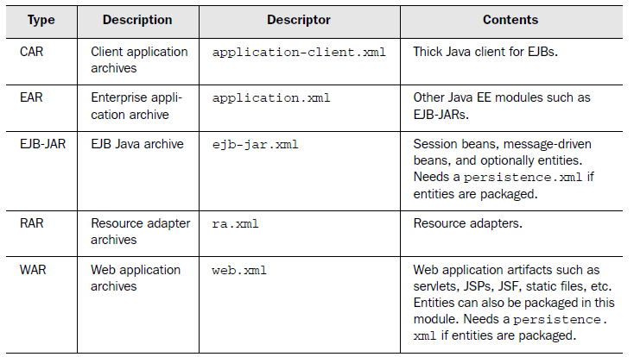

Dissecting the EAR file
META-INF/application.xml
actionBazaar-ejb.jar
actionBazaar.war
actionBazaar-client.jar
lib/actionBazaar-commons.jar
application.xml is the deployment descriptor that describes the standard Java
EE modules packaged in each EAR file.

Applocation.xml content :
<application>
<module>
<ejb>actionBazaar-ejb.jar</ejb>
</module>
<module>
<web>
<web-uri>actionBazaar.war</web-uri>
<context-root>ab</context-root>
</web>
</module>
<module>
<java>actionBazaar-client.jar</java>
</module>
</application>

Exploring class loading
There is a misconception among many developers that all classes are loaded into memory when the JVM starts up; this is not true. Classes are loaded dynamically as and when they are needed at runtime. This process of locating the byte code for a given class name and converting that code into a Java class instance is known as class loading. Your application may have hundreds of EJBs and other resources; loading all these classes into the JVM consumes a lot of memory. Most application servers use a sophisticated mechanism to load classes as and when needed. Therefore,
your EJB class will be loaded into memory only when a client accesses it. However, it is implementation specific. Application servers support the bean pooling mechanism, so EJB classes would be loaded into memory while some
instances would be instantiated and put into the pool during deployment time.

