Introduction To Ejb3.0 and Session Beans

What Is an Enterprise Bean?
Written in the Java programming language, an enterprise bean is a server-side component that encapsulates the business logic of an application. The business logic is the code that fulfills the purpose of the application.
For example: In an inventory control application, the enterprise beans might implement the business logic in methods called checkInventoryLevel and orderProduct. By invoking these methods, remote clients can access the inventory services provided by the application.

In simple words EJB = POJO + Annotations

Benefits of using EJBs
1) EJB-container can manage the ejbs, the developer just need to concentrate on the business logic
2) Portability, scalability, reusable business application
3) Can be distributed to different machines
4) EJB allows application developers to focus on building business logic without having to spend time on building infrastructure code.

Enterprise Bean Type

Session Bean: Performs a task for a client; implements a web service
Entity Bean: Represents a business entity object that exists in persistent storage
Message-Driven Bean: Acts as a listener for the Java Message Service API, processing messages asynchronously

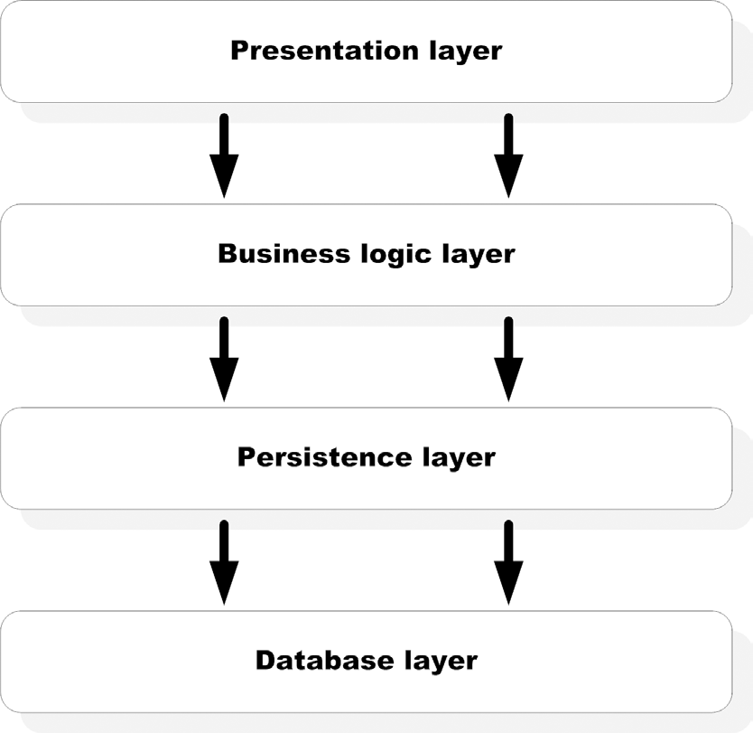
Figure1 - layered architecture

-Session beans and message-driven beans are used to implement business logic in an EJB application, and they live in the ejb-container, which manages these beans and provides services to them.

-Entities are used for persistence. It is the persistence provider that manages entities. A persistence provider is pluggable within the container and is abstracted behind the Java Persistence API (JPA).

Figure 2: Overall organization of the EJB 3 API. The Java persistence API is completely separable from the EJB 3 container. The business logic processing is carried out by two component types: session beans and message-driven beans. Both components are managed by the container. Persistence objects are called entities, which are managed by the persistent provider through the EntityManager interface.

What Is a Session Bean?
A session bean represents a single client inside the Application Server. To access an application that is deployed on the server, the client invokes the session bean's methods. The session bean performs work for its client, shielding the client from complexity by executing business tasks inside the server. The name session implies that a bean instance is available for the duration of a “unit of work” and does not survive a server crash or shutdown.
-Session beans are the only EJB components that are invoked directly by clients. A client can be anything, such as a web application component (servlet, JSP, JSF, and so on), a command-line application, or a Swing GUI desktop application. A client can even be a Microsoft .NET application using web services access.
- Session bean implementation classes can never be abstract, which means that all methods mandated by declared business interfaces must be implemented in the class.
- Note that EJB implementation classes can have nonprivate methods that are not accessible through any interface. Such methods can be useful for creating clever unit-testing rameworks and while implementing lifecycle callback.
- Each session bean implementation has two distinct parts—one or more bean interfaces and a bean implementation class. All session beans must be divided into these two parts. This is because clients cannot have access to the bean implementation class directly. Instead, they must use session beans through a business interface.

Session Beans programming rules :
- A session bean must have at least one business interface.
- The session bean class must be concrete. You cannot define a session bean class as either final or abstract since the container needs to manipulate it.
- You must have a no-argument constructor in the bean class. As we saw, this is because the container invokes this constructor to create a bean instance when a client invokes an EJB. Note that the compiler inserts a default noargument constructor if there is no constructor in a Java class.
- A session bean class can subclass another session bean or any other POJO.
For example, a stateless session bean named BidManager can extend another session bean PlaceBidBean in the following way:
@Stateless
public BidManagerBean extends PlaceBidBean implements BidManager {
...
}
- The business methods and lifecycle callback methods may be defined either in the bean class or in a superclass. It’s worth mentioning here that annotation inheritance is supported with several limitations with EJB 3 session beans. For example, the bean type annotation @Stateless or @Stateful specified in the PlaceBidBean superclass will be ignored when you deploy the BidManagerBean.
- Business method names must not start with “ejb.” For example, avoid a method name like ejbCreate or ejbAddBid because it may interfere with EJB infrastructure processing. You must define all business methods as public, but not final or static. If you are exposing a method in a remote business interface of the EJB, then make sure that the arguments and the return type of the method implement the java.io.Serializable interface.

2 Types of Session Ejbs:
1) Stateful Session Bean
2) Stateless Session Bean

Stateless
Stateless session beans do not maintain any state and model application services that can be completed in a single client invocation. You could build stateless session beans for implementing business processes such as charging a credit card or checking customer credit history.
A session bean can be invoked either locally or remotely using Java RMI. A stateless session bean can be exposed as a web service.

Bean life cycle
The container manages almost every aspect of session beans. This means that neither the client nor the bean is responsible for determining when bean instances are created, when dependencies are injected, when bean instances are destroyed, or when to take optimization measures. The most obvious two events of a bean lifecycle are creation and destruction. All EJBs go through these two phases. In addition, stateful session beans go through the
passivation/activation cycle. The lifecycle for a session bean starts when a bean instance is created. This typically happens when a client receives a reference to the bean either by doing a JNDI lookup or by using dependency injection. The following steps occur when a bean is initialized:
1) The container invokes the newInstance method on the bean object. This essentially translates to a constructor invocation on the bean implementation class.
2) If the bean uses DI, all dependencies on resources, other beans, and environment
components are injected into the newly created bean instance.
After the container determines that an instance is no longer needed, the instance is destroyed.

Understanding lifecycle callbacks
Lifecycle callbacks are bean methods (not exposed by a business interface) that the container calls to notify the bean about a lifecycle transition, or event. When the event occurs, the container invokes the corresponding callback method, and you can use these methods to perform business logic or operations such as initialization and cleanup of resources.
Callback methods are bean methods that are marked with metadata annotations such as @PostContruct and @PreDestroy. They can be public, private, protected, or package-protected. A Post-Construct callback is invoked just after a bean instance is created and dependencies are injected. A PreDestroy callback is invoked just before the bean is destroyed and is helpful for cleaning up resources used by the bean.
While all session beans have PostConstruct and PreDestroy lifecycle events, stateful session beans have two additional ones: PrePassivate and PostActivate. Since stateful session beans maintain state, there is a stateful session bean instance for each client, and there could be many instances of a stateful session bean in the container. If this happens, the container may decide to deactivate a stateful bean instance temporarily when not in use; this process is called passivation. The container activates the bean instance again when the client needs it; this process is called activation. The @PrePassivate and @PostActivate annotations apply to the passivation and activation lifecycle events.
Callbacks must follow the pattern of void <METHOD>(). Unlike business methods, callbacks cannot throw checked exceptions (any exception that doesn’t have java.lang.RuntimeException as a parent).

Example of Stateless session bean:

Stateless session bean:

Interface

Description:
Some important annotations used by stateless session beans:
- @Stateless :
The @Stateless annotation tells the EJB container that Place-BidBean is a stateless session bean. This means that the container automatically provides such services to the bean as automatic concurrency control, thread safety, pooling, and transaction management. In addition, you can add other services for which stateless beans are eligible, such as transparent security and interceptors. In this annotation some params can also be added as shown : @Stateless( name="something...", mappedName="something else...")
- mappedName => is the vendor specific JNDI name
- name => uniquely identifies a EJB within a deployment unit. Although it may not be used during lookup, its there to identify a bean in a deployment unit. This most of the times is used internally by the application servers. Some containers use this parameter to bind the EJB to the global JNDI tree. the name parameter is optional since it is defaulted to an empty String. If the name parameter is omitted, the container assigns the name of the class to the bean.
- description

Client applications can invoke a stateless session bean in three different ways. In addition to local invocation within the same JVM and remote invocation through RMI, stateless beans can be invoked remotely as web services.

If the interface is marked with annotation @Local : the jndi name will go into java:global
If the interface is marked with annotation @Remote : the jndi name will go into a seperate block

- @local :
The @Local annotation on the PlaceBid interface tells the container that the PlaceBid EJB can be accessed locally(means same jvm) through the interface. Since EJB and servlets are typically collocated in the same application, this is probably perfect.

- @Remote :
The @Remote annotation on the interface tells the container that the EJB can be accessed remotely that is from diff jvm(using rmi). If EJB and servlets are typically located in different jvms, this annotation will be used by the interface.

- @WebService :
If the EJB needs to be accessed by non-Java clients like Microsoft .NET applications, web services, based remote access can be enabled using the @WebService annotation applied either on the interface or the bean class. The ability to expose a stateless session bean as a SOAP-based web service is one of the most powerful features

A client to use the stateless ejb made above:

Stateful
A Stateful session bean automatically saves bean state between client invocations without your having to write any additional code. A typical example of a state-aware process is the shopping cart for a web merchant like Amazon.
Unlike with stateless beans, the container makes sure that subsequent method invocations by the same client are handled by the same stateful bean instance.

Rules to use stateful beans
- Stateful bean instance variables used to store conversational state must be Java primitives or Serializable objects.
- Since stateful session beans cannot be pooled and reused like stateless beans, there is a real danger of accumulating too many of them if we don’t have a way to destroy them. Therefore, we have to define a business method for removing the bean instance by the client using the @Remove annotation.
- In addition to the PostConstruct and PreDestroy lifecycle callback methods, stateful session beans have the PrePassivate and PostActivate lifecycle callback methods. A PrePassivate method is invoked before a stateful bean instance is passivated and PostActivate is invoked after a bean instance is brought back into the memory and is method ready.

Sateful Session Bean Interface:
Stateful session beans support local and remote invocation through the @Local and @Remote annotations.
However, a stateful session bean cannot have a web service endpoint interface.
This is because SOAP-based web services are inherently stateless in nature.
Also, you should always include at least one @Remove annotated method in your
stateful bean’s business interface.

Life Cycle Flow:
The container follows these steps:
1) Always creates new bean instances using the default constructor whenever
a new client session is started.
2) Injects resources.
3) Stores the instance in memory.
4) Executes the requested business method invoked through the business
interface by the client.
5) Waits for and executes subsequent client requests.
6) If the client remains idle for a period of time, the container passivates the
bean instance. Essentially, passivation means that the bean is moved out
of active memory, serialized, and stored in temporary storage.
7) If the client invokes a passivated bean, it is activated (brought back into
memory from temporary storage).
8) If the client does not invoke a passivated bean instance for a period of
time, it is destroyed.
9) If the client requests the removal of a bean instance, it is first activated if
necessary and then destroyed.

Life-Cycle callback methods:
- @PostConstruct : Same role as it plays in stateless bean
- @PreDestroy : Same role as it plays in stateless bean
- @PrePassivate
- @PostActivate
Passivation and activation :
If clients don’t invoke a bean for a long enough time, it is not a good idea to continue
keeping it in memory. For a large number of beans, this could easily make the machine run out of memory. The container employs the technique of passivation to save memory when possible.
NOTE Passivation essentially means saving a bean instance into disk instead of holding it in memory. The container accomplishes this task by serializing the entire bean instance and moving it into permanent storage like a file or the database. Activation is the opposite of passivation and is done when the bean instance is needed again. The container activates a bean instance by retrieving it from permanent storage, deserializing it, and moving it back into memory. This means that all bean instance variables that you care about and should be saved into permanent storage must either be a Java primitive or implement the java.io.Serializable interface

The point of the PrePassivate callback is to give the bean a chance to prepare for serialization. This may include copying nonserializable variable values into Serializable variables and clearing unneeded data out of those variables to save total disk space needed to store the bean. Most often the prepassivation step consists of releasing heavy-duty resources such as open database, messaging server, and socket connections that cannot be serialized. A well-behaved bean should ensure that heavy-duty resources are both closed and explicitly set to null before passivation takes place.

Features | Stateless | Stateful
Conversational state | No | Yes
Pooling | Yes | No
Performance problems | Unlikely | possible
Lifecycle events | PostConstruct,  PreDestroy | PostConstruct, PreDestroy,  PrePassivate, PostActivate
Timer | Yes | no
SessionSynchronization for  transactions | No | yes
Web services | Yes | No
Extended PersistenceContext | No | Yes

Example of stateful session bean :

Stateful session bean :

Interface
package ejb3inaction.example.buslogic;
import javax.ejb.Remote;
@Remote
public interface PlaceOrder {
void setBidderId(Long bidderId);
void addItem(Long itemId);
void setShippingInfo(ShippingInfo shippingInfo);
void setBillingInfo(BillingInfo billingInfo);
Long confirmOrder();
}

Description :

- @Stateful: The state of the bean is maintained for specific session.

- @Remove:
The @Remove annotation marks the end of the workflow modeled by a stateful bean. In our case, we are telling the container that there is no longer a need to maintain the bean’s session with the client after the confirmOrder method is invoked. If we didn’t tell the container what method invocation marks the end of the workflow, the container could wait for a long time until it could safely time-out the session. Since stateful beans are guaranteed to be dedicated to a client for the duration of a session, this could mean a lot of “orphaned” state data consuming precious
server resources for long periods of time!

- @Remote:
The @Remote annotation on the interface tells the container that the EJB can be accessed remotely that is from diff jvm(using rmi). If EJB and servlets are typically located in different jvms, this annotation will be used by the interface.

Stateful session bean client:
package ejb3inaction.example.buslogic;
import javax.ejb.EJB;
public class PlaceOrderTestClient {
@EJB
private static PlaceOrder placeOrder;
public static void main(String [] args) throws Exception {
System.out.println("Exercising PlaceOrder EJB...");
placeOrder.setBidderId(new Long(100));
placeOrder.addItem(new Long(200));
placeOrder.addItem(new Long(201));
placeOrder.setShippingInfo(
new ShippingInfo("123 My Sweet Home",
"MyCity","MyState"));
placeOrder.setBillingInfo(
new BillingInfo("123456789","VISA","0708"));
Long orderId = placeOrder.confirmOrder();
System.out.println("Order confirmation number: " + orderId);
}
}

Session Bean Client:
Almost any Java component can be a session bean client. POJOs, servlets, JSPs, or other EJBs can access session beans. In fact, stateless session beans exposed through web services endpoints can even be accessed by non-Java clients such as .NET applications.

A session bean client follows these general steps to use a session bean:
1)The client obtains a reference to the beans directly or indirectly from JNDI.
2)All session bean invocations are made through an interface appropriate
for the access type.
3)The client makes as many method calls as are necessary to complete the
business task at hand.
4)In case of a stateful session bean, the last client invocation should be a
remove method.

Ways to get access to the session bean:
1)Dependency injection : i.e, using the @Ejb annotation.
the @EJB annotation is specifically intended for injecting session beans into client code. Also recall that since injection is only possible within managed environments, this annotation only works inside another EJB, in code running inside an application-client container
(ACC), or in components registered with the web container (such as a servlet or JSF backing bean).
@Ejb annotation has 3 parameters :
-Name : The name element suggests the JNDI name that is used to bind the injected EJB in the environment naming context.
-BeanInterface : The beanInterface specifies the business interface to be used to access the EJB.
-BeanName : The beanName element allows us to distinguish among EJBs if multiple EJBs implement the same business interface.
Keep in mind that you must not inject a stateful session bean into a stateless object, such as a stateless session bean or servlet that may be shared by multiple concurrent clients (you should use JNDI in such cases instead). However, injecting an instance of a stateless session bean into a stateful session bean is perfectly legal.

2)using EJB context lookup

3)using JNDI lookup

