1.pwd-displays the full path name of the current working directory

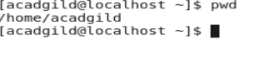

2.vi-It is the screen editor for Unix. It is widely –used default text editor for Unix-based systems and is shipped with vitually all versions of Unix.

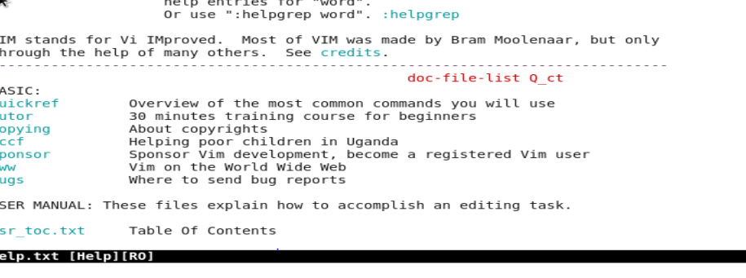

3.touch-It is used to create new empty files and change date and time stamp for the files.

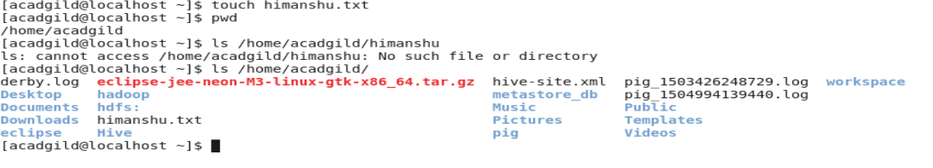

4.mkdir-It is used to create a directory

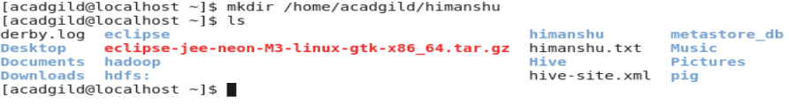

5.rm-It is used for deleting files or directories.

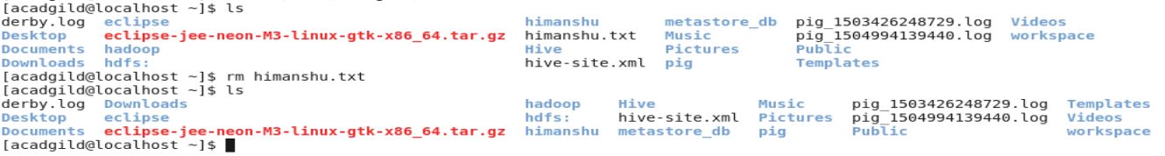

6.ls-List all the files in the current directory



7. echo- It is a command typically used in **shell scripts** and **batch files** to output status text to the screen or a file.

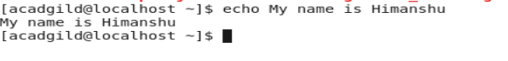

8. cat-It allows to single or multiple files, view contains of a file and concatenates files.

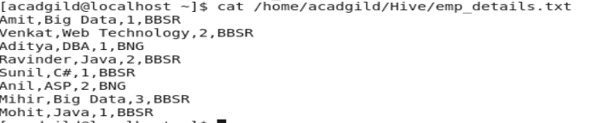

9.who- To show a list of all the users currently logged in to the system.Other features are listed in the below screenshot.

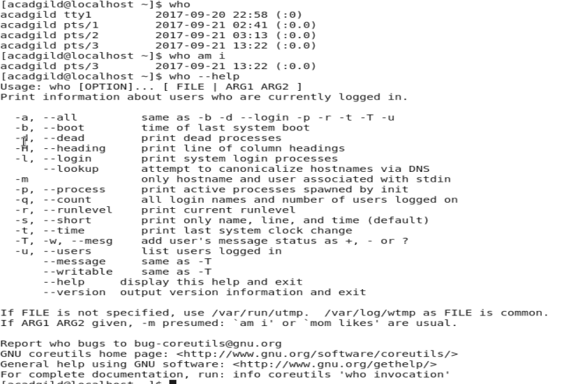

10.cd- It is used to change the working directory.

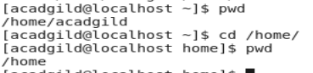

11.date – display the current time and date in given format

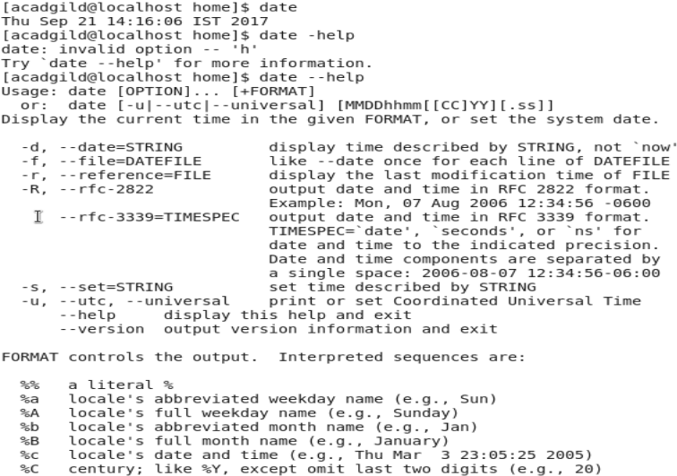

12.cal – display the current month calendar

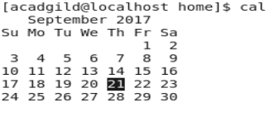

13. mv-It is used to move files from one location to another.

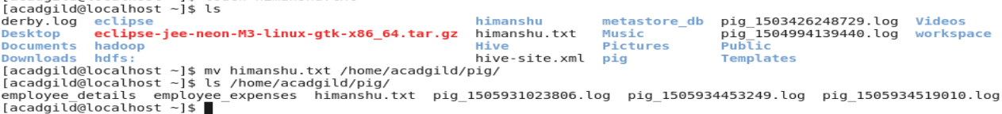

14.cp-It is used to copy files and directories from one location to another.

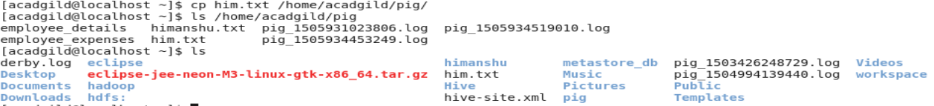

15.which – writes the full path of command to standard output.

