Pokemon Use Case Analysis

Data is loaded from the Pokemon.csv file to the Pig table using below commands given in the screenshot

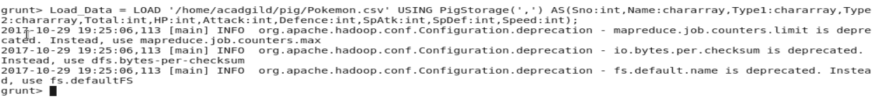

1)Command:

Selected_list = filter Load_Data by Defence>55;

Output:

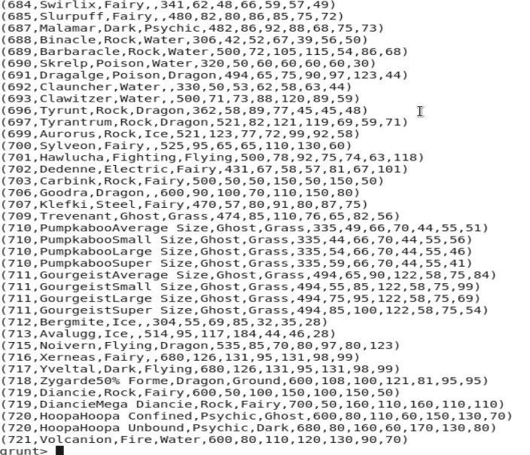

2)

Command:

Group_selected_list = group selected_list ALL;

Count_selected_list= foreach Group_selected_list GENERATE COUNT(selected_list) ;

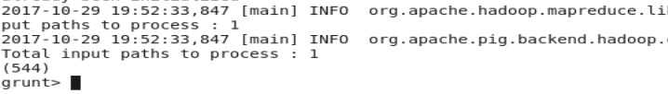

3)

Command:

random_include1 = foreach selected_list GENERATE RANDOM(),Name,Type1,Type2,Total,HP,Attack,Defense,SpAtk,SpDef,Speed;

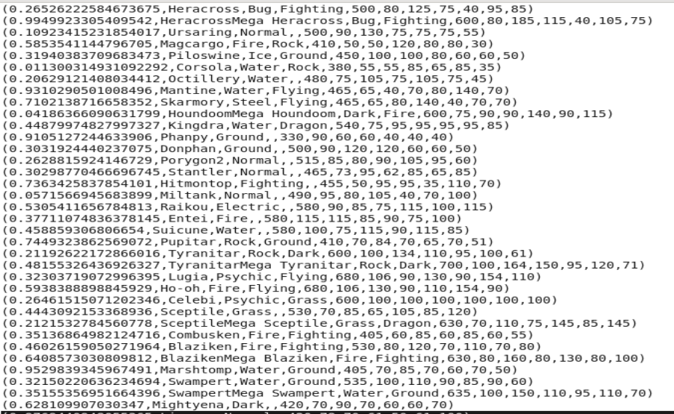

4)

Command:

random1_desending = ORDER random_include1 BY $0 DESC;

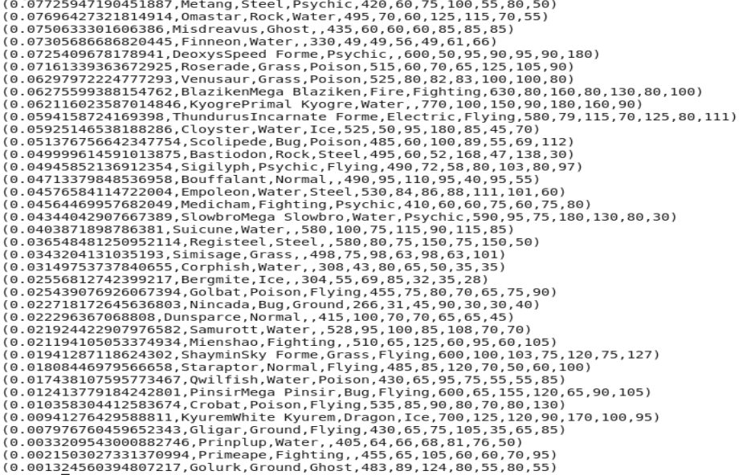

5.

Command Line:

random_include2 = foreach selected_list GENERATE RANDOM(),Name,Type1,Type2,Total,HP,Attack,Defense,SpAtk,SpDef,Speed;

random2_desending = ORDER random_include2 BY $0 DESC;

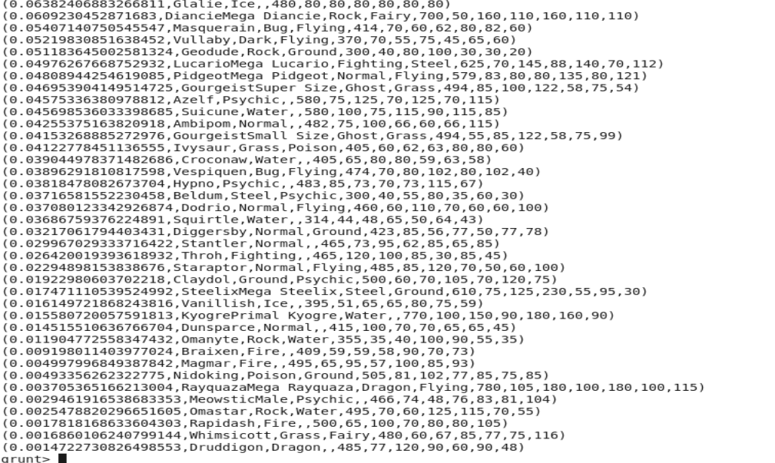

6.

Command Line:

limit_data_random1_desending = LIMIT random1_desending 5 ;

limit_data_random2_desending = LIMIT random2_desending 5 ;

dump limit_data_random1_desending;

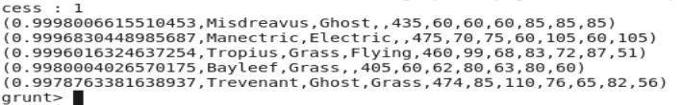

dump limit_data_random2_desending;

