After loading the csv file into Hive tables following commands were executed to get the result.

1)

Select country, sum(totalmedals)

from Olympic

where sport=’Swimming’

group by country;

Output:

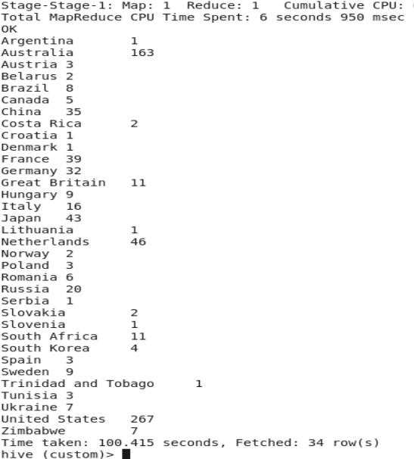

2)

Select year, sum(totalmedals)

from Olympic

where country=’Swimming’

group by year

order by year;

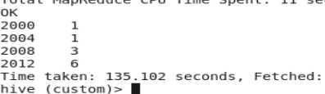

3)

Select country, sum(totalmedals)

from Olympic

group by country

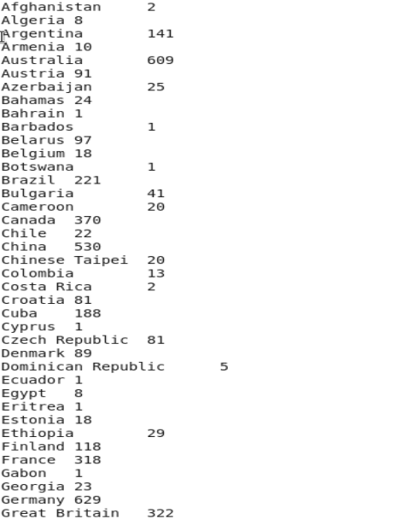

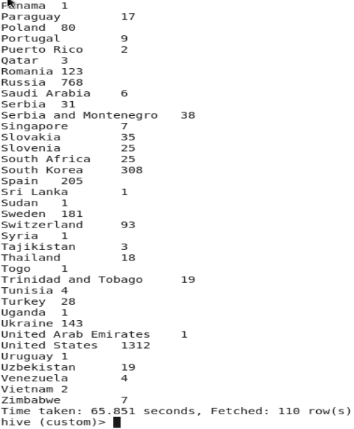

4) Select country, sum(goldmedals)

from Olympic

group by country

