# Hands-on Experiment # 3 : Worksheet

Section_____2_________ Date_____________01/02/2018_____________________

No more than 3 students per one submission of this worksheet.

Student ID ___________6031851521_______ Name_____Sarun Nuntaviriyakul_____________________

Student ID ___________6031848721_________ Name___Watcharin Kriengwatana_____________________

Student ID _________6031847021_____________ Name____Wasuthon Klyhirun______________________

This time, you are provided with a new “Java101.class” as well as its source code.

The file “Java101.class” provides a new method called *Java101.typeOf()* which can be used to determine the data type of its input value.

## Part A: Indicate Resulting Data Types of Expressions with Multiple Data Types

1. Determine the data type as well as the value of each expression in the table below.
2. Write a Java program to verify that your answers (both the data types and the values) are correct.
3. Capture a screenshot showing the output of your program.

|  |  |  |
| --- | --- | --- |
| Expression | Data Type | Value |
| 10.0/2.5 | double | 4.0 |
| “1”+2+3 | String | 123 |
| 1+“2”+3 | String | 123 |
| 3/4*4 | Int | 0 |
| 3.0/4*4 | Double | 3.0 |
| (int)1.5 | Int | 1 |
| 1+1.0F+1.0 | Double | 3.0 |
| 4-5==3-4 | Boolean | true |
| (int)(4-5.5)==3-4 | boolean | true |

List the source code of you program below.

public class TypeCheck{

public static void main(String[] args) {

System.out.println(Java101.typeOf(10.0/2.5) + ":" + (10.0/2.5) );

System.out.println(Java101.typeOf("1"+2+3) + ":" + ("1"+2+3) );

System.out.println(Java101.typeOf(1+"2"+3) + ":" + (1+"2"+3) );

System.out.println(Java101.typeOf(3/4*4) + ":" + (3/4*4) );

System.out.println(Java101.typeOf(3.0/4*4) + ":" + (3.0/4*4) );

System.out.println(Java101.typeOf((int)1.5) + ":" + ((int)1.5) );

System.out.println(Java101.typeOf(1+1.0F+1.0) + ":" + (1+1.0F+1.0) );

System.out.println(Java101.typeOf(4-5==3-4) + ":" + (4-5==3-4) );

System.out.println(Java101.typeOf((int)(4-5.5)==3-4) + ":" + ((int)(4-5.5)==3-4) );

}

}

Insert the screenshot below.

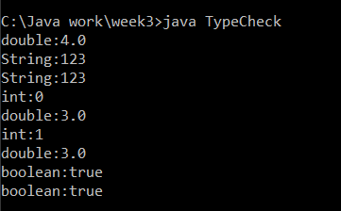

## Part B: Die Simulation

In this part, you will write a “Die Rolling Simulation” program.

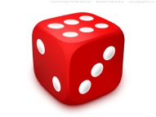

A die has six faces (1-6). When rolled, the face that comes up could be either one of the six faces, each of which with an equal probability of 1/6.

*An execution of the program simulates a roll of a die.*

The file “Java101.class” also provides a method called *Java101.showDieFace()* which takes an int value as its input. When invoked, the method shows the face of a die associated with the input value.

1. Study the following two methods: *Math.random()* and *Math.floor()* from <http://docs.oracle.com/javase/7/docs/api/java/lang/Math.html>
2. Come up with a Java expression using *Math.random()*, *Math.floor()*, and an appropriate cast operator so that the expression produces a random int value in the range of 1 to 6, each of which with equal probability.
3. Write a Java program that performs the simulation of the die described. Name the program appropriately.
4. List the source code as well as screenshots of the program.

Show your Java expression in step 2 here.

int dice = (int)Math.floor(Math.random()*6);

Also, list the source code of the program you wrote below.

import java.lang.Math;

public class RollADie {

public static void main(String[] args) {

int[] num = new int[6];

int dice;

for(int i = 0 ; i < 30 ; i++){

dice = (int)Math.floor(Math.random()*6);

Java101.showDieFace(dice+1);

num[dice] += 1;

}

for(int j = 0 ; j < 6 ; j++){

System.out.println((j+1)+":" +num[j]);

}

}

}

Insert the screenshots below.

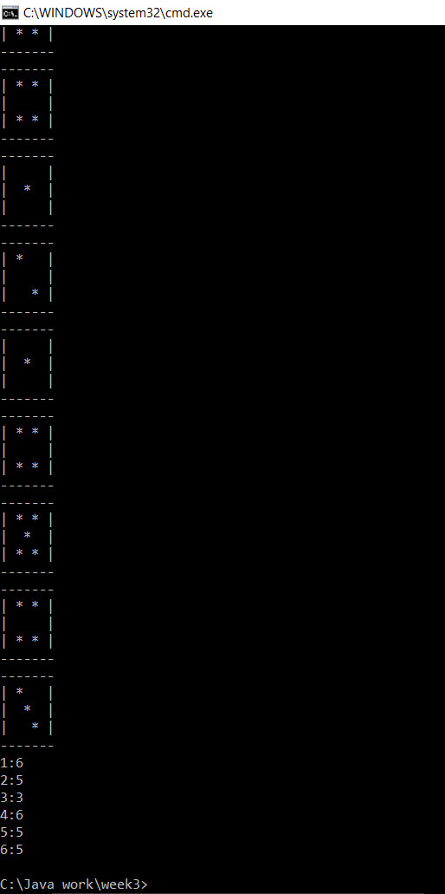

Part C: Test the Die Simulation

1. Run the program you wrote in Part B 30 times. Note the result of each simulation in the table below.

|  |  |  |  |  |  |
| --- | --- | --- | --- | --- | --- |
| Rolling # | Result | Rolling # | Result | Rolling # | Result |
| 1 | 4 | 11 | 6 | 21 | 6 |
| 2 | 6 | 12 | 1 | 22 | 5 |
| 3 | 2 | 13 | 5 | 23 | 4 |
| 4 | 2 | 14 | 6 | 24 | 1 |
| 5 | 2 | 15 | 5 | 25 | 2 |
| 6 | 4 | 16 | 1 | 26 | 1 |
| 7 | 3 | 17 | 2 | 27 | 4 |
| 8 | 3 | 18 | 1 | 28 | 5 |
| 9 | 5 | 19 | 4 | 29 | 4 |
| 10 | 6 | 20 | 1 | 30 | 3 |

1. Use the table below to approximate the probability of the die showing each of the faces.

|  |  |  |  |
| --- | --- | --- | --- |
| Face | Number of Times | Total Number of Trials | Probability of the Face (Number of Times the Results show the faces / Total Number of Trials) |
| 1 | 6 | 30 | 20% |
| 2 | 5 | 30 | 16.67% |
| 3 | 3 | 30 | 10% |
| 4 | 6 | 30 | 20% |
| 5 | 5 | 30 | 16.67% |
| 6 | 5 | 30 | 16.67% |

Submit this worksheet (by only one member of the group) via <http://www.myCourseVille.com> (Assignments > Hands-on Experiment # 3) **within the day after your lecture**.