# Hands-on Experiment # 5 : Worksheet

Section_____2_________ Date_____________14/02/2018_____________________

No more than 3 students per one submission of this worksheet.

Student ID _________6031851521________ Name___Sarun Nuntaviriyakul____________________

Student ID _________6031848721________ Name___Watcharin Kriengwatana_________________

Student ID _________6031847021________ Name___Wasuthon Klyhirun______________________

## Part A: Java API

1. Place the file “Point.class” (which is a Java 7 bytecode) in the same folder as the Java source code files you will be writing in this Hands-on Experiment.
2. Understand the source file “Point.pdf” (Point.java). Assume we want to create a point called “startPoint” at (2,3). Write the code to do the following task:
   1. Create this point
   2. Compute the distance of this point to the original point (origin)
   3. Clear this point

public class pointer {

public static void main(String[] args) {

Point startPoint = new Point(2,3);

double dis = startPoint.distance(Point.origin);

System.out.println("Distance between the two points is " + dis);

startPoint.clear();

}

}

1. Explain the difference between “static data” and “object data”

Static data belongs to the class and can be used by every object, while object data is unique to each object

## Part B: Scanner

1. Write a Java program “PointTest1.java” to read two points from user. Locations x and y are entered by user separately. The output is the distance between two points. (Hint: use “Scanner” to input data from user)
   1. List your source code below.

import java.util.Scanner;

public class PointTest1{

public static void main(String[] args) {

Scanner sc = new Scanner(System.in);

System.out.println("Please enter x1 coordinate: ");

double x1 = sc.nextDouble();

System.out.println("Please enter y1 coordinate: ");

double y1 = sc.nextDouble();

System.out.println("Please enter x2 coordinate: ");

double x2 = sc.nextDouble();

System.out.println("Please enter y2 coordinate: ");

double y2 = sc.nextDouble();

sc.close();

Point point1 = new Point(x1,y1);

Point point2 = new Point(x2,y2);

double dis = point1.distance(point2);

System.out.println("Distance between the two points is "+dis);

}

}

* 1. Capture the program output.

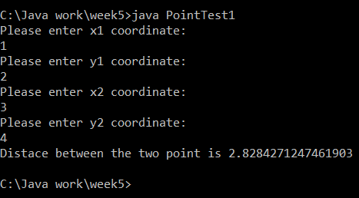

## Part C: BufferedReader (Advanced Problem)

1. Place the file “location.txt” in the same folder as the Java source code. In this file there is a single point, where x and y are shown in Line 1 and 2, respectively. Write a Java program “PointTest2.java” to read “location.txt” and output the distance to the original location (origin). (Hint: use “BufferedReader” to read data from file)
   1. What is the location in the text file “location.txt”?

C:\Java work\week5

* 1. List your source code below.

import java.io.BufferedReader;

import java.io.FileReader;

import java.io.IOException;

public class PointTest2{

public static void main(String[] args) {

try{

FileReader fr = new FileReader("C:/Java work/week2/location1.txt");

BufferedReader br = new BufferedReader(fr);

String line1 = br.readLine();

String line2 = br.readLine();

double num1 = Double.parseDouble(line1);

double num2 = Double.parseDouble(line2);

Point startPoint = new Point(num1,num2);

double dis = startPoint.distance(Point.origin);

System.out.println("Distance between the two points is " + dis);

}

catch (IOException e) {

e.printStackTrace();

}

catch (NumberFormatException e) {

e.printStackTrace();

}

}

}

* 1. Capture the program output.



* 1. Modify location in the text file to “(2, 3)”. Then, rerun your program and capture the program output.

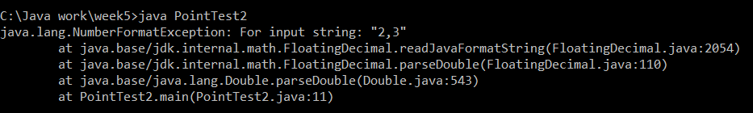

Submit this worksheet (by only one member of the group) via <http://www.myCourseVille.com> (Assignments > Hands-on Experiment # 5) **within the day after your lecture.**