Created an EC2 instance on AWS:
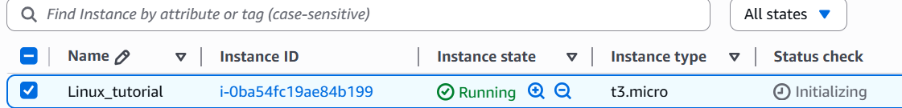
Connected to EC2 instance using SSH:
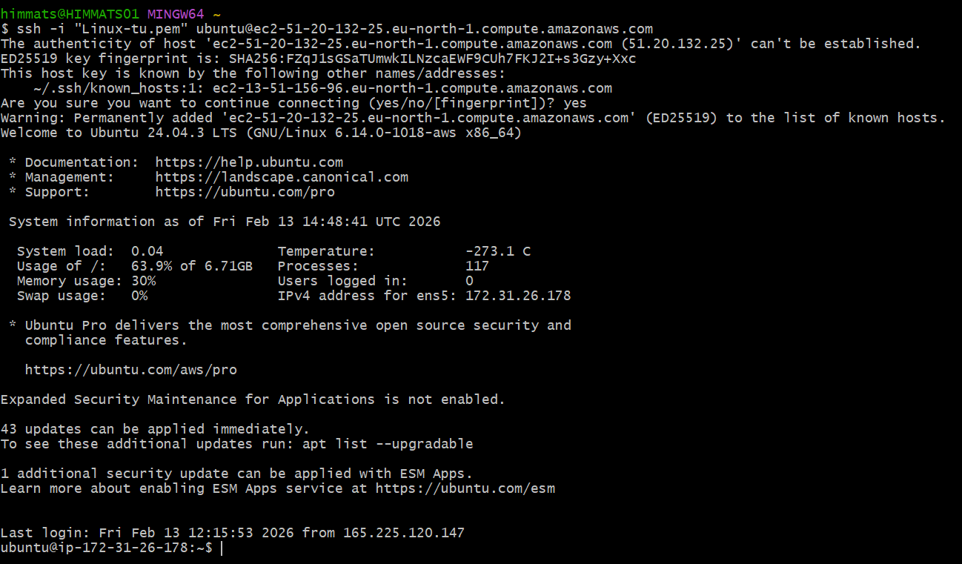
Installed nginx on ec2 server:
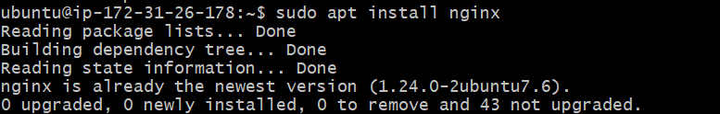
Used systemctl command to check status of nginx:
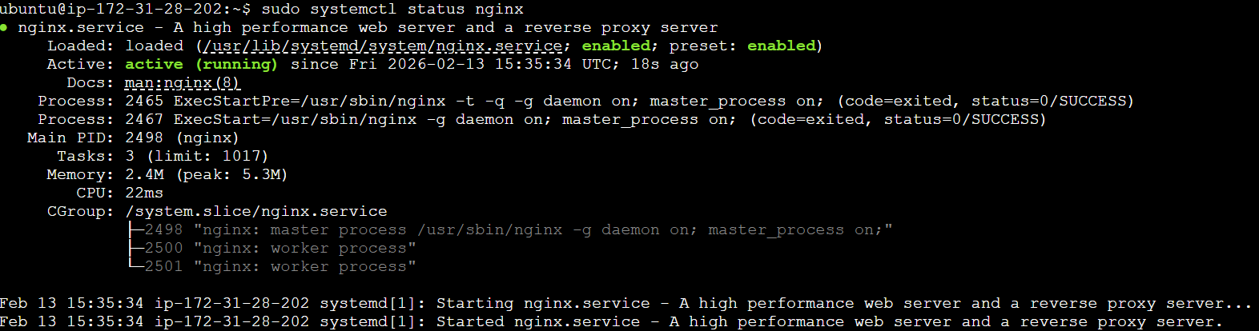
Configured security group for web access:
Added inbound rule for port 80

Nginx welcome page accessible from browser:
