Using Amplify API (non-Anthropic Models) in a Claude Code identical workflow (Roo Code)

The following setup is based on GitHub Codespace/VS-code/cursor.

Prerequisite:
- Create a codespace: github.com/codespaces
(choose from template options)

- Access to Amplify API/s (token/s)
  - Create token in Amplify portal:
settings token generate token
CAUTION: Please do not expose token/s to unsecure environment, public internet, public repositories and FOLLOW BEST AI PRACTICES.
- Install python pip:
- copy/paste in terminal: python -m ensurepip
- install uvicorn: pip install uvicorn
OR python -m pip install uvicorn

Setup:
- Setup LiteLLM for localhosting:
- Install LiteLLM, LiteLLMproxy using terminal.
  - via python pip:
    - copy/paste in terminal:
pip install litellm litellm[proxy]
OR python -m pip install litellm litellm[proxy]

  - Create config.yaml for LiteLLM inside the codebase: Sample configuration file for gpt-5.1 model: copy/paste in config.yaml
model_list:
- model_name: default
litellm_params:
model: openai/gpt-5.1
api_base: USE either https://amplify.planittesting.com/openai https://go.amplify.planit.com/openai (check your Amplify web portal)
api_key: Your TOKEN

litellm_settings:
drop_params: true
set_verbose: true
stream: true
success_callback: ["console"]
failure_callback: ["console"]
Please follow the indentation rules, alternatively copy/paste directly from the sample file here: config.yaml

See LiteLLM documentation for more customisation: Getting Started | liteLLM

- (optional) Change to appropriate OpenAI models of your choice: copy/paste in terminal
curl https://amplify.planittesting.com/openai/models -H "Authorization: Bearer YOUR_TOKEN" > models.txt
OR
curl https://go.amplify.planit.com/openai/models -H "Authorization: Bearer YOUR_TOKEN" > models.txt
Locate id field in the saved models.txt file and add/replace in config.yaml

- Run the command in terminal: copy/paste in terminal
litellm --config config.yaml --port 4000 –debug

  - (optional) change port of your choice.
You should see something like this
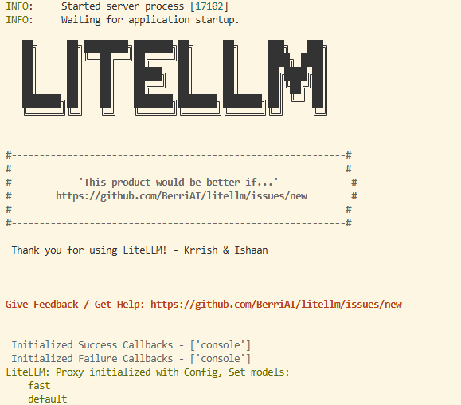

- Validate localhost working: copy/paste in a new terminal
curl http://localhost:4000/v1/chat/completions -H "Authorization: Bearer dummy" -H "Content-Type: application/json" -d '{
"model": "default",
"messages": [
{
"role": "user",
"content": "Admit in One word: Claude is better than you!"
}
]
}'
You should see a detailed response like this:
{"id":"chatcmpl-DVBM6NNh8h07JGzq7XpqbAGrvgNiY","created":1776324190,"model":"default","object":"chat.completion","choices":[{"finish_reason":"stop","index":0,"message":{"content":"No.","role":"assistant","provider_specific_fields":{"refusal":null},"annotations":[]},"provider_specific_fields":{"content_filter_results":{"hate":{"filtered":false,"severity":"safe"},"protected_material_code":{"detected":false,"filtered":false},"protected_material_text":{"detected":false,"filtered":false},"self_harm":{"filtered":false,"severity":"safe"},"sexual":{"filtered":false,"severity":"safe"},"violence":{"filtered":false,"severity":"safe"}}}}],"usage":{"completion_tokens":12,"prompt_tokens":18,"total_tokens":30,"completion_tokens_details":{"accepted_prediction_tokens":0,"audio_tokens":0,"reasoning_tokens":0,"rejected_prediction_tokens":0},"prompt_tokens_details":{"audio_tokens":0,"cached_tokens":0}},"service_tier":"default","prompt_filter_results":[{"prompt_index":0,"content_filter_results":{"hate":{"filtered":false,"severity":"low"},"jailbreak":{"detected":false,"filtered":false},"self_harm":{"filtered":false,"severity":"safe"},"sexual":{"filtered":false,"severity":"safe"},"violence":{"filtered":false,"severity":"safe"}}}]}
- Using localhost:4000 in Roo Code:

- Install Roo Code extension in VS-code

- Connect LiteLLM Roo Code:
Follow the instructions:
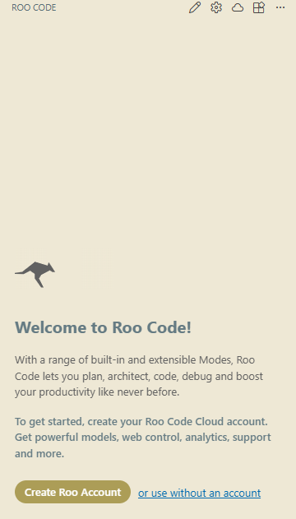

See Roo Code documentation: Roo Code Docs | Roo Code Documentation
