def rot47_decrypt(text: str) -> str:  
 result = []  
 for char in text:  
 ascii_val = ord(char)  
 if 33 <= ascii_val <= 126:  
 result.append(chr(33 + ((ascii_val - 33 - 47) % 94)))  
 else:  
 result.append(char)  
 return ''.join(result)  
  
key = 0x1A  
def xor_encrypt(text):  
 encrypted_bytes = [ord(c) ^ key for c in text]  
 return ''.join(f"{b:02X}" for b in encrypted_bytes)  
  
plaintext = "52592326272456287C2F2E782F7C7D7829457C78457F2F2E7B72792F7D7C727E7B2F7A782979792F72787F29722C2F54"  
m = rot47_decrypt(bytes([b ^ key for b in bytes.fromhex(plaintext)]).decode('utf-8', errors='replace'))  
print(m)

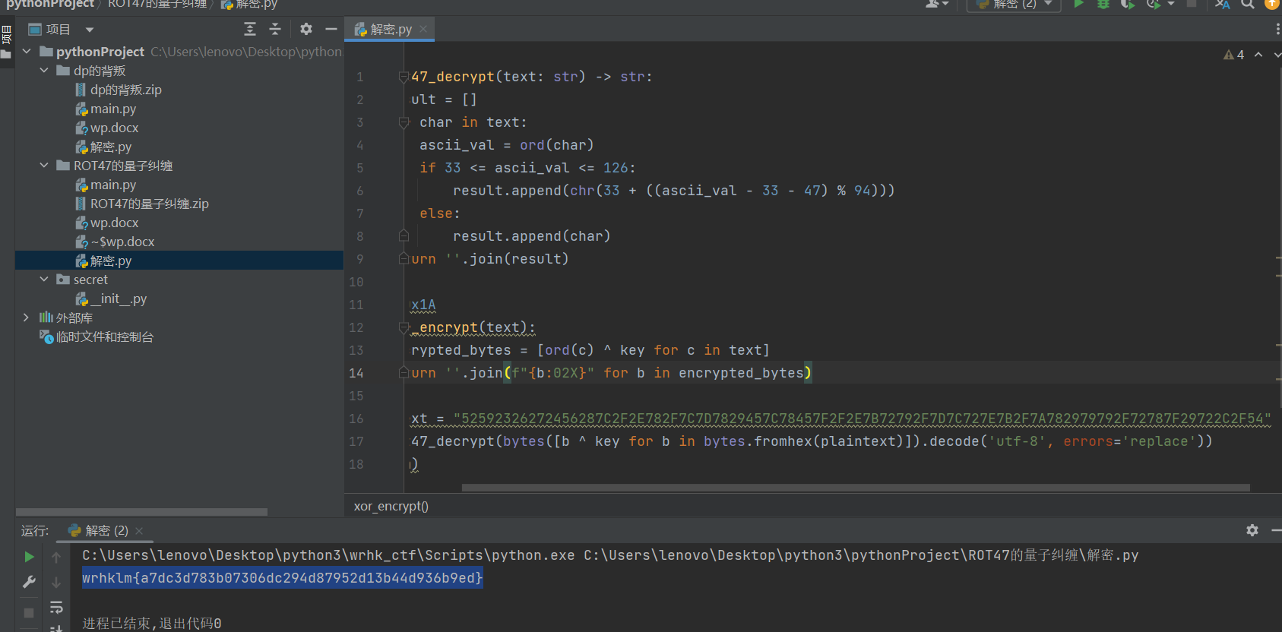

wrhklm{a7dc3d783b07306dc294d87952d13b44d936b9ed}