AI Bug-Fix Agent Workflow
Architecture and developer skill-authoring design — built on the Claude Agent SDK

1. Overview
This design describes an agent workflow that takes a bug report — a description plus attachments such as logs and UI snapshots — and carries it through reproduction, root-cause diagnosis, fix generation, verification, and human-reviewed merge. It also defines a mechanism for developers to author, share, and version reusable “debugging skill sets” that specialize the agents for a codebase or class of bug, without touching the orchestration code.
The design maps onto the Claude Agent SDK's native primitives: an orchestrator agent that delegates to purpose-built subagents, and Agent Skills (SKILL.md files) as the unit of developer-authored, reusable expertise. Each subagent is scoped to the minimum tools it needs, and every automated fix passes through a human review gate before merge — the system proposes patches, it does not auto-merge them.

2. Architecture Diagram
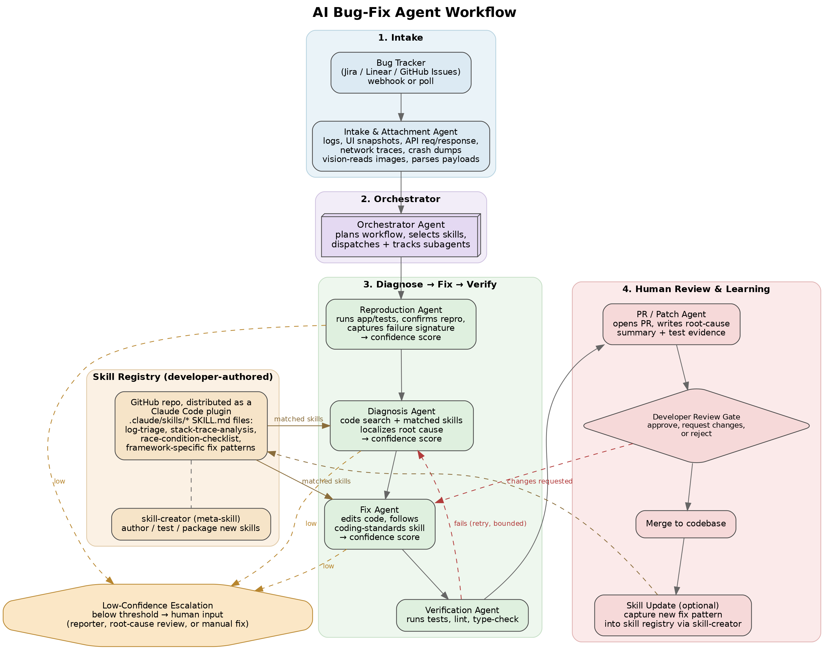

3. Workflow Stages

3.1 Intake
A connector (MCP tool) to the bug tracker — Jira, Linear, or GitHub Issues — receives new or updated tickets via webhook or poll. The Intake & Attachment Agent fetches the ticket description and downloads every attachment into an isolated workspace, then normalizes everything into a structured bug brief: environment, steps to reproduce, expected vs. actual behavior, and extracted error signatures. This brief, not the raw attachments, is what downstream agents consume.
Attachment type | What's extracted | How it's handled
Logs (app, server, crash logs) | Stack traces, error codes, timestamps, correlated request/trace IDs | Grep-style pre-filtering before the file enters the agent's context — large logs are never pasted in raw
UI snapshots (screenshots, screen recordings) | Visible error text, UI state, the sequence of steps implied by the image | Read with vision directly; recordings are frame-sampled at key moments (before/at/after the failure)
API request/response (HAR exports, curl dumps, Postman/Insomnia exports) | Endpoint, method, status code, headers, and a diff of the request/response body against the expected schema | Structured parse (JSON/HAR), not vision — secrets and PII in headers/bodies are redacted before the payload enters context
Network traces (HAR, pcap summaries) | Failed or slow calls, retry storms, timing relative to the reported failure | Parsed for the subset of requests near the failure timestamp; full trace is kept on disk, not loaded wholesale
Crash / core dumps | Offending thread, faulting instruction, memory state at crash | Handed to a specialized crash-analysis skill if one is registered (often needs native tooling); otherwise flagged for manual triage
Environment / config metadata | OS, browser or app version, feature-flag state, build/commit SHA | Attached as-is to the bug brief; used later to decide if the bug is reproducible on the current branch
Every attachment type funnels into the same bug brief, so the Diagnosis Agent reasons over one consistent structure regardless of whether the original evidence was a screenshot, a log file, or an API trace — and regardless of how many of each were attached.

3.2 Orchestration
The Orchestrator Agent owns the plan. It reads the bug brief, decides which downstream subagents to run and in what order, and — critically — which entries in the Skill Registry are relevant to this bug based on each skill's description. Skills are not hard-wired into the pipeline; Claude autonomously matches skill descriptions against the bug signature (for example, a null-pointer stack trace pulls in a null-safety-debug skill, while a flaky-test report pulls in a flaky-test-debugger skill).

3.3 Reproduction
The Reproduction Agent attempts to reproduce the bug in a sandboxed checkout: running the app, the relevant test, or a targeted script derived from the steps in the bug brief. Alongside the failure signature (stack trace, assertion diff, screenshot diff), it emits a confidence score against the rubric in section 4.1 — reproduction is not a bare pass/fail. Below the configured threshold, the workflow stops here rather than guessing (see section 4.4).

3.4 Diagnosis
The Diagnosis Agent combines codebase search (read, grep, glob) with any matched debugging skills to localize the root cause. Skills encode debugging methodology — a checklist for race conditions, a procedure for tracing a memory leak, conventions specific to the codebase's error-handling patterns — so the same base agent behaves like a specialist once the right skill is loaded. Output is a root-cause statement, the specific file/line ranges implicated, and a confidence score (section 4.2) reflecting how directly the evidence supports that root cause.

3.5 Fix Generation
The Fix Agent edits code to address the diagnosed root cause, following any coding-standards or style skills registered for the repo. It is restricted to Read, Edit, and a scoped Bash for running local build/lint commands — it cannot push, merge, or touch CI configuration. Its own confidence score (section 4.3) is capped by the Diagnosis Agent's confidence — a fix can't be more certain than the root-cause understanding it's built on.

3.6 Verification
The Verification Agent runs the existing test suite, adds a regression test that reproduces the original bug where practical, and runs lint/type-check. On failure, control returns to the Diagnosis Agent with the failure output, up to a bounded number of retries (recommended: 2–3) before the workflow escalates to a human rather than looping indefinitely.

3.7 Human Review & Merge
The PR/Patch Agent opens a pull request (or patch) containing the code change, the root-cause summary, the reproduction evidence, and test results. A human developer is the required approval gate: approve and merge, request changes (which routes back to the Fix Agent with review comments), or reject. No path in this design merges code without that gate.

3.8 Learning Loop (optional)
After a merge, the developer can optionally capture the fix pattern as a new or updated skill using the skill-creator meta-skill, so the next similar bug is diagnosed faster. This keeps the Skill Registry as the system's long-term memory instead of relying on model context alone.

4. Confidence Levels & Configuration
Reproduction, Diagnosis, and Fix each return a confidence score as part of their structured output, scored against a fixed rubric rather than a free-form self-rating. The Orchestrator reads these scores to decide whether to proceed automatically, proceed with a review flag, or stop and hand the bug to a human. Confidence degrades forward: the Fix Agent's score is capped by the Diagnosis Agent's score, since a fix cannot be more certain than the root cause it addresses.

4.1 Reproduction confidence
Level | Criteria | Default behavior
High | Reproduced deterministically; failure signature (stack trace / assertion / screenshot diff) matches the report exactly | Proceed to Diagnosis
Medium | Reproduced intermittently (e.g. 2 of 5 attempts), or symptoms match but not the exact signature | Proceed, brief flagged as “partial repro” for Diagnosis
Low | Could not reproduce within the attempt budget; behavior inferred from logs/attachments only | Configurable per repo (section 4.4) — escalate to the reporter and stop, or proceed to Diagnosis flagged low-confidence
What “done” means for a Low-confidence reproduction is not fixed by this design — it's a repo-level setting. Some teams will want to stop and get more detail from the reporter before spending a Diagnosis pass on an unconfirmed bug; others would rather let Diagnosis take a flagged, best-effort pass anyway and let a human catch a bad result at the PR review gate. Section 4.4 shows how each repo picks its own default.

4.2 Diagnosis confidence
Level | Criteria | Default behavior
High | Root cause traced to specific lines with direct causal evidence; ≥2 independent signals agree (e.g. log + failing test + code read) | Proceed to Fix
Medium | Root cause is the strongest of several plausible hypotheses; only one signal supports it, or a matched skill's checklist was only partially satisfied | Proceed to Fix; PR must list the alternative hypotheses considered
Low | Root cause is speculative — no reproducible signal ties it to a specific code path | Stop — escalate to a human before any code is edited

4.3 Fix confidence
Level | Criteria | Default behavior
High | Diagnosis was High; diff is small and localized; full suite plus a new regression test pass on the first attempt | Open PR normally
Medium | Diagnosis was Medium, the fix needed more than one Verification retry, or the diff spans multiple modules | Open PR flagged “review carefully” with retry history attached
Low | Verification never fully passed within the retry budget, or the change is a workaround rather than the diagnosed cause | No PR — stop and hand the diagnosis and attempted fixes to a human as a draft

4.4 Configuring thresholds
Thresholds and below-threshold behavior are project-configurable rather than fixed in the orchestration logic, so a team can tune how cautious the workflow is without touching agent prompts. The Orchestrator reads this config once at the start of every run:
# .claude/bugfix-workflow.yml
reproduction:
max_attempts: 5
min_confidence: medium
below_threshold: escalate_to_reporter # or: proceed_with_warning
diagnosis:
min_confidence: medium
min_independent_signals: 2
below_threshold: escalate_to_human # or: proceed_with_warning
fix:
min_confidence: medium
max_diff_lines_for_auto_pr: 150
verification_retry_budget: 3
below_threshold: draft_only
- min_confidence sets the floor each stage must clear to proceed automatically; below it, below_threshold decides what happens next.
- For reproduction specifically, below_threshold takes one of two values: escalate_to_reporter (default) stops the run and asks the reporter for more detail before Diagnosis ever starts; proceed_with_warning instead lets Diagnosis run anyway, with the bug brief marked low-confidence so downstream agents and the eventual PR reviewer know the repro wasn't confirmed. This is a per-repo choice, not a fixed rule — a team fixing customer-facing production bugs might always want the extra confirmation, while a team iterating on internal tooling might prefer to let Diagnosis take a shot regardless.
- Diagnosis supports the same two-way choice (escalate_to_human vs. proceed_with_warning); Fix does not — a Low-confidence fix always stops as draft_only, since shipping an unverified code change carries more risk than shipping an unverified diagnosis.
- max_diff_lines_for_auto_pr forces the “review carefully” flag once a fix's diff crosses this size, regardless of its confidence score.
- verification_retry_budget is the bounded retry count from section 3.6 — exhausting it without a pass is treated as Low fix confidence.
- Skill authors can tighten these defaults for the bug classes their skill covers by adding a “Confidence Policy” section to the skill body — for example, a security-related skill can force diagnosis min_confidence: high and always escalate, overriding the repo-wide default whenever that skill is the one that matched.

4.5 Calibration before going live
The default thresholds in section 4.4 are starting points, not settled numbers — a repo shouldn't take the workflow's word for what counts as “High confidence” without checking it against bugs whose real root cause and fix are already known. Before enabling the workflow on live tickets, run it in shadow mode against a curated sample of historical, already-fixed tickets and use the results both to set real thresholds and to seed the Skill Registry with the debugging knowledge the backtest shows is missing.
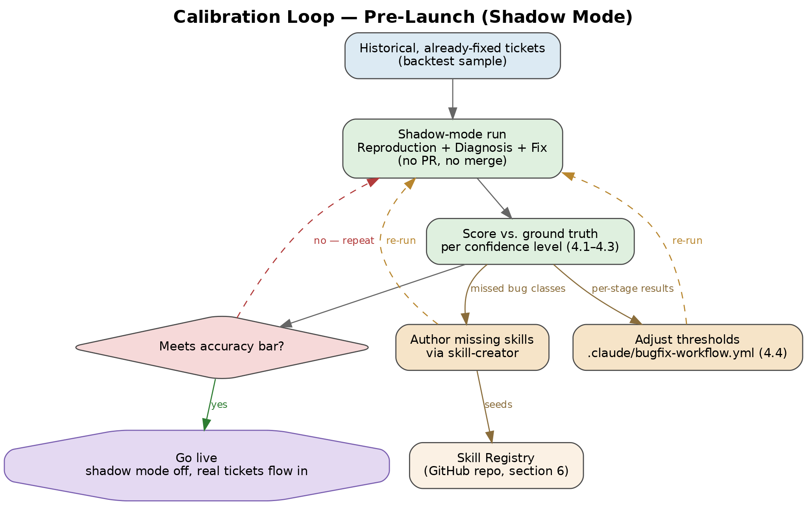
Step | What it does
1. Select a backtest sample | Pull a representative set of historical, already-closed tickets — spanning domains, bug classes, and difficulty — where the true root cause and merged fix are known
2. Run in shadow mode | Run Reproduction, Diagnosis, and Fix against each historical ticket with no PR opened and no merge possible; record each stage's confidence score alongside its output
3. Score against ground truth | For each confidence level per stage, compute how often the agent's output actually matched the known outcome — e.g. what fraction of High-confidence Diagnosis results named the real root cause
4. Adjust thresholds | Raise min_confidence for a stage if a level is scoring worse than its label implies (e.g. Medium-confidence diagnoses are right less than half the time); lower it if a level is consistently reliable and unnecessarily gating on manual review
5. Turn gaps into skills | For tickets where the pipeline diverged from the known fix on a common or recurring bug class, author a new skill (via skill-creator) encoding the missing debugging knowledge, then re-run that ticket to confirm the skill closes the gap
6. Repeat, then go live | Re-score the backtest sample after each threshold or skill change until the accuracy bar the team wants is met, then switch the repo's config from shadow mode to live
This makes calibration the primary way new skills enter the registry before the workflow has any production history to learn from — the post-merge learning loop in section 3.8 keeps the registry current once it's live, but calibration is what gives it a working starting set. Because it uses the same shadow-mode run and the same skill-creator path as ordinary operation, calibration is not a separate one-off script — it's the first few cycles of the same loop the workflow runs in production, just against known-answer tickets instead of open ones. Re-running this calibration periodically (not only once, before initial launch) is recommended whenever thresholds, skills, or the underlying model change materially.

5. Agent-to-Tool Mapping
Each subagent is defined with a restricted tool list — least privilege, so a diagnosis bug can't accidentally push a fix, and a fix bug can't accidentally close the ticket.
Subagent | Purpose | Typical tools | Notes
Intake & Attachment | Fetch ticket + attachments, extract structured brief | Tracker MCP, Read, Bash (log/HAR parsing) | Vision reads images/recordings; redacts secrets from API payloads
Reproduction | Confirm the bug, capture failure signature | Bash (run app/tests), Read | Sandboxed checkout, no write access
Diagnosis | Localize root cause | Read, Grep, Glob, Skill | Loads matched Skill Registry entries
Fix | Edit code | Read, Edit, Bash (build/lint), Skill | No git push, no CI access
Verification | Run tests, lint, type-check | Bash (test runner) | Bounded retry loop back to Diagnosis
PR / Patch | Open PR with summary + evidence | Bash (git, gh/GitLab CLI) | Cannot merge — human gate required

6. Developer Skill-Authoring System
This is the mechanism by which developers give the workflow specific debugging expertise — without modifying the orchestrator or any subagent code.

6.1 What a Skill is
A Skill is a directory containing a SKILL.md file: YAML frontmatter plus Markdown instructions, optionally alongside scripts or reference files. At startup only each skill's name and description are loaded into context; the full body is read only when the skill becomes relevant, which keeps a large skill library cheap to maintain. Skills live under .claude/skills/ and are auto-discovered — no registration step.
Field | Required | Purpose
name | No | Skill identifier
description | Recommended | What it does and when to use it — this is what the model matches against a bug signature
allowed-tools | No | Tools granted without a permission prompt while this skill drives the turn
disallowed-tools | No | Tools removed while the skill is active (e.g. block AskUserQuestion in an unattended run)
disable-model-invocation | No | Set true for skills that should only run when explicitly invoked, never auto-selected
context: fork | No | Runs the skill as an isolated subagent instead of inline in the current conversation
agent | No | Which subagent type executes the skill when context: fork is set
model | No | Override the model for the turn (or the forked subagent) this skill drives

6.2 Recommended layout for this workflow
The registry is organized by domain first, not by skill type — ownership and review responsibility naturally follow the team that knows the bug class, so domain is the boundary that matters (see section 6.7 for how this maps to scoped PR review).
.claude/skills/
frontend/
log-triage/ SKILL.md
ui-snapshot-analysis/ SKILL.md
backend/
stack-trace-analysis/ SKILL.md
race-condition-checklist/ SKILL.md
data/
sql-query-debugging/ SKILL.md
common/
flaky-test-debugger/ SKILL.md
coding-standards/ SKILL.md
meta/
skill-creator/ (author, test, package new skills)
Skills checked into the repo (project-level) are shared by the whole team and versioned with normal git history and code review — a change to a debugging skill goes through a PR like any other change. Skills that are personal shortcuts can instead live at the user level and stay out of the shared registry. common/ holds skills genuinely useful across domains (framework-agnostic debugging methodology, org-wide coding standards), so they aren't duplicated per team; meta/ holds tooling for authoring skills rather than debugging skills themselves.

6.3 Example: a diagnosis skill
Loaded automatically when the bug brief contains a stack trace. Restricted to read-only tools since it only needs to search and reason, not edit.
---
name: stack-trace-analysis
description: >
Analyzes a stack trace or crash log to localize the failing
frame and likely root cause. Use when a bug report includes
a stack trace, unhandled exception, or crash log.
allowed-tools: Read Grep Glob
---
1. Identify the innermost frame that belongs to this codebase
(skip framework/library frames).
2. Grep for the failing symbol's definition and call sites.
3. Check recent git history on the implicated file for related
changes.
4. State the root-cause hypothesis and the evidence for it
before proposing a fix location.

6.4 Example: an isolated reproduction skill
Runs as its own subagent (context: fork) so a long test run doesn't bloat the main conversation, using the built-in Explore agent for a lightweight, read-only pass.
---
name: flaky-test-debugger
description: >
Reproduces and diagnoses intermittently failing tests.
Use when a bug report describes a test that fails only
sometimes.
context: fork
agent: Explore
allowed-tools: Bash(npm test *) Bash(pytest *)
---
Run the named test 20 times in a loop. Report the failure
rate, and for each failure capture the diff between the
passing and failing run's output. Look for shared state,
timing assumptions, or unseeded randomness.

6.5 Example: an explicit, non-auto-invoked fix skill
Some skills should run only when a developer or the PR Agent deliberately invokes them — disable-model-invocation keeps them off the automatic-matching path.
---
name: coding-standards
description: Repo-specific coding and error-handling conventions
to follow when writing a fix.
disable-model-invocation: true
---
- Wrap external calls in the project's Result<T, Error> type,
never throw across module boundaries.
- New error paths must include a structured log line with
the ticket ID.
- Every bug fix adds a regression test in the same PR.

6.6 Shared registry: GitHub repository
The Skill Registry lives in a single Git repository (hosted on GitHub) and is distributed to every project as a Claude Code plugin. Claude Code discovers skills by reading .claude/skills/ on the filesystem and preloads every skill's name and description into context at startup, so the registry only needs to reach that directory — no separate indexing or query service is required for a skill to be found.
Capability | How the GitHub repo provides it
Single source of truth | One repo (e.g. org/debugging-skills) holds every SKILL.md in the layout from section 6.2, shared by every team and project instead of copied around
Versioning & rollback | Native git history: commits, tags, and releases track every change; a bad revision is one git revert away
Review & audit | Skill changes go through normal pull-request review — important since an allowed-tools grant is a permission surface (section 7), and reviewers can read the diff before it merges
Cross-project distribution | Published via Claude Code's plugin marketplace: add a .claude-plugin/marketplace.json to the repo, and any project pulls it in with /plugin marketplace add org/debugging-skills
Discovery at runtime | Claude Code reads every skill's metadata directly from the filesystem once the plugin is installed — matching a bug signature to a skill happens over that preloaded metadata, with no extra lookup step
Concretely: keep the repo's directory structure identical to section 6.2, add the marketplace manifest, and have each project or developer run /plugin marketplace add org/debugging-skills once. From then on, every Orchestrator run in that project sees the same registry, skill edits are reviewed like any other code change, and updates roll out by merging to the shared repo rather than copying files between machines.

6.7 Repository organization: one repo, scoped review
The registry stays a single repository rather than one repo per domain. A CODEOWNERS file maps each domain subdirectory from section 6.2 to the team that owns it, so GitHub routes review automatically without splitting the repo, the marketplace, or the install step:
# .github/CODEOWNERS
/.claude/skills/frontend/ @org/frontend-team
/.claude/skills/backend/ @org/backend-team
/.claude/skills/data/ @org/data-team
/.claude/skills/common/ @org/platform-team
/.claude-plugin/ @org/platform-team
Branch protection requires the matching code owner's approval before a PR touching that path can merge, so a change to frontend/log-triage is reviewed by the frontend team without the backend or data teams needing to weigh in — and without anyone maintaining a second repo, a second marketplace.json, or a second install step. This gets the org the scoped review it wants at the cost of a CODEOWNERS file, not a repo split.
A domain graduates from a subdirectory to its own repo (and its own plugin/marketplace entry) only when one of these triggers is hit — splitting preemptively along domain lines adds operational cost without a concrete problem to solve:
Trigger | Why it justifies a split
Independent release cadence | The domain needs to ship skill updates on its own schedule, and waiting on the shared repo's CI or unrelated PRs is actually blocking it
Access isolation beyond review | The domain needs push-access restriction, not just review routing — e.g. a regulated subsidiary where CODEOWNERS-scoped review isn't sufficient governance
Shared CI becomes a bottleneck | Repo-wide build/test time or flaky cross-domain tests are measurably slowing down merges for every team, not just the one growing fastest
When a split does happen: move the subdirectory to its own repo, add its own .claude-plugin/marketplace.json and CODEOWNERS, and update the affected projects to run /plugin marketplace add org/<domain>-skills alongside the main registry. Everything else in this design — the layout convention, the frontmatter fields, the confidence-policy override pattern — carries over unchanged.

6.8 Authoring workflow for developers
- Start from the skill-creator meta-skill, which scaffolds a new SKILL.md, helps write a description that triggers correctly, and can run evals to check the skill activates on the intended bug reports and not on unrelated ones.
- Test the skill in isolation against a few historical bug tickets before adding it to the shared registry.
- Check in project skills through normal code review — an allowed-tools grant is part of the diff a reviewer should read, since a skill can grant itself broad tool access.
- Version and evolve skills over time; the learning loop in section 3.8 is the main source of new skills, turning each merged fix into institutional debugging knowledge.

7. Safety Guardrails
- Human review gate before merge — no automatic merging in any path.
- Least-privilege tools per subagent (table in section 4); only the PR agent touches git remotes.
- Bounded retry loop between Verification and Diagnosis to prevent infinite fix attempts.
- Reproduction is required before a fix is attempted — the workflow does not patch code for a bug it couldn't confirm.
- Skill allowed-tools grants are reviewed in code review like any other permission change, since a malicious or careless skill could otherwise grant itself broad access.
- All work happens in an isolated checkout/sandbox, never directly against a production branch.
- Secrets, tokens, and PII found in API request/response payloads or logs are redacted at intake, before that content enters any agent's context.
- Low-confidence Reproduction, Diagnosis, or Fix results (section 4) route to a human rather than proceeding on a best guess — confidence gating is enforced by the Orchestrator, not left to each subagent's discretion.
- Thresholds run in shadow mode against historical, already-fixed tickets (section 4.5) before the workflow is enabled on live bugs, so default confidence gates are validated against known outcomes rather than assumed.

8. Open Questions for Implementation
- Which tracker (Jira / Linear / GitHub Issues) is the primary source, and is the connector push (webhook) or pull (poll)?
- Retry budget and escalation path when Verification keeps failing (Slack ping? reassign to a human? leave a draft PR with what was tried?).
- How large a backtest sample (section 4.5) is enough to trust the calibration, and what cadence should re-calibration run on afterward?

9. Appendix: Model Selection
Model choice per agent should follow two things: how costly a mistake at that stage is, and how often the stage actually runs. Diagnosis runs once (or a few bounded retries) per bug but is the highest-leverage step — Fix confidence is capped by it (section 4), so a weak diagnosis caps the whole pipeline. Verification, by contrast, runs on every retry, so it's the stage where model cost compounds fastest. That argues for spending on capability where it's diagnostic and spending on speed/cost where it's mechanical, rather than running one model everywhere.

9.1 Recommended Claude models by agent role
Every subagent definition and every SKILL.md already supports a model field (section 6.1), so these are defaults to set per subagent, with skills able to override per bug class through the same Confidence Policy mechanism already in section 4.4 — for example, a security-related skill can force model: opus-5 for Diagnosis regardless of the repo-wide default.
Subagent | Recommended model | Why
Intake & Attachment | Sonnet 5 | Vision reading of screenshots/recordings plus careful extraction from logs and API payloads; Haiku 4.5 is a viable downgrade for high-volume, simple bug classes
Reproduction | Sonnet 5 | Interpreting test/app output and matching it to the reported failure signature needs real reasoning without being the highest-stakes step
Diagnosis | Opus 5 (Sonnet 5 for cost-conscious repos) | Highest-leverage step — Fix confidence is capped by it, so a root-cause error is the most expensive mistake in the pipeline
Fix | Sonnet 5 | Claude Code's standard coding model; escalate to Opus 5 for fixes that follow a Medium-confidence diagnosis
Verification | Haiku 4.5 | Runs on every retry; mostly running commands and parsing pass/fail output — the cheapest, fastest model is the right call here
PR / Patch | Haiku 4.5 or Sonnet 5 | Root-cause summary writing is straightforward once Diagnosis has already done the reasoning
Orchestrator | Sonnet 5 | Applies the section 4.4 config policy and matches skill descriptions to a bug signature
skill-creator (meta-skill) | Sonnet 5 (Opus 5 for hard domains) | A bad skill gets reused by every future bug that matches it, so mistakes here compound
Reference pricing at time of writing: Opus 5 $5/$25 per million input/output tokens (also offered in a ~2.5x-faster Fast mode at 2x price); Sonnet 5 $2/$10; Haiku 4.5 $1/$5.

9.2 Equivalent guidance for a Google AI (Gemini) implementation
This is not a drop-in swap within the design as written — the Claude Agent SDK mechanisms this document relies on (SKILL.md auto-discovery, allowed-tools, context: fork, the Claude Code plugin marketplace, and the model field itself) are Claude-specific, and a skill's model field only accepts Claude model values. A team building this same workflow on Google's stack instead — via the Gemini API, Vertex AI, or the Gemini Enterprise Agent Platform with a custom orchestrator implementing the same stage boundaries, confidence rubric, and skill-registry concept — would map roles to Gemini models roughly as follows.
Subagent | Recommended Gemini model | Why
Intake & Attachment | Gemini 3.7 Flash | Strong native multimodal input for screenshots/recordings plus structured extraction, at workhorse pricing
Reproduction | Gemini 3.7 Flash | Google's current coding/agentic workhorse tier
Diagnosis | Gemini 3.1 Pro — but benchmark against 3.7 Flash | Pro is the deeper-reasoning tier, though Flash 3.7 has shown it can match or beat Pro on some coding benchmarks (e.g. SWE-bench Verified) — this is exactly the kind of choice the calibration process in 4.5 should settle empirically, not by tier assumption
Fix | Gemini 3.7 Flash | Same coding/agentic workhorse tier as Reproduction
Verification | Gemini 3.5 Flash-Lite | Cheapest, fastest tier for mechanical test/lint output parsing
PR / Patch | Gemini 3.5 Flash-Lite | Templated summary writing doesn't need the workhorse tier
Orchestrator | Gemini 3.7 Flash | Google positions the Flash tier as its agentic/tool-use workhorse, which matches the Orchestrator's job
skill-creator equivalent | Gemini 3.1 Pro | Same high-leverage reasoning case as the Claude recommendation
Reference pricing at time of writing: Gemini 3.1 Pro $2/$12 per million input/output tokens (preview pricing, prompts ≤200k tokens); Gemini 3.7 Flash $0.75/$3.75 introductory, rising to $1.50/$7.50 in 2027; Gemini 3.5 Flash-Lite $0.30/$2.50.
Whichever provider a team ends up on, the Diagnosis tier choice in particular shouldn't rest on published benchmarks alone: run the same historical backtest sample from section 4.5 through both candidate models for that stage and let the accuracy-against-known-outcome scoring decide, the same way thresholds and skill gaps get settled.

9.3 Portability: what changes if you use Gemini instead
Substituting Gemini isn't a uniform change — it splits into three groups depending on how tightly each part of this design leans on Claude Agent SDK mechanics specifically, rather than on the workflow logic itself.
Holds true unchanged — provider-agnostic
- Workflow stages and their responsibilities (section 3)
- The confidence rubric and below-threshold configuration (4.1–4.4)
- The calibration process (4.5)
- Safety guardrails (7)
- Repository organization and CODEOWNERS-based review scoping (6.6–6.7) — a GitHub feature, not a Claude one
None of this depends on which model runs the agents; it's workflow logic the orchestrator enforces regardless of provider.
Holds true conceptually, but needs re-implementing
- The Skill Registry as versioned, reusable debugging expertise in markdown is sound with any provider, but the mechanism sections 6.1–6.5 describe — SKILL.md frontmatter (allowed-tools, disallowed-tools, disable-model-invocation, context: fork, agent, model) and distribution via the Claude Code plugin marketplace (.claude-plugin/marketplace.json, /plugin marketplace add) — is Claude Agent SDK-specific syntax that won't parse or run in a Gemini-based stack. The markdown content and the git repo carry over; the parsing, tool-scoping, and loading logic would need to be hand-built on top of Vertex AI Agent Builder, Google's Agent Development Kit, or a custom orchestrator calling the Gemini API directly.
- The tool restrictions in section 5's table: the least-privilege principle holds, but the specific tool names (Read, Edit, Bash, Grep, Glob, Skill) are Claude-specific — a Gemini implementation needs an equivalent set of scoped function-calling tools per subagent.
Where the conclusion actually flips
Section 6.6 argued against a vector database because Claude Code exhaustively preloads every skill's name and description into context at startup, so nothing needs to be “found” via similarity search. That guarantee is a Claude Code-specific behavior, not a general property of the markdown-based registry. A custom Gemini orchestrator has no equivalent built-in discovery step, so it needs its own — keyword matching on skill descriptions is enough at small scale, but a vector index becomes a reasonable, possibly necessary choice once the registry grows, rather than the unnecessary one it was for the Claude-based design in section 6.6.
Section 9.1 (the Claude model table) stops applying if the workflow doesn't run on Claude at all; section 9.2 is the relevant model guidance for a Gemini implementation.

Implementation consideration
- need to consider 1000 bugs being worked in parallel also restricting bug fixes in same project in parallel. Multiple bugs in the same code base need to be put in a queue.
- All skillset needs to have test for validation

