[Company Name]
Subsystem Integration Design for SOC 2 Compliance
Architecture, integration specifications and evidence automation for SOC 2 Type II (Security)
Field | Value
Document ID | DES-001
Version | 1.0
Classification | Confidential
Document owner | [Head of Platform Engineering]
Approved by | [CISO / CTO]
Effective date | [YYYY-MM-DD]
Review cycle | Annually, or upon significant change
SOC 2 criteria | CC1–CC9 (all Common Criteria)
Revision history
Version | Date | Author | Summary of changes | Approver
1.0 | [YYYY-MM-DD] | [Name] | Initial release | [Name]

Contents

1. Purpose and scope
This document defines how the in-scope subsystems of [System Name] integrate with each other so that security controls are enforced by design and evidenced automatically for a SOC 2 Type II examination. It is the technical companion to the System Description (SYS-001), the policy set (POL-01 to POL-11) and the Control Matrix workbook.
Audience: platform, SRE, security and IT engineers who build and operate the integrations; control owners; and the external service auditor, who uses this document to understand how each control operates and where its evidence comes from.

1.1 In-scope subsystems
Plane | Subsystems
Identity | Identity Provider (IdP), HRIS, Endpoint/MDM
Delivery | Source Control (SCM), CI/CD Pipeline, Artifact Registry, Security Scanning
Runtime | Cloud Platform, Infrastructure as Code (IaC), Container Orchestration, Secrets Manager/KMS, Backup Service
Assurance | Logging/SIEM, Monitoring/APM, On-call/Alerting, Ticketing/ITSM, Evidence Store/GRC

1.2 Out of scope
- Physical data-center controls — carved out to the cloud provider (sub-service organization). See Section 12.
- Trust Services Categories other than Security (Availability, Confidentiality, Processing Integrity, Privacy). The design is compatible with adding them later; availability-related controls (BCP-01 to BCP-04) are included because CC7.5 and CC9.1 require them.
- Corporate systems that neither store customer data nor can affect the production system (e.g., marketing tools), unless they are in the IdP and relevant to CC6.

2. Audit framework and approach
Item | Value
Report type | SOC 2 Type II (design and operating effectiveness over a period)
Criteria | AICPA 2017 Trust Services Criteria (with Revised Points of Focus – 2022): Security / Common Criteria CC1.1–CC9.2
Description criteria | AICPA DC 200 (2018 Description Criteria, with 2022 implementation guidance)
Observation period | [Start date] to [End date] ([3/6/12] months)
Sub-service organizations | [Cloud provider], [other critical SaaS] — carve-out method
Service auditor | [CPA firm]

The service auditor tests each control for design (would it prevent/detect the risk if operated as described?) and operating effectiveness (did it operate consistently across the whole period?). The design choices in this document aim for three outcomes:
- Preventive controls enforced by the platform, not by people remembering to do things (e.g., branch rulesets, pipeline-only deploy). Automated controls are typically tested with a sample of one plus evidence the configuration did not change during the period, which dramatically reduces audit effort.
- Complete, system-generated populations for every recurring control, so the auditor can select samples without relying on manually compiled lists.
- Immutable, timestamped evidence collected continuously, so nothing has to be reconstructed at fieldwork time.

3. Design principles
# | Principle | What it means in practice | Primary criteria
P1 | Identity is the control plane | Every human reaches every subsystem through the IdP (SSO + phishing-resistant MFA + SCIM). No local accounts except vaulted break-glass. | CC6.1–CC6.3
P2 | Everything as code | Infrastructure, IAM, pipelines, detections, monitors and policies are defined in version control and change through reviewed PRs. | CC8.1, CC7.1
P3 | Pipeline is the only path to production | Humans have no standing write access to production; the CI/CD deploy identity does. | CC8.1, CC6.1, CC5.2
P4 | Short-lived, federated machine credentials | CI and workloads authenticate with OIDC/workload identity; static keys are the exception and are inventoried. | CC6.1, CC6.7
P5 | Least privilege with just-in-time elevation | Standing access is read-only; privileged access is requested, approved, time-boxed and logged. | CC6.3, CC7.2
P6 | Log everything that changes the system | Control-plane audit logs from every subsystem flow to the SIEM and an immutable archive. | CC7.2, CC4.1
P7 | Continuous control monitoring | Collectors verify key configurations daily and open tickets on drift. | CC4.1, CC4.2
P8 | Evidence is a by-product | Every control emits evidence automatically to a WORM evidence store keyed by control ID and period. | CC2.1, CC4.1
P9 | Segregation of duties by construction | Author ≠ approver is enforced in SCM; deployer is a machine identity; access reviewers are not the users they review. | CC5.1, CC3.3

4. Reference architecture
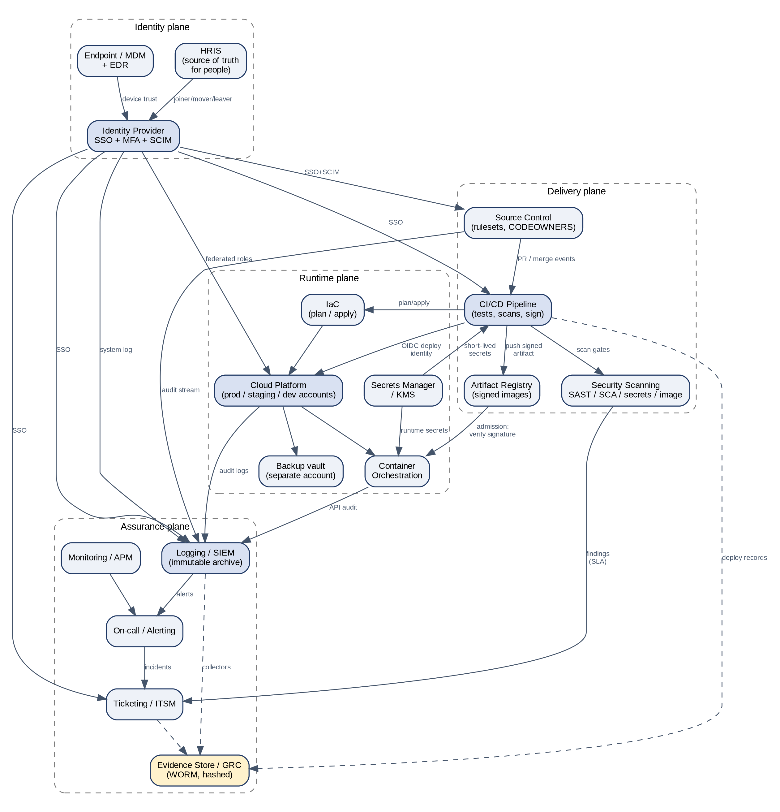
The system is organized into four planes. The identity plane decides who can do what. The delivery plane turns reviewed code into signed artifacts. The runtime plane hosts customer workloads and data. The assurance plane observes everything, raises alerts, records decisions in tickets and stores audit evidence.

4.1 Environment and account structure
Environment | Isolation boundary | Who can change it | Customer data
Production | Dedicated cloud account(s)/project(s) and cluster | CI/CD deploy identity; JIT-elevated SRE for break/fix | Yes
Staging | Separate account/project | CI/CD; engineers read-only | No (synthetic or masked only)
Development | Separate account/project(s) | Engineers | No
Security / log archive | Separate account, write-once | Log pipeline only; Security read | Log data
Backup vault | Separate account with vault lock | Backup service only | Backup copies
Shared services | Separate account (registry, CI runners) | Platform Engineering via IaC | No

Organization-level guardrails (e.g., service control policies / org policies / Azure Policy) prevent: disabling audit logging, leaving approved regions, creating long-lived IAM users, making storage public, and deleting the log archive.

5. Subsystem inventory
Code | Subsystem | Examples | Identity integration | Audit log export
SCM | Source Control | GitHub, GitLab, Bitbucket | SAML/OIDC SSO via IdP + SCIM; enforce SSO for org | Audit log streaming to SIEM (webhook / streaming API)
CI | CI/CD Pipeline | GitHub Actions, GitLab CI, Jenkins, Argo CD | SSO via IdP; deploy via OIDC workload identity to cloud | Run logs + audit events to SIEM; deployment records to evidence store
REG | Artifact Registry | ECR, Artifact Registry, ACR, Harbor, JFrog | Pull/push by workload identity; humans read-only via SSO | Registry audit events to SIEM
CLD | Cloud Platform | AWS, Azure, GCP | Federated SSO from IdP to roles; no IAM users; OIDC for CI | Control-plane audit logs (e.g., CloudTrail / Activity Log / Audit Logs) org-wide to log archive + SIEM
IAC | IaC / Config Mgmt | Terraform/OpenTofu, Pulumi, CloudFormation, Ansible | Executed only by pipeline identity; state in encrypted remote backend | Plan/apply logs archived by pipeline
K8S | Container Orchestration | EKS, AKS, GKE, OpenShift | OIDC to IdP groups for humans; workload identity for pods | API server audit logs to SIEM
IDP | Identity Provider | Okta, Microsoft Entra ID, Google Workspace, JumpCloud | Admin console with phishing-resistant MFA; admin roles least-privileged | System log to SIEM
HRIS | HRIS | Workday, BambooHR, Rippling, HiBob | SSO via IdP | Joiner/mover/leaver events to IdP; reports for audit
SIEM | Logging / SIEM | Splunk, Microsoft Sentinel, Elastic, Datadog Cloud SIEM, Panther | SSO via IdP; RBAC for analysts | Self-audit log retained; immutable archive
MON | Monitoring / APM | Datadog, Prometheus/Grafana, New Relic, Cloud-native monitoring | SSO via IdP | Monitor change audit trail
ONC | On-call / Alerting | PagerDuty, Opsgenie, incident.io | SSO via IdP | Incident timeline export
ITSM | Ticketing / ITSM | Jira, ServiceNow, Linear | SSO via IdP; workflow permissions by role | Audit log / ticket history export
SEC | Security Scanning | SAST, SCA, secret scanning, container & CSPM scanners | SSO via IdP; API tokens scoped read-only | Findings export to SIEM/ITSM
MDM | Endpoint / MDM | Intune, Jamf, Kandji + EDR | SSO via IdP; device-trust signal to IdP | Device compliance export; EDR alerts to SIEM
VAULT | Secrets Manager | HashiCorp Vault, AWS Secrets Manager, Azure Key Vault, GCP Secret Manager | Workload identity for apps/pipelines; humans via SSO + JIT | Access audit log to SIEM
BKP | Backup Service | cloud-native snapshots, AWS Backup, Velero | Service roles; backup vault in separate account with lock | Job status to MON/SIEM
GRC | Evidence Store / GRC | GRC platform or WORM object storage bucket + index | SSO via IdP; write via collector identity only | Access log; object versioning/lock

5.1 Data handled and evidence produced
Code | Integrates with | Data handled | Evidence produced | Key controls
SCM | CI, SEC, ITSM, IDP, SIEM | Source code, IaC, pipeline definitions (Confidential) | Rulesets, merged PR + review data, CODEOWNERS, secret-scanning alerts | CHG-01, CHG-02, CHG-11, INF-06, IAM-01
CI | SCM, REG, CLD, K8S, VAULT, SEC, ITSM | Build artifacts, deploy metadata, secrets at runtime (Restricted) | Pipeline run logs, gate results, deployment records (SHA->PR->run->digest) | CHG-03 to CHG-07, CHG-10, CHG-11
REG | CI, K8S, SEC | Container images, packages (Confidential) | Image signatures, provenance attestations, scan results | CHG-07, VUL-01, VUL-03
CLD | IAC, CI, K8S, SIEM, BKP, VAULT, SEC | Production customer data (Restricted) | IAM exports, config/asset inventory, encryption settings, audit logs | IAM-05, CHG-05, CHG-08, INF-01 to INF-05, BCP-04
IAC | SCM, CI, CLD | Infrastructure definitions, state files (Restricted) | Plan outputs, apply logs, policy-as-code results | CHG-10, INF-01, INF-03, IAM-05
K8S | CI, REG, CLD, SIEM, VAULT | Running workloads, customer data in transit (Restricted) | RBAC bindings, admission policy, audit logs | CHG-07, INF-01, INF-03, IAM-05
IDP | HRIS, all SSO apps (SCIM), MDM, SIEM | Identities, group membership (Confidential) | Auth policies, user/group exports, deprovisioning timestamps | IAM-01 to IAM-04, IAM-08
HRIS | IDP, LMS/GRC | Employee PII (Confidential) | Hire/term lists, background checks, acknowledgments, training | HR-01 to HR-04, IAM-02, IAM-03
SIEM | All log sources, ONC, ITSM | Security logs (Confidential) | Source health, detection rules, alerts, retention config | MON-01 to MON-03, MON-05
MON | CLD, K8S, ONC | Telemetry (Internal) | Monitor definitions, uptime history | MON-04
ONC | SIEM, MON, ITSM, chat | Incident metadata (Internal) | Schedules, escalation policies, paging history | MON-04, IR-02
ITSM | SCM, CI, SIEM, ONC, SEC, GRC | Change, access, incident records (Internal/Confidential) | Access requests, change & emergency tickets, incident & remediation tickets | IAM-02, CHG-09, IR-02, VUL-01
SEC | SCM, CI, REG, CLD, ITSM | Findings (Confidential) | Scan results, SLA reports, exception approvals | CHG-04, INF-02, VUL-01
MDM | IDP, SIEM | Device posture (Internal) | Compliance report, encryption status, wipe logs | INF-08, INF-09
VAULT | CI, K8S, CLD | Secrets & keys (Restricted) | Secret inventory, rotation age, access logs | INF-06, IAM-07, IAM-09
BKP | CLD, K8S, MON | Backup copies of production data (Restricted) | Backup job reports, restore test results | BCP-01, BCP-02
GRC | All collectors, ITSM | Audit evidence (Confidential) | Timestamped, hashed evidence packages per control per period | All controls (evidence repository)
The authoritative, editable version of this inventory is the Integration Inventory tab in the Control Matrix workbook. Source control (GitHub Enterprise Cloud), CI/CD (GitHub Actions) and ticketing (ServiceNow) are now fixed. Their concrete configuration, integration and evidence design is in DES-002. The remaining subsystems stay vendor-neutral until the information request (REQ-001) is answered.

6. Integration specifications
Each subsection below specifies the interfaces for one integration domain: what connects to what, which protocol and identity is used, what happens when it fails, and which controls depend on it.

6.1 Identity integration (HRIS ↔ IdP ↔ applications)
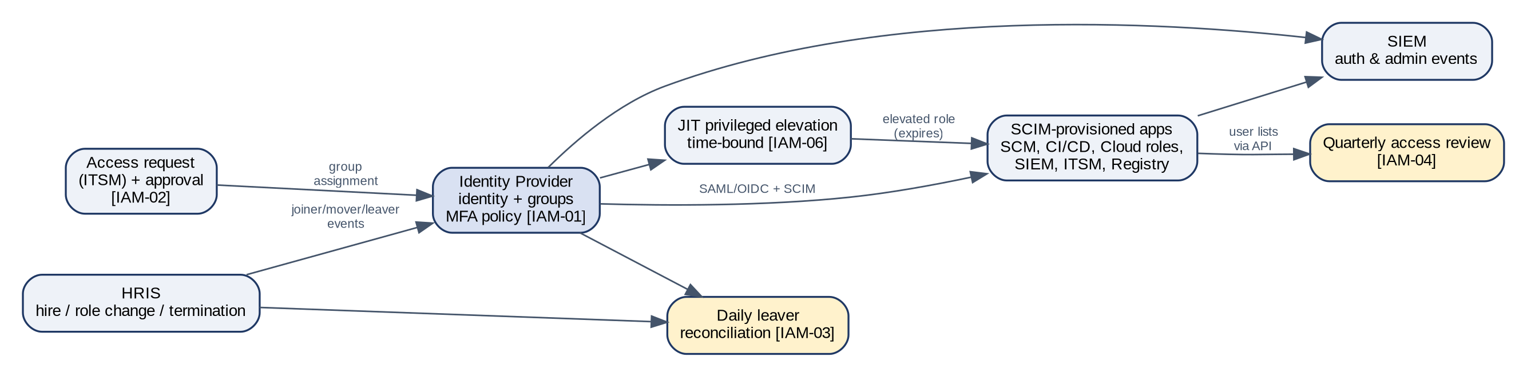

Interfaces
ID | From → To | Protocol | Identity / auth | Trigger / frequency | Failure handling
ID-1 | HRIS → IdP | HRIS connector or SCIM | OAuth client, scoped to worker data | Event-driven (hire, change, termination) + nightly full sync | Sync errors alert IT; nightly reconciliation catches missed events
ID-2 | IdP → SCM, CI/CD, SIEM, ITSM, Registry | SAML 2.0 / OIDC SSO; SCIM 2.0 provisioning | IdP signing certificate; SCIM bearer token in vault | Real time | SCIM failures alert IT; quarterly access review catches residual
ID-3 | IdP → Cloud | SAML/OIDC federation to IAM roles (identity center / federated roles) | Group → role mapping in IaC | Real time | No IAM users exist; break-glass is the fallback
ID-4 | MDM → IdP | Device-trust signal (certificate / compliance API) | MDM integration | At authentication | Non-compliant or unknown device is denied
ID-5 | IdP → SIEM | System-log streaming or API polling | Read-only API token | Streaming / ≤5 min | SIEM source-health alert if silent >1 h
ID-6 | JIT tool → Cloud / K8s | Temporary role assignment | Approver in ITSM or chat workflow | Per request, max [4] h | Auto-expiry; elevation events to SIEM

Design rules
- Authentication policy: phishing-resistant MFA (FIDO2/WebAuthn or platform authenticator) for all users; SMS and voice factors disabled; session lifetime ≤ [12] h; admin console requires re-authentication.
- Enforce SSO at every SaaS subsystem ("require SSO" / "SSO enforcement" settings) and disable password login for members. Record exceptions (e.g., owner break-glass) in the break-glass inventory.
- Access is granted via IdP groups mapped to roles; direct app-level grants are prohibited and detected by the access-review collector.
- Leavers: HRIS termination → IdP deactivation (target: minutes; policy SLA: 24 h; involuntary: immediate) → SCIM deprovisioning → session and token revocation. The col-idp-users job reconciles HRIS terminations to IdP status daily and opens a ticket for any breach.
- Service accounts and bots are owned by a named team, registered in the IdP or cloud IAM with the svc- prefix, and excluded from interactive login.

Controls relying on this integration
ID | Control | Frequency | Evidence
IAM-01 | Centralized SSO with MFA. Access to in-scope subsystems (SCM, CI/CD, cloud console/API, SIEM, ITSM, registry) is federated through the IdP with phishing-resistant MFA enforced; local accounts are disabled or break-glass only. | Continuous | IdP authentication policy config; per-app SSO enforcement settings; list of local accounts
IAM-02 | HRIS-driven provisioning (joiner). New user identities are created in the IdP from the HRIS joiner event; application access is granted via role-based groups following an approved access request. | Per event | Joiner events; access request tickets with approval for sampled hires
IAM-03 | Timely deprovisioning (leaver). Terminated users are disabled in the IdP within 24 hours of termination (immediately for involuntary); downstream app access and tokens are revoked via SCIM. | Per event | HRIS termination list vs. IdP deactivation timestamps
IAM-04 | Quarterly user access reviews. System owners review user and privileged access to in-scope subsystems quarterly; inappropriate access is removed and tracked to closure. | Quarterly | Access review workbooks with reviewer sign-off; removal tickets
IAM-05 | Least privilege and role-based access. Access is granted through predefined roles/groups; production write access is restricted to on-call/SRE roles; standing admin access is minimized. | Continuous | Role definitions; IAM policy exports; group membership
IAM-06 | Just-in-time privileged access. Privileged production access is time-bound, requested with justification, approved, and logged. | Per event | JIT elevation logs with approvals and expiry
IAM-08 | Password and authentication standards. Authentication settings (length, lockout, session timeout) conform to the Access Control Policy. | Continuous | IdP policy configuration export
IAM-09 | Break-glass accounts. Emergency accounts are vaulted, MFA-protected, alert on use, and use is reviewed. | Per event | Break-glass inventory; alert rule; usage review tickets
INF-08 | Endpoint security. Company endpoints are enrolled in MDM with disk encryption, screen lock, OS updates and EDR/anti-malware enforced; non-compliant devices are blocked from SSO. | Continuous | MDM compliance report; device-trust policy in IdP

6.2 Source control integration

Configuration baseline
Setting | Required value | Control
Organization SSO | Enforced; SCIM-managed membership | IAM-01
Member base permission | None / read | IAM-05
Default-branch ruleset | PR required; ≥1 approval; code-owner review; dismiss stale approvals on new commits; required status checks; linear history; block force-push and deletion | CHG-01
Bypass list | Empty (no admin bypass). Emergency bypass only via break-glass, which alerts | CHG-01, CHG-09
Last-push approval | Approval must come from someone other than the last pusher | CHG-02
CODEOWNERS | Required for /.ci/, /.github/workflows/ (or equivalent), /infra/, /policies/, /detections/ | CHG-11
Secret scanning | Enabled with push protection | INF-06
Dependency alerts / SCA | Enabled | CHG-04
Audit log | Streamed to SIEM | MON-01
Deploy keys / PATs | Prohibited or fine-grained with ≤90-day expiry; inventoried | IAM-07

The ruleset is itself managed as code (e.g., an org-settings repository or an IaC provider) so any change to it is a reviewed PR — and the col-scm-rulesets collector exports the effective configuration nightly and alerts on drift.

Repository scoping
Maintain an explicit list of in-scope repositories (those that build or configure production). Tag them (topic/label soc2-scope) so collectors and the auditor can derive the population deterministically. Adding a production repo without the tag is detected by comparing deployment records (Section 6.3) against the tagged list.

6.3 CI/CD pipeline integration
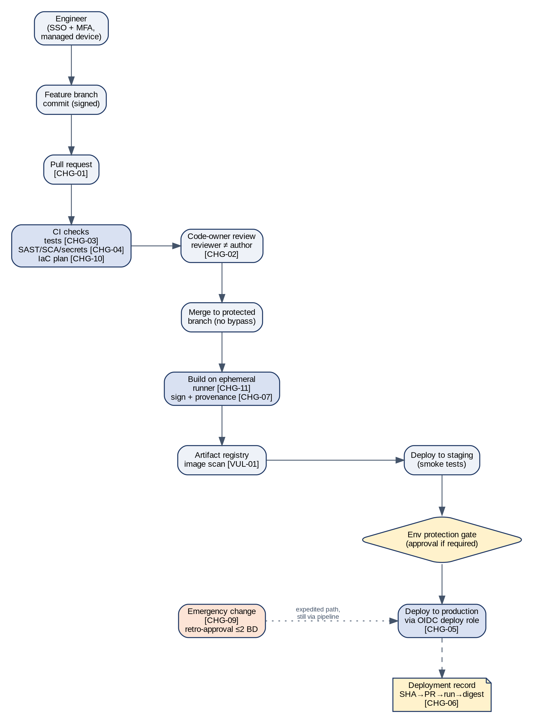

Pipeline stages and gates
Stage | Gate / action | Blocking? | Evidence emitted | Control
PR opened | Unit & integration tests | Yes | Check run result | CHG-03
PR opened | SAST, SCA, secret scan, IaC policy scan, IaC plan | Yes on Critical/High (exception requires approved ticket) | Scanner results, plan output | CHG-04, CHG-10
Review | Code-owner approval; reviewer ≠ author | Yes (SCM ruleset) | PR review record | CHG-02
Merge | Protected branch; status checks green | Yes | Merge commit | CHG-01
Build | Ephemeral runner; pinned actions/plugins by digest; SBOM generated | Yes | Build log, SBOM | CHG-11
Sign | Artifact signed; provenance attestation (e.g., SLSA) attached | Yes | Signature, attestation | CHG-07
Publish | Push to registry; image vulnerability scan | Yes on Critical | Scan report | VUL-01
Deploy staging | Automated smoke tests | Yes | Test results | CHG-03
Deploy production | Environment protection (required reviewers where policy demands); OIDC deploy role | Yes | Deployment record | CHG-05, CHG-06
Admission | Cluster rejects unsigned/unverified images | Yes | Admission log | CHG-07

Workload identity federation (no static cloud keys)
The pipeline obtains short-lived cloud credentials by presenting an OIDC token issued by the CI system. The cloud trust policy restricts which repository, branch and environment can assume the production deploy role. Illustrative, vendor-neutral trust conditions:
Trusted issuer : https://<ci-oidc-issuer>
Audience : <cloud-sts-audience>
Subject must equal:
repo:<org>/<service-repo>:environment:production
Additional conditions:
ref == refs/heads/main
workflow path == .ci/deploy.yml (pipeline file protected by CODEOWNERS)
Session duration: <= 1 hour

Deployment record schema
Every production deployment writes one record to the evidence store (deployments/<yyyy-mm>.jsonl). This is the population the auditor samples for CHG-02/05/06, and it proves traceability end to end:
{
"deploy_id": "d-2026-03-14-0042",
"timestamp_utc": "2026-03-14T18:22:05Z",
"service": "payments-api",
"environment": "production",
"commit_sha": "9f1c2e7...",
"pull_request": "https://<scm>/<org>/payments-api/pull/1234",
"pr_author": "alice",
"pr_approvers": ["bob"],
"pipeline_run": "https://<ci>/runs/987654",
"artifact_digest": "sha256:ab12...",
"signature_verified": true,
"change_ticket": "CHG-5521",
"emergency": false,
"deployer_identity": "role/prod-deployer (OIDC)"
}

Pipeline hardening
- Pipeline definitions live in the repository and are covered by CODEOWNERS (Platform + Security).
- Third-party actions/plugins are pinned to immutable digests; a policy check fails the build on unpinned references.
- Runners are ephemeral (one job per runner) and run in the shared-services account with no production network path except via the deploy role.
- Secrets are fetched at runtime from the secrets manager via workload identity; pipeline-level stored secrets are minimized and inventoried.
- Workflows triggered from forks do not receive secrets or deploy permissions.

Emergency changes
An emergency change still flows through the pipeline, but the approval may be given after deployment. The change is labeled emergency, linked to an incident, and must receive retrospective review within 2 business days (CHG-09). The deployment record sets "emergency": true so the population of emergency changes is complete.

6.4 Cloud platform and IaC integration
- Landing zone: accounts/projects are vended through IaC with guardrails pre-applied (logging, encryption defaults, public-access blocks, region restriction).
- IaC workflow: PR → plan in CI (output posted to PR) → review → merge → apply by the pipeline identity. State is stored in an encrypted, versioned, access-restricted backend with locking.
- Policy-as-code: IaC policy checks (e.g., OPA/Conftest, Checkov, Sentinel or equivalent) run at plan time; CSPM runs continuously in the account to catch anything created outside IaC.
- Drift: a scheduled plan against production detects drift; any non-empty plan opens a ticket. Console changes in production are also detected by the col-cloud-audit-query job (non-pipeline principals making write calls).
- Network: no inbound administrative ports from the internet; admin access through an SSO-backed zero-trust proxy or session manager; WAF in front of public endpoints; egress restricted from production subnets where feasible.
- Encryption: KMS-managed keys for all data stores, volumes, snapshots and backups; TLS 1.2+ everywhere; key policies restrict decrypt to workload roles.
ID | Control | Frequency | Evidence
CHG-08 | Environment segregation. Development, staging and production are logically separated (separate accounts/projects/clusters); production data is not used in non-production without approval and masking. | Continuous | Account/project structure diagram; network config; IAM boundaries
CHG-10 | Infrastructure changes via IaC. Infrastructure changes are defined in IaC, peer reviewed, planned in CI (plan output attached), and applied by the pipeline. | Per event | IaC PRs with plan output and approval; apply logs
INF-01 | Hardened baseline configurations. Cloud accounts, clusters and images are built from hardened baselines (e.g., CIS benchmarks) defined in code. | Continuous | Baseline definitions; image build pipeline; benchmark scan results
INF-02 | Configuration drift detection (CSPM). Cloud posture management continuously evaluates resources against policy; high-risk misconfigurations generate tickets with SLA. | Continuous | CSPM policy set; findings trend; remediation tickets
INF-03 | Network security controls. Production networks restrict inbound traffic to required ports via security groups/firewalls/WAF; administrative access uses zero-trust proxy or bastion with SSO; no public admin ports. | Continuous | Firewall/security-group rules; WAF config; admin access path config
INF-04 | Encryption in transit. External and internal service traffic uses TLS 1.2+; weak ciphers are disabled. | Continuous | Load balancer TLS policy; TLS scan results
INF-05 | Encryption at rest and key management. Production data stores, backups and volumes are encrypted at rest using managed KMS keys; key access is restricted and key usage logged. | Continuous | Encryption settings export; KMS key policies
INF-11 | Data loss prevention / egress restrictions. Transfer of confidential data outside approved systems is restricted (egress controls, storage bucket public-access blocks, DLP on email/SaaS where applicable). | Continuous | Public access block config; egress rules; DLP policy

6.5 Container orchestration and artifact registry
- Cluster API authentication via IdP (OIDC) for humans with RBAC bound to IdP groups; no shared kubeconfigs; production write RBAC only for JIT-elevated SRE and the deploy identity.
- Admission policy (e.g., a policy engine) enforces: signed images from the approved registry only, no privileged containers, no host networking/paths, resource limits, and required labels (service, owner, data-classification).
- API server audit logs forwarded to SIEM.
- Registry: immutable tags for release images; retention policy keeps every image that ran in production for at least the audit retention period; scan-on-push enabled.

6.6 Secrets and key management
- Single approved secrets manager per environment; applications fetch secrets at runtime using workload identity.
- Rotation: automatic where supported; otherwise ≤ 90 days. Rotation age is reported by col-cloud-iam / vault inventory.
- Secret access is logged to SIEM; anomalous access (new principal, unusual volume) alerts.
- Break-glass credentials are stored in the vault with dual control and an alert on retrieval (IAM-09).

6.7 Logging, monitoring and detection integration
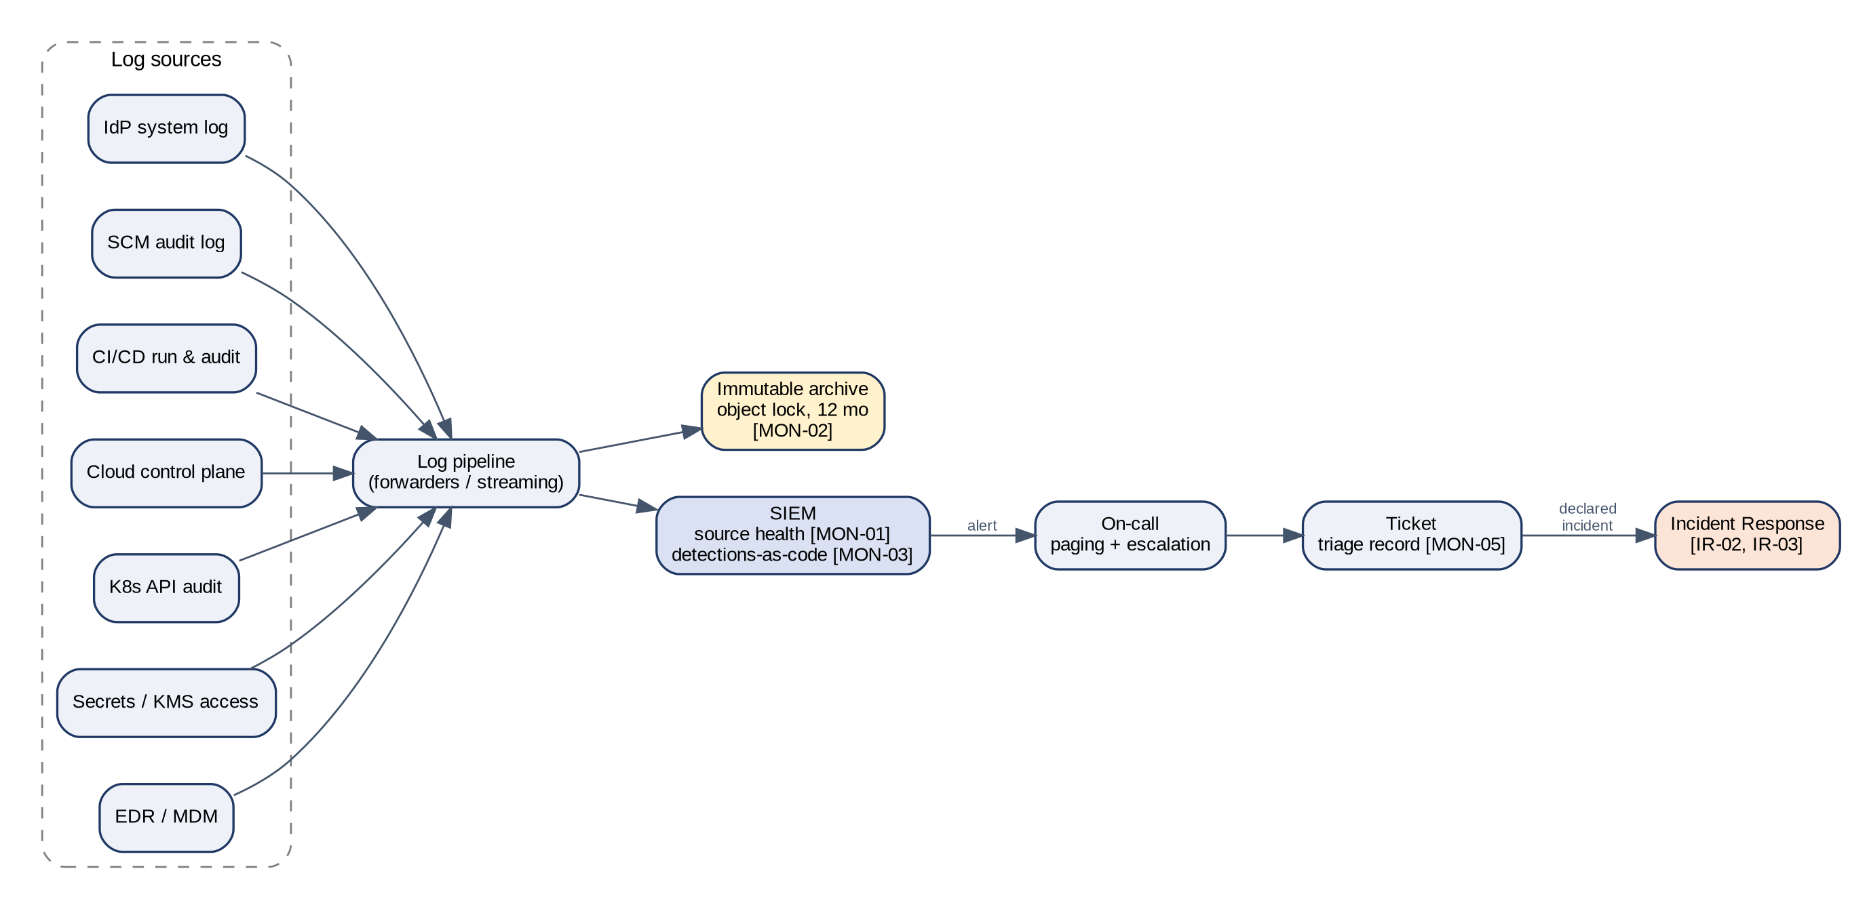

Log source catalog
Source | Events of interest | Transport | Hot retention | Archive
IdP system log | Sign-ins, MFA changes, admin actions, policy changes | Streaming / API | 90 days | 12 months+
SCM audit log | Ruleset changes, permission changes, repo visibility, token creation | Streaming | 90 days | 12 months+
CI/CD | Workflow changes, secret access, deployment events | Webhook / API | 90 days | 12 months+
Cloud control plane | All management API calls, org-wide | Native trail to archive account | 90 days | 12 months+ (object lock)
Kubernetes API | RBAC changes, exec into pods, secret reads | Audit webhook / native | 90 days | 12 months+
Secrets / KMS | Secret reads, key usage, policy changes | Native | 90 days | 12 months+
Endpoint / EDR | Malware detections, tamper events | API | 90 days | 12 months+
ITSM | Workflow and permission changes | API | 90 days | 12 months+

Minimum detection catalog (MON-03)
Detection | Severity | Response
MFA disabled / factor reset for a privileged user | High | Page Security on-call
SSO enforcement or branch ruleset changed/disabled | High | Page Security; auto-revert where possible
Admin role granted outside IaC or JIT | High | Page Security
Break-glass account used | Critical | Page Security + CISO
Production write by non-pipeline, non-JIT principal | High | Page Security
Audit logging disabled or log source silent > 1 h | High | Page Security
Storage made public / security group opened to 0.0.0.0/0 on admin port | High | Page Platform; auto-remediate
Impossible travel / anomalous sign-in | Medium | Ticket, triage within 1 business day
Pipeline secret accessed from unexpected workflow | High | Page Security
Malware detected on endpoint | High | Isolate device; ticket

Detections are maintained as code in a detections repository covered by CODEOWNERS, so changes to alerting logic are reviewed and auditable.

6.8 Ticketing / ITSM integration
The ITSM system is the system of record for human decisions. Automated integrations create tickets so that every exception has an owner, an SLA and an auditable outcome.
Ticket type | Created by | Required fields | SLA | Control
Access request | User (self-service portal) | System, role, justification, approver (manager + system owner) | 2 BD | IAM-02
Access removal / review finding | Access review, leaver recon | User, system, reason | 1 BD (leaver 24 h) | IAM-03, IAM-04
Change (standard) | Linked automatically from PR (optional for PR-evidenced changes) | PR link, risk, rollback | — | CHG-06
Emergency change | Engineer | Incident link, retro-approver | Retro-approval ≤ 2 BD | CHG-09
Security alert triage | SIEM integration | Alert ID, analyst, disposition | Per severity | MON-05
Security incident | On-call / Security | Severity, timeline, notifications, PIR link | Per IR plan | IR-02
Vulnerability | Scanner/CSPM integration | Asset, CVE/finding, severity, due date | Crit 7d / High 30d / Med 90d | VUL-01, INF-02
Risk exception | Requestor | Risk, compensating control, expiry, CISO approval | ≤ 12 months | CHG-04, RSK-01
Vendor review | GRC reminder | Vendor, tier, report reviewed, CUECs | Annual | VEN-02

Workflow rules: approvers cannot approve their own requests; closing a ticket requires a resolution note; SLA breaches are reported monthly to the steering group (GOV-04).

6.9 Security scanning and vulnerability management
Scanner | Where it runs | Scope | Output routing
SAST | PR pipeline | In-scope repos | PR annotation; Critical/High blocks merge
SCA / dependency | PR pipeline + daily | Manifests & lockfiles | PR block; tickets for existing issues
Secret scanning | Push protection + CI | All repos | Block push; alert Security
IaC scanning | PR pipeline | IaC directories | PR block
Container image | Build + registry (continuous) | All images running in production | Tickets with SLA
CSPM | Continuous | All cloud accounts | Tickets with SLA
External / infrastructure | Weekly | Public endpoints | Tickets with SLA
Penetration test | Annually (third party) | Application + infrastructure | Report; tickets

Remediation SLAs: Critical 7 days, High 30 days, Medium 90 days, Low best effort. Exceptions require a risk-exception ticket approved by the CISO with an expiry date.

6.10 Endpoint integration
Endpoints are enrolled in MDM at provisioning. The MDM enforces disk encryption, screen lock, OS update deadlines, firewall and EDR. The IdP evaluates device posture at sign-in and blocks unmanaged or non-compliant devices from in-scope subsystems (INF-08). Lost/terminated devices are remotely locked or wiped and the action is logged (INF-09).

6.11 Backup and recovery integration
- Automated backups for every production data store per RPO ([RPO, e.g., 24 h]) with point-in-time recovery where supported.
- Copies replicated to the isolated backup account/region with vault lock (immutable) to defend against ransomware (R-09).
- col-backups records daily job status; failures page on-call.
- Quarterly restore tests (BCP-02) record the dataset, restore time vs. RTO ([RTO, e.g., 4 h]), and integrity check results.

7. Evidence automation architecture
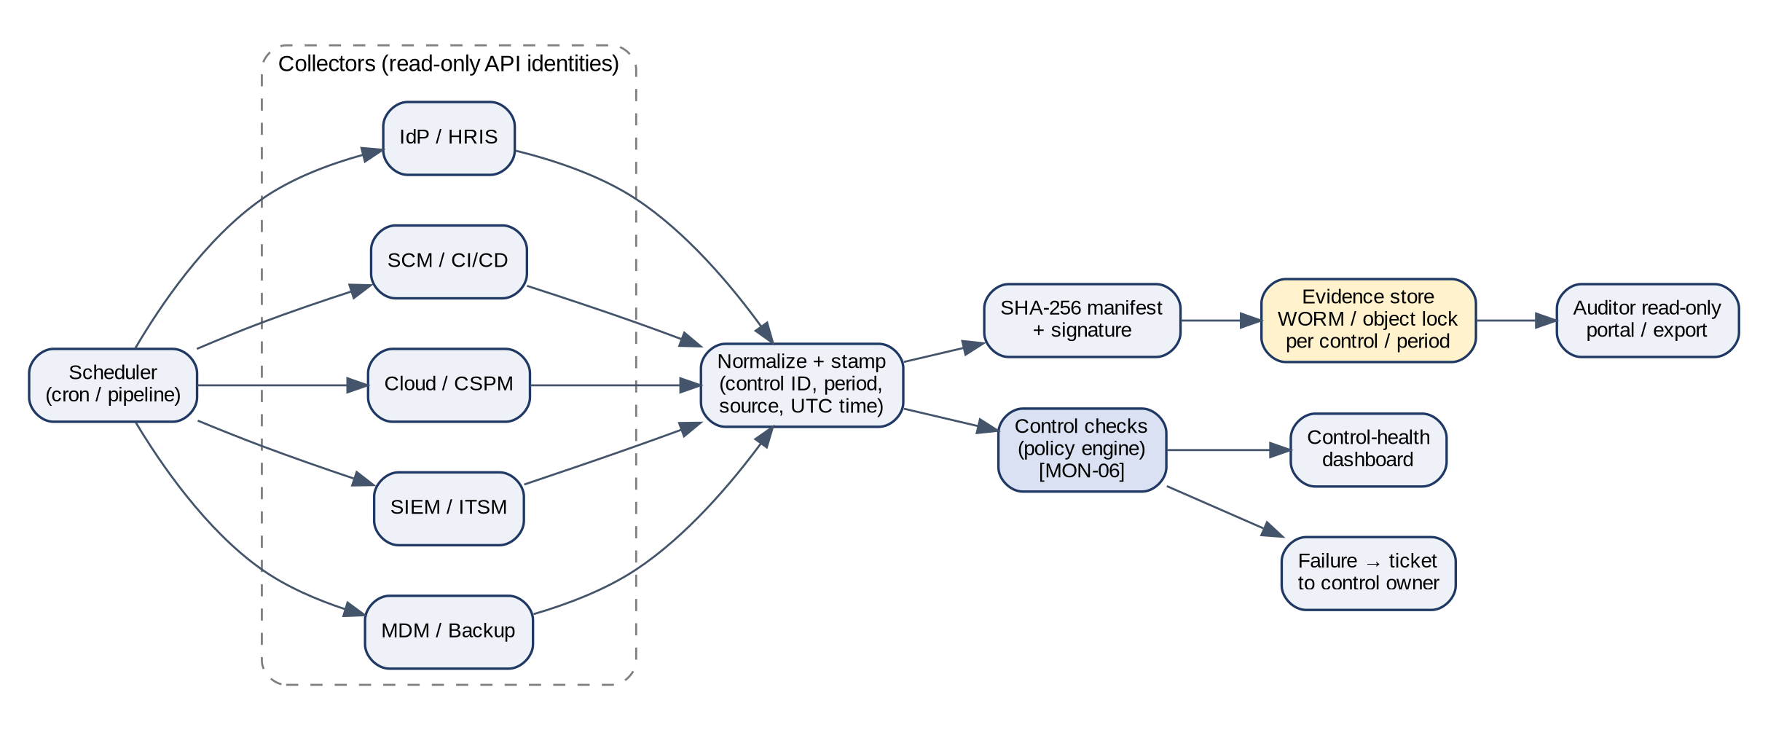

7.1 Collector jobs
Collector | Source | Method | Frequency | Output | Controls
col-idp-policy | IDP | REST API: auth policies, MFA factors, app SSO assignments | Nightly | idp/policies/<date>.json + diff | IAM-01, IAM-08
col-idp-users | IDP, HRIS | API: users, status, lastLogin, deactivated_at; HRIS terminations | Daily | iam/leaver-recon/<date>.csv; ticket if SLA breached | IAM-02, IAM-03
col-access-review | IDP, SCM, CLD, CI, SIEM, ITSM | API user & role listings per system; row counts for completeness | Quarterly (1st business day) | access-review/<Qn>/<system>.csv | IAM-04
col-scm-rulesets | GitHub | gh api /orgs/{org}/rulesets (+ /rulesets/{id}); /repos/{o}/{r}/rules/branches/main for soc2_scope repos; diff vs. baseline | Nightly | scm/rulesets/<date>.json + drift alert | CHG-01, CHG-02
col-scm-prs | GitHub | GraphQL search is:pr is:merged base:main merged:<range> → author, mergedBy, APPROVED reviewers, mergeCommit, check runs | Daily | scm/merged-prs/<yyyy-mm>.jsonl | CHG-02, CHG-03
col-deploys | GitHub, ServiceNow | /repos/{o}/{r}/deployments?environment=production + statuses; join ServiceNow change number; attestation reference | Per deploy / daily | deployments/<yyyy-mm>.jsonl | CHG-05, CHG-06, CHG-07
col-cloud-iam | CLD | API: roles, policies, users, access keys & ages; org SCP/policies | Nightly | cloud/iam/<date>.json | IAM-05, IAM-07, CHG-05
col-cloud-audit-query | CLD, SIEM | Saved search: production write API calls by non-pipeline principals | Monthly | cloud/non-pipeline-changes/<yyyy-mm>.csv | CHG-05, MON-01
col-cspm | SEC, CLD | CSPM API: benchmark score, open findings by severity, age | Weekly | cspm/<date>.json | INF-01, INF-02, INF-05, INF-11
col-vulns | SEC, ITSM | Scanner API + ITSM JQL: findings, SLA status | Weekly | vuln/sla/<date>.csv | VUL-01, CHG-04
col-siem-health | SIEM | Query: last event per log source; retention settings | Daily | siem/source-health/<date>.csv | MON-01, MON-02
col-mdm | MDM | API: device list, encryption, OS version, compliance | Weekly | mdm/compliance/<date>.csv | INF-08
col-backups | BKP | API: backup job status, vault lock config | Daily | backup/jobs/<date>.csv | BCP-01
col-hr-training | HRIS / LMS | Report API: training & policy acknowledgment completion | Monthly | hr/training/<yyyy-mm>.csv | HR-02, HR-03
col-inventory | CLD, MDM, SCM, IDP | Asset inventory export (resources, devices, repos, SaaS apps) | Nightly | inventory/<date>/*.csv | INF-07, GOV-08
col-gh-environments | GitHub | /repos/{o}/{r}/environments/production + /deployment_protection_rules; /orgs/{org}/actions/permissions(+/workflow, /selected-actions) | Nightly | gh/environments/<date>.json + drift alert | CHG-05, CHG-11
col-gh-sn-recon | GitHub, ServiceNow | Match GitHub production deployments to ServiceNow change_request (DevOps) by run ID / change number; list unmatched both ways | Monthly + quarterly sign-off | recon/deploy-change/<yyyy-mm>.csv | CHG-06, CHG-05
col-sn-changes | ServiceNow | Table API change_request + sysapproval_approver for period (type, state, approval, requested_by, approver, close_code) | Daily | servicenow/changes/<yyyy-mm>.jsonl | CHG-06, CHG-09
col-sn-access | ServiceNow | Table API sc_req_item (access catalog item) + approvals; sys_user_has_role for privileged roles | Daily / quarterly | servicenow/access/<date>.csv | IAM-02, IAM-04
col-gh-access | GitHub | /orgs/{org}/members(?role=admin), teams, outside_collaborators, personal-access-tokens, installations | Quarterly + weekly | gh/access/<date>/*.csv | IAM-04, IAM-07
col-gh-alerts | GitHub, ServiceNow | /orgs/{org}/code-scanning|secret-scanning|dependabot/alerts; join ServiceNow ticket + SLA state | Weekly | vuln/github/<date>.csv | CHG-04, VUL-01, INF-06

7.2 Evidence store design
Aspect | Design
Storage | Dedicated bucket/container in the security account with object lock (compliance mode) and versioning
Path convention | evidence/<control-id>/<period YYYY-Qn>/<source>/<artifact>_<UTC timestamp>.<ext>
Metadata | control_id, period, source_system, collector_name, collector_version, query/API call used, record_count, collected_at_utc, sha256
Integrity | Per-run manifest of SHA-256 hashes, signed by the collector identity
Access | Write: collector identities only. Read: Compliance, Security, auditor (read-only, time-boxed). No delete.
Retention | Observation period + [7] years (or per legal requirements)
Completeness | Each export records row counts and the exact query; quarterly QA compares counts with the source UI

7.3 Information Produced by the Entity (IPE)
Auditors must verify that reports used as evidence are complete and accurate. For each system-generated population (merged PRs, deployments, hires/terminations, alerts, tickets), retain:
- The exact query or API call (stored with the export).
- A timestamp and the identity that ran it.
- A record count, and a reconciliation to an independent source where one exists (e.g., HRIS terminations vs. IdP deactivations; deployment records vs. cloud audit log deploy events).
- Evidence the collector code itself is change-controlled (collector repo under CHG-01).

7.4 Continuous control monitoring checks (MON-06)
Check | Pass condition | Frequency
SSO enforced on every in-scope SaaS | 100% of apps in inventory report SSO enforced | Daily
MFA coverage | 100% of active IdP users enrolled in phishing-resistant factor | Daily
Branch protection | All soc2-scope repos have required ruleset with empty bypass list | Daily
Leaver SLA | 0 terminated users active > 24 h | Daily
Static cloud keys | 0 human IAM users; service keys ≤ 90 days | Daily
Encryption at rest | 0 unencrypted production stores | Daily
Log sources healthy | All sources reported within last hour | Hourly
Backups | All production stores backed up within RPO | Daily
Vulnerability SLA | 0 Critical/High past due without exception | Weekly
Non-pipeline production changes | 0 unexplained write events | Monthly

A failed check opens a ticket for the control owner and appears on the control-health dashboard reviewed at the steering meeting (GOV-04). Failures and their resolution are themselves evidence of CC4.1/CC4.2 operating.

8. Criteria-to-control mapping
Criterion | Summary | Mapped controls
CC1.1 | Demonstrates commitment to integrity and ethical values | GOV-01, GOV-07, HR-02
CC1.2 | Board exercises oversight responsibility, independent of management | GOV-02
CC1.3 | Management establishes structures, reporting lines, authorities and responsibilities | GOV-03, GOV-04, HR-04
CC1.4 | Demonstrates commitment to attract, develop and retain competent individuals | HR-01, HR-03, HR-04
CC1.5 | Holds individuals accountable for internal control responsibilities | HR-02, HR-04, HR-05
CC2.1 | Obtains/generates and uses relevant, quality information | GOV-04, GOV-08, CHG-06, INF-07, MON-01
CC2.2 | Internally communicates objectives and responsibilities for internal control | GOV-01, GOV-07, HR-02, HR-03
CC2.3 | Communicates with external parties regarding internal control matters | GOV-06, GOV-07, VEN-02, IR-01, IR-02
CC3.1 | Specifies objectives with sufficient clarity to identify and assess risks | RSK-01, RSK-02
CC3.2 | Identifies and analyzes risks to the achievement of objectives | RSK-01, INF-07
CC3.3 | Considers the potential for fraud in assessing risks | RSK-01
CC3.4 | Identifies and assesses changes that could significantly impact internal control | GOV-08, RSK-01, RSK-03, CHG-12
CC4.1 | Selects, develops and performs ongoing and/or separate evaluations | GOV-04, GOV-05, IAM-04, INF-02, VUL-02, MON-01, MON-06
CC4.2 | Evaluates and communicates internal control deficiencies in a timely manner | GOV-02, GOV-04, GOV-05, MON-06, IR-03
CC5.1 | Selects and develops control activities that mitigate risks | GOV-05, RSK-01
CC5.2 | Selects and develops general control activities over technology | CHG-01, CHG-05, INF-01, MON-06
CC5.3 | Deploys control activities through policies and procedures | GOV-01
CC6.1 | Logical access security software, infrastructure and architectures | IAM-01, IAM-05, IAM-06, IAM-07, IAM-08, IAM-09, CHG-05, CHG-08, CHG-11, INF-03, INF-04, INF-05, INF-06, INF-07, INF-08, MON-02
CC6.2 | Registers and authorizes new users prior to issuing credentials | IAM-01, IAM-02, IAM-03, IAM-04, IAM-07
CC6.3 | Authorizes, modifies or removes access based on roles and least privilege | IAM-02, IAM-03, IAM-04, IAM-05, IAM-06
CC6.4 | Restricts physical access to facilities and protected information assets | INF-10
CC6.5 | Discontinues logical and physical protections over assets on disposal | INF-09
CC6.6 | Implements logical access measures against threats from outside system boundaries | INF-03
CC6.7 | Restricts transmission, movement and removal of information | INF-04, INF-05, INF-06, INF-08, INF-11
CC6.8 | Prevents or detects unauthorized or malicious software | CHG-04, CHG-07, CHG-11, INF-08, VUL-01
CC7.1 | Uses detection and monitoring procedures to identify configuration changes and vulnerabilities | CHG-04, CHG-10, INF-01, INF-02, VUL-01, VUL-02, VUL-03
CC7.2 | Monitors system components for anomalies indicative of malicious acts or errors | IAM-06, IAM-09, MON-01, MON-02, MON-03, MON-04
CC7.3 | Evaluates security events to determine whether they are incidents | MON-03, MON-05, IR-01, IR-02
CC7.4 | Responds to identified security incidents via a defined program | IR-01, IR-02, IR-03, IR-04
CC7.5 | Identifies, develops and implements activities to recover from incidents | IR-01, IR-03, IR-04, BCP-01, BCP-02, BCP-03, BCP-04
CC8.1 | Authorizes, designs, develops, configures, documents, tests, approves and implements changes | CHG-01, CHG-02, CHG-03, CHG-04, CHG-05, CHG-06, CHG-07, CHG-08, CHG-09, CHG-10, CHG-11, CHG-12
CC9.1 | Identifies and develops risk mitigation activities for business disruption | RSK-03, RSK-04, MON-04, BCP-01, BCP-02, BCP-03, BCP-04
CC9.2 | Assesses and manages risks associated with vendors and business partners | VEN-01, VEN-02, VEN-03
The full matrix with descriptions, owners, test procedures and sample sizes is in the Control Matrix workbook (Control Matrix and TSC Coverage tabs).

9. Segregation of duties
Activity | Engineer | Code owner / reviewer | Platform / SRE | Security | IT / Identity | Compliance
Write code / IaC | Performs | — | Performs | — | — | —
Approve PR | Cannot approve own | Approves | Approves (not own) | Approves security paths | — | —
Deploy to production | — (pipeline) | — | — (pipeline); JIT for break/fix | — | — | —
Change branch rulesets / pipeline config | — | Reviews | Proposes via PR | Approves | — | Notified
Grant access | Requests | — | — | — | Provisions via IdP groups | —
Approve access | — | System owner approves | System owner approves | — | Cannot approve own | —
Review access (quarterly) | — | — | System owner | Reviews admins | Executes removals | Oversees
Modify SIEM detections | — | — | — | Performs via PR | — | —
Manage evidence store | — | — | — | Admin (no delete) | — | Read

10. Integration failure modes
Integrations are themselves part of the control environment: if an integration silently fails, a control stops operating. Each integration is monitored.
Integration failure | Detection | Control impact | Compensating action
HRIS → IdP sync fails | Connector error alert; daily leaver recon | IAM-03 | Manual deprovisioning; recon ticket
SCIM push to app fails | IdP provisioning error alert | IAM-03, IAM-04 | Manual removal; access review
Log source stops sending | SIEM source-health alert (> 1 h) | MON-01, MON-03 | Investigate; backfill from native store
Collector job fails | Job failure alert to Compliance | All evidence | Re-run; document gap in evidence log
Scanner outage | Pipeline check missing → merge blocked | CHG-04 | Time-boxed exception with approval
Backup job fails | Backup status alert → on-call | BCP-01 | Re-run; incident if RPO breached
ITSM integration fails | Integration error alert | MON-05, VUL-01 | Manual ticket creation from source alerts

Any period during which a control did not operate must be disclosed to the auditor; record gaps in the evidence log with dates, cause and remediation.

11. Implementation roadmap
Phase | Timing | Deliverables | Exit criteria
0. Scope & gap assessment | Weeks 1–2 | System boundary, inventory, gap list vs. Control Matrix | Approved scope; TSC Coverage shows no design gaps
1. Identity foundation | Weeks 2–6 | SSO+MFA on all subsystems, SCIM, HRIS integration, JIT, break-glass | MON-06 identity checks green
2. Delivery controls | Weeks 4–8 | Rulesets, CODEOWNERS, pipeline gates, OIDC deploy, signing, deployment records | 0 non-pipeline prod changes for 30 days
3. Runtime & detection | Weeks 6–10 | Guardrails, CSPM, log pipeline, detection catalog, backups | All log sources healthy; detections tested
4. Evidence automation | Weeks 8–12 | Collectors, evidence store, dashboard, PBC mapping | All collectors running; sample evidence pack reviewed
5. Policies & people | Weeks 1–12 (parallel) | Approved policies, training, acknowledgments, risk assessment, vendor reviews | All annual controls performed once
6. Readiness assessment | Week 12–13 | Internal walkthrough / mock audit (optionally Type I) | No open design deficiencies
7. Observation period | [3–12] months | Controls operate; quarterly QA of evidence | Clean evidence for every period
8. Fieldwork & report | 4–8 weeks after period end | PBC fulfilment, walkthroughs, management assertion | SOC 2 Type II report issued

12. Sub-service organizations and CUECs

12.1 Carved-out sub-service organizations
Sub-service organization | Service | Controls relied upon (CSOCs) | Monitoring
[Cloud provider] | IaaS / PaaS hosting | Physical security, environmental protection, hardware disposal, hypervisor security | Annual SOC 2 report review (VEN-02)
[IdP vendor] | Identity | Availability & security of the IdP service | Annual SOC 2 report review
GitHub, Inc. | Source control / CI | Platform security of hosted SCM and runners | Annual SOC 2 report review
[SIEM vendor] | Log analytics | Integrity and availability of log storage | Annual SOC 2 report review

12.2 Complementary user entity controls (for your customers)
These are controls your customers must operate for the system's commitments to be met. Include them in the System Description.
- Customers are responsible for managing their own users' access to the application, including timely removal.
- Customers are responsible for configuring SSO/MFA for their tenant where the product supports it.
- Customers are responsible for the security of credentials and API keys issued to them.
- Customers are responsible for notifying [Company] of suspected security incidents affecting their accounts.
- Customers are responsible for the accuracy and lawful basis of data they submit.

13. Assumptions and open decisions
# | Item | Owner | Status
A1 | Final list of in-scope repositories and cloud accounts | Platform Engineering | [Open]
A2 | Observation period length and start date | CISO + auditor | [Open]
A3 | Whether a change ticket is required in addition to PR evidence for standard changes | Engineering Manager + auditor | Resolved: ServiceNow DevOps Change creates a change for every production deployment (DES-002 §6)
A4 | RTO/RPO values per service | SRE Lead | [Open]
A5 | Evidence retention period | Legal / Compliance | [Open]

Appendix A. Glossary
Term | Meaning
CUEC | Complementary User Entity Control — a control the customer must operate
CSOC | Complementary Subservice Organization Control — a control the carved-out vendor must operate
IPE | Information Produced by the Entity — system reports used as audit evidence
JIT | Just-in-time (time-bound) privileged access
OIDC | OpenID Connect; used here for workload identity federation from CI to cloud
PBC | Provided By Client — the auditor's evidence request list
SCIM | System for Cross-domain Identity Management — automated user provisioning
TSC | Trust Services Criteria
WORM | Write once, read many (immutable storage)

Appendix B. Related documents
ID | Document
DES-002 | GitHub, GitHub Actions & ServiceNow Integration Specification
REQ-001 | Subsystem Information Request
SYS-001 | System Description (DC 200)
POL-01 – POL-11 | Policy set
PLN-01 | Incident Response Plan
PLN-02 | Business Continuity & Disaster Recovery Plan
PRC-01 | Change Management & Deployment Procedure
PRC-02 | User Access Management & Review Procedure
PRC-03 | Evidence Collection & Audit Readiness Runbook
TPL-001 | Audit Forms & Templates
XLS-001 | SOC 2 Control Matrix & Evidence Tracker (workbook)

