TECHNICAL DESIGN DOCUMENT
Hybrid RAG Architecture for AI-Powered Test Execution Insights
Vanilla RAG + Graph RAG + Relevance-Based Hybrid Planning

Technical Architecture • Data Pipeline • Retrieval Logic • Interfaces • Evaluation

Document Purpose
This document defines the technical architecture and processing flow for a hybrid Retrieval-Augmented Generation (RAG) system designed to produce context-aware insights from software-testing artifacts such as test cases, requirements, defects, execution logs, reports, screenshots, and related project documentation.

Attribute | Value
Document Type | Technical Design / Architecture Document
Architecture | Five-module Hybrid RAG pipeline
Primary Retrieval Modes | Semantic Vector Retrieval and Knowledge-Graph Retrieval
Decision Strategy | Vanilla RAG first; Graph RAG when relevance is below threshold
Primary Output | Context-grounded, structured AI response with source metadata
Version | 1.0
Date | 25 August 2026

Table of Contents
- 1. Executive Summary
- 2. Objectives and Scope
- 3. System Architecture Overview
- 4. End-to-End Data Flow
- 5. Module 1 — Input & Data Ingestion
- 6. Module 2 — Vanilla RAG / Semantic Retrieval
- 7. Module 3 — Graph RAG Pipeline
- 8. Module 4 — Hybrid RAG Planner
- 9. Module 5 — Context Augmentation & Response Generation
- 10. Data Model and Storage Architecture
- 11. Retrieval and Ranking Algorithms
- 12. Relevance Threshold Decision Logic
- 13. Prompt Construction and Response Generation
- 14. Interfaces and Data Contracts
- 15. Non-Functional Requirements
- 16. Security, Governance and Reliability
- 17. Evaluation Metrics and Testing Strategy
- 18. Deployment and Operational Considerations
- 19. Example End-to-End Scenario
- 20. Risks, Limitations and Future Enhancements
- 21. Conclusion

1. Executive Summary
The proposed system is a hybrid Retrieval-Augmented Generation (RAG) architecture for AI-powered test execution insights. Its purpose is to answer natural-language questions using enterprise testing artifacts while reducing unsupported or hallucinated responses. The architecture combines two retrieval strategies: Vanilla RAG, which performs semantic similarity search over a vector store, and Graph RAG, which traverses a knowledge graph to recover relationships, dependencies, and multi-hop context.
The central design decision is implemented by Module 4, the Hybrid RAG Planner. Vanilla RAG is always attempted first because semantic retrieval is generally faster and less expensive. The resulting relevance score is compared with a configurable threshold T. If the score is sufficient, the Vanilla RAG context is forwarded. If it is insufficient, Graph RAG is invoked to obtain more relationship-aware context. Only the selected context is passed to Module 5, where it is augmented with the original query and metadata, converted into a structured prompt, sent to an LLM, and formatted into the final response.
Core Architectural Principle
Use the simplest retrieval mechanism that is sufficiently confident. Escalate from semantic retrieval to graph-based retrieval only when the Vanilla RAG relevance score falls below the configured threshold.

2. Objectives and Scope

2.1 Objectives
- Ingest heterogeneous software-testing artifacts from multiple sources.
- Normalize, parse, chunk, embed, and index content for efficient retrieval.
- Maintain both a vector representation and a relationship-aware knowledge graph.
- Retrieve semantically relevant evidence using Vanilla RAG.
- Retrieve multi-hop relationships and dependencies using Graph RAG.
- Automatically select the appropriate retrieval result using a relevance threshold.
- Generate grounded, structured responses with source metadata.
- Provide measurable retrieval and response quality through explicit metrics.

2.2 Scope
The architecture covers data ingestion, preprocessing, indexing, semantic retrieval, graph retrieval, hybrid planning, context augmentation, prompt construction, LLM inference, response formatting, and evaluation. The design does not prescribe one specific LLM, vector database, graph database, or cloud provider; those are implementation choices that can be selected according to project constraints.

2.3 Representative Queries
Query Type | Example | Preferred Retrieval
Direct semantic lookup | Find test cases related to login timeout handling. | Vanilla RAG
Requirement-to-test mapping | Which tests validate REQ-102? | Vanilla RAG or Graph RAG
Multi-hop dependency | Which defects are linked to the most unstable feature? | Graph RAG
Execution insight | Why did the latest automation build fail? | Hybrid planner; graph if semantic score is low
Cross-artifact synthesis | Summarize failures, affected requirements, and linked test cases. | Hybrid planner

3. System Architecture Overview
The architecture is organized into five processing modules connected by explicit data contracts. Module 1 builds the indexed knowledge repository. Modules 2 and 3 provide alternative retrieval paths. Module 4 performs retrieval planning and selects exactly one context source. Module 5 generates the final response.
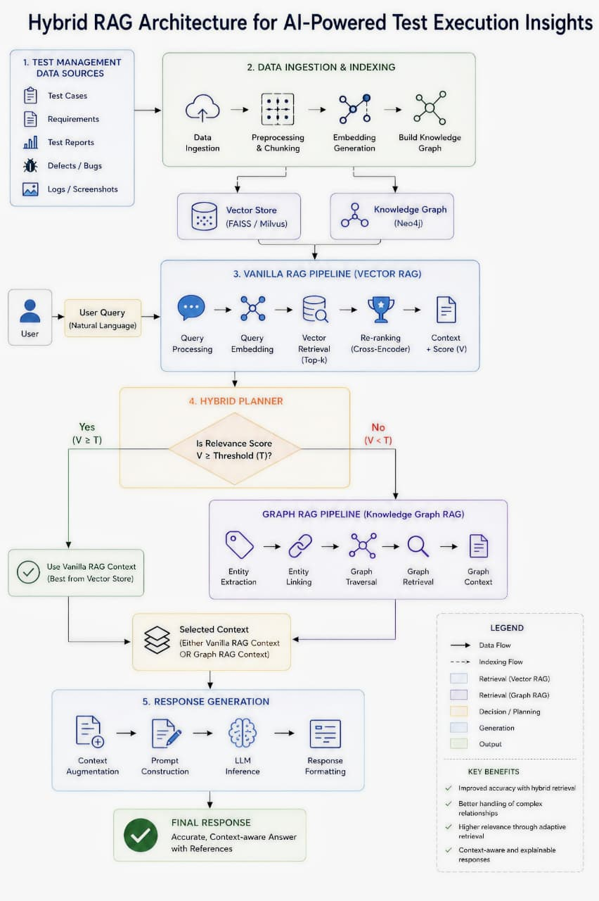
Overall Hybrid RAG Architecture

3.1 Logical Components
Component | Responsibility | Primary Output
Data Sources | Provide testing artifacts and operational evidence. | Raw artifacts
Ingestion Engine | Connect, extract, batch, schedule, and incrementally load data. | Normalized input
Preprocessing Layer | Clean, deduplicate, normalize, parse, extract metadata, and OCR when required. | Processed documents
Vector Store | Store embeddings, chunks, and metadata for similarity retrieval. | Top-k semantic candidates
Knowledge Graph | Store entities and typed relationships. | Connected graph context
Hybrid Planner | Evaluate relevance and choose retrieval path. | Selected context
LLM Layer | Generate grounded response from selected context. | Final response

4. End-to-End Data Flow
1. Ingestion: Collect artifacts from test management systems, repositories, files, APIs, CI/CD systems, and manual uploads.
2. Preprocessing: Clean, deduplicate, normalize, parse documents, extract metadata, and apply OCR where required.
3. Indexing: Chunk documents; generate embeddings for semantic retrieval; extract entities and relationships for graph construction.
4. Query Intake: Receive a natural-language user query and perform query preprocessing.
5. Semantic Retrieval: Generate a query embedding and retrieve top-k chunks using vector similarity.
6. Ranking and Scoring: Re-rank candidates and compute a relevance/confidence score.
7. Hybrid Decision: Compare the Vanilla RAG score with threshold T.
8. Graph Escalation: If the score is below T, extract/link entities and perform graph traversal and relationship-aware retrieval.
9. Context Selection: Forward only the selected Vanilla RAG or Graph RAG context plus metadata.
10. Generation: Augment context with the query, construct the prompt, invoke the LLM, and format the response.
Data Flow Invariant
The response-generation layer should not independently query both retrieval systems. Module 4 selects one retrieval result so that Module 5 receives a single authoritative context path for generation.

5. Module 1 — Input & Data Ingestion
Module 1 establishes the indexed knowledge repository used by both retrieval strategies. It accepts structured and unstructured testing information and transforms it into searchable vector data, structured relational data, and a relationship-aware knowledge graph.
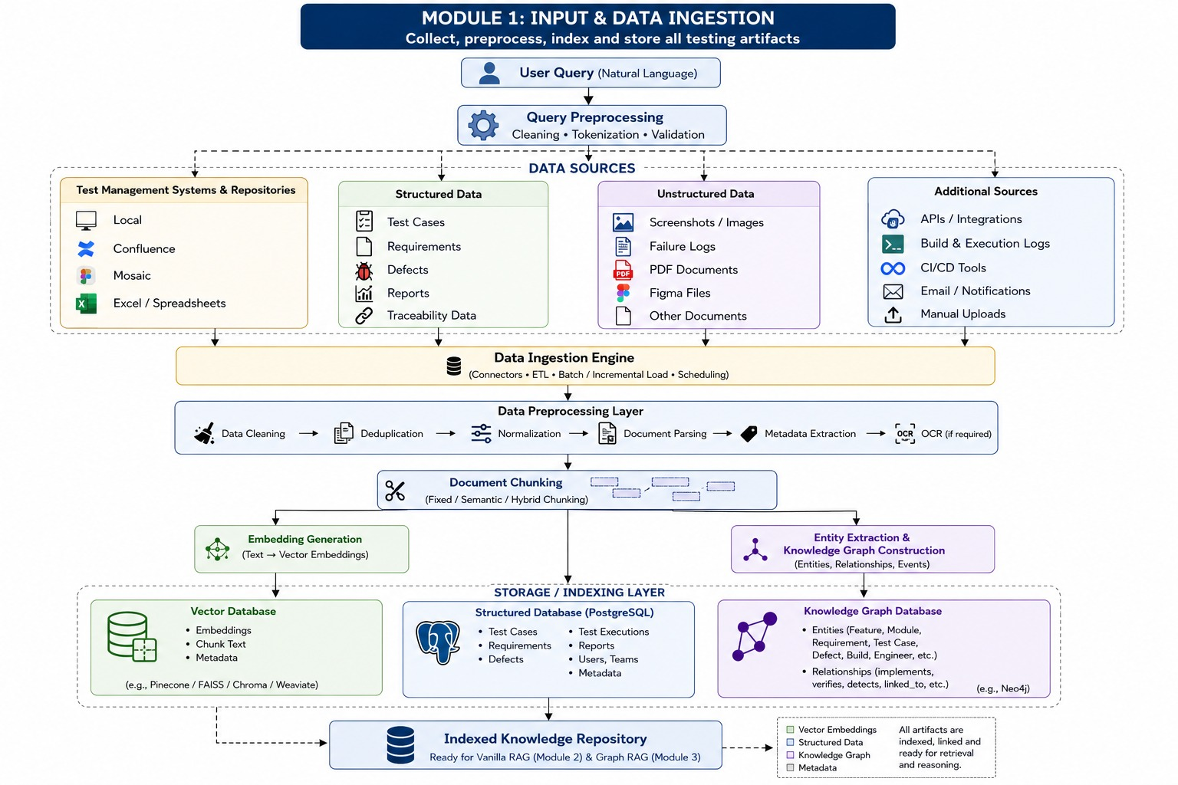
Module 1 — Input & Data Ingestion

5.1 Data Sources
Category | Examples | Processing
Test management systems | Local repositories, Confluence, Mosaic, Excel/Spreadsheets | Connector/API or file ingestion
Structured data | Test cases, requirements, defects, reports, traceability | Schema-aware parsing
Unstructured data | Screenshots, images, failure logs, PDFs, Figma files, documents | Document parsing/OCR
Additional sources | APIs, CI/CD tools, build logs, email notifications, manual uploads | Connector/event/batch ingestion

5.2 Preprocessing Pipeline
- Data cleaning: remove invalid, malformed, or irrelevant content.
- Deduplication: prevent repeated artifacts from polluting retrieval results.
- Normalization: standardize fields, identifiers, dates, status values, and textual representation.
- Document parsing: extract text and structural information from supported formats.
- Metadata extraction: capture project, module, source, artifact type, priority, date, IDs, and other attributes.
- OCR: extract text from screenshots or scanned documents when text is not directly available.

5.3 Document Chunking
Documents are divided into retrieval units using fixed, semantic, or hybrid chunking. Chunk boundaries should preserve enough local context to make a chunk independently useful while avoiding unnecessarily large embeddings.

5.4 Dual Indexing
Index | Stored Information | Purpose
Vector database | Embedding vector, chunk text, metadata | Semantic similarity retrieval
Structured database | Test cases, executions, requirements, defects, reports, users, teams, metadata | Transactional and structured access
Knowledge graph | Entities, relationships, events, attributes | Multi-hop relationship reasoning

6. Module 2 — Vanilla RAG / Semantic Retrieval
Vanilla RAG is the first retrieval path. It converts the query into a dense vector representation and searches the vector database for semantically similar chunks. Retrieved chunks are re-ranked and assigned a final relevance score.
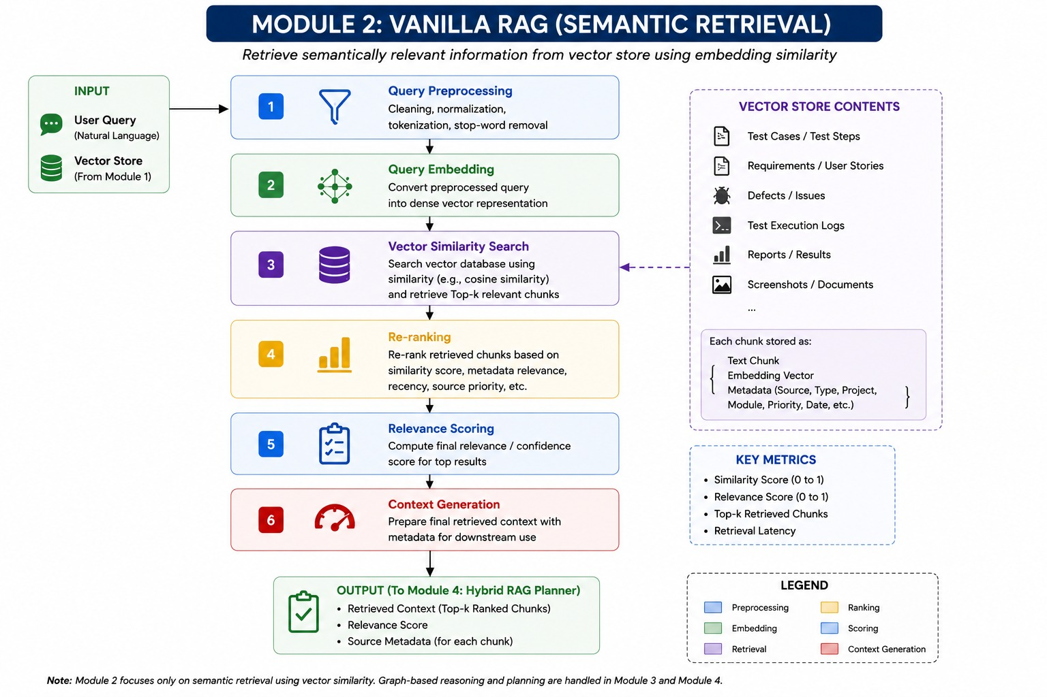
Module 2 — Vanilla RAG / Semantic Retrieval

6.1 Processing Stages
Stage | Function | Output
1. Query preprocessing | Cleaning, normalization, tokenization, stop-word handling. | Preprocessed query
2. Query embedding | Convert query into dense vector representation. | Query vector
3. Vector similarity search | Search using cosine or another supported similarity metric. | Top-k chunks
4. Re-ranking | Re-order candidates using similarity, metadata relevance, recency, source priority, etc. | Ranked candidates
5. Relevance scoring | Compute final confidence/relevance score. | Score Sᵥ
6. Context generation | Package top-ranked chunks and metadata. | Vanilla RAG context

6.2 Key Metrics
- Similarity score (typically normalized to 0–1)
- Final relevance score (0–1)
- Top-k retrieved chunks
- Retrieval latency

6.3 Example Retrieval Flow
query
-> preprocess(query)
-> q_vector = embed(query)
-> candidates = vector_search(q_vector, top_k=k)
-> ranked = rerank(candidates, metadata, similarity)
-> score_v = relevance_score(ranked)
-> context_v = build_context(ranked)

7. Module 3 — Graph RAG Pipeline
Graph RAG complements semantic retrieval by representing testing artifacts as entities connected by typed relationships. It is designed for questions where the answer depends on dependencies, traceability, or multi-hop relationships rather than only textual similarity.
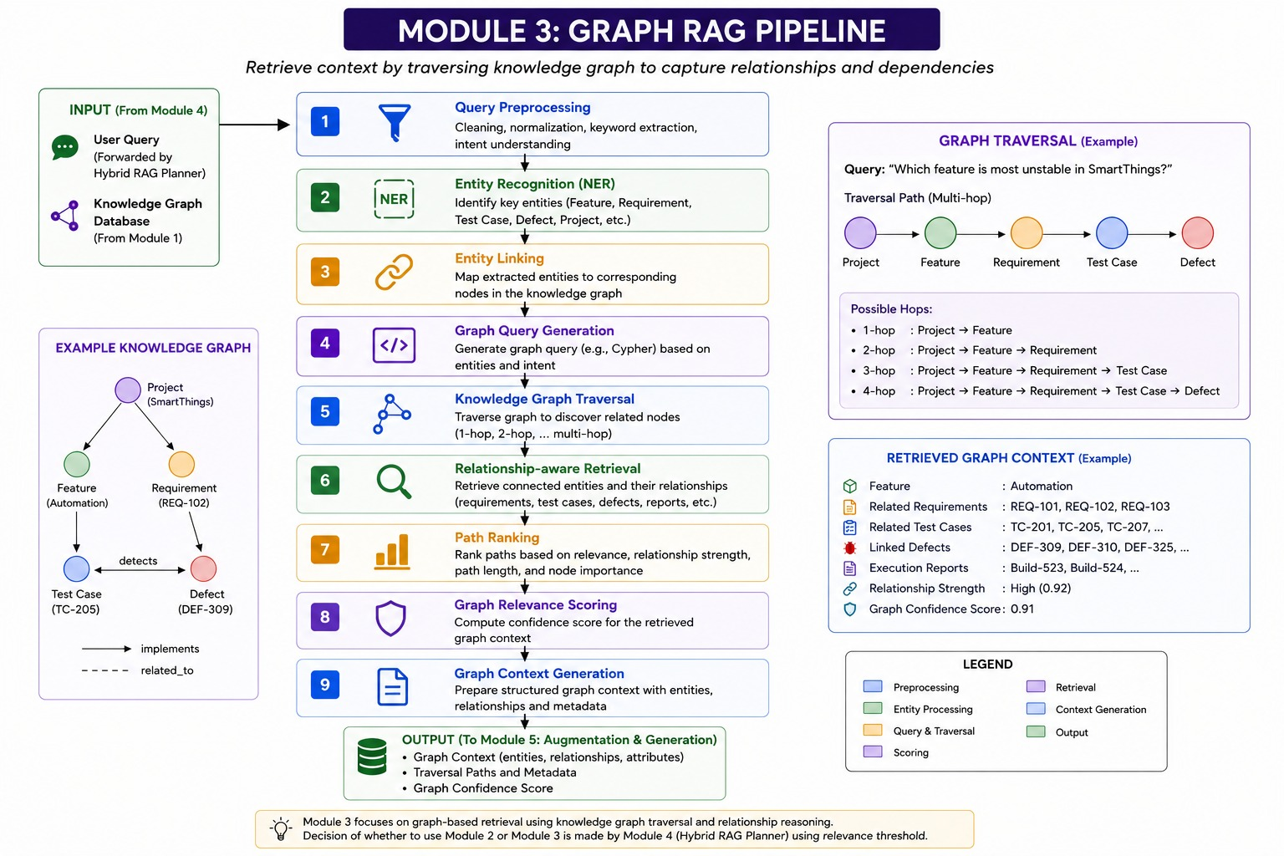
Module 3 — Graph RAG Pipeline

7.1 Processing Stages
Stage | Function | Output
1. Query preprocessing | Clean, normalize, extract keywords, infer intent. | Processed query
2. Entity recognition | Identify projects, features, requirements, test cases, defects, etc. | Entities
3. Entity linking | Map entities to graph nodes. | Linked node IDs
4. Graph query generation | Generate a graph query such as Cypher. | Graph query
5. Graph traversal | Traverse 1-hop through multi-hop relationships. | Candidate paths/nodes
6. Relationship-aware retrieval | Collect connected entities and their relationships. | Graph context
7. Path ranking | Rank paths using relevance, relationship strength, path length, node importance. | Ranked paths
8. Graph relevance scoring | Compute graph confidence. | Score Sg
9. Graph context generation | Package entities, relationships, attributes, paths, and metadata. | Graph context

7.2 Example Knowledge Graph
Project -> Feature -> Requirement -> Test Case -> Defect
Example:
SmartThings
-> Automation
-> REQ-102
-> TC-205
-> DEF-309
A multi-hop traversal allows the system to answer questions such as which defects are connected to a feature through a requirement and test case, even when the relevant information is distributed across separate artifacts.

8. Module 4 — Hybrid RAG Planner
Module 4 is the decision-making layer. It receives the user query and data-store access, executes Vanilla RAG first, evaluates its relevance score, and conditionally escalates to Graph RAG.
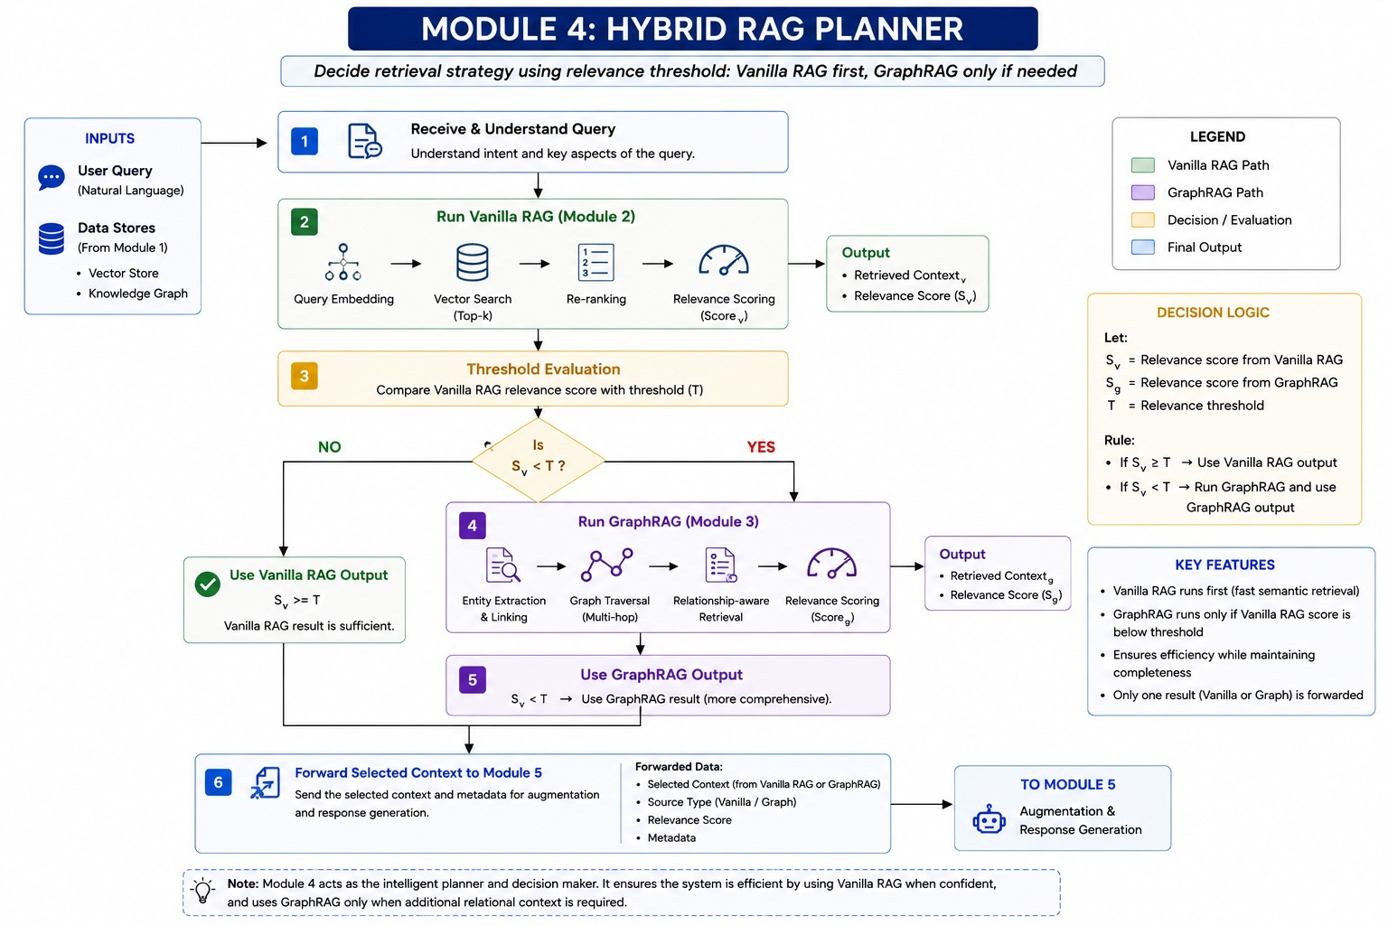
Module 4 — Hybrid RAG Planner

8.1 Decision Variables
Symbol | Meaning
Sᵥ | Relevance score produced by Vanilla RAG
Sg | Relevance score produced by Graph RAG
T | Configured relevance threshold
Cᵥ | Vanilla RAG retrieved context
Cg | Graph RAG retrieved context

8.2 Decision Rule
if S_v >= T:
selected_context = C_v
selected_source = "Vanilla RAG"
else:
C_g, S_g = run_graph_rag(query)
selected_context = C_g
selected_source = "Graph RAG"
This design minimizes unnecessary graph traversal while preserving a fallback mechanism for complex queries. The graph path is therefore an escalation mechanism rather than a parallel retrieval path that always runs.

8.3 Planner Outputs
- Selected context.
- Source type: Vanilla RAG or Graph RAG.
- Relevance/confidence score.
- Source metadata and artifact identifiers.
- Optional retrieval diagnostics for logging and evaluation.

9. Module 5 — Context Augmentation & Response Generation
Module 5 consumes the selected context from Module 4. It does not decide which retrieval mechanism to use. Its role is to combine the query and evidence, construct a consistent prompt, invoke the LLM, and format the response.
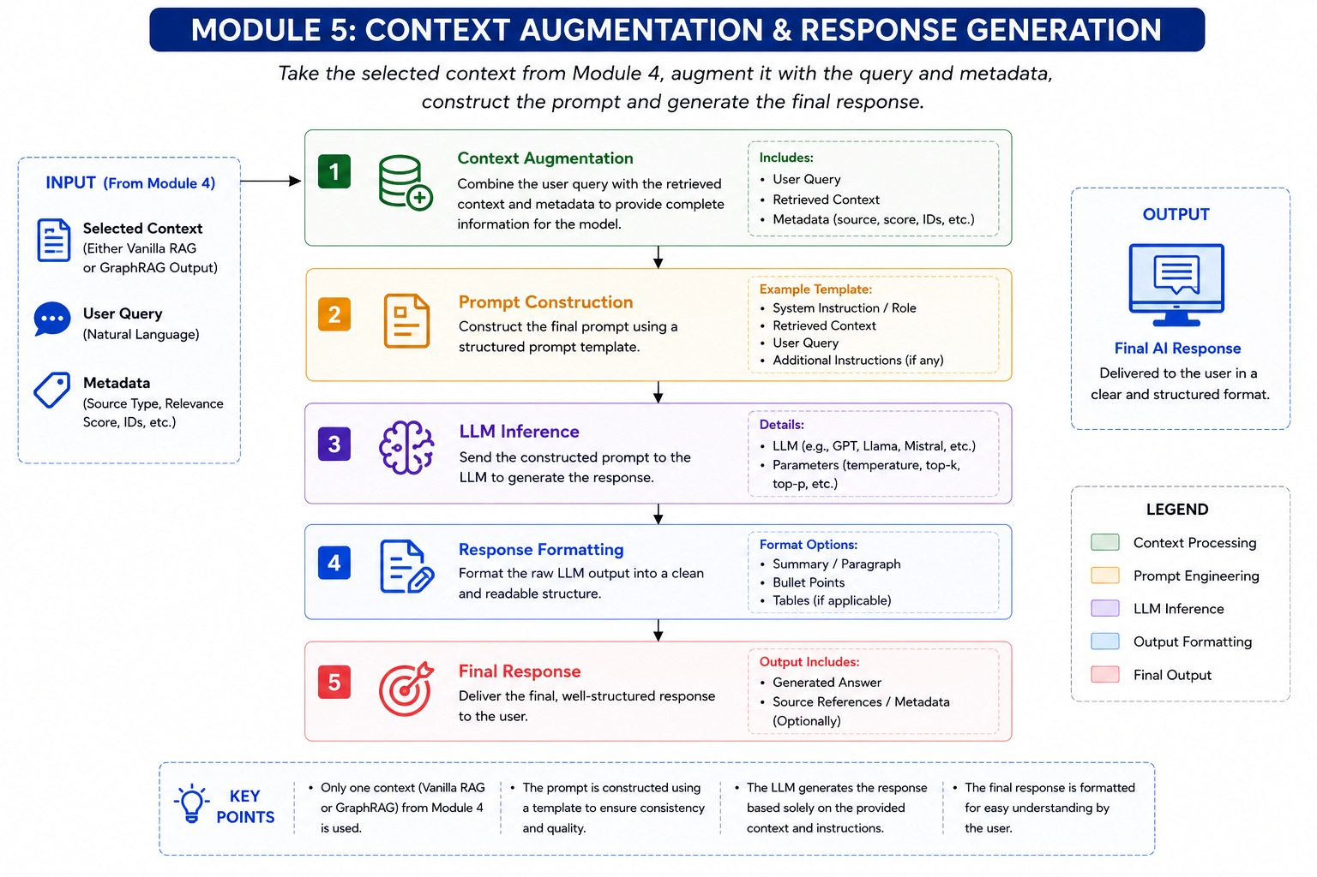
Module 5 — Context Augmentation & Response Generation

9.1 Processing Stages
Stage | Description
Context augmentation | Combine user query, selected context, and metadata.
Prompt construction | Apply a structured prompt template containing role, evidence, query, and instructions.
LLM inference | Send the prompt to the selected LLM using configured generation parameters.
Response formatting | Convert raw model output into readable summaries, bullets, tables, or other formats.
Final response | Return the grounded response and optionally source references/metadata.

9.2 Prompt Template
SYSTEM / ROLE
You are an AI assistant for software-testing analysis.
Use only the supplied evidence for factual claims.
RETRIEVED CONTEXT
{selected_context}
METADATA
{source_metadata}
USER QUERY
{user_query}
INSTRUCTIONS
- Answer directly and clearly.
- Distinguish evidence from inference.
- Cite artifact IDs/sources when available.
- If the evidence is insufficient, state the limitation.

10. Data Model and Storage Architecture
The system uses polyglot storage because semantic retrieval, structured access, and relationship traversal have different data-access requirements.

10.1 Vector Chunk Schema
Field | Type / Example | Purpose
chunk_id | UUID | Unique retrieval unit
text | String | Chunk content
embedding | Dense float vector | Semantic search representation
source_id | String | Originating artifact
source_type | Requirement/TestCase/Defect/etc. | Artifact category
project | String | Project identifier
module | String | Module/component
priority | String/Enum | Business or testing priority
created_at | Timestamp | Artifact creation time
updated_at | Timestamp | Freshness tracking

10.2 Knowledge Graph Model
Node Type | Representative Attributes | Example Relationships
Project | project_id, name | contains Feature
Feature | feature_id, name | implements Requirement
Requirement | requirement_id, text, priority | verified_by Test Case
Test Case | test_id, status, steps | detects Defect
Defect | defect_id, severity, status | linked_to Test Case
Execution | build_id, result, timestamp | executes Test Case
Report | report_id, date, summary | references Execution

11. Retrieval and Ranking Algorithms

11.1 Vector Similarity
Cosine similarity is a suitable baseline for dense embedding retrieval. For query vector q and chunk vector d:
cosine_similarity(q, d) = (q · d) / (||q|| × ||d||)
The implementation may use an approximate nearest-neighbor index for scale. The exact index and distance metric should match the embedding model and vector-store capabilities.

11.2 Re-ranking
Initial vector retrieval optimizes recall. Re-ranking improves precision by incorporating additional signals. A conceptual weighted score can be expressed as:
R = w1*semantic_similarity + w2*metadata_relevance + w3*recency + w4*source_priority
Weights should be validated empirically rather than treated as fixed architectural constants.

11.3 Graph Path Ranking
Graph retrieval can rank paths according to semantic relevance, relationship strength, path length, and node importance. Shorter, stronger, highly relevant paths should generally receive higher priority, subject to the query intent.
G = a*entity_relevance + b*relationship_strength + c*node_importance - d*path_length

12. Relevance Threshold Decision Logic
The relevance threshold T controls the trade-off between retrieval efficiency and retrieval completeness. A high threshold causes more queries to escalate to Graph RAG; a low threshold keeps more queries on the faster semantic path.
Condition | Action | Rationale
Sᵥ ≥ T | Use Vanilla RAG context | Semantic evidence is considered sufficient.
Sᵥ < T | Run Graph RAG and use Graph context | Additional relational context is required.

12.1 Threshold Calibration
- Create a representative validation set of real testing queries.
- Label whether Vanilla RAG alone provides sufficient evidence.
- Measure retrieval precision/recall and downstream answer quality.
- Evaluate multiple threshold candidates.
- Select T based on a cost-quality trade-off rather than retrieval score alone.
- Re-calibrate when embedding models, data distributions, or ranking logic change.
Important Implementation Note
A numerical similarity score is not automatically equivalent to answer confidence. The system should calibrate the threshold against downstream retrieval sufficiency and answer correctness.

13. Prompt Construction and Response Generation

13.1 Context Package
Field | Required | Description
user_query | Yes | Original natural-language request.
selected_context | Yes | Only Vanilla or Graph context selected by Module 4.
source_type | Yes | Retrieval source used.
relevance_score | Recommended | Score that justified selection.
source_metadata | Recommended | Artifact IDs, types, dates, project/module, etc.
retrieval_trace | Optional | Diagnostics for audit/evaluation.

13.2 Generation Controls
- Temperature: keep low for factual test-analysis use cases unless creative synthesis is explicitly desired.
- Top-k/top-p: tune for the selected model and validation set.
- Maximum output tokens: enforce a predictable response budget.
- Grounding instruction: restrict factual claims to retrieved evidence.
- Insufficient-evidence behavior: explicitly state when the context cannot support a conclusion.

13.3 Response Structure
For test execution insights, a useful response can contain: direct answer, supporting evidence, affected artifacts, relevance/source information, and a concise limitation section when evidence is incomplete.

14. Interfaces and Data Contracts

14.1 Query Request
{
"query": "Which feature is most unstable?",
"project": "SmartThings",
"filters": {
"date_from": "2026-08-01",
"date_to": "2026-08-25"
}
}

14.2 Planner Response
{
"selected_source": "graph",
"relevance_score": 0.91,
"context": [...],
"metadata": {
"project": "SmartThings",
"artifact_ids": ["REQ-102", "TC-205", "DEF-309"]
}
}

14.3 Generation Response
{
"answer": "...",
"source_type": "Graph RAG",
"relevance_score": 0.91,
"sources": ["REQ-102", "TC-205", "DEF-309"]
}

15. Non-Functional Requirements
Requirement | Target / Principle
Performance | Prefer Vanilla RAG for low-latency queries; invoke Graph RAG conditionally.
Scalability | Use ANN vector indexes and indexed graph traversals; support incremental ingestion.
Availability | Isolate retrieval services so one component failure does not corrupt indexed data.
Observability | Log query ID, retrieval path, scores, latency, selected source, and model response metadata.
Maintainability | Keep module boundaries and data contracts explicit.
Extensibility | Allow additional retrievers or rerankers without redesigning the response layer.
Explainability | Expose artifact IDs, source type, and retrieval scores where appropriate.
Data freshness | Support batch and incremental ingestion with timestamps/versioning.

16. Security, Governance and Reliability
- Apply authentication and authorization at ingestion, retrieval, and administrative interfaces.
- Enforce project/tenant-level access filters before retrieval so unauthorized chunks cannot enter the prompt.
- Propagate source permissions into vector metadata and graph nodes/edges.
- Encrypt data in transit and at rest according to deployment requirements.
- Avoid placing secrets, credentials, or unnecessary personal data into embeddings or prompts.
- Record audit metadata for retrieval decisions and generated responses.
- Version embedding models and indexing pipelines so retrieval behavior can be reproduced.
- Implement input validation and prompt-injection defenses for retrieved documents and user queries.
- Use timeouts and circuit breakers for vector stores, graph databases, connectors, and LLM providers.
Critical Security Control
Access control must happen before context reaches the LLM. Retrieval relevance must never override authorization boundaries.

17. Evaluation Metrics and Testing Strategy

17.1 Retrieval Metrics
Metric | Meaning
Recall@k | Whether relevant evidence appears among top-k results.
Precision@k | How much of top-k retrieval is relevant.
MRR | How early the first relevant result appears.
nDCG | Quality of ranked retrieval when relevance has multiple grades.
Retrieval latency | Time spent retrieving and ranking context.
Graph path quality | Relevance and correctness of selected graph paths.

17.2 End-to-End Metrics
- Answer correctness against a human-validated reference set.
- Groundedness: factual claims supported by retrieved evidence.
- Citation/source coverage.
- Abstention quality when evidence is insufficient.
- Average latency and P95/P99 latency.
- Percentage of queries escalated from Vanilla RAG to Graph RAG.
- Cost per query, including graph escalation and LLM usage.

17.3 Test Levels
Level | Examples
Unit | Chunking, embedding calls, score calculation, entity extraction.
Integration | Vector store, graph DB, structured DB, connectors.
Planner | Threshold routing and selected-source correctness.
Retrieval | Top-k relevance, reranking, graph traversal.
Generation | Prompt grounding, formatting, source attribution.
Security | Access-control leakage, prompt injection, tenant isolation.
Performance | Latency under concurrent queries and ingestion load.
Regression | Fixed query benchmark after model/index/ranking changes.

18. Deployment and Operational Considerations

18.1 Suggested Service Boundaries
- Ingestion Service
- Preprocessing/Chunking Service
- Embedding Service
- Vector Retrieval Service
- Graph Retrieval Service
- Hybrid Planner Service
- LLM Gateway / Generation Service
- Observability and Evaluation Service

18.2 Operational Pipeline
Sources
-> Ingestion
-> Preprocessing
-> Chunking
-> Embeddings ----> Vector Store
-> Entity/Relation Extraction -> Knowledge Graph
User Query
-> Hybrid Planner
-> Vanilla RAG
-> [Graph RAG if S_v < T]
-> Selected Context
-> Prompt Builder
-> LLM Gateway
-> Formatted Response

18.3 Caching Opportunities
- Cache query embeddings for repeated queries.
- Cache stable vector retrieval results for short time windows.
- Cache expensive graph traversals for frequently requested entities.
- Cache prompt-independent reference data where access policies permit.

19. Example End-to-End Scenario
Consider the query: “Which feature is most unstable in SmartThings?” The system should determine whether semantic retrieval alone can support the answer or whether relationship traversal is required.
Step | Component | Action
1 | Module 1 | Testing artifacts for SmartThings have already been indexed in the vector store and knowledge graph.
2 | Module 4 | Receives the user query and invokes Vanilla RAG first.
3 | Module 2 | Embeds the query, retrieves top-k chunks, re-ranks them, and computes Sᵥ.
4 | Module 4 | Compares Sᵥ with threshold T.
5A | If Sᵥ ≥ T | Use the Vanilla RAG context and forward it to Module 5.
5B | If Sᵥ < T | Invoke Module 3 to traverse Project → Feature → Requirement → Test Case → Defect and gather relationship-aware evidence.
6 | Module 4 | Forwards only the selected context and metadata.
7 | Module 5 | Augments context, constructs the prompt, invokes the LLM, and formats the answer.
8 | Final | Return a concise, evidence-grounded response with artifact references where available.

20. Risks, Limitations and Future Enhancements

20.1 Risks and Mitigations
Risk | Impact | Mitigation
Poor chunking | Relevant evidence may be split or lost. | Use semantic/hybrid chunking and benchmark chunk sizes.
Embedding mismatch | Semantic retrieval quality decreases. | Version models and evaluate on domain-specific queries.
False confidence | Low-quality context may be treated as sufficient. | Calibrate threshold using downstream correctness.
Graph incompleteness | Relationship answers may be incomplete. | Improve entity extraction, linking, and ingestion coverage.
Stale data | Responses reflect outdated execution state. | Incremental ingestion and freshness metadata.
Access leakage | Unauthorized evidence may reach the LLM. | Enforce authorization before retrieval/context assembly.
LLM hallucination | Unsupported conclusions. | Strict grounding prompts, citations, evaluation, and abstention.

20.2 Future Enhancements
- Learn the escalation threshold dynamically from query type and historical retrieval quality.
- Add hybrid scoring that combines vector evidence and graph evidence without always running both.
- Introduce query classification to predict when graph retrieval is likely to be necessary.
- Add temporal reasoning for build and execution trends.
- Add feedback loops from user ratings and analyst corrections.
- Use cross-encoder reranking for higher retrieval precision.
- Support multimodal retrieval for screenshots, diagrams, and UI evidence.
- Add answer-level evidence attribution and confidence calibration.
- Introduce evaluation dashboards for retrieval path, score distribution, latency, and answer quality.

21. Conclusion
The Hybrid RAG architecture provides a practical approach to AI-assisted test execution analysis by combining the speed of semantic vector retrieval with the relational reasoning capability of knowledge graphs. The key architectural innovation is not simply using two retrieval technologies; it is the controlled decision mechanism in Module 4 that selects the simplest sufficient retrieval path.
Module 1 establishes a common indexed knowledge repository. Module 2 provides fast semantic retrieval. Module 3 provides relationship-aware multi-hop retrieval. Module 4 evaluates confidence and decides whether escalation is needed. Module 5 converts the selected evidence into a grounded, structured response. Together, these modules create an extensible pipeline that can support test analysis, traceability, defect investigation, execution insights, and other engineering questions while maintaining explicit retrieval provenance.

Appendix A — Architecture Diagrams
Overall Hybrid RAG Architecture

Module 1 — Input & Data Ingestion

Module 2 — Vanilla RAG / Semantic Retrieval

Module 3 — Graph RAG Pipeline

Module 4 — Hybrid RAG Planner

Module 5 — Context Augmentation & Response Generation

