**[Your Full Name]**  
Address: [Your Address]  
Phone: +8801XXXXXXXXX  
Email: [Your Email Address]  
LinkedIn: linkedin.com/in/[YourLinkedInID]

**Career Objective**

A highly motivated and detail-oriented recent graduate with a degree in [Your Major/Field of Study]. Seeking an entry-level position to leverage my skills in [Relevant Skills/Industry] and contribute to organizational goals while gaining practical experience.

**Education**

Bachelor of [Your Degree]  
[University Name], [City]  
Graduation Date: [Month, Year]  
CGPA: [Your CGPA] (if relevant)

Higher Secondary Certificate (HSC)  
[College Name], [City]  
Year of Completion: [Year]  
GPA: [Your GPA]

Secondary School Certificate (SSC)  
[School Name], [City]  
Year of Completion: [Year]  
GPA: [Your GPA]

**Skills**

* Technical Skills: [e.g., MS Office, C++, Python, Excel, etc.]
* Software/Tools: [e.g., Adobe Photoshop, AutoCAD, Tableau, etc.]
* Soft Skills: [e.g., Communication, Teamwork, Problem Solving]
* Languages: [e.g., English, Bengali]

**Projects (if any)**

Project Title – [Role/Your Contribution]  
Brief description: Explain what the project was about, your role, and any skills or technologies you used.

**Internships / Volunteering (if any)**

Intern, [Company Name]  
[City, Duration: e.g., June 2023 - August 2023]

* Assisted with [specific tasks or responsibilities].
* Gained experience in [related skills or tools].

**Extracurricular Activities**

* Position in Club/Organization Name – Brief Description
* Volunteer Work at Organization Name – Brief Description

**References**

1. [Reference Person’s Full Name]  
   Position: [Their Position]  
   Company/Organization: [Their Organization’s Name]  
   Contact Number: [Their Phone Number]  
   Email: [Their Email Address]
2. [Reference Person’s Full Name]  
   Position: [Their Position]  
   Company/Organization: [Their Organization’s Name]  
   Contact Number: [Their Phone Number]  
   Email: [Their Email Address]

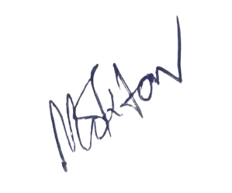

**Date**: [DD/MM/YYYY]

**Signature** [আপনার স্বাক্ষর]  
**[Your Full Name]**