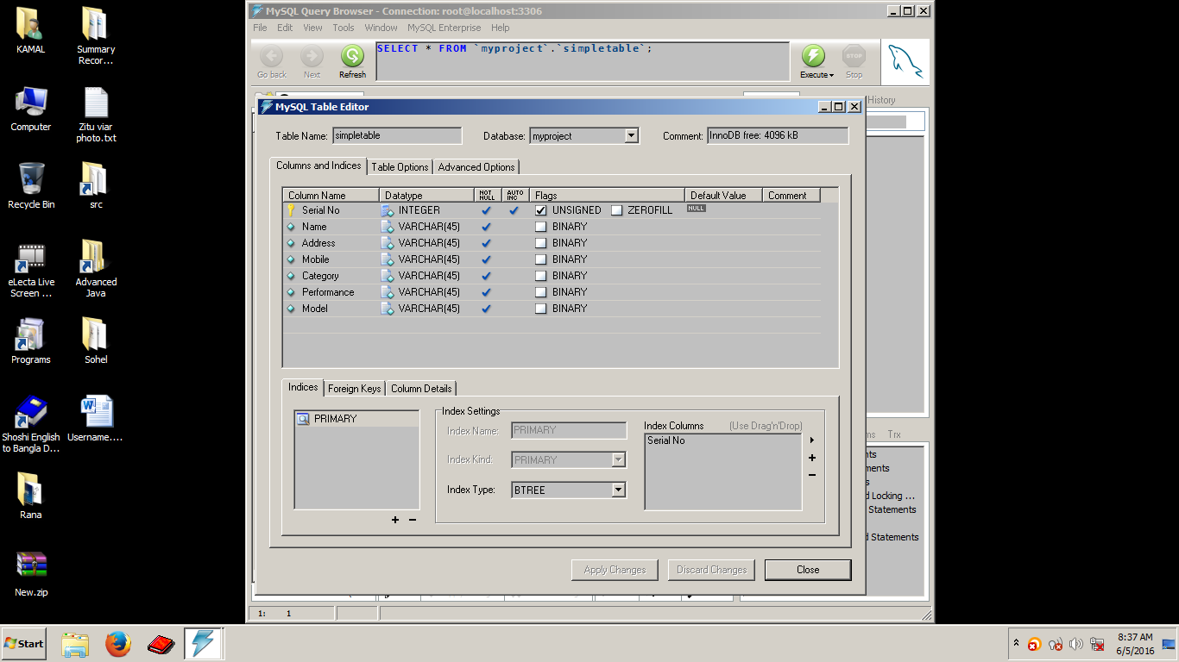

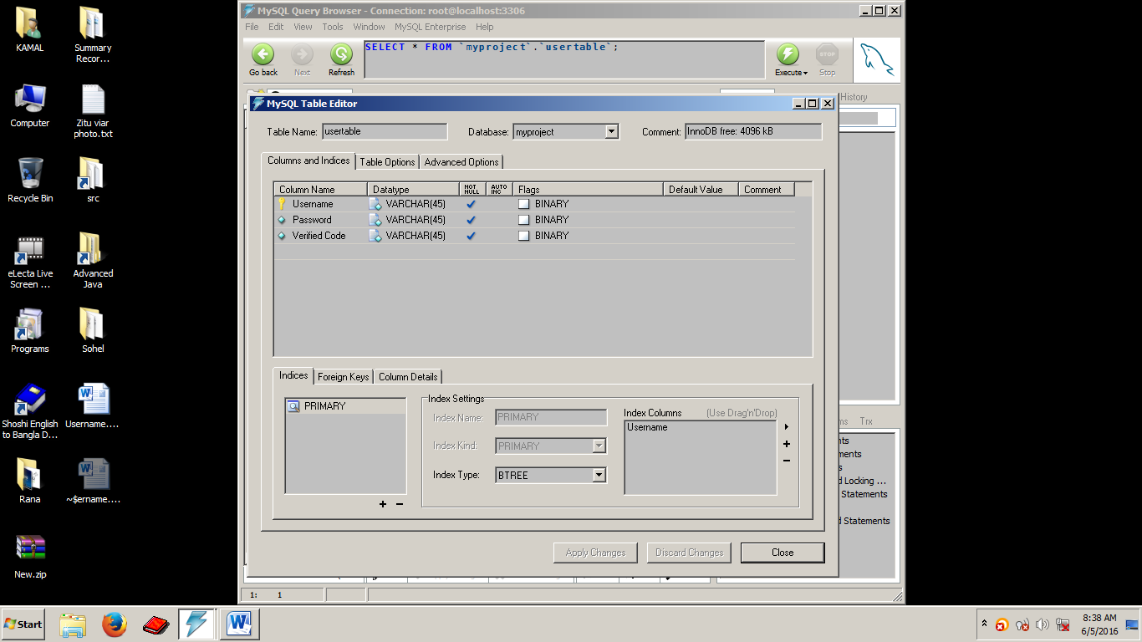

Username

Password

Username

Password

Confirm password

Verified code

Serial No

Name

Address

Mobile

Category

Performance

Model

Data not inserted

Confirm the password

Registration

snText

nameText

addressTextArea

mobileText

jRadioButton1

jCheckBox1: low medium high

modelComboBox