***What is Replication?***

Replication is the process of copying and maintaining data from one database (called the *primary* or *source*) to one or more databases (called *replicas* or *targets*). It ensures that multiple copies of the data are synchronized and can serve various purposes, such as high availability, disaster recovery, load balancing, and fault tolerance.

**Replication in Azure**

Azure provides built-in replication features for high availability and disaster recovery:

1. **Active Geo-Replication**:
   * Allows up to 4 readable secondaries.
   * Supports failover within 30 seconds.
   * Ideal for global applications.

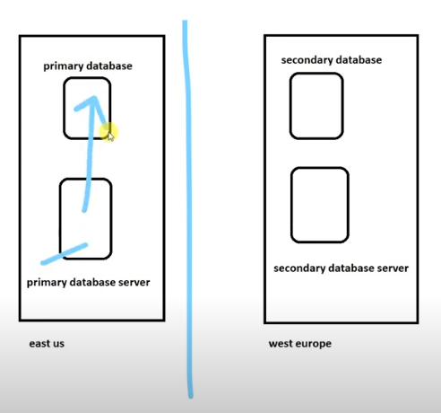

1. **Failover Groups**:
   * Automatic failover for critical databases.
   * Multiple databases can be grouped together for replication.
2. **Zone Redundant Configuration**:
   * Replicates data within availability zones in a single region.

***Steps for Setting Up Active Geo-Replication***

**1. Navigate to Azure Portal**

* Go to the Azure Portal and locate your Azure SQL Database.
* Select your database from the list of resources.

**2. Open the Geo-Replication Blade**

* In the left menu, select **Geo-Replication** under the **Settings** section.
* A map and list of Azure regions will appear.

**3. Choose a Target Region**

* Click on the desired target region for the secondary database.
* Ensure that the chosen region supports Active Geo-Replication.

**4. Configure the Secondary Database**

* Provide the necessary details for the secondary database:
  + **Server**: Select an existing server in the target region or create a new one.
  + **Pricing Tier**: Match or exceed the pricing tier of the primary database.
* Ensure you configure the secondary database with appropriate performance levels.

**5. Initiate Replication**

* Click **OK** to start creating the secondary database.
* Azure will asynchronously replicate the data from the primary database to the secondary database.



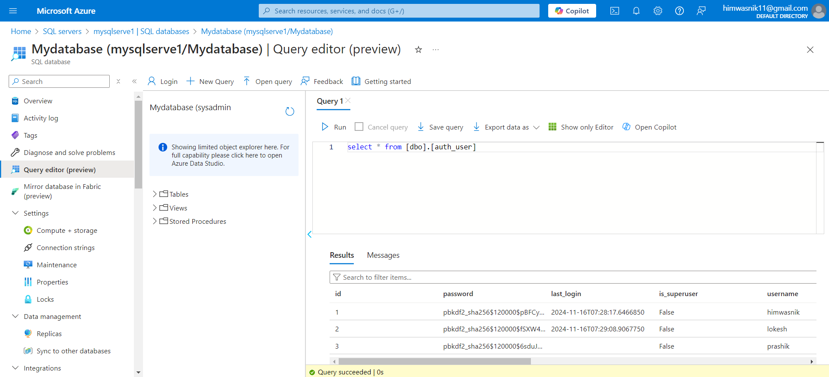

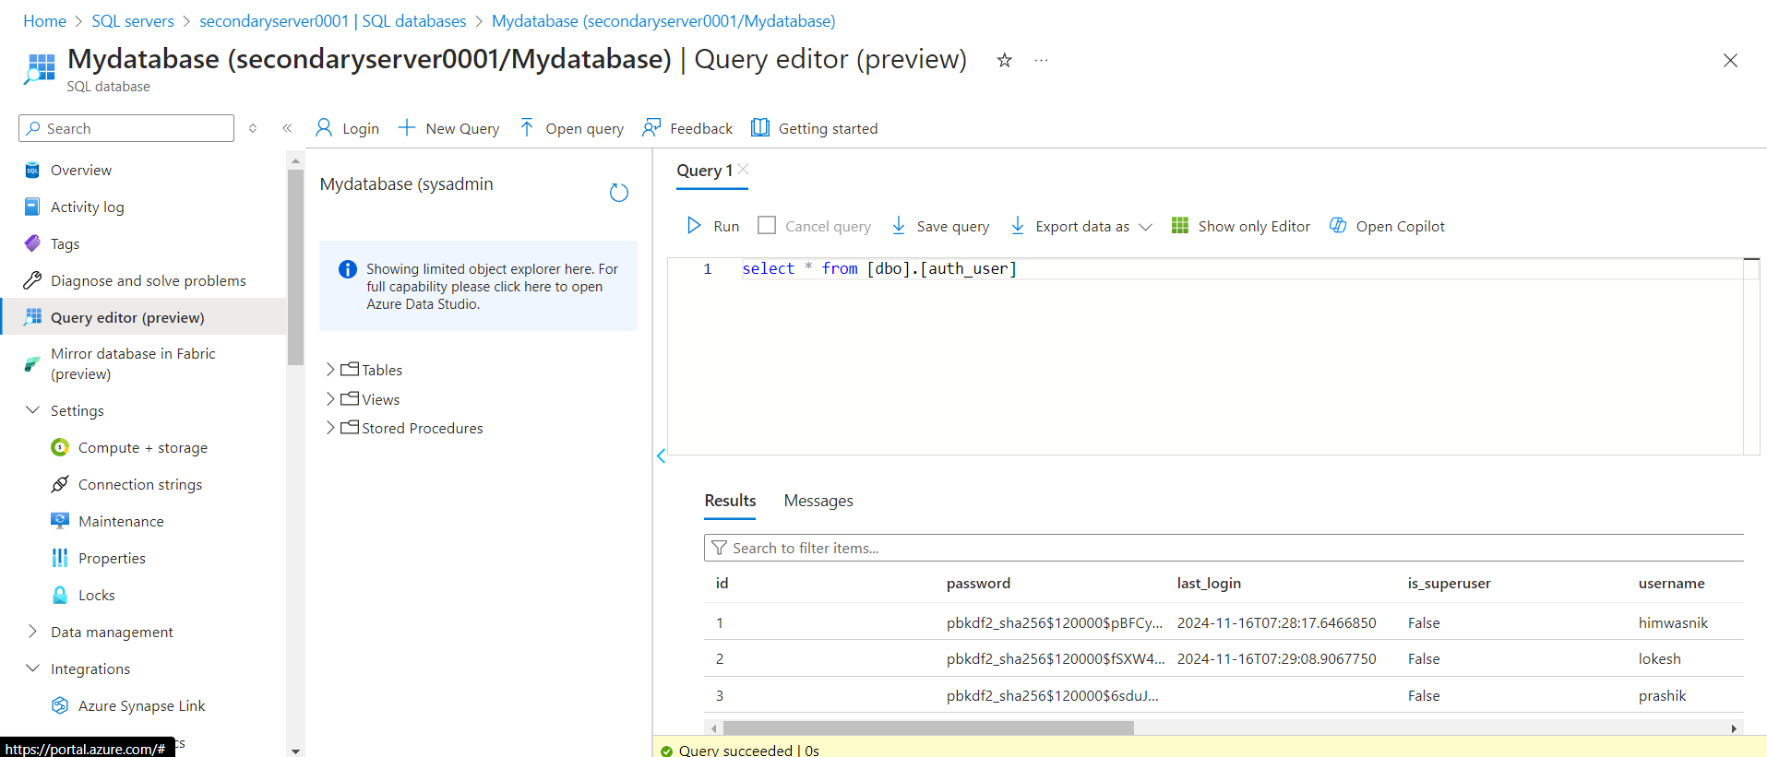

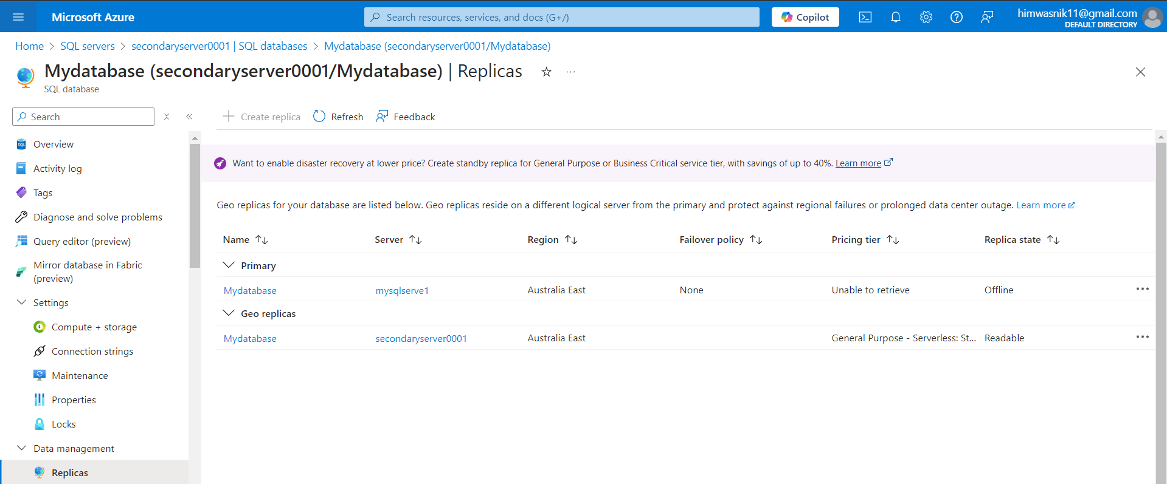

***Steps to Configure a Failover Group for Azure SQL Database***

A **Failover Group** in Azure SQL Database enables seamless failover for a group of databases between two Azure regions. This ensures high availability and disaster recovery across geographic regions. It includes automatic failover and is often used with **geo-replication**.

**1. Prerequisites**

* Two SQL servers in different Azure regions:
  + **Primary Server**: primary-server.database.windows.net
  + **Secondary Server**: secondary-server.database.windows.net
* Databases to include in the failover group already exist on the primary server.

**2. Steps to Create a Failover Group**

**Step 1: Set Up Geo-Replication for Databases**

1. **Navigate to Azure SQL Database in the Portal**:
   * Go to the **primary database** on the **primary server**.
   * Under the **Replication** section, click **Geo-Replication**.
   * Select the secondary server (secondary-server) and the target region.
2. **Verify Replication**:
   * Ensure the database is replicated to the secondary server and shows as a read-only replica.

**Step 2: Create the Failover Group**

1. **In the Azure Portal**:
   * Go to the **primary SQL server** (primary-server).
   * Click **Failover Groups** under **Settings**.
2. **Add a Failover Group**:
   * Click **Add Group**.
   * Provide the following details:
     + **Failover Group Name**: my-failover-group.
     + **Secondary Server**: Select secondary-server.
     + **Read/Write Failover Policy**: Choose Automatic or Manual.
     + **Add Databases**: Select the databases to include in the failover group.
3. **Click Create**:
   * Azure will create the failover group and establish a connection between the servers.

