***Employee-Wage-Computation***

**UC1: Added Employee Attendance Check**

print("Welcome to Employee Wage Computation Program")

import random

print("Welcome to Employee Wage Computation Program")

# UC1: Check Employee Attendance

attendance = random.choice([0, 1])

if attendance == 1:

print("Employee is Present")

else:

print("Employee is Absent")

**Explanation:-**

* Class **Variables**: Constants such as WAGE_PER_HOUR, FULL_DAY_HOURS, PART_TIME_HOURS, etc., are class variables used throughout the calculations.
* Attendance **Check (UC 1)**: The is_employee_present() method uses random.choice() to randomly assign whether an employee is present or absent.

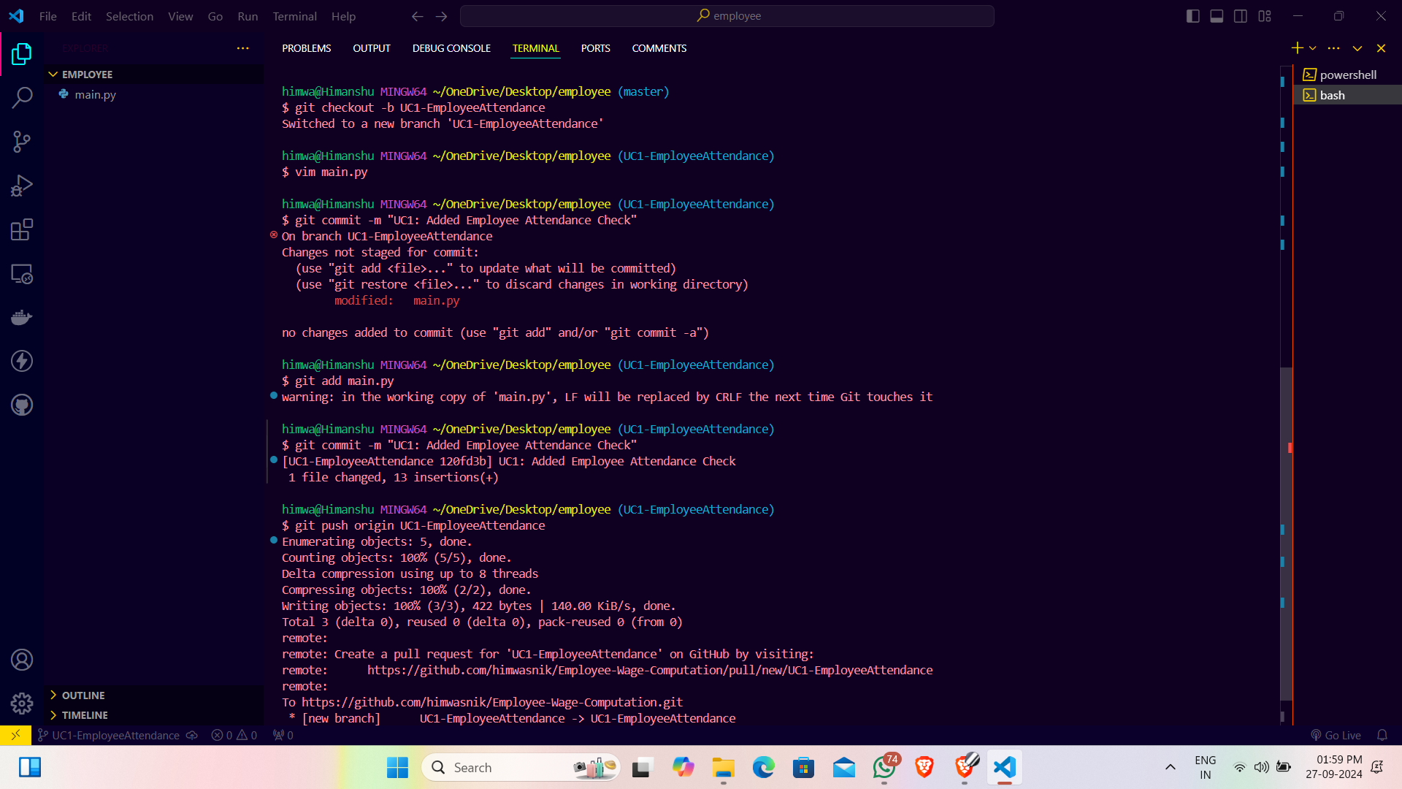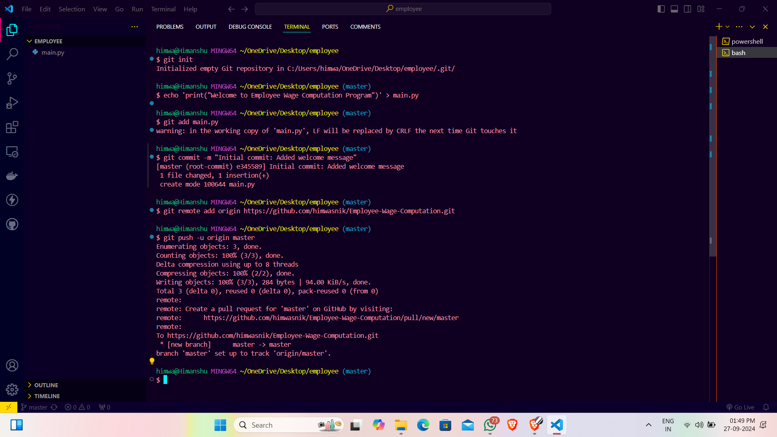

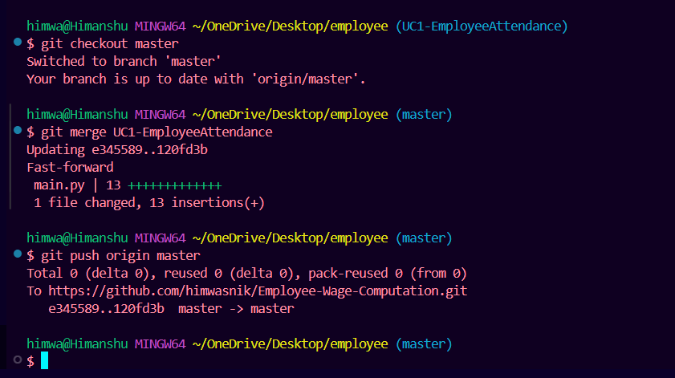

[***UC2: Added Daily Employee Wage Calculation***](https://github.com/himwasnik/Employee-Wage-Computation/commit/499065c06cf220ca12895d199b2ecf79a42a9dc9)

# UC2: Daily Employee Wage

wage_per_hour = 20

full_day_hour = 8

daily_wage = wage_per_hour * full_day_hour

print(f"Daily Employee Wage: {daily_wage}")

**Explanation:-**

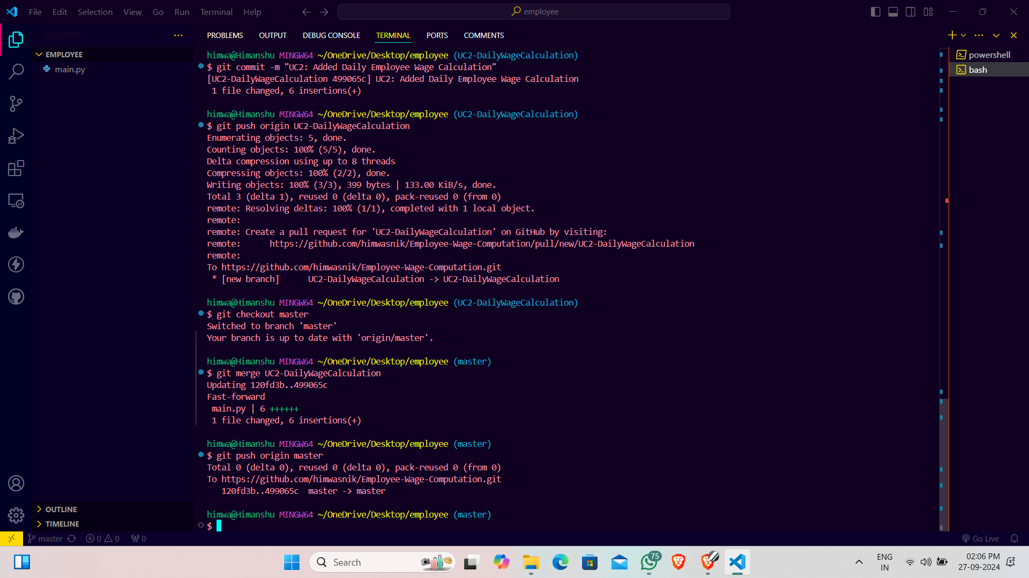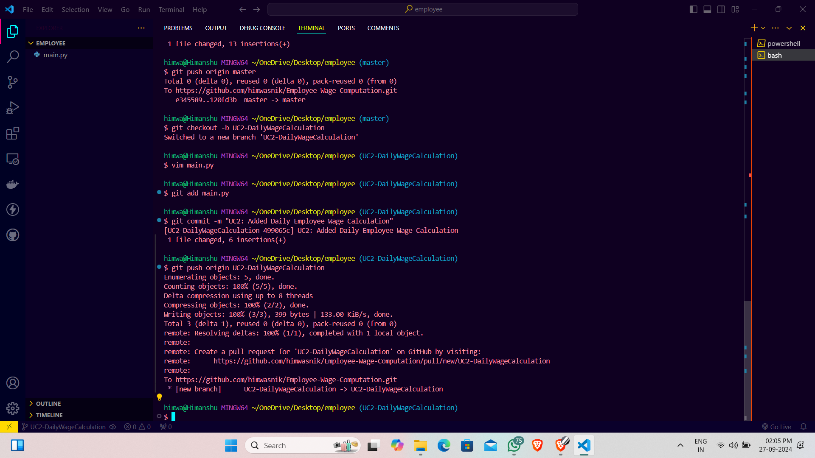Daily Wage Calculation (UC 2): calculate_daily_wage() takes the number of hours worked as input and calculates the daily wage based on WAGE_PER_HOUR

***UC3: Part-Time Employee Wage***

part_time_hour = 4

part_time_wage = wage_per_hour * part_time_hour

print(f"Part-time Employee Wage: {part_time_wage}")

**Explanation:-**

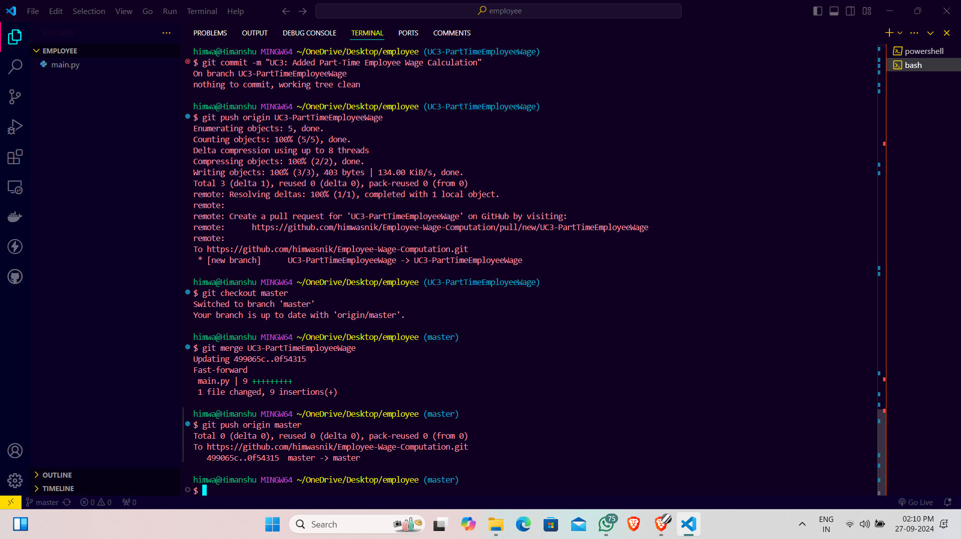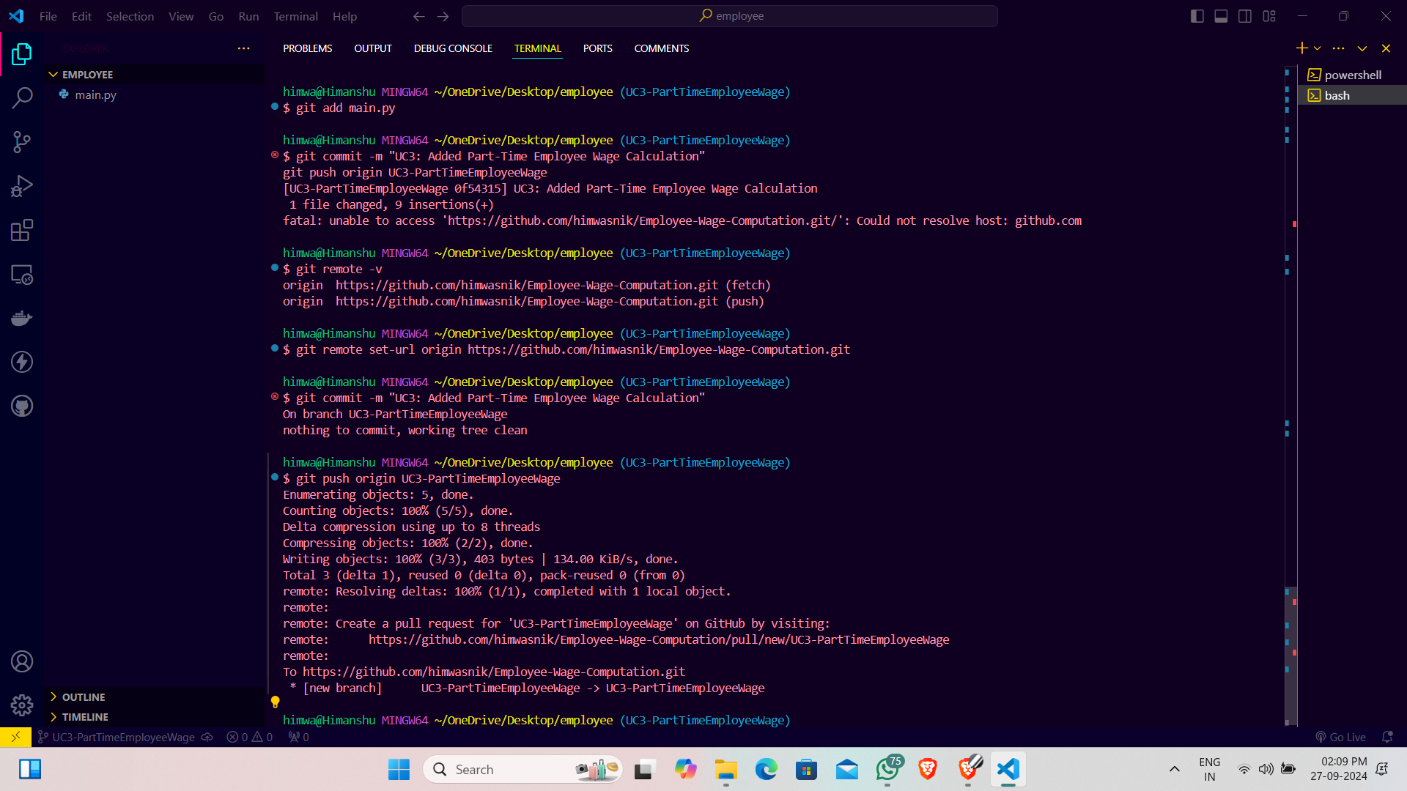Part-Time Wage (UC 3): part_time_employee_wage() method calculates the wage based on part-time hours.

***UC4: Solve using Switch Case***

def employee_wage(employee_type):

switcher = {

1: full_day_hour * wage_per_hour, # Full-time employee

2: part_time_hour * wage_per_hour # Part-time employee

}

return switcher.get(employee_type, 0) # Default for absent

employee_type = random.choice([0, 1, 2]) # 0: Absent, 1: Full-time, 2: Part-time

print(f"Employee Wage (Switch Case): {employee_wage(employee_type)}")

**Explanation:-**

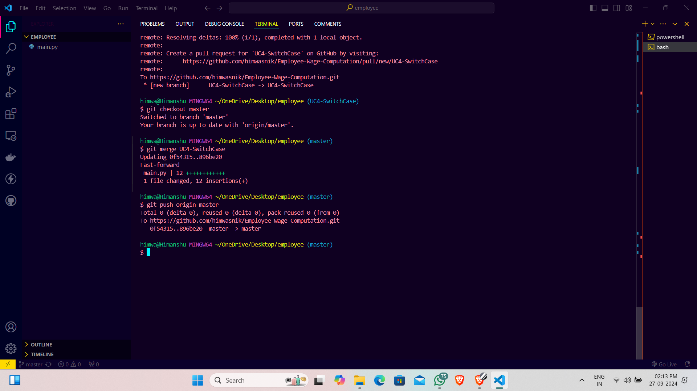Monthly Wage Calculation (UC 4): monthly_wage() calculates the wage for 20 working days in a month.

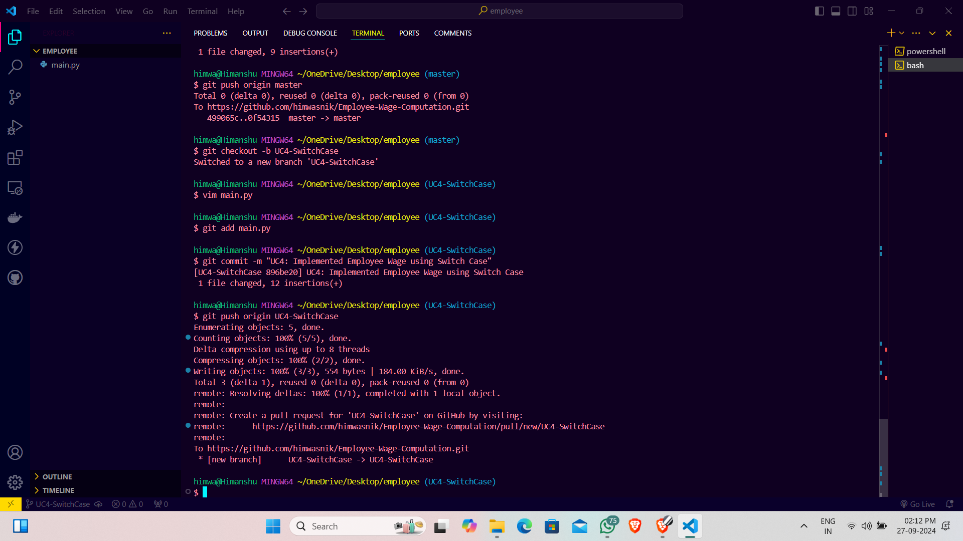

***UC5: Calculate Wages for a Month***

working_days_per_month = 20

monthly_wage = working_days_per_month * daily_wage

print(f"Monthly Employee Wage: {monthly_wage}")

**Explanation:-**

**Conditional Monthly Wage Calculation (UC 5)**: conditional_monthly_wage() keeps track of both total days and hours worked, stopping when either condition exceeds the monthly limits.

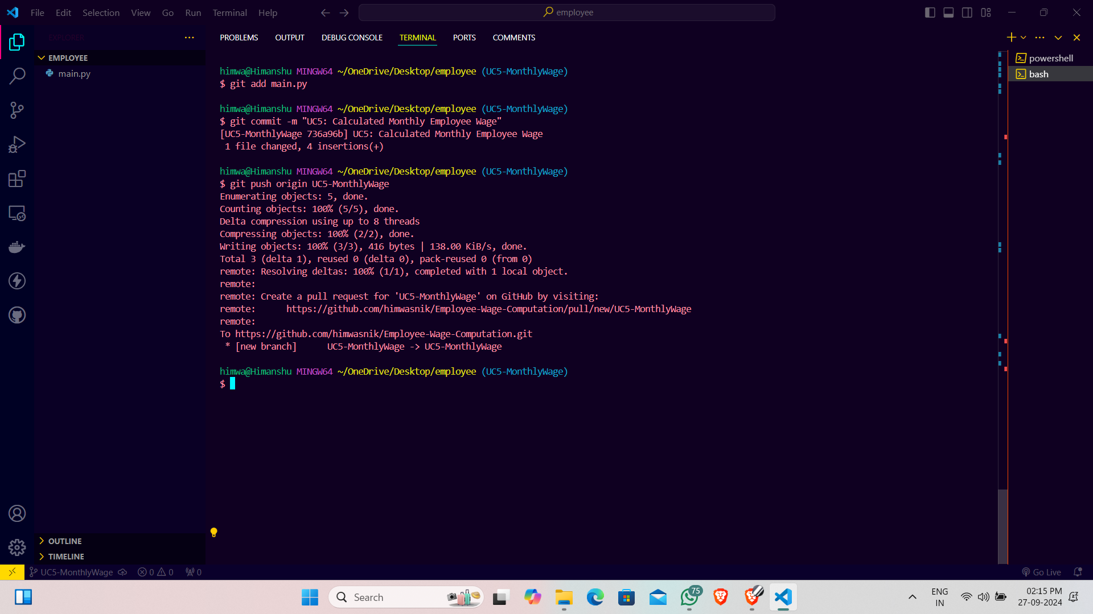

***UC6: Calculate Wages Till Condition***

max_hours_per_month = 100

total_working_days = 0

total_working_hours = 0

while total_working_days < 20 and total_working_hours < max_hours_per_month:

hours_worked = random.choice([0, 4, 8]) # 0: Absent, 4: Part-time, 8: Full-time

total_working_hours += hours_worked

total_working_days += 1

total_wage = total_working_hours * wage_per_hour

print(f"Total Employee Wage for the Month: {total_wage}")

**Explanation:-**

**Main Method (UC 6)**: compute_employee_wage() is the main entry point, calling conditional_monthly_wage() and printing the total monthly wage based on the conditions.

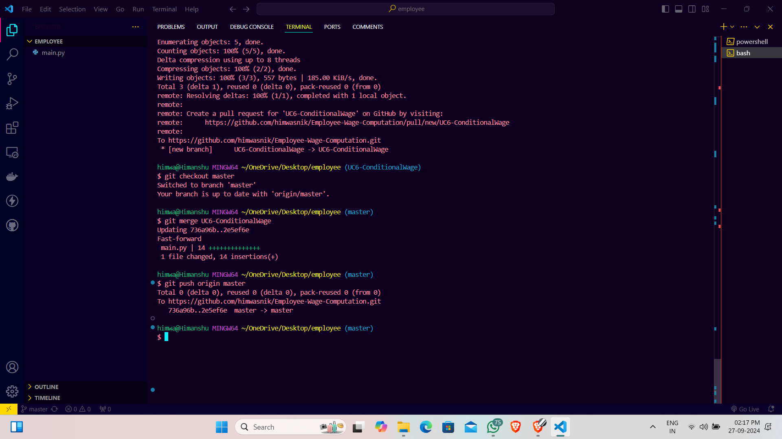

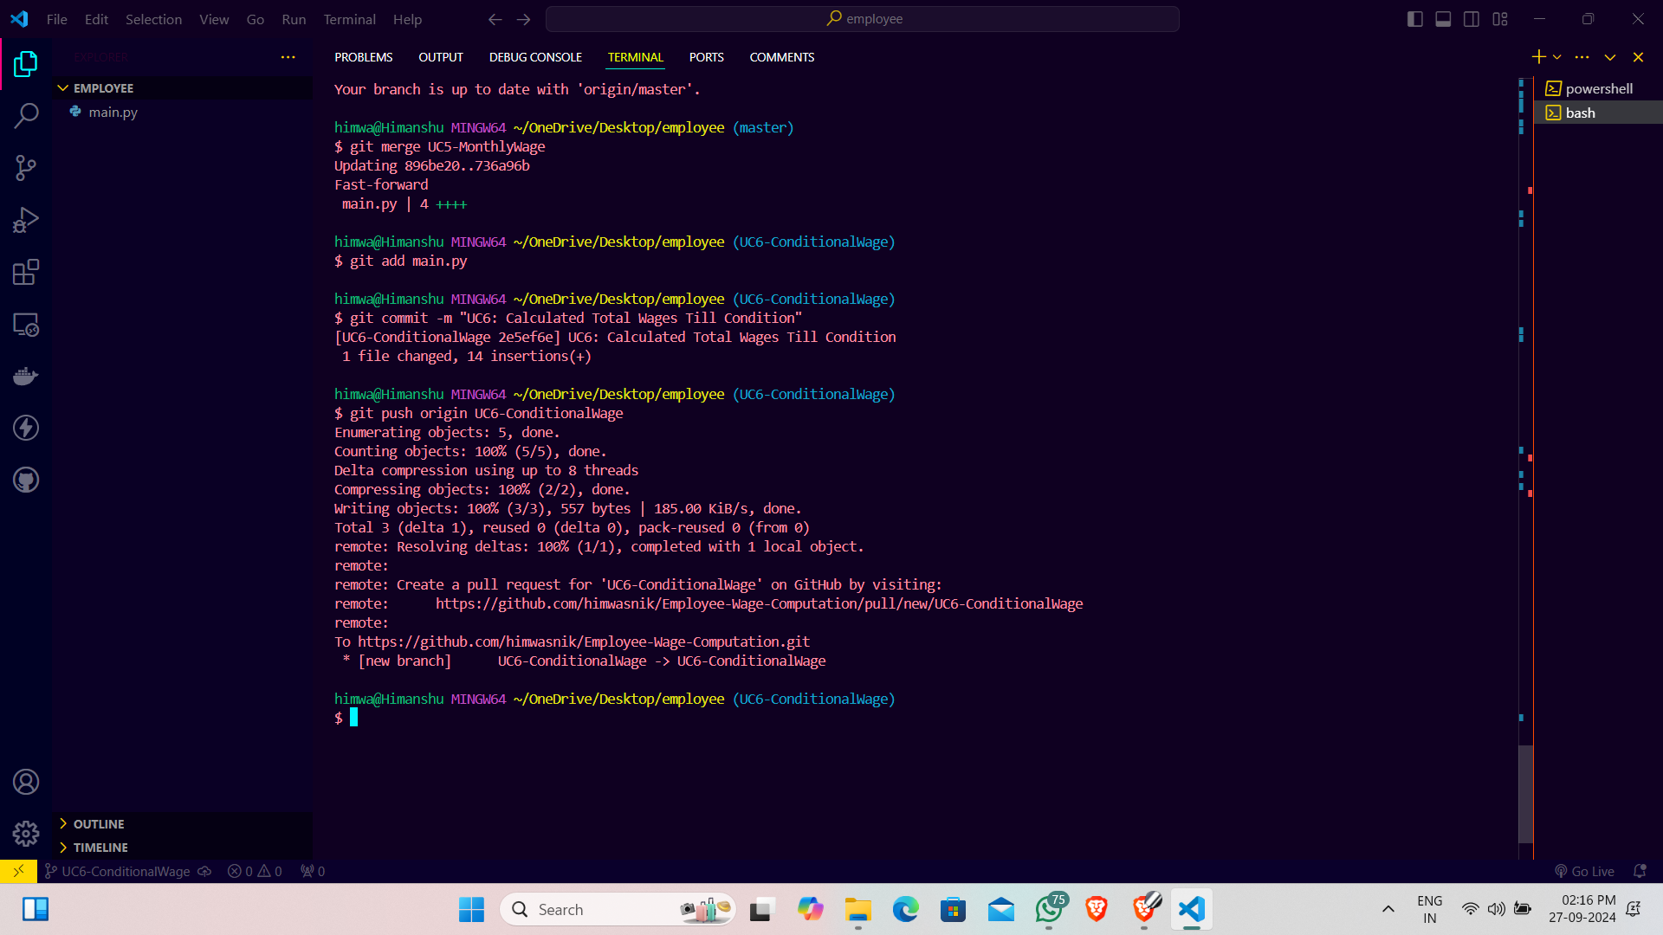

***UC7: Refactor code using class method***

class EmployeeWageComputation:

wage_per_hour = 20

full_day_hour = 8

part_time_hour = 4

@classmethod

def calculate_wage(cls, employee_type):

if employee_type == 1: # Full-time

return cls.full_day_hour * cls.wage_per_hour

elif employee_type == 2: # Part-time

return cls.part_time_hour * cls.wage_per_hour

else:

return 0 # Absent

employee_type = random.choice([0, 1, 2]) # 0: Absent, 1: Full-time, 2: Part-time

wage = EmployeeWageComputation.calculate_wage(employee_type)

print(f"Employee Wage (Class Method): {wage}")

