Amazon RDS (Relational Database Service) - Overview
Amazon RDS (Relational Database Service) is a fully managed database service that makes it easy to set up, operate, and scale relational databases in the cloud. It automates administrative tasks like provisioning, patching, backups, and monitoring.

Key Features of Amazon RDS
1️Supports Multiple Database Engines
- MySQL
- PostgreSQL
- MariaDB
- Oracle
- SQL Server
- Amazon Aurora (AWS’s own high-performance DB)
2️Automated Backups & Snapshots
- RDS provides automated backups and manual snapshots for disaster recovery.
3️High Availability (Multi-AZ Deployments)
- RDS automatically replicates the database in a different Availability Zone (AZ) for failover support.
4️Read Replicas for Scalability
- RDS allows Read Replicas to offload read traffic and improve performance.
5️Automatic Patching & Maintenance
- AWS handles database software updates and security patches automatically.
6️Security & Encryption
- Supports IAM authentication, Security Groups, and KMS encryption to protect data.
7️Performance Monitoring with Amazon CloudWatch
- Metrics such as CPU, memory, IOPS, connections, and query performance are monitored.
8️Serverless Option (Aurora Serverless)
- Automatically scales up or down based on demand, perfect for unpredictable workloads.

Common Use Cases
- Web applications & mobile apps needing managed databases
- E-commerce platforms handling transactional data
- Analytics & reporting applications
- Multi-region deployments for disaster recovery
- Migrating on-premise databases to AWS

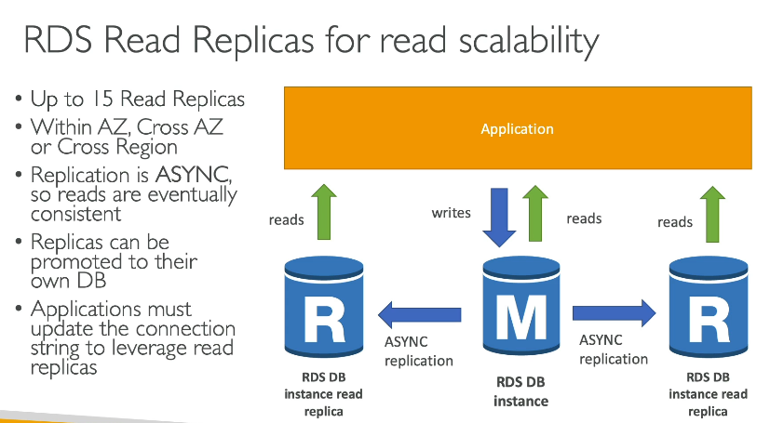
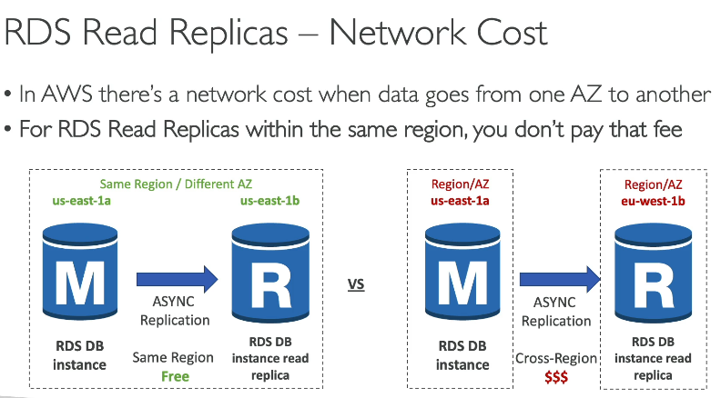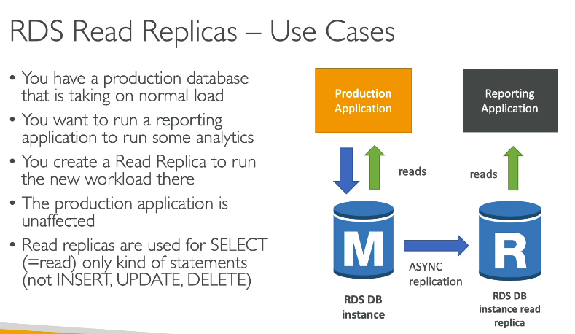

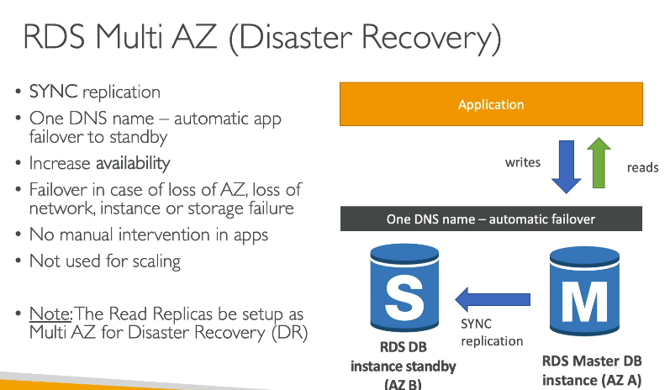

RDS Multi-AZ vs. Read Replicas
Amazon RDS offers Multi-AZ Deployment and Read Replicas, but they serve different purposes:
Feature |  |  | RDS Multi-AZ 🏛 | Read Replicas 📖
Purpose |  |  | High Availability (Failover & Disaster Recovery) | Scalability & Performance (Handling Read Traffic)
Replication Type |  |  | Synchronous (Data is copied immediately) | Asynchronous (Slight delay in data replication)
Primary Benefit |  |  | Ensures automatic failover to a standby database in case of failure | Allows multiple read-only copies of the database to distribute read traffic
Failover Support |  |  | ✅ Yes (Automatic in case of failure) | ❌ No (Not automatic; must be manually promoted)
Writes Allowed? |  |  | ✅ Yes (Only on primary DB) | ❌ No (Only read operations are allowed)
Use Case |  |  | Critical applications that need high availability | Applications with high read traffic (e.g., analytics, reporting, dashboards)
Number of Copies |  |  | 1 standby replica (in another AZ) | Up to 15 read replicas (in same or different regions)
Cross-Region Support? |  |  | ❌ No, only within the same AWS region | ✅ Yes, read replicas can be in different AWS regions
Cost |  |  | Slightly higher cost due to standby instance | Can be cost-effective for read-heavy applications
🚀 Steps to Set Up RDS from AWS Console
1️Go to AWS Management Console → RDS
2️Click "Create Database"
3️Select Database Engine (e.g., MySQL, PostgreSQL)
4️Choose Deployment Option
- Single-AZ (for dev/test)
- Multi-AZ (for production HA)
5️Configure DB Instance Size & Storage
Example: db.t3.micro (2 vCPUs, 1GB RAM)
20 GB SSD Storage
6️Set Admin Credentials (Username & Password)
7️Configure VPC & Security Group (Allow access from your EC2 web app)
8️Enable Automatic Backups & Monitoring
9️Click "Create Database"

Multi-AZ Deployment (High Availability)
Scenario: E-Commerce Website Database (Critical System)
Imagine you run an e-commerce website, and your database handles customer orders. If the primary database fails, the entire checkout process stops.
Solution: Use RDS Multi-AZ to ensure automatic failover.
🔹 AWS keeps a standby copy in another Availability Zone (AZ).
🔹 If the primary fails, AWS automatically promotes the standby without data loss.
How to Enable Multi-AZ in AWS Console?
1 Go to AWS Console → RDS
2️Select Your Database → Modify
3️Enable Multi-AZ Deployment
4️Save & Apply Changes
✅ Best for mission-critical applications that need 99.99% uptime.

🔹 Read Replicas (Scalability)
Scenario: A News Website with Millions of Readers
Imagine you run a news website, and thousands of users are reading articles at the same time.
🔹 If all traffic goes to a single database, it may slow down due to high read requests.
Solution: Use Read Replicas to distribute the load.
🔹 Read traffic is spread across multiple replicas, reducing the load on the primary DB.
🔹 If needed, one replica can be promoted to become the new primary DB (manual step).
How to Create Read Replicas in AWS Console?
1️Go to AWS Console → RDS
2️Select Your Database → Create Read Replica
3️Choose Number of Replicas (up to 15)
4️Select Availability Zone or Another AWS Region
5️Click Create
✅ Best for read-heavy applications like blogs, analytics, and dashboards.

When Does RDS Multi-AZ Trigger a Failover?
AWS RDS automatically promotes the standby instance to primary when any of these failover conditions occur:
Failover Condition |  |  | Description
Primary DB Instance Failure |  |  | The primary database crashes due to hardware/software failure.
Availability Zone Failure |  |  | If the entire AZ goes down due to power loss, network failure, or AWS infrastructure issues.
Manual Failover Initiated |  |  | You manually trigger a failover using the AWS Management Console or AWS CLI.
Instance Restart with Failover |  |  | If you restart your RDS instance with the "Failover" option enabled.
Loss of Network Connectivity |  |  | The primary database loses connectivity to AWS services or applications.
Storage Failure (EBS Volume Issue) |  |  | If the primary instance’s underlying EBS storage fails, AWS triggers a failover.
High Latency or Unresponsive Primary Instance |  |  | AWS continuously monitors the instance’s health metrics and triggers failover if the primary is too slow.
Host-Level Maintenance by AWS |  |  | AWS performs maintenance on the underlying hardware, requiring a failover.

🔹 What Happens During a Failover?
1️AWS Promotes the Standby Instance 🚀
- The standby instance (already in sync) becomes the new primary database.
2️Database Endpoint Remains the Same 🔗
- Your application does not need to change the connection string because RDS keeps the same database endpoint.
3️Minimal Downtime (~60 seconds to a few minutes) ⏳
- The failover usually completes within 60 seconds (may vary depending on database size and load).
4️A New Standby Instance is Created 🆕
- After failover, AWS creates a new standby replica in a different AZ.

What is RDS Proxy?
Amazon RDS Proxy is a fully managed database proxy service for Amazon RDS and Amazon Aurora. It pools and shares database connections to improve application scalability, performance, and security.

🔹 Why Use RDS Proxy?
Feature | Benefit
Connection Pooling | Efficiently manages database connections, reducing overhead.
Automatic Failover | Works with Multi-AZ RDS, ensuring fast failover (seconds instead of minutes).
Better Scalability | Handles thousands of connections without overloading the database.
Improved Security | IAM-based authentication and secrets stored in AWS Secrets Manager.
Reduces Connection Overhead | Reuses connections, reducing time-consuming connection creation.

🔹 How RDS Proxy Works
1️Application connects to RDS Proxy instead of directly to RDS.
2️RDS Proxy manages database connections efficiently, reducing idle connections.
3️If a failover happens, RDS Proxy redirects traffic to the new database seamlessly.

🔹 Scenario: High Traffic Web Application
📌 Problem:
- You run a high-traffic e-commerce website that frequently opens and closes database connections.
- During peak hours, too many connections overwhelm the RDS instance, causing delays.
✅ Solution: Use RDS Proxy
- The application connects to RDS Proxy, which manages and reuses database connections.
- RDS Proxy pools connections, reducing the load on RDS and improving response time.
- If RDS fails over, RDS Proxy automatically reroutes connections, minimizing downtime.

🔹 Steps to Set Up RDS Proxy (AWS Console)
Step 1: Enable RDS Proxy
1️Go to AWS Console → RDS
2️Click Proxies → Create Proxy
3️Choose your RDS/Aurora database
4️Enable IAM authentication and connect AWS Secrets Manager
5️Set idle connection timeout (e.g., 5 minutes)
6️Click Create Proxy
Step 2: Update Application to Use Proxy
- Update your database connection string to point to the RDS Proxy endpoint instead of the RDS endpoint.
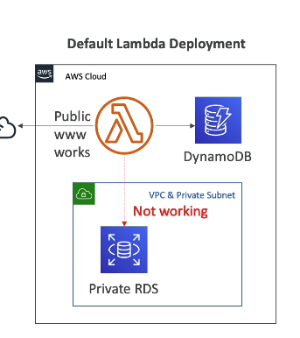
- 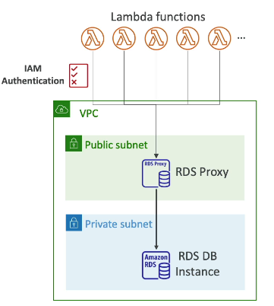

What is an RDS Parameter Group?
An RDS Parameter Group is a collection of database engine configuration settings that you can apply to your Amazon RDS instance. It allows you to customize how the database engine behaves.
🔹 Think of it like a "configuration file" for your RDS instance!

🔹 Why Use an RDS Parameter Group?
Feature | Benefit
Custom Database Settings | Adjust settings like query timeout, memory allocation, and cache size.
Fine-tuned Performance | Optimize database performance based on workload.
Automatic Parameter Application | Some parameters take effect immediately; others require a reboot.
Different Parameter Groups for Different Workloads | Use different settings for Dev, Test, and Production environments.

🔹 Scenario: Optimizing Query Performance
📌 Problem:
- Your PostgreSQL RDS instance is running slow during high-traffic hours.
- Queries take too long, and CPU utilization is high.
✅ Solution: Use a Custom Parameter Group
- Create a new parameter group and adjust key settings:
  - Increase work_mem (for better query execution).
  - Increase max_connections (to allow more users).
  - Reduce idle_in_transaction_timeout (to free up locked resources).
- Apply the new parameter group to your RDS instance.
- Reboot the RDS instance to apply changes.

🔹 Types of Parameter Groups
1️Default Parameter Group
- Created automatically by AWS for each database engine.
- Cannot be modified but can be used as a reference.
2️Custom Parameter Group
- Created manually by users.
- Allows you to modify database settings based on requirements.

🔹 Steps to Create and Apply an RDS Parameter Group (AWS Console)
Step 1: Create a Parameter Group
1️Go to AWS Management Console → RDS
2️Click Parameter Groups → Create Parameter Group
3️Select Database Engine (e.g., MySQL, PostgreSQL)
4️Give a name and description → Click Create
Step 2: Modify Parameters
1️Select the newly created parameter group
2️Click Edit Parameters
3️Modify settings like:
- max_connections
- query_cache_size
- innodb_buffer_pool_size
- work_mem
4️Click Save Changes
Step 3: Apply Parameter Group to RDS Instance
1️Go to RDS Instances
2️Select your RDS instance
3️Click Modify → Change Parameter Group
4️Click Apply Immediately (for dynamic changes) or Require Reboot (for static changes)
5️Reboot the RDS instance if necessary.

RDS Backups and Snapshots 💾🔄
Amazon RDS provides two types of backup mechanisms: Automated Backups and Manual Snapshots. These backups ensure data durability, recovery, and disaster recovery planning.

1️Automated Backups 🕒
Automated backups are enabled by default when you create an RDS instance and allow you to restore your database to a specific point in time.
🔹 Key Features:
✅ Automated daily backups stored in S3
✅ Point-in-time recovery (PITR) (restore database to a specific time)
✅ Retention period: 1 to 35 days
✅ Stored even after DB instance deletion (if backup retention is enabled)
✅ Free storage equal to the size of the DB instance
🔹 Scenario: Database Crash Recovery
📌 Problem: Your RDS instance is accidentally deleted, and you need to restore the database.
✅ Solution: Use automated backups to restore it to the latest backup or a specific point in time.
🔹 How to Restore from Automated Backup (AWS Console)
1️Open AWS Management Console → RDS
2️Click Automated backups
3️Select the DB instance → Click Restore
4️Choose the point-in-time recovery (PITR)
5️Set a new instance name → Click Restore

2️Manual Snapshots 📸
RDS Snapshots are user-initiated backups stored until manually deleted.
🔹 Key Features:
✅ Manually created backups
✅ Stored indefinitely (not deleted automatically)
✅ Used for long-term retention and cloning databases
✅ Can be shared across AWS accounts
🔹 Scenario: Migrating a Database
📌 Problem: You need to copy a production database and use it for testing.
✅ Solution: Create a manual snapshot, then restore it as a new database instance.

🔹 How to Create an RDS Snapshot (AWS Console)
1️Open AWS Management Console → RDS
2️Select your RDS instance
3️Click Actions → Take Snapshot
4️Enter a snapshot name → Click Create Snapshot

3️Differences: Automated Backups vs. Snapshots
Feature | Automated Backups | Manual Snapshots
Created by | AWS (Daily) | User-Initiated
Retention | 1-35 Days | Indefinitely
Point-in-Time Recovery | ✅ Yes | ❌ No
Stored In | S3 | S3
Survives Instance Deletion? | ❌ No (unless backup retention is enabled) | ✅ Yes
Cross-Region Copy? | ❌ No | ✅ Yes
4️Best Practices for RDS Backups
✔ Set a proper backup retention period (e.g., 7-14 days for production).
✔ Use automated backups for daily snapshots and PITR.
✔ Use manual snapshots for long-term backups and before major upgrades.
✔ Enable backup encryption for security.
✔ Test restoration periodically to ensure backups work correctly.

RDS Events and Logs
Amazon RDS provides various events and logs to monitor and troubleshoot database activity, performance, and issues.

1️ RDS Events
RDS generates events to notify users about significant changes or issues with the database.
📌 Key Event Categories:
- Instance events – Instance restarts, failovers, maintenance, etc.
- Backup events – Automated or manual backups, snapshot creations.
- Security events – Changes in security groups, SSL/TLS certificate updates.
- Maintenance events – OS patches, database software updates.
- Failover events – Multi-AZ failovers, instance health issues.
✅ Example Scenario:
- If an RDS instance undergoes maintenance, AWS triggers an event, and you receive a notification via SNS (Simple Notification Service) if configured.

2️RDS Logs
RDS stores logs that help in monitoring and troubleshooting database performance.
📌 Types of Logs:
- Error Logs – Records database errors, crash reports.
- Slow Query Logs – Logs queries that exceed a specific execution time (useful for performance tuning).
- General Logs – Tracks all connections and queries (for auditing).
- Audit Logs – Captures user activities for security and compliance.
✅ Example Scenario:
- If users report slow queries, you can check the Slow Query Log to identify and optimize inefficient queries.

Amazon RDS & CloudWatch
Amazon RDS integrates with Amazon CloudWatch to monitor performance, set up alarms, and automate actions based on database metrics.

1️RDS Metrics in CloudWatch
CloudWatch provides real-time monitoring of RDS instances through default and custom metrics.
📌 Key Metrics Monitored:
✅ CPU Utilization – Percentage of CPU used. High values indicate load issues.
✅ Freeable Memory – Amount of RAM available. Low values may lead to slow performance.
✅ Database Connections – Number of open database connections. High spikes may indicate inefficient queries.
✅ Read/Write Latency – Time taken for read/write operations. High values suggest slow performance.
✅ Read/Write IOPS – Input/output operations per second, crucial for performance tuning.
✅ Disk Queue Depth – Number of pending I/O operations. High values indicate disk bottlenecks.
✅ Free Storage Space – Available storage capacity. Critical to prevent downtime.
✅ Replica Lag (for Read Replicas) – Time delay in replication. High values indicate sync issues.
✅ Example Scenario:
Your RDS instance is slow, and users report delayed queries. Checking CloudWatch, you see:
- High Read Latency (>200ms)
- CPU Utilization > 80%
- High Database Connections
➡ Solution: Scale up the instance or optimize slow queries.

2️Setting Up CloudWatch Alarms for RDS
CloudWatch allows you to create alarms to automatically notify you when certain thresholds are exceeded.
📌 Steps to Create a CloudWatch Alarm for RDS:
1️Go to AWS CloudWatch → Alarms → Create Alarm
2️Select RDS Metrics (e.g., CPU Utilization, Free Storage Space)
3️Set a Threshold (e.g., CPU Utilization > 80% for 5 minutes)
4️Choose SNS Notification (Email, SMS, or Lambda function)
5️Create Alarm – You’ll now receive alerts when the threshold is exceeded.

3️Enhanced Monitoring vs. CloudWatch Metrics
- Default CloudWatch Metrics – Provides instance-level statistics (CPU, memory, storage, connections).
- Enhanced Monitoring (Agent-Based) – Gives OS-level insights such as RAM usage, disk I/O per process (useful for debugging).
- Performance Insights – Helps identify slow queries and bottlenecks.

4️Streaming RDS Logs to CloudWatch
You can stream error logs, slow query logs, and general logs to CloudWatch Logs for centralized monitoring.
📌 Steps to Enable RDS Log Streaming to CloudWatch:
1️Go to RDS Console → Select DB instance
2lick on Modify → Enable "CloudWatch Logs Exports"
3️Select logs to stream (Error logs, Slow query logs, General logs)
4️Click Save Changes and reboot the DB if needed
5️Go to CloudWatch Logs to view the logs in real time

Amazon RDS Performance Insights 🚀
RDS Performance Insights is an AWS monitoring feature that helps analyze and troubleshoot database performance issues. It provides real-time and historical performance data to identify slow queries, high CPU usage, and bottlenecks.

1️Why Use Performance Insights?
✅ Identify Slow Queries – Detect which SQL statements are causing high load.
✅ Analyse Database Load – See how different queries affect performance.
✅ View Historical Data – Monitor trends over time (default 7 days, up to 2 years with retention).
✅ Find CPU Bottlenecks – Check whether the database is CPU-bound or I/O-bound.
✅ Optimize Performance – Helps with tuning queries and scaling decisions.

2️How RDS Performance Insights Works
Performance Insights collects data about:
📌 Active Sessions – Number of concurrent database connections.
📌 Wait Events – Time spent waiting for CPU, I/O, or locks.
📌 SQL Queries – Identifies slow queries impacting performance.
📌 Database Engine Metrics – CPU, memory, disk usage, and query execution details.
It provides a graphical dashboard showing which queries contribute most to database load.

3️Steps to Enable Performance Insights in RDS
✅ Step 1: Enable Performance Insights
1️Go to AWS Console → RDS Dashboard
2️Select your DB instance
3️Click Modify
4️Scroll to Performance Insights
5️Enable Performance Insights and choose:
- Retention Period (7 days default, up to 2 years for paid storage)
- AWS KMS Key (for encryption)
Click Save Changes and reboot if required.

✅ Step 2: View Performance Insights Dashboard
1️Go to AWS RDS Console → Click Performance Insights
2️Select the Database Instance
3️You’ll see:
- Active Sessions Graph – Shows load over time.
- Top SQL Queries – Displays queries consuming the most resources.
- Wait Events Breakdown – Helps identify performance bottlenecks (CPU, I/O, Locks).

4️Scenario-Based Example
📌 Scenario: High Database Load and Slow Queries
Problem:
Your application is experiencing slow responses from the RDS database. Users report that some transactions take longer than expected.
Steps to Troubleshoot with Performance Insights:
1️Open Performance Insights for the RDS instance.
2️Check Active Sessions – If sessions are high, your DB is under load.
3️Look at the Top SQL Queries – Identify long-running or frequently executed queries.
4️Analyze Wait Events – If CPU wait is high, the instance might be under-provisioned.
5️Solution:
- Optimize slow SQL queries (e.g., add indexes, rewrite inefficient queries).
- Scale up RDS instance (increase CPU/Memory).
- Use Read Replicas if read-heavy workload.

5️Best Practices for RDS Performance Insights
✅ Enable Performance Insights for production databases.
✅ Monitor Active Sessions to detect performance spikes.
✅ Analyse Wait Events to identify bottlenecks.
✅ Optimize Queries based on the Top SQL section.
✅ Scale Up or Use Read Replicas if the database is overburdened.

Minimum 6-Hour Cooldown Period Between Scaling Events
- RDS Storage Auto Scaling does not allow back-to-back scaling events.
- Once storage is increased, RDS enforces a cooldown period of 6 hours before another scaling event can occur.

If your RDS database experiences failures, you need a solution that ensures automatic recovery. AWS provides multiple options to handle failures effectively.

📌 Best Options for Automatic Recovery:
1️RDS Multi-AZ Deployment (Recommended for High Availability)
- ✅ Automatic Failover: If the primary DB instance fails, AWS automatically promotes the standby instance.
- ✅ Minimal Downtime: Failover typically completes in less than 60 seconds.
- ✅ Synchronous Replication: Data is always in sync between the primary and standby instances.
- ✅ Best for: Mission-critical applications that require high availability.
• If you need automatic failover → Use Multi-AZ Deployment
• If you need backup and recovery → Use Automated Backups & Snapshots
• If you want automatic instance restart → Use RDS Auto Healing
• If you need failover with manual promotion → Use Read Replicas

If your RDS backups are impacting performance, you can take several steps to reduce the load on your production database during backups.

📌 Best Practices to Improve Performance During Backups
1️Use Amazon RDS Multi-AZ Deployment (Recommended)
- ✅ Backups run on the standby instance instead of the primary, reducing the impact on your production workload.
- ✅ Ensures high availability while backups are taken.
Solution |  |  |  |  |  | Impact on Performance | When to Use?
Multi-AZ Deployment |  |  |  |  |  | 🔥 Best (Backups on standby) | Critical production workloads
Read Replicas |  |  |  |  |  | 🚀 High (Offloads reads) | Read-heavy applications
Schedule Backups |  |  |  |  |  | ✅ Medium | Apps with predictable traffic
AWS Backup |  |  |  |  |  | ✅ Medium | Centralized backup management
Increase Instance Size |  |  |  |  |  | ⚡ High | Performance bottlenecks

