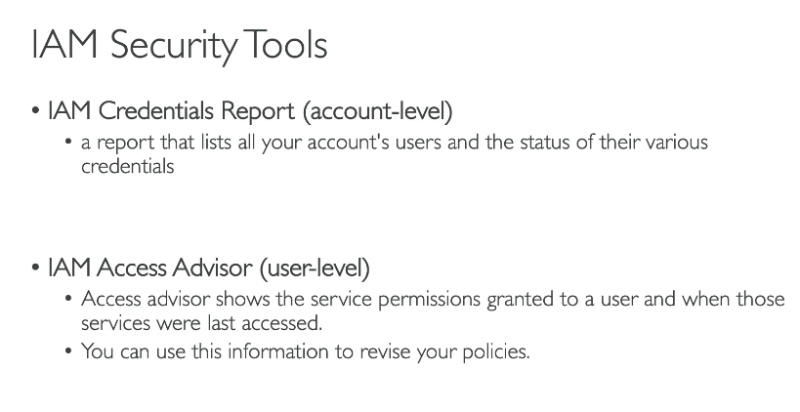
IAM Security Tools Overview (with Scenario Examples)
Tool | What It Does | Scenario
IAM Credential Report | Lists all users and details like password age, access keys, MFA enabled, etc. | 🔎 You want to audit your IAM users and check who hasn't rotated their password or keys recently.
IAM Access Advisor | Shows what services a user/role has accessed and when. Helps right-size permissions. | 🧾 You gave a user AmazonS3FullAccess, but they only used EC2. Use Access Advisor to trim S3 permissions.
IAM Policy Simulator | Simulates and tests what actions are allowed/denied for a user, group, or role. | 🧪 You created a new custom policy and want to test if a user can PutObject in S3 before assigning it.
Service Last Accessed Data | Shows the last time a service was accessed by a user or role. | 🕒 You're reviewing permissions and want to remove unused services from IAM roles.
AWS Config Rules (IAM-focused) | Audits IAM configurations like ensuring users have MFA, no unused keys, etc. | 📋 Enforce a rule to check that all users must have MFA enabled.
AWS CloudTrail | Logs all IAM activity (who did what, when, and from where). | 🧠 You suspect unauthorized IAM changes. Use CloudTrail to trace who made them.
AWS Access Analyzer | Analyzes IAM roles and policies for unintended public or cross-account access. | 🔓 A role allows access to your S3 bucket from another AWS account. Access Analyzer helps detect it.

🛡️ Best Practices Using These Tools:
- ✅ Run IAM Credential Report weekly to review inactive keys, passwords, or lack of MFA.
- ✅ Use IAM Access Analyzer regularly to avoid accidental data exposure.
- ✅ Simulate policies before applying to production users/roles.
- ✅ Remove unused IAM entities using last accessed data.
- ✅ Enable CloudTrail in all regions to ensure you're capturing IAM activity.

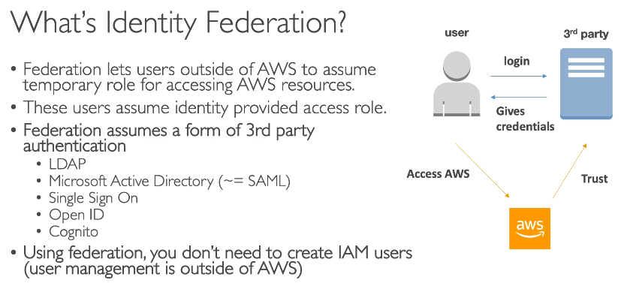
What is Identity Federation?
Identity federation allows users to log in to AWS using their existing credentials from external identity providers (IdPs) like:
- Microsoft Active Directory (via SAML 2.0)
- Google, Facebook, Apple (via OpenID Connect)
- Amazon Cognito User Pools
You don’t create IAM users for them – they authenticate with the IdaP and assume a temporary role in AWS.

🔐 Identity Federation with SAML (e.g., Active Directory)
🔧 Use Case:
Your organization uses Microsoft Active Directory (AD) for user authentication. You want users to log in to the AWS Management Console without creating IAM users.
🛠️ Steps:
- Setup SAML-based IdP (e.g., Microsoft AD FS).
- In AWS IAM, create a SAML Identity Provider using metadata from AD FS.
- Create an IAM role with:
  - Trust relationship allowing SAML IdaP to assume the role.
  - Permissions you want federated users to have.
- Give users the SAML login link.
✅ Result: Users log into AD, get authenticated, redirected to AWS, and assume the role temporarily.

👥 Identity Federation with Amazon Cognito
🎯 Use Case:
You have a mobile or web app where users can sign in with Google, Facebook, or email/password, and then access AWS services like S3 or DynamoDB.
🛠️ Steps:
- Create a Cognito User Pool (handles user sign-up, sign-in, and directory).
- (Optional) Integrate Identity Providers like Google, Facebook, or SAML IdP.
- Create an Identity Pool (Cognito Federated Identities) to allow access to AWS services.
- Map roles (unauthenticated and authenticated) with required permissions.
- From your app, authenticate users, get temporary AWS credentials via Identity Pool.
✅ Result: Authenticated users can access AWS resources securely and temporarily using the IAM roles assigned.

🔁 Summary Comparison
Feature | SAML Federation | Cognito Federation
Used For | Enterprise Login (e.g., AD) | Web/mobile apps
Login Source | SAML-compliant IdP | Social, SAML, User Pools
Role Access | IAM Role via SAML Assertion | IAM Role via Identity Pool
Suitable For | Corporate SSO | App users, guest access

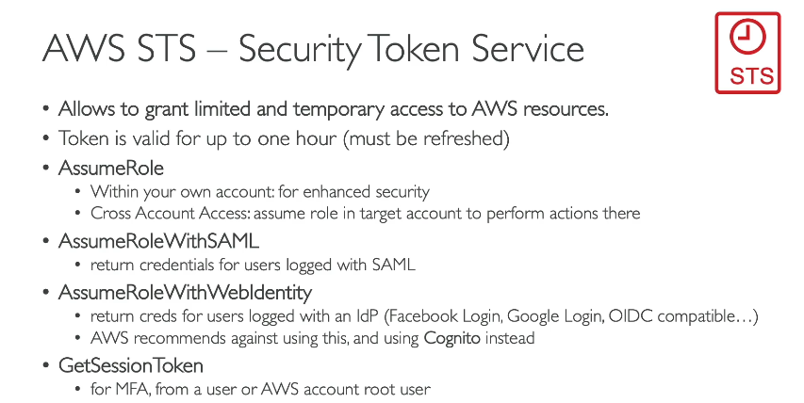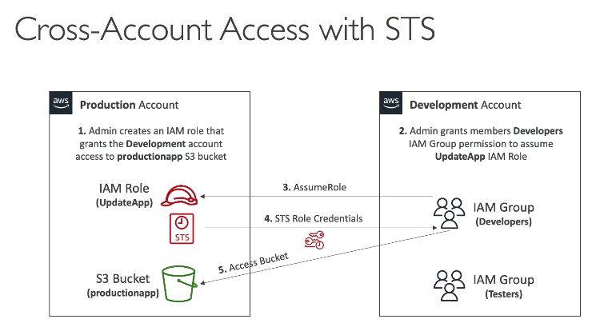
What is AWS STS?
AWS STS (Security Token Service) allows you to generate temporary security credentials to access AWS services. These credentials are:
- Temporary
- Scoped with permissions
- Used for Cross-Account Access, Federation, and Delegation

🔄 What is Cross-Account Access?
Cross-Account Access means allowing a user or role in Account A to access resources in Account B using IAM Roles and STS.
Amazon Cognito User Pools Overview
Amazon Cognito User Pools is a user directory service that allows you to create and manage user identities for your applications.
It provides sign-up, sign-in, and access control features for web and mobile apps.
Cognito Identity Pools Overview
Amazon Cognito Identity Pools allow you to authorize users to access AWS services directly (e.g., S3, DynamoDB) using temporary AWS credentials.
While User Pools handle authentication, Identity Pools handle authorization — especially for federated users.

🔄 Key Difference from User Pools:
Feature |  |  |  |  |  |  |  |  | User Pools |  |  |  |  |  |  | Identity Pools
Purpose |  |  |  |  |  |  |  |  | Authentication (Who are you?) |  |  |  |  |  |  | Authorization (What can you access?)
Provides |  |  |  |  |  |  |  |  | Sign-up, Sign-in, tokens |  |  |  |  |  |  | Temporary AWS credentials (IAM)
Tokens |  |  |  |  |  |  |  |  | JWT (ID/Access/Refresh) |  |  |  |  |  |  | AWS STS credentials
Federation |  |  |  |  |  |  |  |  | SAML, OIDC, Social |  |  |  |  |  |  | Same + User Pools
Used with |  |  |  |  |  |  |  |  | App authentication |  |  |  |  |  |  | AWS service access (S3, DynamoDB, etc.)

Use Amazon Cognito Identity Federation" correctly because it enables your mobile app users to securely access their own S3 resources with temporary credentials, simplifying authentication and authorization without managing IAM users. This approach aligns perfectly with providing personalized, scalable access in mobile applications.

