AWS Lambda is a serverless compute service that runs your code in response to events and automatically manages the underlying infrastructure. It allows you to execute code without provisioning or managing servers. You only pay for the compute time your code consumes.
How AWS Lambda Works:
- Event-Driven Execution – AWS Lambda runs code in response to events from AWS services like API Gateway, S3, DynamoDB, SNS, etc.
- Fully Managed – AWS handles scaling, security, and maintenance.
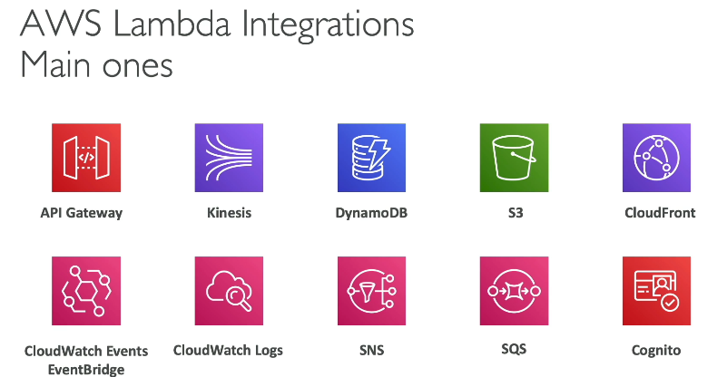
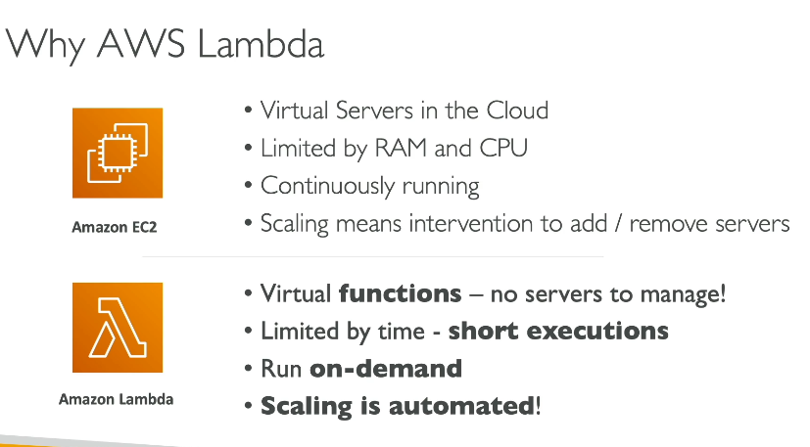
- Pay-per-Use – You only pay for the time your function executes.

Auto-Resize Images (S3 Trigger)
Scenario: You upload an image to an S3 bucket, and AWS Lambda automatically resizes it.
📌 How it works:
- You upload an image to S3.
- This triggers a Lambda function.
- The function resizes the image and saves it in another S3 bucket.
✅ Use Case: Useful for profile pictures, thumbnails, etc.

Example 1: Automatic Email Sending
Problem: You have a chat app, and you want to send a "Welcome Email" when a user signs up.
Without Lambda:
- You need a separate server running 24/7 to send emails.
- You pay even when no one is signing up.

With Lambda:
- When a new user signs up, it triggers Lambda.
- Lambda sends the welcome email and then stops.
- You pay only for that email-sending time.

Use Case: Sending a Welcome Email When a User Logs In
When a user logs in (e.g., Himanshu), AWS Lambda will send a welcome email saying:
📧 "Hi Himanshu, welcome!"

Step-by-Step Implementation
✅ Step 1: Create an AWS Lambda Function
- Go to AWS Console → Lambda → Create Function
- Choose Python as the runtime
- Select Create a new role with basic permissions
- Click Create Function

✅ Step 2: Set Up AWS SES (Simple Email Service)
AWS SES is used to send emails.
- Go to AWS SES Console
- Verify your email (e.g., himanshu@example.com)
- Once verified, you can send emails using SES

✅ Step 3: Write Lambda Function to Send Email
Edit your Lambda function and paste this code:
import boto3
import json
# AWS SES client
ses_client = boto3.client('ses', region_name='us-east-1') # Change region if needed

SENDER_EMAIL = "your-verified-email@example.com"
def lambda_handler(event, context):
# Get the user's name and email from the event
user_name = event.get("user_name", "User")
user_email = event.get("user_email")

if not user_email:
return {
"statusCode": 400,
"body": json.dumps("User email is required")
}
# Email subject and body
subject = "Welcome to ChatApp!"
body = f"Hi {user_name},\n\nWelcome to ChatApp! We’re excited to have you.\n\nBest Regards,\nChatApp Team"

# Send email using SES
response = ses_client.send_email(
Source=SENDER_EMAIL,
Destination={"ToAddresses": [user_email]},
Message={
"Subject": {"Data": subject},
"Body": {"Text": {"Data": body}}
}
)
return {
"statusCode": 200,
"body": json.dumps(f"Welcome email sent to {user_email}")
}

✅ What this does?
- Takes user name and email as input
- Sends a welcome email via AWS SES

✅ Step 4: Expose Lambda via API Gateway
- Go to AWS API Gateway → Create New REST API
- Create a POST method
- Link it to the Lambda function
- Deploy the API to get a public URL

✅ Step 5: Modify Django to Call Lambda
In Django, send a request to AWS Lambda when a user logs in:
import requests
import json
LAMBDA_URL = "https://your-api-gateway-url.amazonaws.com/prod"
def send_welcome_email(user_name, user_email):
payload = {"user_name": user_name, "user_email": user_email}
response = requests.post(LAMBDA_URL, json=payload)
return json.loads(response.text)
Now, in your Django login view, call this function:
def login_user(request):
if request.method == "POST":
user_name = request.POST.get("username")
user_email = request.POST.get("email")
# Call AWS Lambda to send a welcome email
send_welcome_email(user_name, user_email)
return JsonResponse({"message": "Login successful!"})

✅ Final Workflow
1️User logs in to Django
2️Django sends user_name + email to AWS Lambda
3️AWS Lambda triggers SES to send an email
4️User receives 📧 "Hi Himanshu, Welcome!"

Lambda Permissions - IAM Roles & Resource Policies
To allow AWS Lambda to interact with other AWS services like S3, DynamoDB, SNS, SQS, CloudWatch, etc., we need to configure IAM Roles and Resource Policies.

1️IAM Role for Lambda (Execution Role)
Every Lambda function needs an IAM Role with the required permissions to access AWS resources.
✅ Example: Grant Lambda Access to S3 & CloudWatch Logs
1️Go to AWS IAM → Roles → Create Role
2️Select Trusted Entity: AWS Service → Lambda
3️Attach Policies:
- AmazonS3FullAccess (if you want full access to S3)
- AWSLambdaBasicExecutionRole (for CloudWatch logging)
4️Name the role: LambdaS3ExecutionRole
5️Click Create Role
2️Attach the IAM Role to Your Lambda Function
1️Go to AWS Lambda → Select Your Function
2️Scroll to Permissions
3️Click Edit Role and choose LambdaS3ExecutionRole
3 Resource-Based Policy (Example: Allow S3 to Trigger Lambda)
When S3 sends events to Lambda, S3 needs permission to invoke Lambda.
S3 Event Invocation Permission Example
This allows S3 to invoke the Lambda function:
{
"Effect": "Allow",
"Principal": {
"Service": "s3.amazonaws.com"
},
"Action": "lambda:InvokeFunction",
"Resource": "arn:aws:lambda:us-east-1:123456789012:function:MyLambdaFunction",
"Condition": {
"ArnLike": {
"AWS:SourceArn": "arn:aws:s3:::my-source-bucket"
}
}
IAM Role (Execution Role) → Grants Lambda permission to access AWS resources.
- Example: Lambda needs access to read/write S3, update DynamoDB, or send emails via SES.
- This role is attached to Lambda and allows it to interact with other AWS services.
Resource-Based Policy → Grants external services permission to invoke Lambda.
- Example: S3 triggers a Lambda function when a file is uploaded.
- This policy is attached to Lambda and allows S3, API Gateway, SNS, or EventBridge to invoke it.

Lambda Monitoring & X-Ray Tracing
To monitor AWS Lambda performance, errors, and execution flow, you can use:
✅ Amazon CloudWatch – Logs & Metrics
✅ AWS X-Ray – Distributed Tracing

1️Lambda Monitoring with CloudWatch
✅ What CloudWatch Monitors in Lambda?
- Invocations – Number of times Lambda was triggered
- Duration – Execution time of the function
- Errors – Number of errors (e.g., timeouts, exceptions)
- Throttles – Requests exceeding concurrency limits
- Cold Starts – Time taken to initialize the function
How to Enable CloudWatch for Lambda?
1️Go to AWS Lambda → Select Your Function
2️Click on Monitor → View CloudWatch Logs
3️Inside CloudWatch Logs, each execution has a log entry

2️AWS X-Ray for Distributed Tracing
AWS X-Ray helps in tracing end-to-end requests, identifying performance bottlenecks, and debugging failures in distributed systems.
Use Case: Tracing Lambda Execution in a Chat App
For your Chat App, X-Ray can:
✅ Track API calls from Lambda to MySQL, S3, and SNS
✅ Detect slow queries in MySQL
✅ Monitor message delivery via SNS
How to Enable AWS X-Ray for Lambda?
1️Go to AWS Lambda → Select Function
2️Click Configuration → Monitoring and Operations Tools
3️Enable Active Tracing
4️Click Save

3️ View Tracing Data in AWS X-Ray
1️ Go to AWS X-Ray → Traces
2️Click on Service Map
3️You'll see a flow diagram of Lambda calling S3, DynamoDB, MySQL
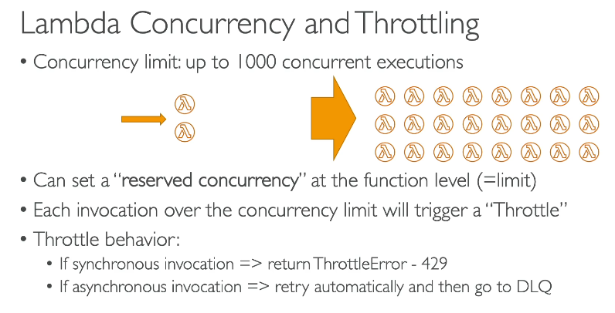
AWS Lambda Concurrency Explained 🚀
Lambda Concurrency determines how many instances of your function can run at the same time. If multiple users trigger your Lambda simultaneously, concurrency ensures parallel execution without delays.

1️Types of Lambda Concurrency
AWS Lambda supports three types of concurrency management:
Concurrency Type | Description | Use Case
Unreserved Concurrency | Default mode (AWS manages concurrency) | Good for general workloads
Reserved Concurrency | Sets a fixed number of concurrent executions | Prevents overuse of Lambda
Provisioned Concurrency | Keeps instances pre-warmed to avoid cold starts | Best for low-latency apps

2️How Concurrency Works?
✅ If 100 users send requests at the same time and Lambda has 50 concurrency, 50 requests run instantly, while the rest wait or get throttled.
✅ Each new invocation creates a new execution instance, up to the maximum concurrency limit.
✅ AWS scales automatically, but overuse may throttle new requests.

3️Managing Concurrency in AWS Lambda
Reserved Concurrency (Prevents Overuse)
- Guarantees a fixed number of concurrent executions for your function.
- If all reserved slots are busy, new requests are dropped (throttled).
📌 Use case: Ensuring one Lambda doesn’t use all your AWS account’s concurrency.
Provisioned Concurrency (Avoid Cold Starts)
- Pre-warms Lambda instances so requests start instantly.
- Unlike Reserved Concurrency, it ensures instances are always ready.
📌 Use case: Real-time applications (Chat, Video Streaming, APIs).

