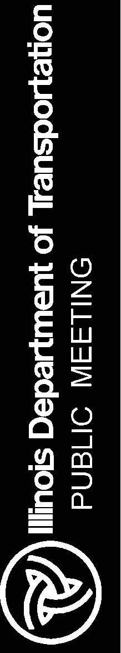 | The Illinois Department of Transportation cordially invites you to attend the open house public meeting concerning the preliminary engineering and environmental study (Phase I) for the improvement of Illinois Route 394 at Burville Road in Crete Township in Will County. The general scope of work for this improvement consists of intersection improvements through the introduction of a Restricted Crossing U-Turn (RCUT). The RCUT is an innovative and proven solution that will improve safety and operations by changing how Burville Road traffic crosses or turns left at Illinois Route 394. The RCUT will not change any of the movements that are possible from Illinois Route 394. The details of the meeting are as follows:  Date: Thursday, October 25, 2018  Time: 4:00 to 7:00 p.m.  Location: Crete Township Office  1367 Wood Street  Crete, IL 60417  Purpose of the meeting:  - To discuss the purpose and need for the improvement  - To present the proposed improvement plans  - To obtain public input  Interested persons may attend anytime between 4:00 p.m. and 7:00 p.m. Exhibits will be on display and an audio-visual presentation will be shown continuously during the meeting. Project team members will be present to discuss the project and answer questions.  This meeting will be accessible to people with disabilities. Anyone needing special assistance should contact Mike Phan, Project Manager, at (847) 705-4634. Persons planning to attend who will need a sign language interpreter or other similar accommodations should notify the Department’s TTY/TTD number (800) 526-0844/or 711; TTY users (Spanish)  (800) 501-0864/or 711; and Telebraille (877) 526-6670 at least five (5) days prior to the meeting.  All correspondence regarding this project should be sent to:  Illinois Department of Transportation  201 W. Center Court  Schaumburg, IL 60196-1096  Attn: Bureau of Programming  Carlos A. Feliciano  or submitted through the project email: DOT.IL394atBurville@illinois.gov

