Module 5) HTML5

Q-1) What are the new tags added in HTML5?

A-1) There are many types of new tags added in HTML5.

such as:

* <header></header>
* <footer></footer>
* <section></section>
* <article></article>
* <nav></nav>
* <svg></svg>etc.

A lot of new elements are added in HTML5 to facilitate some extra functionality to write an easy and fast code to create an engaging and effective website.

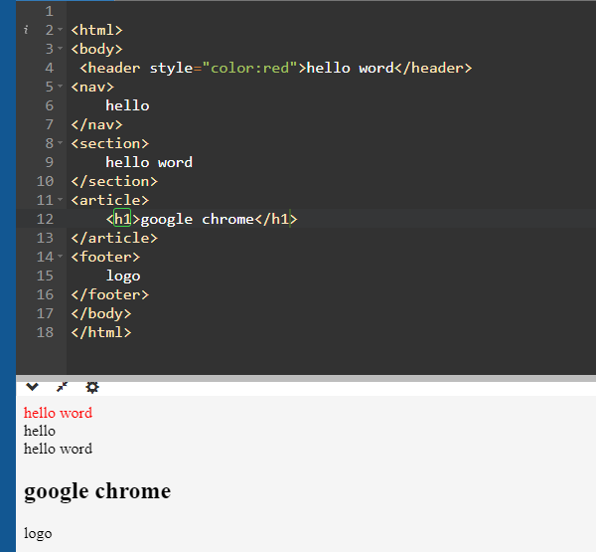

Q-2) How to embed audio and video in a webpage?

A-2)**embed video webpage:** The <video> element allows us to

embed video files into an HTML, very similar to the way images

are embedded.

Attributes we can include are:

* src
* type

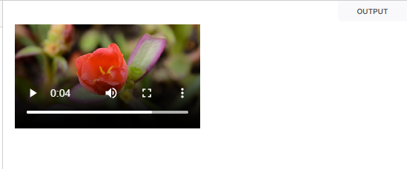 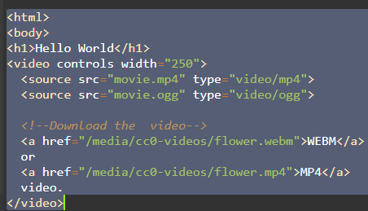

* **embed audio webpage:** The <audio> tag is used to embed sound content in a document, such as music or other audio streams.

 represented using the src attribute or the [<source>](https://developer.mozilla.org/en-US/docs/Web/HTML/Element/source) element.

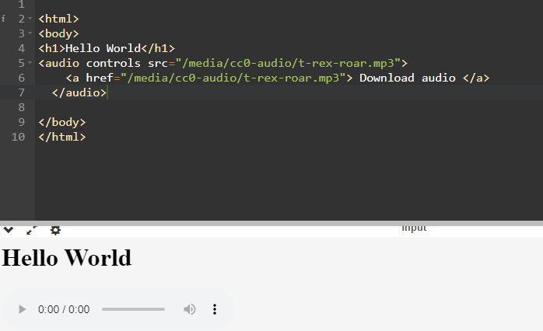

Q-3) Semantic element in HTML5?

A-3) In HTML there are some semantic elements that can be used to define different parts of a web page:

* <article>
* <aside>
* <details>
* <figure>
* <footer>
* <header>
* <main>
* <mark>
* <nav>
* <section>
* <summary>
* <time>

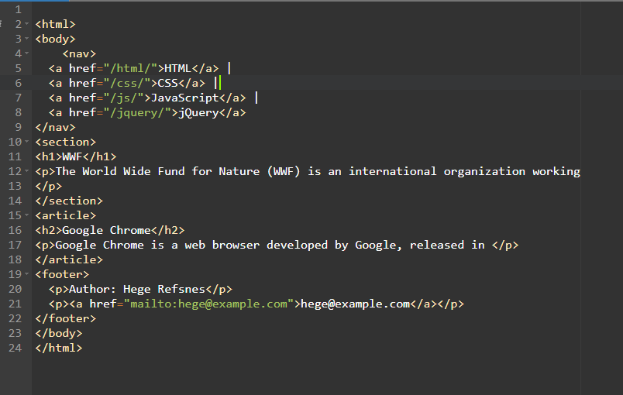

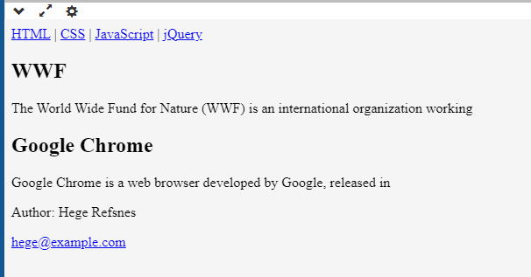

Q-4)Canvas and SVG tags?

A-4)**canvas:** The HTML5 canvas element can be used to draw graphics on the webpage via JavaScript.

**SVG:**SVG stands for Scalable  vector graphics.

SVG images can be printed with high quality at any resolution.

