604 Assignment 1

-Hinal Desai

-ML51414

1. List the names of the entity tables. Do not include the tables: Num, Tests and Scores

* Employees

Categories

Products

Suppliers

Customers

OrderDetails

Orders

Shippers

1. Let us assume that the HR Director is a super fan of a popular zombie apocalypse-themed show on TV and takes it too seriously. He has established new procedures that employees are required to get certified annually in neutralizing zombie threats. He wants to track this certification process in the TSQLV4 database which contains the employee data. The data the director requires includes:
   * + certification for each employee,
     + date of certification achievement,
     + annual renewal date, and
     + training hours.
   1. Provide a diagram showing a database that:
      1. New or revised tables that need to be created, normalize to at least third normal form (5 pts)

* New Tables to be created:

1. PostalCode – Postalcode, country, city, region
2. Certification – certid, empid, achievementdate, renewaldate, trininghours
3. Ships – shipid, shipname, shipaddress, postalcode

Revised Tables:

1. Employees – empid, lastname, firstname, title, titleofcourtesy, birthdate, hiredate, address, postalcode, phone, mgrid
2. Suppliers – supplierid, companyname, contactname, contacttitle, address, postalcode, phone, fax
3. Customers – custid, , companyname, contactname, contacttitle, address, postalcode, phone, fax
4. Orders – ordered, custid, empid, orderdate, requireddate, shippeddate, shipperid, freight, shipid
   * 1. Existing tables that have a relationship with the new tables (5 pts)

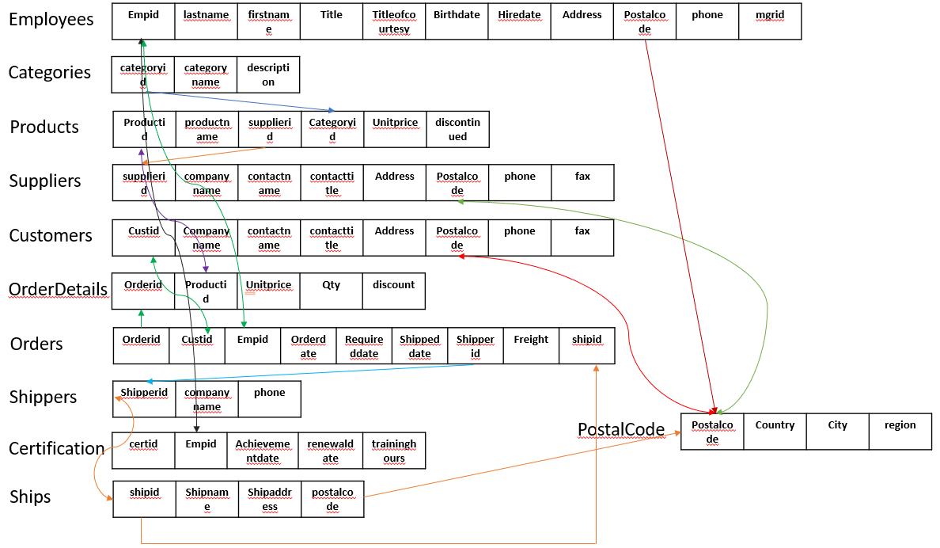

* + 1. show data types for each new data field(5 pts)

**PostalCode**

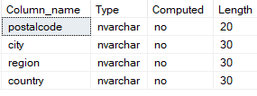

**HR.Certification**

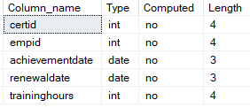

**HR.Employees**

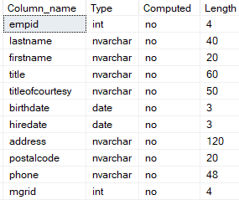

**Production.Categories**

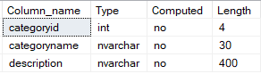

**Production.Products**

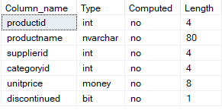

**Production.Suppliers**

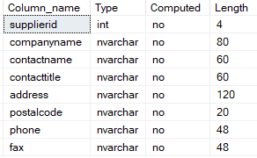

**Sales.Customers**

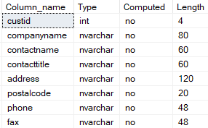

**Sales.OrderDetails**

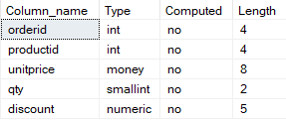

**Sales.Orders**

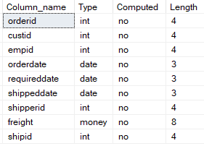

**Sales.Shippers**

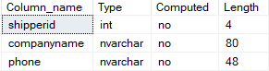

**Sales.Ships**

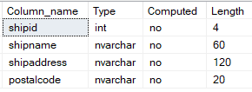

* + 1. label the relationships and cardinality between the new tables and existing tables (5 pts). You may use Crow notation, Chen notation or just write it out (e.g. optional zero to many, mandatory one to many, etc)
* Employees: Employees – Optional one to Many

Employees: Certification – Mandatory one to Many

Employees: Orders – Optional One to Optional Many

Orders: OrderDetails – Mandatory one to Mandatory one

Orders: Ships - Mandatory one or many to Mandatory one

Orders: Shippers - Mandatory one or many to Mandatory one

OrderDetails: Products – Mandatory one to Mandatory one or many

Customers: Orders - Mandatory one to Mandatory one or many

Categories: Products - Mandatory one to Mandatory one or many

Suppliers: Products – Many to Many

PostalCode: Employees – Mandatory one to Optional many

PostalCode: Customers – Mandatory one to Optional many

PostalCode: Suppliers – Mandatory one to Optional many

PostalCode: Ships – Mandatory one to Optional many

* + 1. Show the degree - binary, unary or ternary of the relationships (5 pts)This diagram can be done in Visio, Word, Lucidchart, other software tool of preference, or you can scan in a hand drawn document.

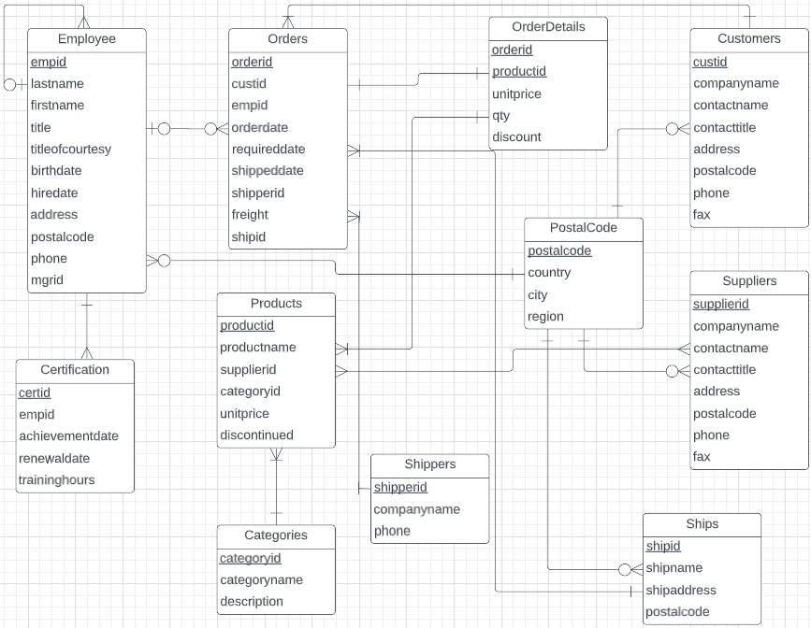

* 1. Create the new database table (s) in your physical database. (30 points)

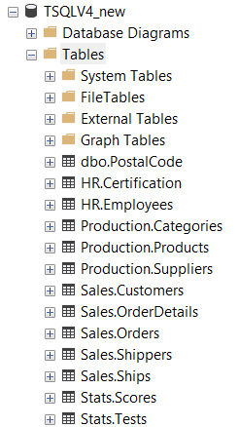

* 1. Perform a backup of the database using sql/operating system level commands, zip the backup file, document with answers to 1, and diagram, then submit to instructor using Blackboard.
* Backup files: TSQLV4.BAK and TSQLV4_new.BAK

Commands used:

BACKUP DATABASE TSQLV4_new

TO DISK = 'C:\Work\TSQLV4_new.BAK'

GO

BACKUP DATABASE TSQLV4

TO DISK = 'C:\Work\TSQLV4.BAK'

GO