**Paper 1**

In today’s world, the internet has become a youth sensation. Not only youth, but people of every age group rely on the internet for their day-to-day activities. They surf the internet to learn, play, meet new people, buy groceries, appliances, etc. However, it is a proven fact that the internet not only provides help but is also a root cause of various issues. Various surveys have been conducted that support the fact that the internet is used as a tool to mislead and deceive people. There have been cases where a large number of people were subjected to pornographic materials and then were threatened. Also, we are well aware of the internet fraud cases where various people are looted by giving them tempting offers. All of these scenarios lead to the individual suffering from depression and stress.

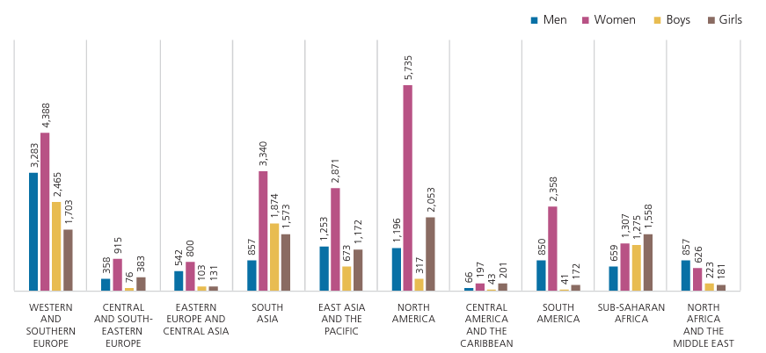

Figure: Figure: Number of detected victims of trafficking in persons, by age group and sex, by region of detection, 2018.[1]

The above figure illustrates the trafficking crime rate in 2018 over various regions. This rate is ever-increasing and with modernization, we are reaching new heights and these are having adverse effects.

To help the general public and to catch hold of these internet predators, the State Police came up with various strategies. They created various fake profiles on many popular social media sites to look for bad actors. They employed several “ethical hackers” to access known social media forums, platforms, and websites that have been proven to host inappropriate content. They asked for foreign intelligence services to access U.S. servers without judicial authorization to provide data in the search of online predators. And lastly, they hired local university graduates to build an artificial intelligence application to further help find online criminals.

But the strategies that the State Police is adopting are also not ethical. With data governing the market, we tend to see ethics and privacy breach aspects in every kind of work that we do. Let us evaluate the strategies that the State Police is planning to adopt to catch hold of the online predators:

1. **Creation of Fake profiles:**

Every social media sites have it mentioned in their policies that the profiles created should be authentic. These sites restrict the creation of fake profiles. For example, Facebook has mentioned in its policies that state: ‘Users may not provide any false personal information on Facebook, or create an account for anyone other than yourself without permission. It is a violation of our policies to use a fake name or operate under a false identity.’[2]. The rules remain the same for everyone. The State Police breached the laws and used unethical methods, though for a good cause.

Applying the Ethical Theories:

Subjective Relativism: According to Subjective relativism, the act of creating fake profiles is incorrect in my opinion but it might not be the same concerning the State police. They may argue stating that it is valid in this case.

Cultural Relativism: According to Cultural relativism, the act of the State Police does not hold good as they do not abide by the rules, laws, and regulations set by the society.

Ethical Egoism: According to Ethical Egoism, The State Police did what best suited them and what had long-term benefits. Hence, they are correct.

Kantianism: According to Kantianism, the State Police went against the rules of ‘Not creating a Fake Profile’. Hence whatever they did was incorrect.

Utilitarianism: According to Utilitarianism, the benefits of creating a fake profile are way higher than the consequences of breaking the rule. Hence it is good to create a fake profile.

Social Contract Theory: According to Social Contract Theory, the social media sites had rules to not create fake profiles hence the State Police had no right to do so.

Virtue Ethics: According to Virtue Ethics, a virtuous person would never create a fake profile and hence the State Police’s act is not correct.

1. **Ethical hackers:**

‘Ethical hacking is a powerful policy in fighting online threats with the rise of cybercrime. Generally speaking, ethical hackers are allowed to shatter into ostensibly 'secure' computer systems without malevolent intent, but with the goal of finding susceptibility in sequence to conduct about better preservation.’[3] If this is to be considered then hiring ethical hackers to catch hold of the online predators seems fair.

Applying the Ethical Theories:

Subjective Relativism: According to Subjective relativism, hiring ethical hackers seems fair to me as well as the State Police. Hence it is correct.

Cultural Relativism: According to Cultural relativism, hacking in any term is not accepted by society. Hence this act is incorrect.

Ethical Egoism: According to Ethical Egoism, The State Police did what best suited them and what had long-term benefits. Hence, they are correct.

Kantianism: According to Kantianism, the State Police went against the rules of not hacking any social media sites. Hence whatever they did was incorrect.

Utilitarianism: According to Utilitarianism, the benefits of hacking are way higher than the consequences of letting the predators stay. Hence it is a good act to hire ethical hackers.

Social Contract Theory: According to Social Contract Theory, the social media sites had rules to not break into and hack the websites hence the State Police had no right to do so.

Virtue Ethics: According to Virtue Ethics, a virtuous person would never hack into a website and hence the State Police’s act is not correct.

1. **Help of Foreign Intelligence services:**

Taking help from foreign intelligence for finding out cybercrime is a great thought and should be helpful but it should be done with proper authorization and permissions. The State Police was going to hand over very sensitive data in the hands of these intelligence officers. Hence having proper permissions to access that data and permission to hand it over to the intelligence team is of utmost importance. The State Police did not take judicial permissions and went ahead with sharing this information with the intelligence team. This might have severe consequences. Hence the State Police should have taken permission before sharing the data.

Applying the Ethical Theories:

Subjective Relativism: According to Subjective relativism, sharing sensitive data without permission might be the need of the hour for the State Police. Hence what they did was correct.

Cultural Relativism: According to Cultural relativism, sharing sensitive information without permission is not acceptable. Hence the State Police’s act is incorrect

Ethical Egoism: According to Ethical Egoism, The State Police did what best suited them and what had long-term benefits. Hence, they are correct.

Kantianism: According to Kantianism, the State Police went against the rules of sharing sensitive information with third parties without proper judicial permission. Hence whatever they did was incorrect.

Utilitarianism: According to Utilitarianism, it is difficult to weigh this situation. We do see that the benefits we get are very good but what if the intelligence officer steals and misuses the data. We can assume that since the State Police would monitor this case we can be rest assured that there will be no such deed done. If that assumption is to be believed then we can say that the State Police did the correct thing.

Social Contract Theory: According to Social Contract Theory, sharing any sensitive information with third parties without permission is illegal. Hence the State Police should have taken permission first before sharing the data.

Virtue Ethics: According to Virtue Ethics, a virtuous person would never share any sensitive data until he has proper authorization to do so. Hence the State Police’s act is ethically incorrect.

1. **Hiring University Graduates:**

Hiring students from a local university to build an artificial intelligence system is not a bad thought but sharing the sensitive information to build so is of high risk. The graduate students have no expertise and lack experience. Handing over such confidential information is of utmost risk as they do not have the experience of handling such data. If there is any miss that happens while testing the application or even when building it, and if this causes the data to be leaked into the market, then the State Police will be in great trouble. Hence it is better to hire professionals who have experience and make them sign an NDA (Non-Disclosure Agreement). In this way, the data will be at a lesser risk and the state police will achieve what it intended to. The US government currently has no one law but has a bunch of laws in place for regulating sensitive data privacy.[4] The State Police took advantage of this situation and shared it with the local university students.

Applying the Ethical Theories:

Subjective Relativism: According to Subjective relativism, sharing sensitive data with local university students might be permissible to the State Police. Hence what they did was correct.

Cultural Relativism: According to Cultural relativism, sharing sensitive information with inexperienced individuals puts the data at risk and is not acceptable. Hence the State Police’s act is incorrect

Ethical Egoism: According to Ethical Egoism, The State Police did what best suited them and what had long-term benefits. Hence, they are correct.

Kantianism: According to Kantianism, the State Police technically did not break any rules as there are no rules in place and hence what they did is acceptable.

Utilitarianism: According to Utilitarianism, according to my ideologies, the risks are higher than the benefits and inexperienced students cannot be trusted with sensitive data and there is a high chance of data leak. Hence it is not appropriate to share this information with students.

Virtue Ethics: According to Virtue Ethics, a virtuous person would have weighed his options. He would have handed over the data to professionals instead of students. Hence what the State Police did was incorrect.

In conclusion, the State Police should have thought of some better way rather than creating fake profiles. The State Police was not completely wrong for hiring an ethical hacker. They should have taken permission before sharing the information with foreign intelligence and instead of sharing the information with students, they should have given it to professionals,

**References and Citations:**

[1] Global Report on Trafficking in Persons 2020 (January 2021). UNITED NATIONS OFFICE ON DRUGS AND CRIME. <https://www.unodc.org/documents/data-and-analysis/tip/2021/GLOTiP_2020_15jan_web.pdf>

[2] Cops Are Creating Totally Bogus Facebook Profiles Just So They Can Arrest People (October 2013). Business Insider. <https://www.businessinsider.com/police-make-fake-facebook-profiles-to-arrest-people-2013-10?international=true&r=US&IR=T>

[3] A REVIEW PAPER ON ETHICAL HACKING (December 2020). International Journal of Advanced Research in Engineering and Technology. <https://www.iaeme.com/MasterAdmin/Journal_uploads/IJARET/VOLUME_11_ISSUE_12/IJARET_11_12_018.pdf>

[4] The State of Consumer Data Privacy Laws in the US (And Why It Matters) (September 2021). NYTimes. <https://www.nytimes.com/wirecutter/blog/state-of-privacy-laws-in-us/>