**University of Maryland, Baltimore County.**

Hinal Bhavesh Desai.

Ethical and Legal Issues in Data Science.

Contact Tracing (Paper 2)

Prof. Sunela Thomas

April 3, 2022.

The world was hit by the COVID-19 pandemic in November 2019 and since then, the government worldwide is taking various measures for the safety of the public and to reduce the impact of the disease. One such measure in that direction is contact tracing. Case investigation and contact tracing, a core disease control measure employed by local and state health department personnel for decades, is a key strategy for preventing the further spread of COVID-19. The Centers for Disease Control and Prevention (CDC) has laid out various guidelines for preventing the spread of COVID-19 and for contact tracing. The public health staff works with the patients to help them recall everyone with whom they have had [close contact](https://www.cdc.gov/coronavirus/2019-ncov/php/contact-tracing/contact-tracing-plan/appendix.html#contact) during the timeframe while they may have been infectious. Public health staff then begin contact tracing by warning these exposed individuals (contacts) of their potential exposure as rapidly and sensitively as possible. To protect patient privacy, contacts are only informed that they may have been exposed to a patient with the infection. Contacts are then educated and advised to remain quarantined and maintain the social distancing norms. (Prevention, Case Investigation and Contact Tracing : Part of a Multipronged Approach to Fight the COVID-19 Pandemic, 2022)

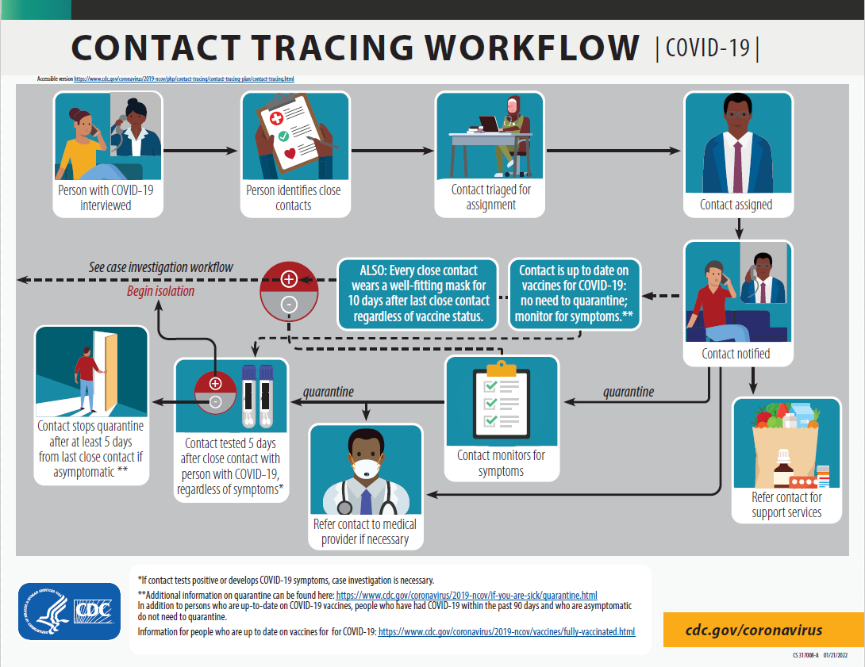

Fig1: Contact Tracing Workflow (Prevention, Contact Tracing for COVID-19, 2022)

Case investigation, contact tracing, and contact follow-up and monitoring will need to be linked with timely testing, clinical services, and agile data management systems to facilitate the real-time electronic transmission of laboratory and case data for public health action. Case management tools can help automate key pieces of the case investigation and contact tracing process, making the overall process more efficient. Since public health workers have to deal with a lot of confidential data, they need to be very careful. They need to abide by the various ethical theories so as to maintain the data ethically. (Prevention, Case Investigation and Contact Tracing : Part of a Multipronged Approach to Fight the COVID-19 Pandemic, 2022)

As per Utilitarianism, the CDC took the correct step by not disclosing the name of the patient while contact tracing. This won’t disclose the patient’s identity and will also inform the contacted people to be cautious hence preventing the spread. As per Social Contract Theory as well, keeping the patient’s identity anonymous is of great help as this will help him maintain his privacy and help him recover without the fear of being subject to various questions from society. Hence his rights prevail.

Also while transmitting the data from laboratories to the CDC, one needs to make sure that the channel via which this data is transmitted is secure and no breach has occurred.

The Indian government came up with a contact tracing app known as ‘Arogya Setu’ which will notify a customer when he comes in close contact with a person infected with COVID-19. This mobile application was a mandate for all the citizens. It uses the phone’s bluetooth and location services to notify a user when they have been near a person with Covid-19 by scanning a database of known cases of infection. When a person is infected, he/she gets notified on a daily basis for 14 days from the day they are detected positive so as to keep a check on their health. Though this app had various benefits, there were a lot flaws. Aarogya Setu stores location data and requires constant access to the phone's Bluetooth which, experts say, makes it invasive from a security and privacy viewpoint. Also, it was mandatory for everyone to download the app, which was also under question. The former Indian Supreme Court judge BN Srikrishna said ’ Under what law do you mandate it? So far it is not backed by any law’. If Utilitarianism is to be considered then the app is of utmost benefits as it helps the government in contact tracing and hence prevents the spread. The apps use can be termed as ethical as per Utilitarianism. But as per Social Contract theory, Kantian Theory, and Virtue Ethics, a person’s rights are violated by forcing him to download an app that is nowhere mentioned in the law. A French ethical hacker Robert Baptiste has stated ‘Forcing people to install an app doesn't make a success story. It just means that repression works’. Also tracing a person’s location is invading their privacy. This app monitors one’s location continuously and hence is an invasion of one’s privacy. Also, since it uses bluetooth, which travels through walls, there are chances of false positives or incorrect data, which might turn life-threatening to people and is ethically incorrect. Also, The app allows the authorities to upload the collected information to a government-owned and operated server, which will provide data to persons carrying out medical and administrative interventions necessary in relation to Covid-19. The Software Freedom Law Centre, a consortium of lawyers, technology experts, and students, says it is problematic as it means the government can share the data with practically anyone it wants which is ethically incorrect as per all the theories. Unlike the UK's Covid-19 tracing app, Aarogya Setu is not open source, which means that it cannot be audited for security flaws by independent coders and researchers. (Clarance, 2020)

Apple and Google also had coronavirus tracking APIs hosted which used a mathematically derived key from a user’s private key to identify a user. The user can report his/her health status, whether positive or negative in the API and this data is then shared with the central database. Though they used encryption mechanisms, it was very easy to track back a patient from the key if one came to know the mathematical formula being used. This clearly showed ethical issues and had to be addressed immediately. Hence Apple and Google agreed on changing their mechanism to a random key generation one which is safer and it becomes difficult to trace back a user. They also pledged that they will shut down these APIs as soon as the outbreak ends. To abide by the ethical policies, they even changed the protocols from a contact-tracing system to an exposure notification system that would not mislead the users. But the biggest drawback of this API was that the health authorities had no means of verifying the data. Until a person decides to enter his health status to the API, the health authorities will not be informed and vice versa if a false positive is entered then also there is no means to track it. According to Utilitarianism, this is ethically incorrect as the app is defeating its purpose and is not as beneficial as it was considered. According to Social Contract theory and Virtue Ethics, people are allowed to enter false positives as well and hence it increases the risk and is ethically incorrect. (Brandom, 2020)

Due to privacy concerns, people are attracted more toward physical contact tracing rather than digital contact tracing. John Hopkins University published an article on the ethical issues associated with where it states that Respecting privacy is a core ethical principle and this is raising the question of whether digital contact tracing should be used or not. Tracking someone's personal information is beyond what most people are accustomed to, and some may consider it a violation of their privacy. One of the major concerns is who will have access to an individual's private information, for what purposes, and for how long. When you consider the possibilities of linking data from your mobile device to other things like health behaviors and health-care system use, genomic testing, consumer habits, credit card data, and more, it's concerning. People are fearful that these data points may be amalgamated and used in a sinister way to track residents. Other uses can be avoided, but significant safeguards are required to ensure that they do not occur. Another ethical concern is respecting autonomy. This relates to how we consider the role of consent in using digital tools for public health purposes. From a strictly public health standpoint, the most helpful information would most likely come from compelling everyone who has a smartphone to download an app and have that information shared with public health authorities without consent. Without such a mandate—which, given our values and approach, is unlikely—individuals have two options: they can opt-in or out of the technology's use, the information it collects, and with whom it may be shared. An opt-out method would require consumers to turn off functionality after downloading an app, rather than opt-in, which would need the individual to turn it on. Equity is another ethical principle to consider. If digital contact tracing provides a benefit, then how do we also protect people without smartphones who don't have access to the technology? Policies should make sure that access to the technology and its benefits, as well as the distribution of its burdens, are shared equitably. A final consideration is the level of performance of the technology. We don't yet know whether these tools work. Do they actually predict who has been exposed in ways that will help public health professionals combat the pandemic, and with what level of precision? Too many false positives or false negatives won't serve the goal of augmenting traditional contact tracing efforts. (Volkin, 2020)

In my opinion, data science engineers need to create a system that is ethically correct and which solves the purpose of contact tracing. A mix of the Apple/Google API and the Arogya Setu app can help solve the problem. The main ethical issue with Arogya Setu was invading a person’s privacy whereas the issue with Apple/Google API was the false positives. Data engineers should use the random token generation technique instead of the location technique to trace people and the entire system should be linked with the government’s database so as soon as a positive record crops up in the government database, people whose phones have the token of the positive person are notified. In this way, no one’s privacy is invaded and there is no chance of anyone entering false positive information. One more important point to be taken care of is that a customer’s consent has to be taken prior to sending information. Also, all the terms and conditions need to be clearly mentioned in the disclaimer and user consent on the same is of utmost importance. Also, the data that is being stored with the government should be stored securely and should not be shared with any local bodies. In this way, the purpose of contact tracing is solved ethically.

# References

Brandom, R. (2020, April 24). *Apple and Google pledge to shut down coronavirus tracker when pandemic ends*. Retrieved from The Verge: https://www.theverge.com/2020/4/24/21234457/apple-google-coronavirus-contact-tracing-tracker-exposure-notification-shut-down

Clarance, A. (2020, May 15). *Aarogya Setu: Why India's Covid-19 contact tracing app is controversial*. Retrieved from BBC News: https://www.bbc.com/news/world-asia-india-52659520

Prevention, C. o. (2022, Feb 28). *Case Investigation and Contact Tracing : Part of a Multipronged Approach to Fight the COVID-19 Pandemic*. Retrieved from https://www.cdc.gov/coronavirus/2019-ncov/php/principles-contact-tracing.html#previous

Prevention, C. o. (2022, Feb 2022). *Contact Tracing for COVID-19*. Retrieved from https://www.cdc.gov/coronavirus/2019-ncov/php/contact-tracing/contact-tracing-plan/contact-tracing.html

Volkin, S. (2020, May 26). *DIGITAL CONTACT TRACING POSES ETHICAL CHALLENGES*. Retrieved from John Hopkins University: https://hub.jhu.edu/2020/05/26/digital-contact-tracing-ethics/