Hinal Bhavesh Desai (ML51414)

05/08/2022

**Boeing 737 Max**

Case Study

Abstract

The following document gives a description of the issues that happened with Boeing’s 737 Max, their causes, and recommendations for the same

**Executive Summary**

Boeing’s 737 Max had 2 back to back crashes which involved a loss of a lot of human lives. These crashes involved new aircraft. There were multiple reasons why these crashes occurred. The below paper mentions the reasons, their causes, and a few recommendations for the same.

**Introduction**

The Boeing Company is an American multinational corporation that designs, manufactures, and sells airplanes, rotorcraft, rockets, satellites, telecommunications equipment, and missiles worldwide. In 2018 and 2019, Boeing’s 737 Max had 2 fatal crashes back to back. There are multiple reasons for these crashes. Boeing's production quality, such as outsourcing software to companies with no or little experience in the aerospace industry, has caused the company to shift from a quality and productivity-oriented company to a cost-cutting, stocks-oriented company, which was one of the major reasons that led to the crash. There were various other reasons like angle-of-attack sensor failure, activation of MCAS software, etc. The below paper will depict the main challenges, their causes, and recommendations for the same in detail.

**Main Challenges**

* *Stakeholder losses* – After the 2 crashes, Boeing suffered various losses as it had to ground all its aircraft. Boeing had various stakeholders including itself. The other stakeholders included airline industries such as American Airlines and Southwest. Due to these crashes, Boeing not only lost its shares but also lost the reputation and trust that the stakeholders had. American Airlines and Southwest were also forced to ground their aircrafts.
* *Technical Issues* – The inertia of the plane might lead it to overswing and stall depending on the angle. To counter increased stall risk, Boeing developed the Maneuvering Characteristics Augmentation System (MCAS). The angle of attack (AoA) sensor is used by the MCAS to identify how the plane's nose is angled in relation to the oncoming air. Airspeed, altitude, and AoA are all monitored by MCAS. The software is of great help but goes for a toll when it starts to push the pilot’s control columns forward assuming that the aircraft is about to stall. Also, the size of the engines fitted in the 737 were quite huge due to which the clearance between the ground and the engines became smaller.
* *Negligence –* The Federal Aviation Association was responsible for certifying the new systems for Boeing. The negligence of the FAA and Boeing towards the minute details while testing was a huge factor that led to these crashes. Also, the engineers developing the software did not have much experience. There is accumulating evidence that Boeing and the FAA were aware of MCAS's design flaws and lack of communication with pilots regarding its presence and operation. After all these, there was a clear go-ahead given to the aircraft and the MCAS software.

**Causes**

* *Cost-cutting* – The sheer need of meeting the high expectations of society to enter the IT industry, and rely on an IT infrastructure for a hardware-like issue is the very first point where Boeing’s failure started. The growing reliance of many firms on information technology (IT) and the high percentage of IT investment in all invested capital in the business environment necessitates increased attention in exchange for less investment and higher returns. Companies must contend with rising client demands, expanded markets, and increased competition. This puts more pressure on businesses to reduce total costs. Companies that can't afford to fail, such as those in the aerospace, transportation, and space industries, are particularly vulnerable to failure. MCAS was less expensive than changing the airframe to suit the larger engines but was not efficient. This was one of the major root causes that led to 737’s failure and hence the loss of stakeholders’ money.
* *Lack of Research* – For cost-cutting reasons, the MCAS designed by experienced engineers was decommissioned. The new enhanced software improvements were outsourced to organizations with no prior experience in aircraft software development. Is it worth making such trade-offs when the safety of hundreds of people is at stake? The answer to this would be a big no. Just to save on money, first Boeing switched to software rather than fixing their hardware. And then instead of having experienced engineers switched with amateurs acted like a whistleblower. Bill Foster quoted ‘If we choose to ignore science and refuse to fund important scientific research, we voluntarily cede our place as a world leader in innovation.’[1] The thought of entering into the IT industry for aerospace was a huge turn that Boeing was taking and needed proper backing and research. Investing money in the MCAS software would have achieved fruitful results. Also, the pilots were never trained to use the software and the documentation was all the more problematic.
* *Management Failure –* Senior management must be preserved in any firm to the extent that knowledge transfer is done correctly. With their domain experience, a senior team will always be present to help new groups or outsourced teams down the right route. Boeing suffered a huge blow during the software testing phase when numerous top engineers who were the brains of software like MCAS were laid go. There was no sufficient instruction to discover and determine the upgraded software issues. Engineers have expressed dissatisfaction with tight timelines, and hasty deliveries are not unusual. Similar was the situation with 737. Also, FAA was very negligent in certifying the aircraft as well.

**Recommendations**

* *A Penny Saved is a Penny earned* – Cost-cutting is the new mantra of the new age era and it is effective only when implemented correctly. Boeing wanted to cut the huge costs but the method they chose was incorrect. Leaning towards software and developing MCAS was a great move towards digitalization but the cost-cutting that happened during the testing phase was not required. If cost-cutting is to be implemented then there are various other departments where cost-cutting can be implemented. Testing should never be compromised. There are various other strategies like:[2]
  + Eliminating liaisons and coordinators.
  + Reducing excessive service levels.
  + Change the process.
  + Reduced business requirements.
  + Getting to 30% or More: Cross-Department and Program-Elimination Ideas
  + Coordinate parallel activities.
  + Eliminate duplicated analysis.
  + Eliminate low-value meetings and forums.
  + Restructure or cut cross-department activities.
* *Research* – It is said that ‘Too many cooks spoil the broth’. Boeing introduced 2 major changes simultaneously, fitting the huge engines and MCAS to control them. They should first appoint a proper testing team for MCAS and should test with smaller engines.Basically, more emphasis should be given to the research and testing phase of MCAS. Once the program succeeds, then the engines should be replaced and testing should be done again. Once satisfactory results are gained then only a final go should be given to the program. Testing in the aerospace industry is of utmost importance. To validate the safety and well-being of commuters, the crew on the flight, and the vehicle itself, specific strict guidelines need to be followed without compromising when it comes to testing and validating aerospace software applications.[3]
* *Management Retainment* – The senior members of the team who were involved in the designing phase of MCAS had the most insights about the software and its point of failure and upgradation needs. If they were retained, then they could have provided various details while testing which would have been of utmost importance. Boeing was very confident of its past success and hence laid off the maximum of its senior developers and had a communication gap with the third-party vendors to whom they outsourced the project. Senior employees are the pillar of every project and should be retained at any cost. Even after the project is built and stabilized, senior experienced employees are of utmost importance. Below are the benefits of retaining employees in a business: [4]

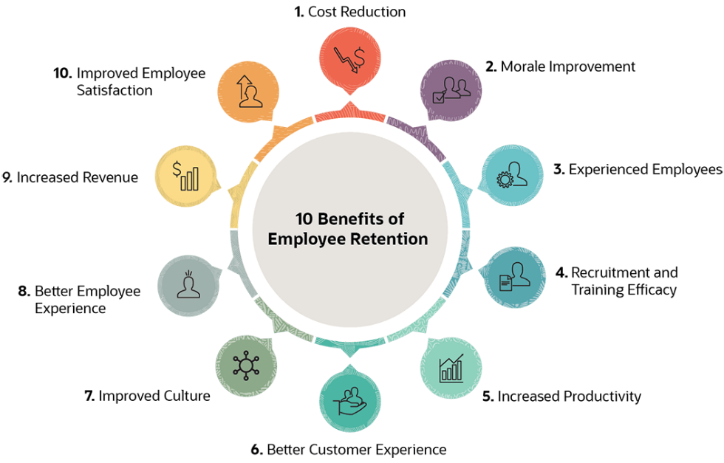

**References**

[1] Bill Foster. <https://www.brainyquote.com/authors/bill-foster-quotes>

[2] Kevin Coyne, Shawn T. Coyne, and Edward J. Coyne, Sr. (May 2010). When You’ve Got to Cut Costs—Now. <https://hbr.org/2010/05/when-youve-got-to-cut-costs-now>

[3] Debjani Goswami. (15 Dec, 2020). How Significant is Software Testing in the Aerospace Industry? <https://medium.com/qualitest/how-significant-is-software-testing-in-the-aerospace-industry-8031678c844e>

[4] Marc Holliday. (23 Feb, 2021). 10 Benefits of Employee Retention for Businesses. <https://www.netsuite.com/portal/resource/articles/human-resources/employee-retention-benefits.shtml?mc24943=v1>

[5] Michael A Roberto. (3 Nov, 2020). Boeing’s 737 Max: Company Culture and Product Failure.